1. Create an array of 10 elements and print them using the for each loop.

2. Take the number input from the console and add all the positive numbers. (not to consider the negative number if entered)

3. Create a labeled break and write a simple logic and execute the program.

4. Do the addition of around 10 even numbers, but use the continue statement in the logic.

SBA1

CODE FOR SBA1, QUESTION 1:

**package** com.ust.test;

**public** **class** SBA1_Array {

**public** **static** **void** main(String[]args){

**int**[]array={13,22,34,47,59,65,76,89,90,97};

**for**(**int** i:array)

{

System.***out***.println(i);

}

}

}

OUTPUT:

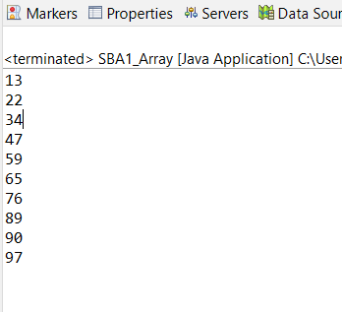

CODE FOR QUESTION 2:

**package** com.ust.test;

**import** java.util.Scanner;

**public** **class** SBA1_Sum {

**public** **static** **void** main(String[]args){

**int** sum=0;

Scanner input=**new** Scanner(System.***in***);

System.***out***.println("Enter a number");

**int** number=input.nextInt();

**while**(number>=0) {

sum+=number;

System.***out***.println("Enter a number");

number=input.nextInt();

}

System.***out***.println("Sum ="+sum);

input.close();

}

}

OUTPUT:

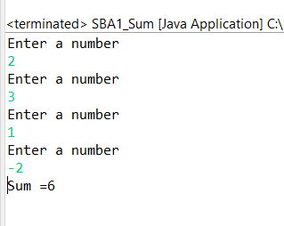

CODE FOR QUESTION 3:

**package** com.ust.test;

**public** **class** SBA1_Labeledbreak {

**public** **static** **void** main(String[]args){

first:

**for**(**int** i=1;i<4;i++) {

second:

**for**(**int** j=1;j<3;j++) {

System.***out***.println("i="+i+";j="+j);

**if**(i==2)

**break** first;

}

}

}

}

OUTPUT:

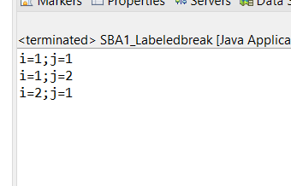

CODE FOR QUESTION 4:

**package** com.ust.test;

**import** java.util.Scanner;

**public** **class** SBA1_Continue {

**public** **static** **void** main(String[]args){

**int** sum=0,i=0,j;

Scanner sc=**new** Scanner(System.***in***);

System.***out***.println("Enter any limit if any ");

j=sc.nextInt();

**for**(i=1;i<=(2*j);i++) {

**if**(i%2==0)

sum=sum+i;

**else**

**continue**;

}

System.***out***.println("The sum of first " +j+"even numbers are "+sum);

}

}

OUTPUT:

