1.Write a program to reverse the String (use char [] or String built in method).

2.Write programs to depict the usage of contains(), length(), replace(), concat(), equals().

CODE FOR 1st program:

**package** com.ust.test;

**import** java.lang.*;

**import** java.io.*;

**import** java.util.*;

**public** **class** SBA2_reverseString {

**public** **static** **void** main(String[]args){

String input="STUDENTS";

**char**[] try1=input.toCharArray();

**for**(**int** i=try1.length-1;i>=0;i--) {

System.***out***.print(try1[i]);

}

}

}

OUTPUT:

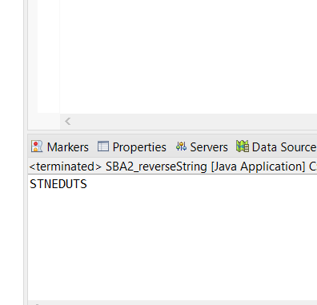

CODE FOR 2nd PROGRAM:

**package** com.ust.test;

**import** java.lang.String;

**public** **class** SBA2_StringMethods {

**public** **static** **void** main(String[]args){

String s1="Hai";

String s2="Good morning";

String s3="Hai";

System.***out***.println("Length of first string:"+s1.length());

System.***out***.println("The concatenated string is:"+s1.concat(s2));

System.***out***.println(s1.equals(s3));

System.***out***.println(s2.contains("Good"));

String replace=s1.replace('a', 'i');

System.***out***.println(replace);

}

}

OUTPUT:

