SBA 8:

SBA8-Springboot Application:

Pom.xml code:

<?xml version="1.0" encoding="UTF-8"?>

<project xmlns="http://maven.apache.org/POM/4.0.0" xmlns:xsi="http://www.w3.org/2001/XMLSchema-instance"

xsi:schemaLocation="http://maven.apache.org/POM/4.0.0 https://maven.apache.org/xsd/maven-4.0.0.xsd">

<modelVersion>4.0.0</modelVersion>

<parent>

<groupId>org.springframework.boot</groupId>

<artifactId>spring-boot-starter-parent</artifactId>

<version>2.5.0</version>

<relativePath/> <!-- lookup parent from repository -->

</parent>

<groupId>com.example</groupId>

<artifactId>spring-boot-initial</artifactId>

<version>0.0.1-SNAPSHOT</version>

<name>spring-boot-initial</name>

<description>Demo project for Spring Boot</description>

<properties>

<java.version>1.8</java.version>

</properties>

<dependencies>

<dependency>

<groupId>org.springframework.boot</groupId>

<artifactId>spring-boot-starter-web</artifactId>

</dependency>

<dependency>

<groupId>org.springframework.boot</groupId>

<artifactId>spring-boot-starter-test</artifactId>

<scope>test</scope>

</dependency>

</dependencies>

<build>

<plugins>

<plugin>

<groupId>org.springframework.boot</groupId>

<artifactId>spring-boot-maven-plugin</artifactId>

</plugin>

</plugins>

</build>

</project>

DemoApplication:

package com.example.test;

import org.springframework.boot.SpringApplication;

import org.springframework.boot.autoconfigure.SpringBootApplication;

@SpringBootApplication

public class DemoApplication

{

public static void main(String[] args)

{

SpringApplication.run(DemoApplication.class, args);

}

}

Product:

package com.example.test;

public class Product

{

private String id;

private String name;

public String getId() {

return id;

}

public void setId(String id) {

this.id = id;

}

public String getName() {

return name;

}

public void setName(String name) {

this.name = name;

}

}

ProductServiceController:

package com.example.test;

import java.util.HashMap;

import java.util.Map;

import org.springframework.http.HttpStatus;

import org.springframework.http.ResponseEntity;

import org.springframework.web.bind.annotation.PathVariable;

import org.springframework.web.bind.annotation.RequestBody;

import org.springframework.web.bind.annotation.RequestMapping;

import org.springframework.web.bind.annotation.RequestMethod;

import org.springframework.web.bind.annotation.RestController;

@RestController

public class ProductServiceController

{

private static Map<String, Product> productRepo = new HashMap<>();

static {

Product honey = new Product();

honey.setId("1");

honey.setName("Honey");

productRepo.put(honey.getId(), honey);

Product almond = new Product();

almond.setId("2");

almond.setName("Almond");

productRepo.put(almond.getId(), almond);

}

@RequestMapping(value = "/products/{id}", method = RequestMethod.DELETE)

public ResponseEntity<Object> delete(@PathVariable("id") String id) {

productRepo.remove(id);

return new ResponseEntity<>("Product is deleted successsfully", HttpStatus.OK);

}

@RequestMapping(value = "/products/{id}", method = RequestMethod.PUT)

public ResponseEntity<Object> updateProduct(@PathVariable("id") String id, @RequestBody Product product) {

productRepo.remove(id);

product.setId(id);

productRepo.put(id, product);

return new ResponseEntity<>("Product is updated successsfully", HttpStatus.OK);

}

@RequestMapping(value = "/products", method = RequestMethod.POST)

public ResponseEntity<Object> createProduct(@RequestBody Product product) {

productRepo.put(product.getId(), product);

return new ResponseEntity<>("Product is created successfully", HttpStatus.CREATED);

}

@RequestMapping(value = "/products")

public ResponseEntity<Object> getProduct() {

return new ResponseEntity<>(productRepo.values(), HttpStatus.OK);

}

}

SBA_Main:

Pom.xml:

<project xmlns="http://maven.apache.org/POM/4.0.0" xmlns:xsi="http://www.w3.org/2001/XMLSchema-instance" xsi:schemaLocation="http://maven.apache.org/POM/4.0.0 https://maven.apache.org/xsd/maven-4.0.0.xsd">

<modelVersion>4.0.0</modelVersion>

<groupId>RestAssured</groupId>

<artifactId>RestAssured</artifactId>

<version>0.0.1-SNAPSHOT</version>

<dependencies>

<dependency>

<groupId>io.rest-assured</groupId>

<artifactId>rest-assured</artifactId>

<version>4.3.0</version>

<scope>test</scope>

</dependency>

<dependency>

<groupId>io.rest-assured</groupId>

<artifactId>json-path</artifactId>

<version>4.2.0</version>

<scope>test</scope>

</dependency>

<dependency>

<groupId>io.rest-assured</groupId>

<artifactId>xml-path</artifactId>

<version>4.2.0</version>

<scope>test</scope>

</dependency>

<dependency>

<groupId>io.rest-assured</groupId>

<artifactId>json-schema-validator</artifactId>

<version>4.2.0</version>

<scope>test</scope>

</dependency>

<dependency>

<groupId>com.googlecode.json-simple</groupId>

<artifactId>json-simple</artifactId>

<version>1.1.1</version>

</dependency>

<dependency>

<groupId>org.testng</groupId>

<artifactId>testng</artifactId>

<version>7.1.0</version>

<scope>test</scope>

</dependency>

</dependencies>

</project>

TestRunner:

package com.example.test;

import static io.restassured.RestAssured.given;

import org.json.simple.JSONObject;

import org.testng.annotations.Test;

import io.restassured.http.ContentType;

public class TestRunner {

@Test

public void Get() {

given().get("http://localhost:8080/products/").then().

statusCode(200).

log().all();

}

@Test

public void Put() {

JSONObject request = new JSONObject();

request.put("name", "Cucumber");

given().contentType(ContentType.JSON).

body(request).

when().

put("http://localhost:8080/products/2").

then().statusCode(200);

}

@Test

public void Delete() {

JSONObject request = new JSONObject();

given().

body(request.toJSONString()).

when().

delete("http://localhost:8080/products/2").

then().statusCode(200).

log().all();

}

}

Post_Rqst:

package com.example.test;

import static io.restassured.RestAssured.given;

import org.json.simple.JSONObject;

import org.testng.annotations.Test;

import io.restassured.http.ContentType;

public class Post_Rqst {

@Test

public void test2() {

JSONObject request = new JSONObject();

request.put("id", "5");

request.put("name", "Guava");

//System.out.println(request);

//System.out.println(request.toString());

given().contentType(ContentType.JSON).

body(request).

when().

post("http://localhost:8080/products").

then().statusCode(201 );

}

}

OUTPUT SCREENSHOTS OF TestRunner:

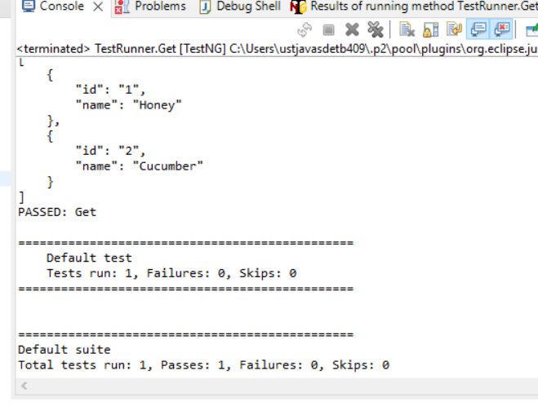

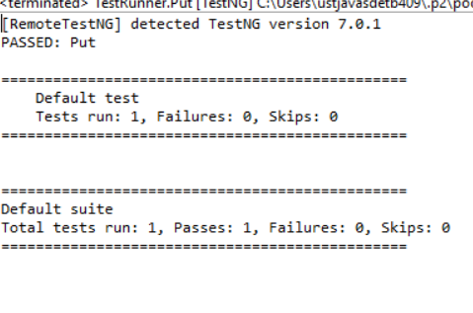

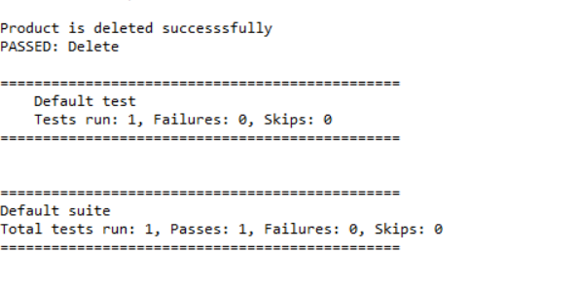

OUTPUT SCREENSHOT OF Post_Rqst:

