LINUX:
INSTALLATION OF WSL IN WINDOWS:
First get to the windows store and install ubuntu18.0 LTS
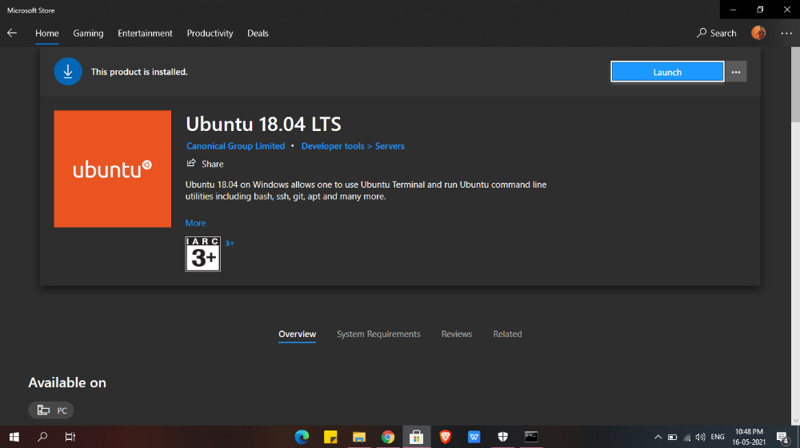

After installing it make sure u enable the wsl from turn on and off
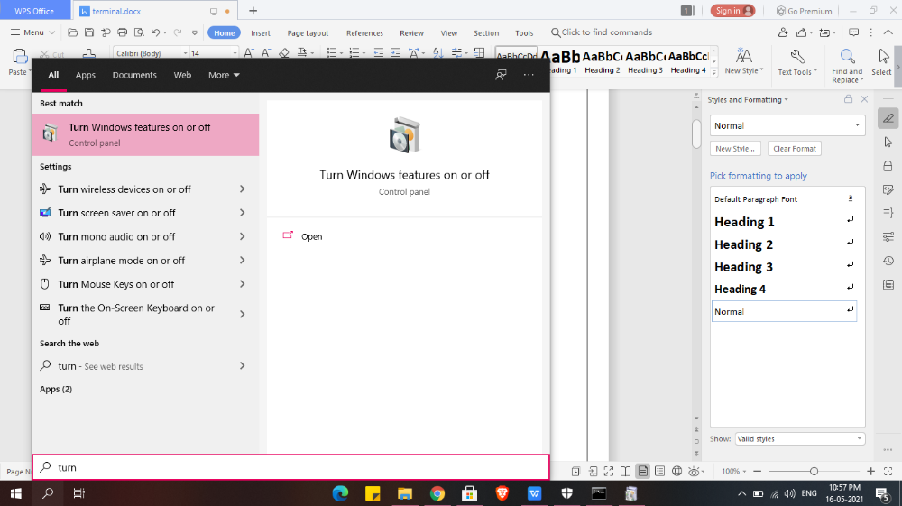

Enabling windows subsystem for linux

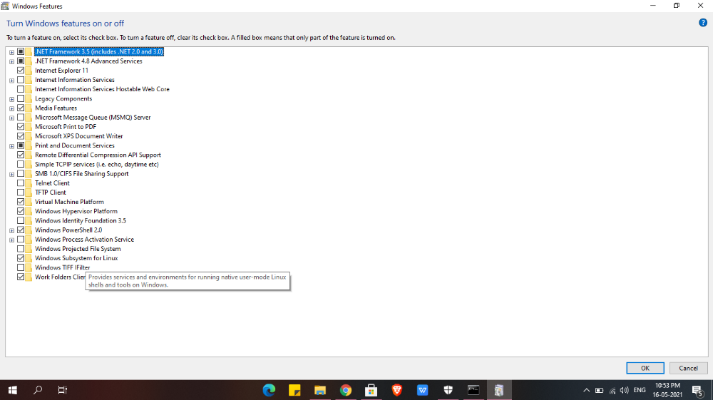

Search ubuntu 18.0 LTS and use it
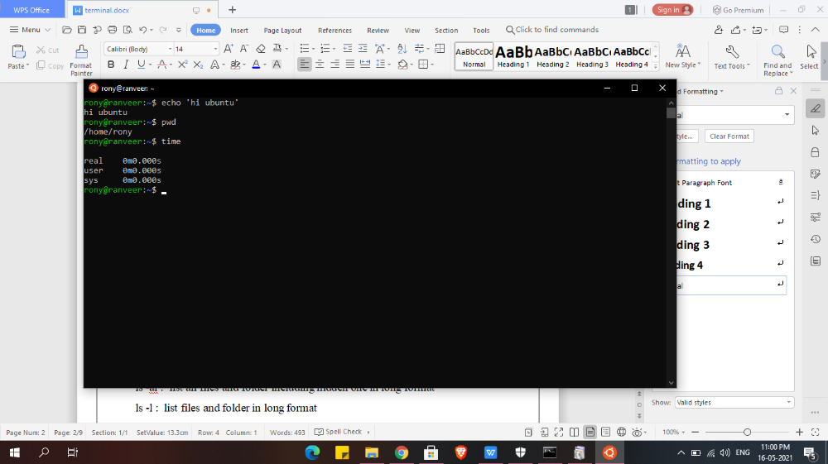

>Is
ls ~: gives/jump all file present in system or all home directory
ls .. : give content or file present in parent directory
ls . : List files and folder in current directory
ls ~ : show u all content in home directory
ls -a : list all files and folder including hidden one
ls -al : list all files and folder including hidden one in long format
ls -l : list files and folder in long format
ls -p :give all files in current directory
ls -p | grep pdf :gives if any pdf file is present (you can write whatever type of file in place of pdf like txt n all)
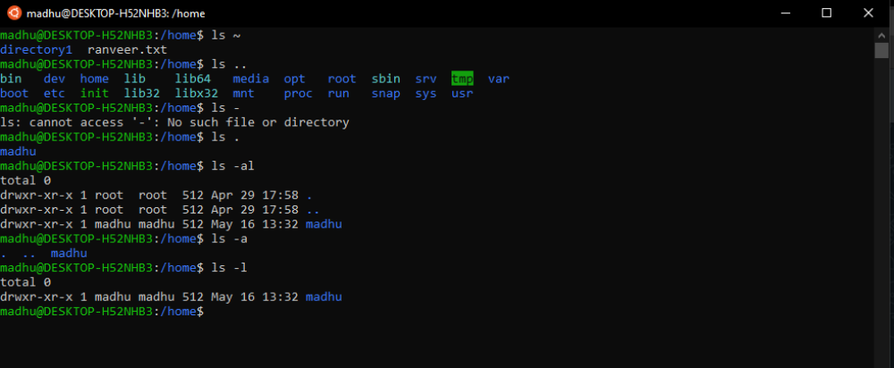

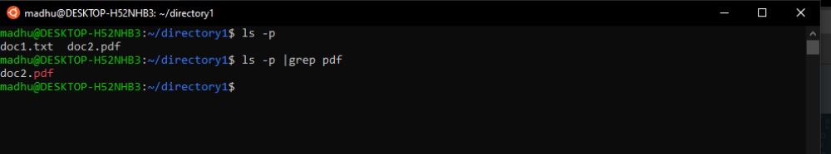

>mkdir:
mkdir directory_name : create directory
rmdir dire_name : removes that particular directory
mkdir -p directory_name1/directory_name2 : create nested directory
(2 is inside 1)
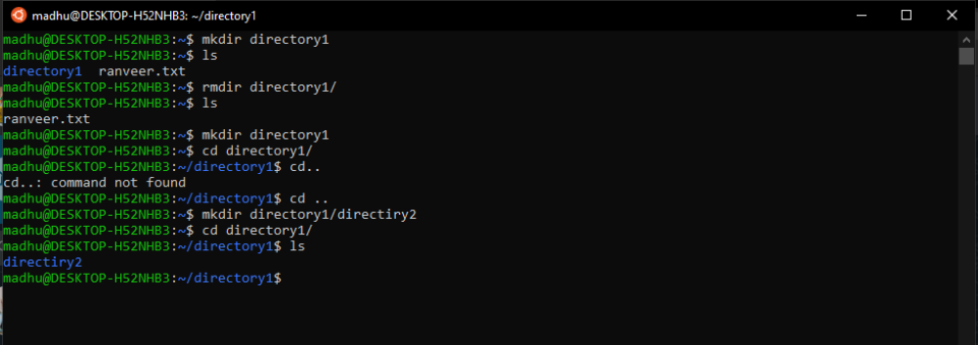
>cd:
cd directory_name/ : take u to that directory
cd .. : take u to one directory before
cd - : take u to previous working directory
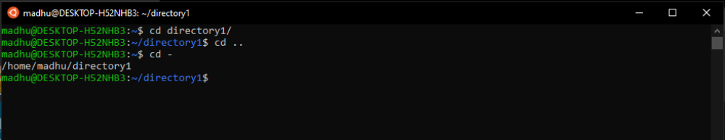

>touch:
touch file_name : create empty file
cd /etc/ :take u to home directory directly
ls -t : gives highlight on last modified directory
ls -lt :give complete details about recent modified file plus other file present
touch file_name : create file name of file_name
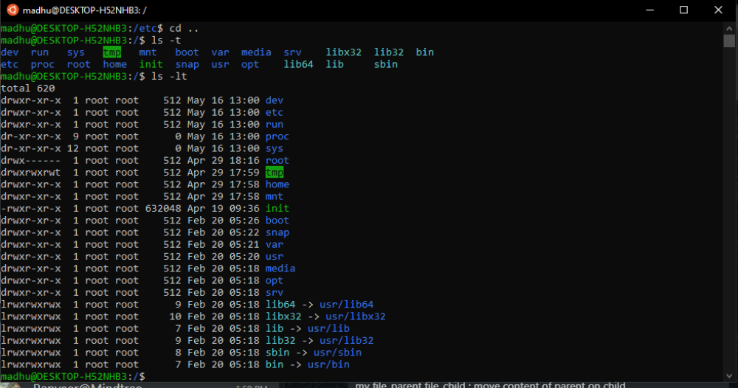

>rm:
rm -r file_name : deletes that perticular file_name
rm -i file_name : ask user permission before deletion
rm -I file_name : dosnt ask user before deletion
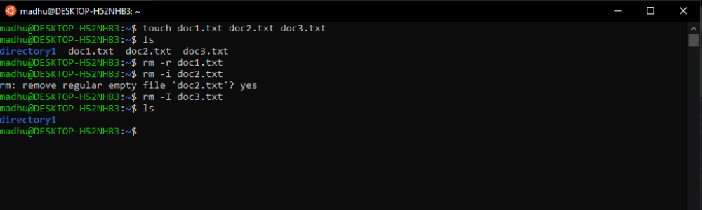

rm -r directory_name: remove the directory recursively
rm -ir directory_name : removes the file or dir with asking permission
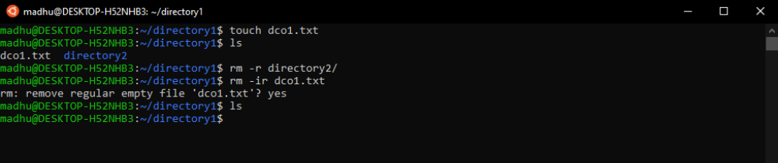

ls -s file_name : gives all file presnt inside in tabular format
ls -l file_name : gives all file presnt inside in long vertical format
pwd : present working directory
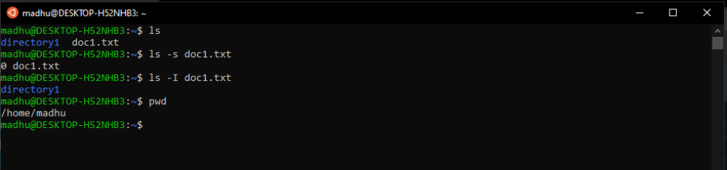

>CP AND MV:

cp file_parent file_child : copy content of parent on child
mv file_parent file_child : move content of parent on child
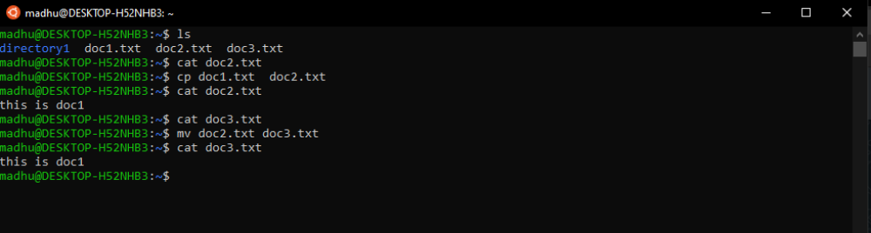

>In:
ln -s test temp/ : symbolic link test file into temp dir // ln command is used to link files with dir
~ : wherever this symbol is used it wil always take u to home always
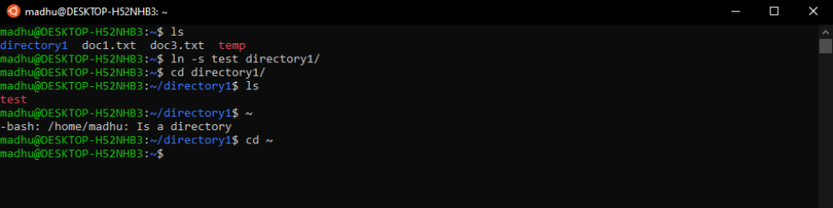
if u want to check which file is linked in that particular dir:
output:
temp1:
test
ln -s file_name ~/home_dir/ : link file_name to home_dir
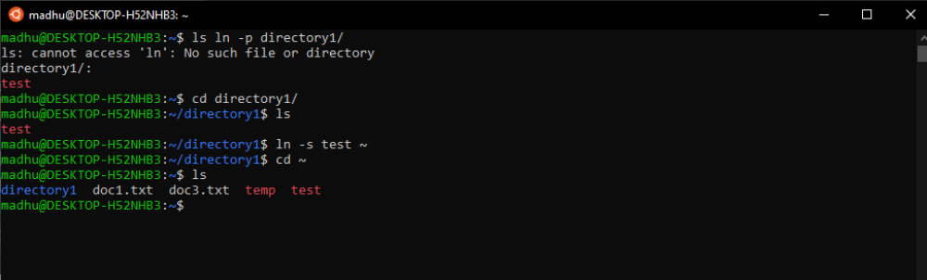

>Man:
man command_name : gives complete details about that perticular command_name

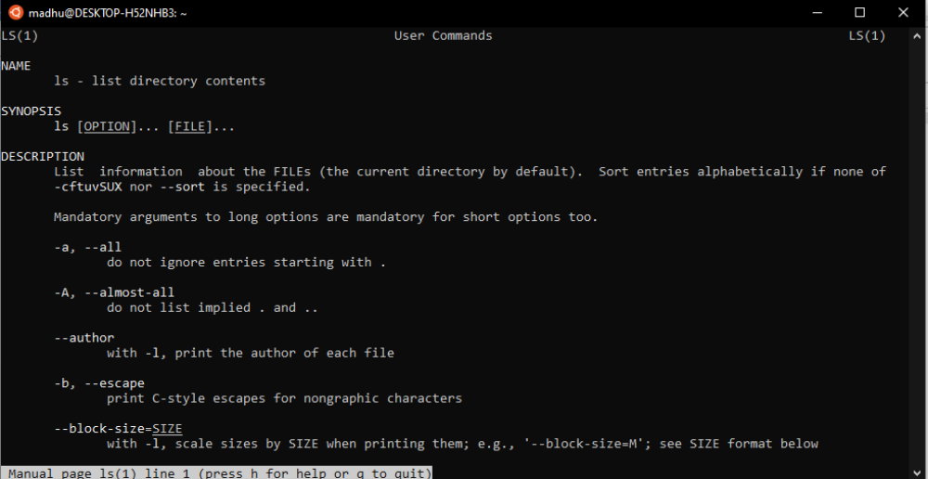

>nano:
for making shell script we use nano command in terminal

>chmod:
This command is used for changing the permission ..what read write and execution feature can be given to user group and owner
+1 for read
+2 for write
+4 for execute

