**Application Stop Steps:**

1. Login to AU10123 with user id **appldev** and password **test12345678**
2. Run command **adstpappl.sh apps/apps,** as shown below:

WebLogic server password is **welcome1**

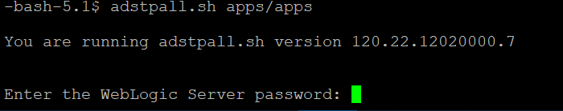

You need to wait until status of script **Exit with 0,** expected time is 5-10 mins.

**Database Stop Steps:**

1. Login to AU10123 with user id **oradev**  and password **test12345678**
2. Run command **sqlplus / as sysdba,** once you connect to SQL prompt, need to run **shu immediate;** command as shown below. It will take couple of mins.

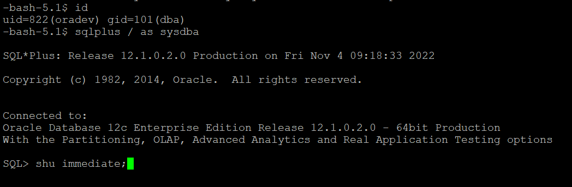

**Database Start Steps:**

1. Login to AU10123 with user id **oradev**  and password **test12345678**
2. Run command **sqlplus / as sysdba,** once you connect to SQL prompt, need to run **startup;** command as shown below. It will take couple of mins.

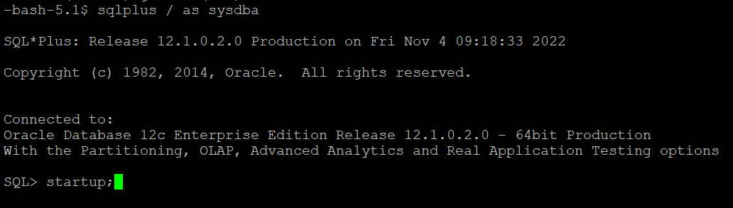

**Application Start Steps:**

1. Login to AU10123 with user id **appldev** and password **test12345678**
2. Run command **adstrtal.sh apps/apps,** as shown below:

WebLogic server password is **welcome1**

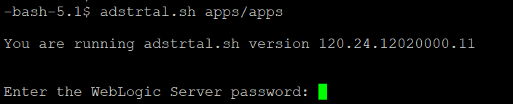

It will take 10-15 mins