**Topics: Normal distribution, Functions of Random Variables**

1. The time required for servicing transmissions is normally distributed with *μ* = 45 minutes and *σ* = 8 minutes. The service manager plans to have work begin on the transmission of a customer’s car 10 minutes after the car is dropped off and the customer is told that the car will be ready within 1 hour from drop-off. What is the probability that the service manager cannot meet his commitment?
2. 0.3875
3. 0.2676
4. 0.5
5. 0.6987

Sol B. 0.2676

Since the work will begin 10 mins after the car is dropped.

Therefore, to finish the work in 1 hour we must have X <= 50

Find P ( X >50 ) = 1 – P(X <= 50)

Standard Normal Variable Z = X - µ/SD

= 50 – 45/8

= 0.625

= 73.405% from Z table

P ( X > 50 ) = 1 - P ( X <= 50 )

= 100 – 73.405

= 26.595 %

The Probability that the service manager cannot meet his commitment = 0.26595

USING PYTHON CODE

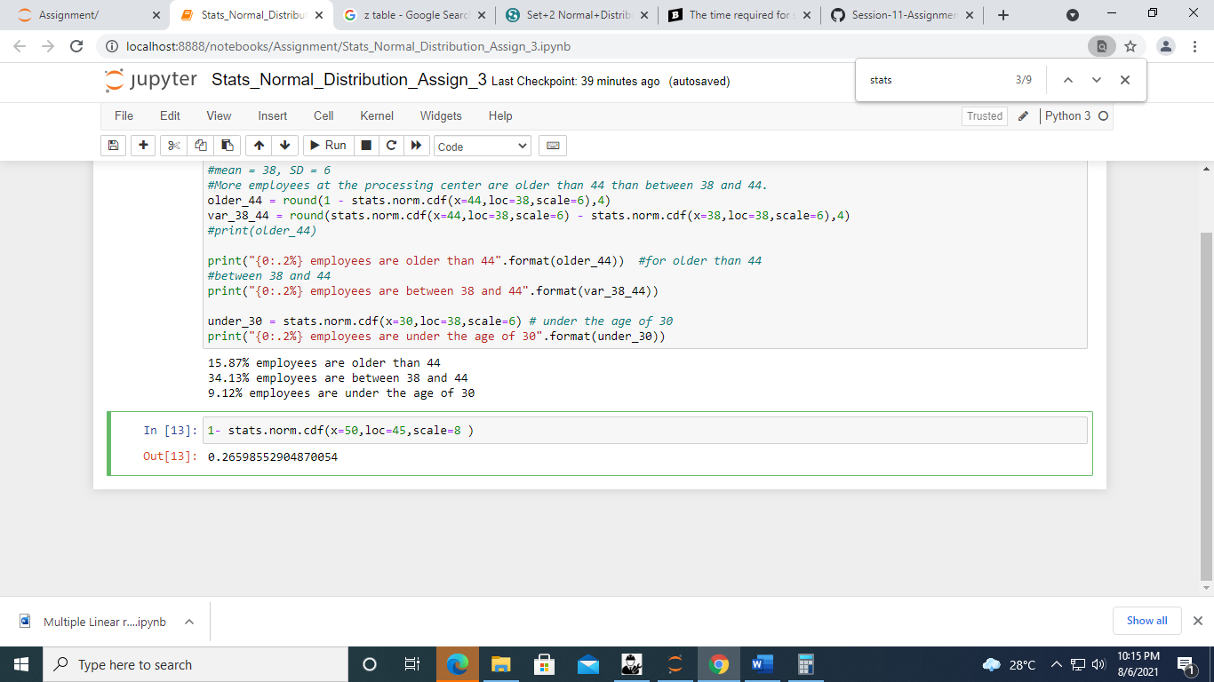

1. The current age (in years) of 400 clerical employees at an insurance claims processing center is normally distributed with mean *μ* = 38 and Standard deviation *σ* =6. For each statement below, please specify True/False. If false, briefly explain why.
2. More employees at the processing center are older than 44 than between 38 and 44.

False

1. A training program for employees under the age of 30 at the center would be expected to attract about 36 employees.

Sol Size = 400

Population Mean = 38

Standard Deviation SD = 6

1. Probability of employee greater than 44 = P(X > 44)

P( X>44 ) = 1 - P( X<=44 )

Z score for 44 = Value – mean/ SD

= 44 – 38/6

= 1

= 84.13 % from Z table

P( X>44 ) = 1 – P( X<=44 )

= 100 – 84.13

= 15.87 %

No. of employees older than 44 = 15.87 % of 400

= 15.87 * 400 /100

= 63 out of 400

Z score for 38 = Value – mean/SD

= 38 – 38/6

= 0

= 50 % from z score table

P( 38 < X < 44 ) = (Z score for 44) – (Z score for 38)

= 84.13 – 50 = 34.13 %

No of employees between age of 38 and 44 = 34.13 % of 400

= 34.13 * 400 /100

= 137 people out of 400

FALSE

USING PYTHON CODE

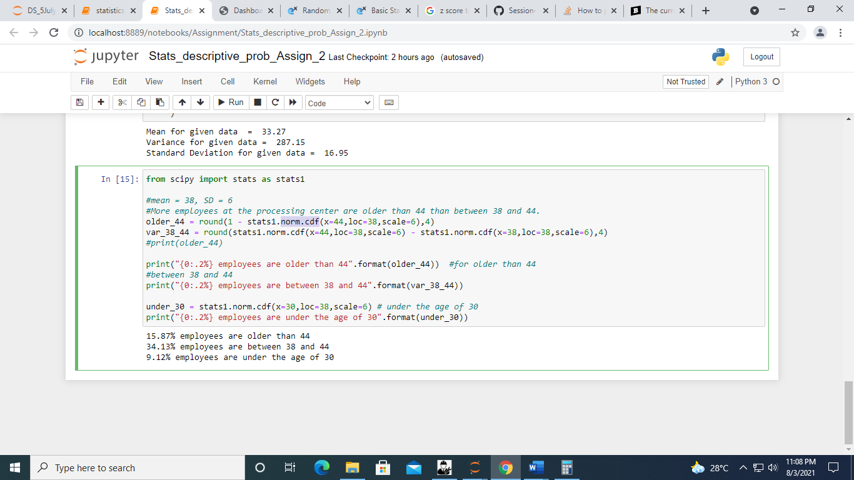

No. of employees older than 44 = 15.87 % of 400

= 63 out of 400

No of employees between age of 38 and 44 = 34.13 % of 400

= 137 people out of 400

**FALSE**

B. No. of employees under the age of 30 = 9.12% of 400

= 36 out of 400

**TRUE**

1. If *X1* ~ *N*(μ, σ2) and *X*2 ~ *N*(μ, σ2) are *iid* normal random variables, then what is the difference between 2 *X*1 and *X*1 + *X*2? Discuss both their distributions and parameters.

Ans. iid = independent, identically distributed random variable

X1 = N ( µ, σ2 ) , *X*2 ~ *N* ( μ, σ2 )

This means that the X1 and X2 are normally distributed with mean and variance. Mean and variance are the parameters of the of the normal distribution.

Where −∞ < µ < ∞, σ 2 > 0.

Increasing mean shifts the density towards right and increasing variance flattens the density without shifting it.

If X1 and X2 are 2 independent, identically distributed random variable then their sum and differences are also normally distributed with their means and variance being added. Means and variance are parameters of ND.

X1 + X2 = N ( µ + µ, σ2 + σ2 )

X1 - X2 = N ( µ - µ, σ2 + σ2 )

If X1 and X2 are 2 independent, identically distributed random variable then 2 X1 will also be normally distributed with mean and variance being multiplied by 2.

2 X1 = N ( 2 µ, (2σ)2 )

= N( 2 µ, 4σ2 )

1. Let X ~ N(100, 202). Find two values, *a* and *b*, symmetric about the mean, such that the probability of the random variable taking a value between them is 0.99.
2. 90.5, 105.9
3. 80.2, 119.8
4. 22, 78
5. 48.5, 151.5
6. 90.1, 109.9

Sol.

We need to find two values a and b such that they are symmetric about mean and the probability of the random variable X taking a value between them is 0.99

Ie. P ( a < X < b) = .99

The probability of X outside a and be will be 1 - 0.99 = .01

Therefore, the probability of X to the left of a = 0.01/2 = - 0.005

Therefore, the probability of X to the right of b = 0.01/2 = - 0.005

To find the probability of random variable X which is at a and b, we need to find Z value

Z = X - µ / σ

X = Z * σ + µ

Z (- 0.005 ) *20 + 100 = -(- 2.575) * 20 +100 = 151.5

Z ( 0.005 ) *20 + 100 = (- 2.575) * 20 +100 = 48.5

USING PYTHON CODE

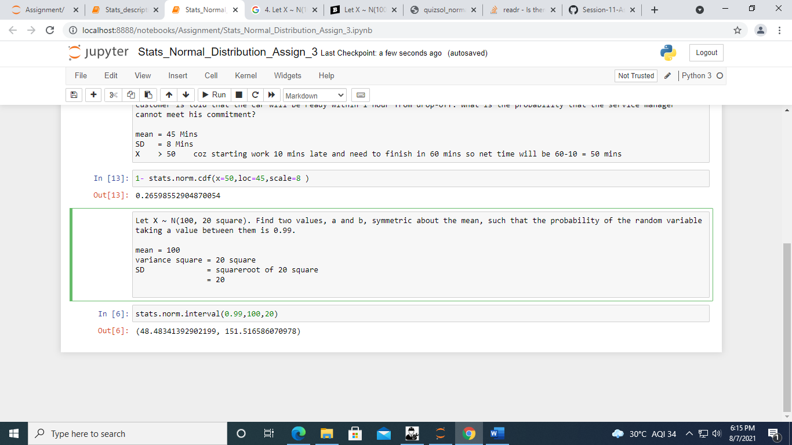

1. Consider a company that has two different divisions. The annual profits from the two divisions are independent and have distributions Profit1 ~ N(5, 32) and Profit2 ~ N(7, 42) respectively. Both the profits are in $ Million. Answer the following questions about the total profit of the company in Rupees. Assume that $1 = Rs. 45
2. Specify a Rupee range (centered on the mean) such that it contains 95% probability for the annual profit of the company.
3. Specify the 5th percentile of profit (in Rupees) for the company
4. Which of the two divisions has a larger probability of making a loss in a given year?

Sol. IN .ipynb file