Development of Sina Microblog Client Based on Sina SDK and API
Free Project of COMP 2020, Group 10
Teacher: Dr. Louis TANG
Department of Computer Science and Technology
BNU-HKBU United International College

Abstract: Sina microblog is the most popular microblog service provider in China mainland with more than fifty million users. For satisfy users' need, sina has opened its application API and SDK. Based on these, our project, named GodTweet, aims to be a client for sina microblog users and provides basically and necessary functions for user, like send, received and repost messages, so that they can use sina microblog without open any Internet browser. GodTweet is designed with object-oriented paradigm and it is coding in Java. The architecture of GodTweet is constructed to be general so that it can integrate not only sina microblog but also other microblogs in the future.

1 Introduction
Since 2006, Twitter, which is the first and the most famous microblog service provider, has influenced the Internet deeply and become the most important way for people to share information. Under this background, to capture the Chinese market, Sina started its own microblog service on September 2009 and became the most popular microblog service provider in China mainland. Aims to rich its applications and attract more user, Sina started its open platform for developers freely.

With considering both of the prospect of Sina microblogthe and the influences of QQ client, our group decided to develop a client for sina microblog with providing basic functions such like sending, receiving and reposting messages so that users can use Sina microblog directly by using a desktop client, which is more familiar to traditional IM user. In addition, with considering other microblog service providers such like 163, Tencent, the architecture of our client is tried to construct more general so that it can be compatible with other microblogs.

The basic functions we provide in the client GodTweet are followed:
● 2 ways to login to Sina microblog:
1. Simple HTTP way.
2. oAuth way.
● Display current user's information
1. Avatar with a link links to user's Sina microblog homepage.
2. User name.
3. Numbers of current user's following, follower, and message sent by the current user.
● Receive and display messages or user information in different categories:
1. Home: contains all kinds of messages.
2. Mention: contains messages which has mentioned me.
3. MyTweet: contains messages which sent by me.
4. Comment: contains messages which is comment to my words.
5. Favorite: contains messages which I like.
6. Following: Contain basic information of people I am following.
7. Follower: contains basic information of people who is following me.
● Available basic operations:
1. Reply, Retweet, Favorite/unfavorite, Delete operations available for different types of message.
2. Unfollow operation available for Following.
3. Refresh operations available for synchronizing messages and information between Sina server and GodTweet client.
4. Send message operations available for replying, retweeting others' words.
5. Open user's homepage operation available for opening current user / following / follower's homepage.

The difficulties we had met during developing this project are followed:
● Analysis of Sina SDK which is a little large and complex.
● The version of Sina API is not the same as Sina SDK, which lead to something unavailable in Sina SDK.
● Constructing the a suitable architecture for GodTweet.
● Complex GUI
● Design of multi-threads
● Version control and code synchronization
● Time management which is the biggest problem because of the final examination.

2 Design and methodology:
In order to develop the program, our group mainly use these technologies:
●Multithreading
●Graphical User Interfaces
●JSON(JavaScript Object Notation)
●Object-Oriented Programming

Multithreading
At first, we only designed a single thread in this program, but we found a big problem after we finish all the functions: after the user login, he had to wait for a long time because the main frame didn't display until it got all the data from Sina microblog servers. Thus we designed the following threads, they are:
- Check New Thread
The function of this thread is to repeated check whether there is a new tweet(mention,follower) or not. This thread will run in every 10 second. When it get a new tweet(mention,follower) signal from the servers, it will change the corresponding icon to notice the user.
- Home Tread
- Mention Tread
- My Tweet Tread
- Comments Thread
The threads about are independent of the main frame. So it will display the main frame and get the data from the servers at the same time.
Meanwhile, when there has a new signal, we use these threads to refresh the user interface.

Graphical User Interfaces
The GUI of GodTweet is designed through GUI designer(Netbeans) and Visual Swing(Eclipse) . Since the code produced by Netbeans is more efficient but hard to understand by beginner, we use it to do the Frames(MainFrame, ReTweetFrame, CommentFrame and LoginFrame) which need nothing extra modification. VS is similar to VE and it is easy to be modified, so we use it to design the Panels(SingleTweetPanel, SingleFriendPanel, SingleCommentPanel). Somewhere we use both of them and combine their codes by ourselves.

JSON(JavaScript Object Notation)
The program use Sina Mircoblog SDK to connect the Sina Microblog servers and exchange the data with API in the servers using HTTP data type. In the interactive between program and API, the program get the JSON data from the server and then analysis and call the data. (解析与调用）
Most of the calling functions are defined in the SDK, but we had to write some by ourselves.

Object-Oriented Programming
Through this free project, we understand the idea about OOP design more.
Before we wrote this program, we first considered what class did we need and then analysised the relationship among the classes. We also considered each user and tweet as an object. Most of the data operation is object-oriented.

The design of our program:
This Structure picture (click to see the Structure) shows the whole structure of our program.
Here are the explanations:

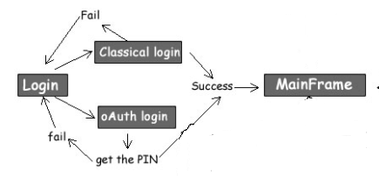
This are the login methods.
We have designed two ways to login the microblog account, one is Basic Authentication and the other one is Open Authorization.
User can type in his account and password to login his microblog directly. But there has some risk the password will be eavesdropped in this way.
So we provided the OAuth Login method to avoid that. User has to login his account in the Sina microblog website get the PIN then he can use the PIN to login his account through the client.

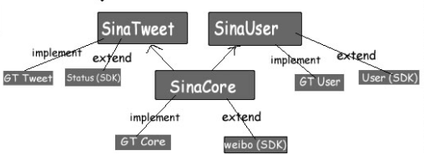
In order to develop a microblog client that users can use it to login different microblogs. We had designed three interface class: GtCore.java、GtTweet.java、GtUser.java. All the data operation methods are defined within these three class. So that if there are several microblog service providers, we can use the same method name to operate data.

SinaCore.java
Extends weibo.java(from SDK) and implements GtCore.java. This is the core class for program to handle user requests and server response.
SinaTweet.java
Extends Status.java(from SDK) and implements GtTweets.java. This class contains the descriptions and operations about Tweets. Each tweet is an object.
SinaUser.java
Extends User.java(from SDK) and implements GtUser.java. This class contains the users including the program user himself and other Sina microblog users' information. Such as the amount of following、followers、tweets and so on.

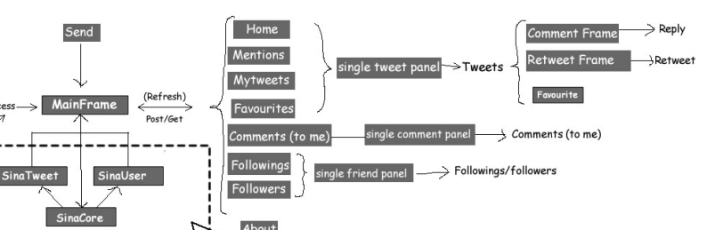

This is the Graphical User Interface design.
In the main frame, there are two parts: the information panel shows the tweets(comments\followers etc.) and the text field to send tweets.
It's eight parts in the information panel. They are : home, mentions, my tweets, favourite tweets, comments to me, my followings, my followers and About part to show the program information.
It's clear to see that in the first 4 parts that shows tweets. Each tweet is a tweet panel, and user can reply、retweet or set it as favourite.
The Comments/Followers/Followings parts are almost the same as the first 4 parts.

3 Implementation and experiment：
Here are some screen shots to show the implementation, click to open it.
The two ways to login user's microblog.
Basic Authentication
Open Authorization
Send the tweet
send
The notification when there have new tweets/comments/followers/
new
The Home panel shows my followings' tweets (including user's own tweets).
Home
The reply、retweet and set favourite functions.
reply retweet favourite
The Mention panel shows all the tweets which mention user ID or retweet my tweet.
mention
The My Tweet panel shows all the tweets that user posted.
Mytweet
The Comments panel shows all the comments to my tweet.
comments
The Favourite panel shows the tweets which the user set favourite before.
favourite
The Followings panel shows the friends who the user are following.
following
The followers panel shows the user's followers
folowers

4 Conclusion
The development of GodTweet last for about 10 days and now it can perform expected functions Smoothly. In these 10 days, 3 days were used to analyze the Sina SDK and constructe our own architecture. Then the following main parts took our 4 days. At last we spent 3 days to design the thread and debug. After did this project, we have learned the followings:
- More clear and deeper understanding of Object-oriented programming. After analyzing the SDK, we have learned more about how others construct a class, an object. After constructing our own architecture by referencing the SDK, we learned how to do that by ourself, how to deal with the relationship between classes in this project, how to choose a way to make the architecture more general and what is impossible in this project.
- Skills to design and modify code generated by tools. Since the construction of code generated by Netbeans is different from it generated by VS, we learned how to modify them and combine them. And also know that which one is better to use. The GUI Designer of Netbeans is better than others in eclipse.
- Usage of API and SDK provided by others to develop our own applications. Before this project, we had never touch something like this but now we more clear about API and SDK and know how to analyze them and use them. It is not difficult.
- Knowledge of JSON. Because the SDK and API are not totally the same(API is newer than SDK), so we need to update the code of SDK by referencing the newer API. So we have a chance to modify something about JSON in this project.
- More important, how to cooperate with others. Everyone in our group participated in this project actively, which was a situation we had never meet before, so we have more chance to communicate with other, talking about difficulties and problems. These are what we learned more important than techniques
- The most important. After this project, we know that impossible is nothing. We had never believe that we can finished it, but finally we did it. This gain will give us more confidence in our further study and development.

- References and Appendix
Sina API documentation
Sina SDK Research report
Sina SDK
Java API

