

Rising Dragon Taekwondo Management System: A
Centralized Scheduling and Record-Keeping Solution for
Multi-Location Operations

In Partial fulfillment of the requirements in IT12/L
System Integration and Architecture

Presented By:

Alfanta, Rendell Jhon
Federizo, Veronica
Malicse, Joshua

IT 12/L - 3441

Presented To:

CHARISSE P. BARBOSA
Instructor

October, 2026
Chapter 1

THE COMPANY

Company Profile

Rising Dragon Taekwondo is a martial arts school in Davao City. Its Head Coach has been with the school since 2014, overseeing the training programs and coaching staff across its various locations. The Head Coach reports personally interacting with more than 20 students daily across all locations, which totals more than a hundred students in a given week.
The school currently operates six locations in total, which include one main dojo and five partner schools around Davao City. Because of this setup, the Head Coach rotates through the main dojo and the five partner schools to conduct classes, and also spends time coordinating with the other coaches and handling administrative tasks. Coaches are assigned to locations based on their personal availability, and the Head Coach reports no serious scheduling conflicts so far, likely because of close coordination through chat.
Rising Dragon Taekwondo keeps its enrollment simple and accessible. The school does not offer tiered membership plans, so everyone follows the same enrollment structure with a standard fee arrangement. Inquiries typically come through Facebook Messenger, and the school also receives walk-ins at the dojo from people who pass by or hear about it from current members. A parent respondent added that families commonly discover the school through its partner school branches or Facebook. Once someone agrees to join, they can start classes right away without a lengthy enrollment process. Basic student information is recorded on paper forms kept at the dojo, and the Head Coach reports that this paper system has been reliable, with no lost, delayed, or mixed-up registrations.
The school's mission is to teach taekwondo in a way that builds discipline and character alongside physical skill. Its students range from complete beginners just starting out to advanced belt holders who have trained for years. Some of these students go on to compete as athletes, representing Rising Dragon Taekwondo in local and regional tournaments.

Organizational Chart

Rising Dragon Taekwondo has a simple three-level hierarchy, with the Head Coach at the top leading all training programs and coaching staff since 2014. Below the Head Coach are four Assistant Coaches, who are assigned to locations based on their availability rather than on a fixed schedule. At the bottom are the students, who are grouped under whichever coach they are training with at the time, so the labels “Student 1” through “Student N” reflect this changing group rather than a fixed count.
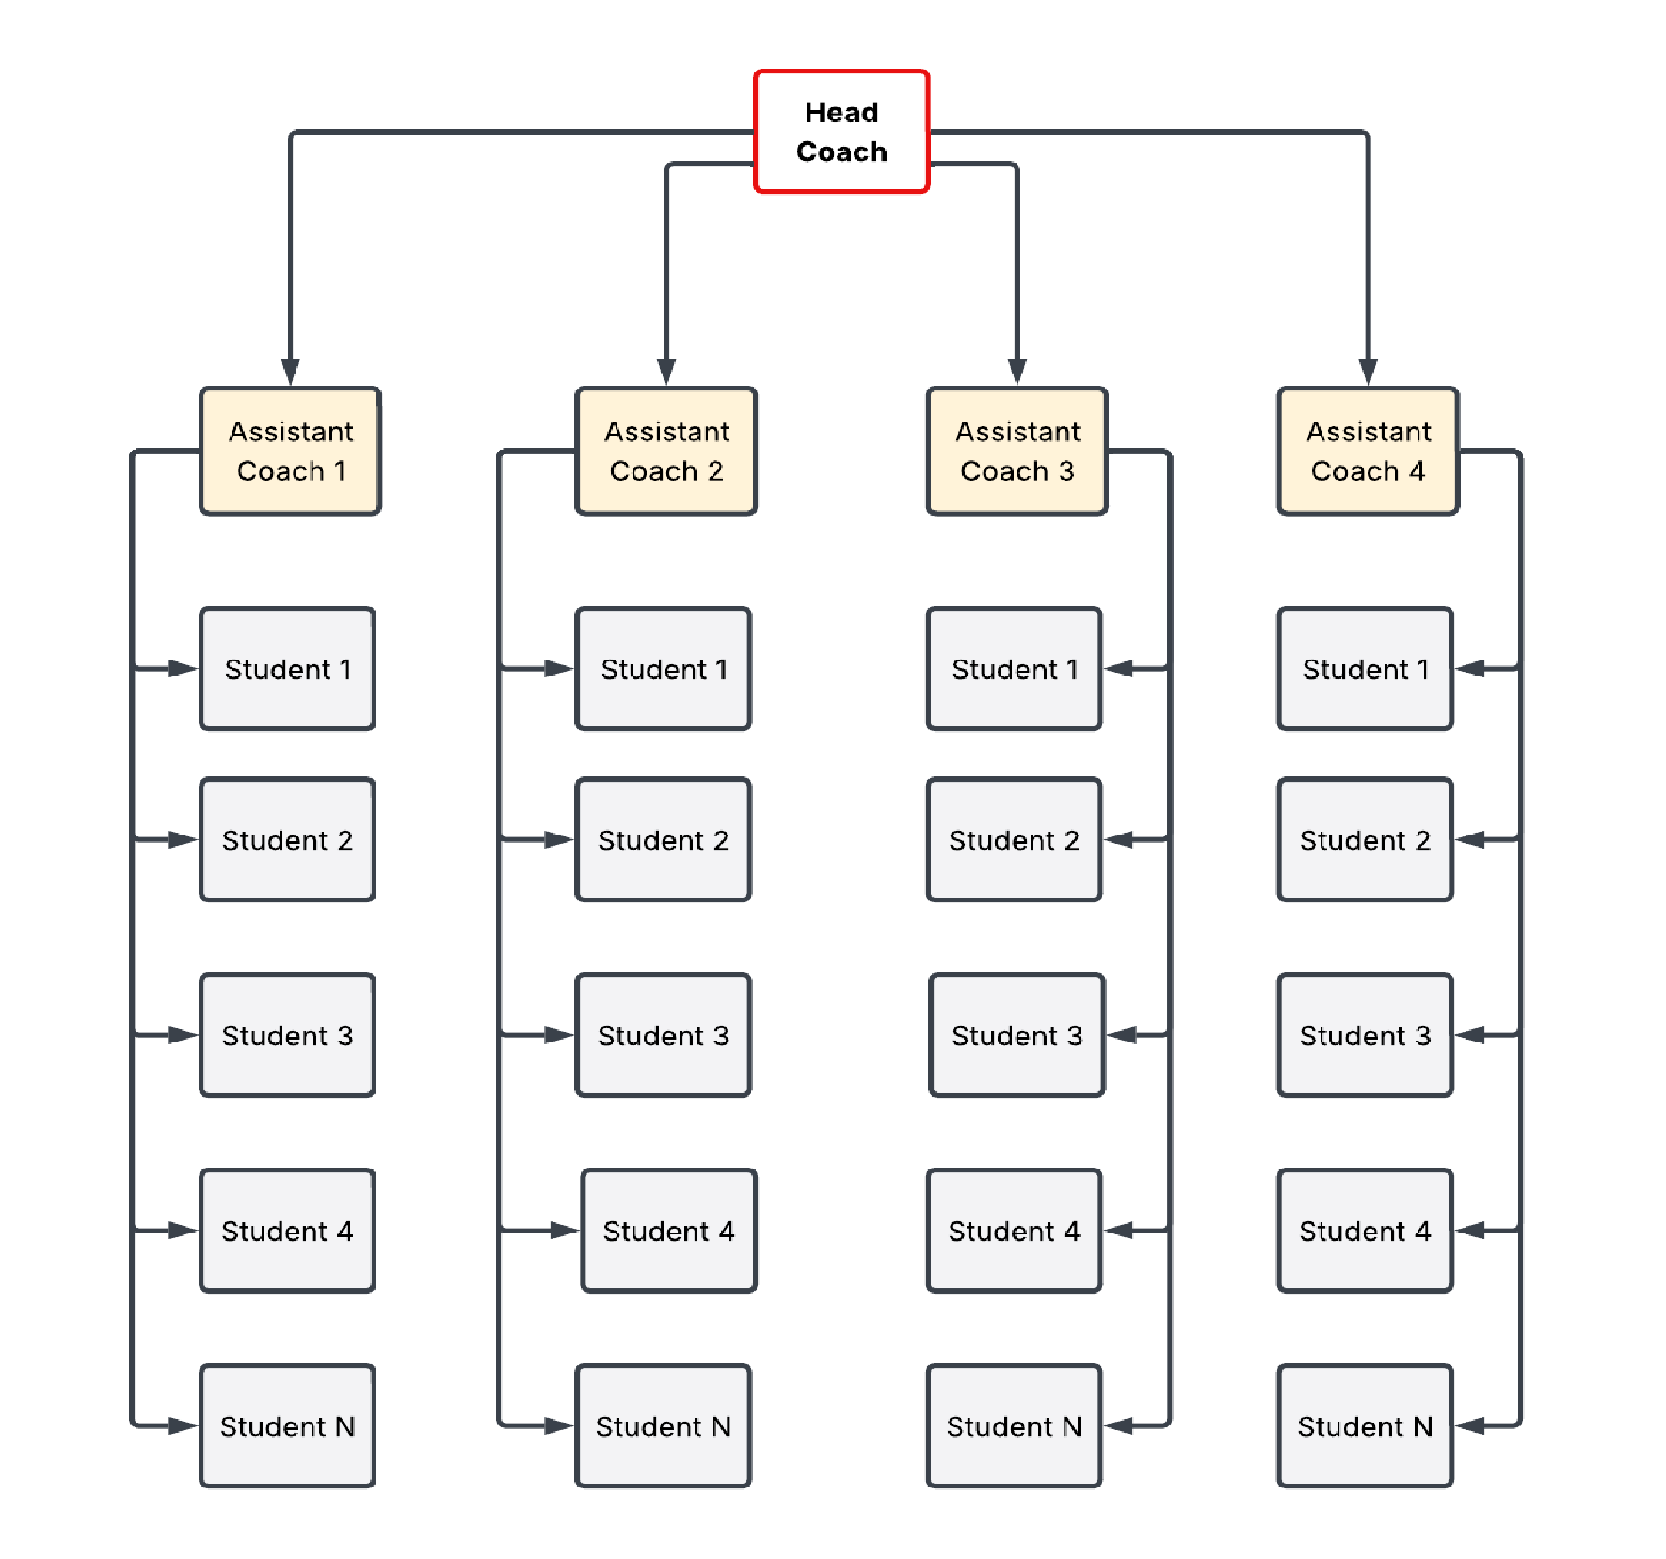

Figure 1. Rising Dragon Taekwondo Organizational Structure

Business Environment
Rising Dragon Taekwondo runs one main dojo and five partner schools across Davao City, all led by a Head Coach who has overseen the organization since 2014. Coaches are assigned to locations based on their personal availability rather than a fixed master schedule, and schedule updates are communicated through chat groups. The Head Coach personally interacts with more than twenty students daily and more than a hundred weekly, and relies on individual reports submitted by instructors from each location because no centralized system connects the six locations.

The school's enrollment process is simple, with no tiered plans or lengthy onboarding; students can start classes immediately after agreeing to a standard fee arrangement, and their information is recorded on paper forms. Payments are accepted through GCash, bank transfers, or cash, and payment due dates are tracked on paper records. Overdue reminders are sent through a shared group chat, and one parent respondent reported sometimes forgetting due dates and not always noticing these reminders right away. Attendance is not formally recorded; coaches rely on visual recognition of their enrolled students. Belt promotions are decided by the coach's evaluation of technique, discipline, and improvement, and are noted on paper records, with parents informed through chat messages. The Head Coach reports no promotion disputes. Students provide their own uniforms, belts, and protective gear, while the school keeps limited shared training equipment, such as mats and paddles, which is checked visually rather than through a formal inventory.

Although the informal system has not caused major losses or disputes so far, it has left the business dependent on manual coordination. The Head Coach identifies scheduling as the most stressful and time-consuming part of the operation, because coordinating coach availability across six locations requires constant communication, and notes that scheduling affects the school's other operations. Parent notifications about payments and promotions are also sent through chat messages.

Description of the Existing System

Scheduling and Instructor Coordination
The school does not currently use formal scheduling software. The Head Coach and the other coaches coordinate class schedules through chat groups, and there is no fixed master schedule. Assignments are made according to each coach's personal availability, with the aim of matching instructors to locations that fit their schedules. Because coaches adjust their availability regularly, schedule changes happen often, and updates are communicated through the chat groups. Arranging classes across the six locations therefore requires constant back-and-forth coordination to ensure that every session is covered. The Head Coach describes scheduling as the most stressful and time-consuming part of managing the school.

Belt promotion and Evaluation
Belt promotion at Rising Dragon Taekwondo is decided by the coaches' own evaluation. During regular classes, the coach assesses a student's skills, and the Head Coach describes basing this assessment on observed technique, discipline, and overall improvement. Once the coach judges a student ready, that decision takes precedence over anything a student may have tracked informally; the Head Coach notes that some students may track their own progress, but the coach's evaluation is what determines promotion. Promotions are noted on paper records, and parents are informed through chat messages. The parent respondent reported that instructors regularly give feedback and that families leave progress assessment to the coaches. In some cases, students who have remained at one belt level for a long period are promoted and are usually directed toward becoming instructors rather than competitors. The Head Coach reports no disputes over promotion decisions and considers promotion tracking a minor concern at most.

Student Records, Payments, and Attendance
Student information is recorded manually on paper forms kept at the dojo, and payment due dates are tracked using paper records. Payments are accepted through GCash, bank transfer, or cash. When a payment is overdue, a reminder is sent; according to the parent respondent, reminders are sent in the group chat, and the parent sometimes forgets due dates and does not always notice the reminders right away. The Head Coach reported no major payment miscounts or lost transactions. Attendance is not formally recorded. Instead, coaches rely on visual recognition: they know their enrolled students and count who is present during each session. The Head Coach reported that attendance can usually be recalled from memory and that it has not been a major problem.

Communication and Reporting Across Locations
There is no centralized system linking the main dojo and the five partner schools. To get an overall picture of the six locations, the Head Coach relies on individual reports submitted by the instructors at each location and manually compiles information from these various sources. The interviews did not ask whether this manual compilation has caused errors or delays, so none is claimed here. Because there is no centralized system, a combined view of students, attendance, and payments across the six locations depends on the Head Coach's manual compilation.

Data Flow Diagram
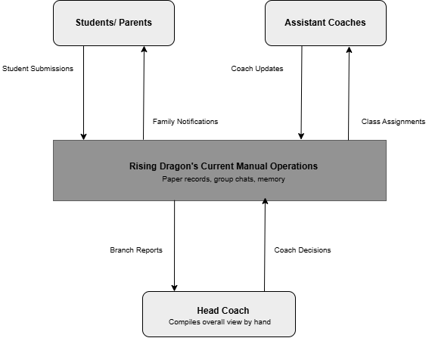

Figure 2: Context Diagram of the Existing Rising Dragon Taekwondo System

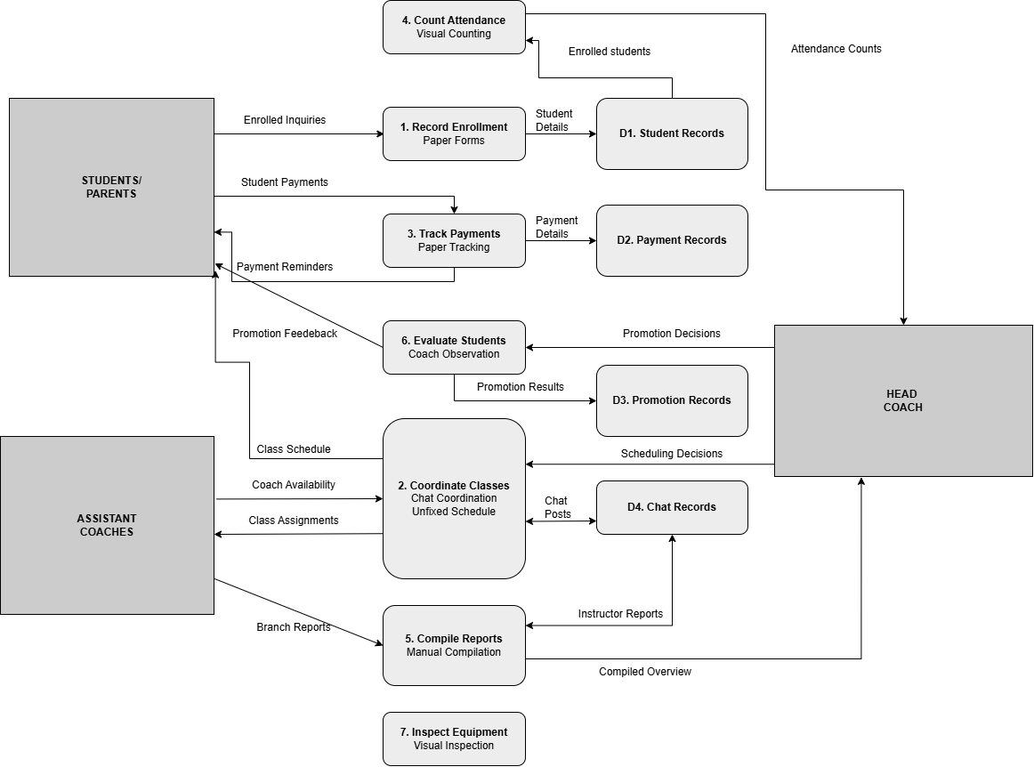

Figure 3: Level-0 Data Flow Diagram of the Existing Rising Dragon Taekwondo
System

Chapter 2

THE PROBLEM

Statement of the Problem
Rising Dragon Taekwondo currently operates six locations across Davao City using a largely manual and informal system. Because there is no centralized software, the Head Coach and the other coaches rely on paper records, group chats, and memory to manage daily operations. The interviews, conducted with the Head Coach and, separately, with a parent respondent, found that this approach has not caused major financial losses or disputes. Based on the interviews, the study identifies three operational problems of differing severity. The primary problem is the time and effort required to coordinate coach schedules across six locations. The second is the lack of centralized attendance records and branch reporting, which requires the Head Coach to compile information from separate instructor reports. The third is that payment reminders sent through a shared group chat can be overlooked; one parent reported sometimes missing them. The interviews did not identify major attendance failures or payment losses. These findings come from only two respondents and should be read with that limitation in mind.

Problem 1: Coach Scheduling Across Six Locations Takes Significant Time and Effort
Of the three problems, scheduling is the highest priority. The Head Coach identified it as the most stressful or most difficult task in answer to four separate questions: which task takes the most time or causes the most stress, which task is hardest because of the six-location setup, which area causes the most trouble on a regular basis, and which single area a new system should fix. The Head Coach described scheduling as the most time-consuming and stressful part of managing the school and said that a system that helps with scheduling would make things much easier for everyone. The parent respondent also said they would appreciate clearer schedules.

In the current process, there is no fixed master schedule. Each coach has their own availability, and assignments are made by matching coaches to the locations that fit their schedules. Schedules change regularly as coaches adjust their availability, and these changes are communicated through chat groups. The Head Coach explained that arranging classes across the main dojo and the five partner schools requires constant back-and-forth coordination and a lot of time to make sure that all sessions are covered.
The Head Coach reported that there have not been any serious scheduling conflicts or double-bookings so far, which the Head Coach suggested is likely due to close coordination through chat. Double-booking a coach or leaving a location uncovered is therefore a possible risk rather than a problem that has already occurred, and the current approach manages that risk through constant effort. The interviews did not address the school's growth, but because the current approach depends on constant communication, it may become harder to sustain if the school adds more locations, coaches, or students.

Problem 2: Attendance and Branch Information Are Not Centralized
There is no centralized system linking the main dojo and the five partner schools. In the Head Coach's own words, “I rely on individual reports submitted by instructors from each location. There is no centralized system, so I manually compile information from various sources.” Attendance is not formally recorded; instead, coaches rely on visual recognition, knowing their enrolled students and counting who is present during each session. Because attendance is not formally recorded, no written attendance history exists that can be checked later, and a combined picture of the six locations has to be assembled by hand by the Head Coach.
This problem is less severe than Problem 1, and it should not be read as a demonstrated failure. The Head Coach said that attendance can usually be recalled from memory and that it has not been a major problem or a priority. The interviews did not ask whether the instructors' reports have ever been incomplete, inconsistent, or late, and no such incident was reported, so none is claimed here. The problem lies in the absence of a centralized record and in the manual effort needed to gather and combine information from separate sources.

Problem 3: Payment Reminders Sent Through the Shared Group Chat Can Be Overlooked
Payment due dates are tracked using paper records, and when a payment is overdue, a reminder is sent through the shared group chat. One parent respondent described how this can be missed: “Sometimes I forget payment due dates. Although reminders are sent in the group chat, I don't always catch them right away.” The parent added that they would appreciate more reliable payment reminders, possibly through individual messages rather than only group chats.
This problem is the most limited of the three. The Head Coach reported no major payment miscounts or lost transactions, and the interviews do not show that the school has lost money or that payment processing has failed. The concern is limited to how easily a reminder can be overlooked in a group chat. Because it was raised by a single parent, it is presented as an indication of a possible gap rather than as a verified or widespread problem.
Taken together, the three problems differ in severity. Problem 1 is the highest priority because it was repeatedly identified by the Head Coach as the most stressful and time-consuming task. Problems 2 and 3 describe weaknesses in how information is gathered and communicated, but the interviews did not establish major attendance failures or payment losses. Because the findings are based on only two respondents, the Head Coach and one parent, they indicate where the school's operational difficulties are most likely to lie and should not be generalized to all staff or families.

Feasibility Study Operational Feasibility
The proposed centralized management system is intended to give the school a single place for the scheduling, student, payment, attendance, and promotion information that is currently handled through paper records and chat groups. The school already uses digital tools: coaches and parents communicate through Messenger and group chats, and the school accepts GCash payments, so some familiarity with digital tools can be expected. However, ease of use and staff acceptance have not yet been tested and should be confirmed through user testing. The Head Coach identified scheduling as the most time-consuming task, so the proposed system is expected to reduce time spent on coordination, but this benefit has not been measured. Because attendance is not currently recorded, an attendance feature would add a new step to class routines rather than save time, so the expected time savings apply mainly to scheduling and branch-level compilation.

Technical Feasibility
The school already uses digital tools such as Facebook Messenger for communication and accepts GCash for payments, which suggests that staff and families have access to smartphones and the internet. A web-based or mobile-friendly system would therefore be a reasonable fit, since it can run on devices that users already own. The system does not require complex hardware or expensive servers, as it can be hosted on a cloud platform that is easy to maintain.

Economic Feasibility
Currently, the school does not use management software, and its main expenses are venue rental, utilities, and coach fees, which are tracked informally through manual records. The interviews did not collect cost or savings figures, and the Head Coach reported no notable payment problems, so this study does not claim that the proposed system will recover lost income. The expected benefits are mainly operational: less time spent coordinating schedules and clearer payment reminders for parents. Development and hosting costs, and any resulting savings, remain to be estimated.

Schedule Feasibility
The proposed system can be developed and implemented within a reasonable timeframe, such as one academic semester. The Head Coach described scheduling as stressful and time-consuming and said that a system that helps with scheduling would make things much easier, which suggests openness to a new tool; the willingness of the Assistant Coaches was not directly assessed, since they were not interviewed. Because the enrollment process is simple and there are no tiered plans, the data structure for student records is likely to be straightforward, which should make the system easier to build and launch quickly.

Chapter 3

THE SOLUTION

Methodology
The proponents use the Agile Methodology to develop the proposed Rising Dragon Taekwondo Management System. Agile is a software development approach in which the system is built in small, repeated cycles called iterations or sprints. Instead of planning and documenting the entire system before any code is written, the team builds one module at a time, tests it, reviews it, and refines it before moving on to the next (Pressman & Maxim, 2020).

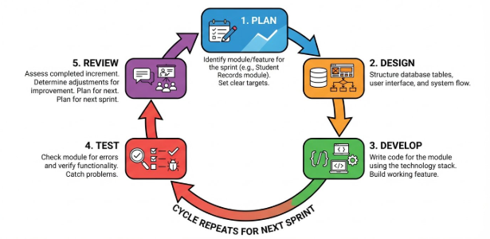
Agile suits this project for two reasons. First, the school’s operations were still being understood as the project began, and the requirements became clearer as the work progressed, so the team needed an approach that allows adjustments without redoing the whole system. Second, the three problems identified in Chapters 1 and 2 differ in severity, with scheduling as the highest priority, so the modules can be built and refined one at a time in order of priority. The findings also come from only two respondents, and Chapter 2 notes that ease of use and staff acceptance have not yet been tested, which makes repeated review and refinement appropriate.

Figure 4. Agile Development Methodology

Figure 4 shows the cycle that each iteration follows. In the Plan phase, the team identifies the module or feature to be built and sets clear targets. In the Design phase, it structures the database tables, user interface, and system flow for that module. In the Develop phase, it writes the code for the module using the agreed technology stack. In the Test phase, it checks the module for errors and verifies that it works as intended. In the Review phase, it assesses the completed increment and determines the adjustments needed. These adjustments are carried into the next iteration, which either refines the same module or begins the next one, so the system is improved continuously.
The order of the modules follows their priority and their dependencies on one another, as set out in the Implementation Plan. This section describes the development approach only. It does not report any completed testing, user feedback, or user evaluation of the system.

System Objectives
The proposed system aims to address the three problems identified in Chapters 1 and 2 through the following specific objectives:
The proposed solution is a role-based web system for the Head Coach and Assistant Coaches. It brings branch setup, coach availability and scheduling, student records, attendance history, coach progress checks, branch reports, payment tracking and reminders, and approved promotions into one system. Monthly bills use one academy-wide fee and each student’s enrollment-date cycle; reminder emails can be sent automatically or manually. Payments themselves remain outside the system.
- To provide a centralized scheduling function in which Assistant Coaches submit their availability and the Head Coach assigns coaches to the six locations from a single master schedule, checking each assignment for conflicts, in order to reduce the back-and-forth coordination currently done through chat groups (Problem 1).
- To record attendance for each scheduled class session so that a written attendance history is available for each student and location (Problem 2).
- To generate a branch report for a selected location and date range from the student, schedule, attendance, and coach progress records stored in the system, so the Head Coach can review branch activity and student development without manually compiling separate instructor reports (Problem 2).
- To apply one academy-wide monthly fee configured by the Head Coach, create monthly bills on each student’s enrollment-date cycle after the first payment is recorded, and track each bill’s amount, due date, paid or unpaid status, payment date, and method, including payments recorded in advance for a selected future bill (Problem 3).
- To send personalized payment reminder emails through Gmail SMTP automatically at the configured before-due, due-date, and after-due intervals while a bill remains unpaid, while also allowing the Head Coach to send an email manually during an available reminder window and review or retry failed attempts (Problem 3).
- To provide user and role management that distinguishes the permissions of the Head Coach and the Assistant Coaches.
- To maintain student records, including guardian contact details and email, as the basis for attendance, payment reminders, and branch reports.
- To record an approved belt promotion and update the student’s belt history, while leaving the decision on promotion readiness to the coaches.
- To allow the Head Coach to add branch records so schedules, student records, attendance, and branch reports can be associated with the correct location.
- To let coaches record student progress checks by focus area, observed progress level, assessment-readiness recommendation, observation, and next step, so the student history and branch reports can show the student’s development (Problem 2).

Objective 1 addresses Problem 1, the highest priority, because the Head Coach repeatedly identified scheduling as the most stressful and time-consuming task. Objectives 2, 3, and 10 address Problem 2 by creating attendance records, branch reports, and coach-recorded student progress checks. Objectives 4 and 5 address Problem 3 through shared monthly billing and payment reminders. Objectives 6 to 9 support the system’s operation; Objective 9 lets the Head Coach add branch records used by other modules. The three problems differ in severity, and the interviews did not establish major attendance failures, payment losses, or serious double-bookings. The findings come from only two respondents, the Head Coach and one parent, so the objectives rest on a limited set of findings.

System Requirements
The requirements below are proposed for the system. Because the system is web-based, they are stated in general terms. No device specifications have been measured or confirmed on the school’s devices, and no prices or performance figures are set. The feasibility study in Chapter 2 found that staff and families already use digital tools such as Messenger and GCash, which suggests access to smartphones and the internet.

Hardware Requirements
Hardware | Proposed Specification | Purpose
Internet-capable phone or computer | A smartphone, laptop, or desktop computer with a supported modern web browser | Used by the Head Coach and Assistant Coaches to access the web-based system
Internet connection | Internet access at the locations where the system is used; no speed requirement is set | Needed to reach the web-based system and to send reminder emails
Device Compatibility | An internet-capable phone or computer with a supported modern web browser; compatibility with the staff’s existing devices must be checked | Accessing the web-based system; no minimum model or hardware specification has been set
Table 1. Hardware Requirements

Table 1 lists the general hardware requirements. Because the system is web-based, staff need an internet-capable phone or computer with a supported modern web browser and an internet connection. No fixed minimum device specifications have been established. Compatibility with the staff’s existing devices should be checked during implementation and evaluation; no new hardware purchase is assumed. Parents and guardians need a device that can receive email.

Software Requirements
Software | Specification | Purpose
Operating system | Any operating system that supports a modern web browser | Platform on which the system is accessed
Web browser | A supported modern web browser, such as Google Chrome, Mozilla Firefox, Microsoft Edge, or Safari | Accessing the web-based system
Frontend framework | Next.js | Building the user interface of the system
Backend platform | Supabase (PostgreSQL), including Supabase Auth | Cloud database, authentication, and backend services
Hosting platform | Vercel | Deploying the web-based system so it can be accessed online
Email service | Gmail account with Gmail SMTP | Sending personalized payment reminder emails to parents and guardians
Table 2. Software Requirements

Table 2 lists the proposed software required to run and access the system. The system is web-based, so staff use a web browser and do not need to install a native application. Next.js is used to build a responsive interface that works on both smartphones and laptops. Supabase provides the hosted database, the backend services, and authentication, so the school does not need to maintain its own server. Reminder emails are sent through Gmail SMTP, and Vercel hosts the system online. Using the system requires only a web browser and an internet connection from the staff.
Developer tools note: Visual Studio Code, Git and GitHub, and Facebook Messenger or Google Meet are used by the proponents only for development and team coordination. They are not required by school staff to use the system and are therefore not listed in Table 2.

Entity-Relationship Diagram

Figure 5 should show the current data model: users and branches; students assigned to branches; coach availability and recurring class templates linked to scheduled classes; attendance linked to both a student and a class; progress checks and promotions linked to a student and coach; payment records linked to students; reminder records linked to payments; and the academy-wide payment settings. The diagram should use the primary keys, foreign keys, and relationships in the current Supabase schema.

[Insert Entity-Relationship Diagram here]

Figure 5. Entity-Relationship Diagram of the Proposed Rising Dragon Taekwondo Management System

Use Case Diagram

The Use Case Diagram in Figure 6 should show how the Head Coach and Assistant Coaches use the current system. Both roles can log in, view schedules, manage their own profile and password, and view notifications. Assistant Coaches submit weekly availability, view students within their permitted access, mark attendance for assigned classes, and record progress checks within their permitted branch access. The Head Coach manages branches and coach accounts, reviews availability, maintains the master schedule, views system-wide student and attendance information, records payments and advance payments, configures the shared monthly fee and reminder intervals, manually sends or retries eligible payment reminders, records approved promotions, and generates branch reports. Automated monthly bill generation and scheduled reminder emails run as system processes rather than user actions. Parents and guardians do not log in; reminder emails go to the registered guardian email address.

[Insert Use Case Diagram here]

Figure 6. Use Case Diagram of the Proposed Rising Dragon Taekwondo Management System

Scopes and Limitations

The system is designed for the Head Coach and four Assistant Coaches of Rising Dragon Taekwondo and covers the six locations: the main dojo and five partner schools in Davao City. It is web-based and accessed by staff through smartphones or laptops. Parents and guardians do not log in; payment reminder emails are sent to the email address registered for the student’s parent or guardian. Coaches can record progress checks, which are available in the student’s progress history and branch reporting. Access to functions and records follows each user’s role. Table 3 separates the main functions that address the three identified problems from supporting functions.
Type | Feature | What It Covers | Related Problem
Core | Scheduling and Availability | Assistant Coaches submit their availability, and the Head Coach assigns coaches to the six locations in a single master schedule. Each assignment is checked for conflicts. | Problem 1 (highest priority)
Core | Attendance Tracking | Recording attendance for each scheduled class session. | Problem 2
Core | Branch Reporting | Generating a report for selected branches and a date range from student, schedule, attendance, and coach progress records. Reports include branch activity, attendance, progress-check totals, readiness recommendations, and recent coach notes; they can be printed or saved as PDF. | Problem 2
Core | Student Progress Checks | Recording dated coach observations by focus area, observed progress level, assessment-readiness recommendation, and next step. Checks appear in the student’s progress history and branch reports; promotion decisions remain with coaches. | Problem 2
Core | Payment due-date tracking and reminder emails | Using one Head Coach-configured monthly fee for all students; generating enrollment-date-cycle bills after the initial payment record; tracking paid or unpaid status, dates, and method; recording advance payment against a selected future bill; and sending personalized Gmail SMTP reminders automatically at configured intervals or manually by the Head Coach. Reminder history and failed-email retry are available. The system does not process payments. | Problem 3
Supporting | User and Role Management | Login and role-based permissions for the Head Coach and Assistant Coaches, plus personal profile and password settings for each account. | Supports all features
Supporting | Student Records | Student details, including guardian contact details and email, belt level, enrollment date, branch, and links to attendance and coach-recorded progress history. | Supports attendance, reminders, and reports
Supporting | Promotions | Recording an approved belt promotion and updating the student’s belt history. | Not tied to the three problems
Supporting | Branch Setup | The Head Coach can add branch records that identify the locations used by the system’s schedules, student records, attendance, and reports. | Supports all features
Table 3. Core and Supporting Features of the Proposed System

Student Records and Promotions are supporting features. Student records supply the information used by attendance, billing, reminders, and reports, while promotions record a decision already made by a coach. Progress checks directly support Problem 2 because they create a dated student history and provide branch-level information. A readiness entry is a coach’s recommendation; the system does not decide or approve a promotion.

The system will not cover the following:
- Payment processing. The system will not accept or process cash, GCash, or bank-transfer payments. It only tracks due dates and paid or unpaid status and sends reminders.
- Promotion decisions. The system will not decide whether a student is ready for promotion. The coaches make that decision, and the system records the approved promotion.
- Equipment and inventory management. Equipment issues have not been significant, and shared equipment will continue to be checked visually.
- A parent-facing interface, SMS reminders, a native mobile app, and offline use.

The following limitations apply:
Progress checks record the assessment date, focus area, observed progress level, coach recommendation about belt-assessment readiness, observation, and optional next step. These are coach-entered observations, not an objective automated measurement of skill. The system does not decide that a student is ready, approve an assessment, or automatically promote a student; those decisions remain with the coaches.

- The problems come from interviews with only two respondents, the Head Coach and one parent. The Assistant Coaches were not interviewed. The problems differ in severity, and the interviews did not identify lost attendance records, serious double-bookings, payment losses, or promotion disputes. Paper enrollment has also been reliable. The findings should not be generalized to all staff or families.
- The expected reduction in scheduling effort and in the time spent compiling reports has not been measured, and staff acceptance and ease of use have not been tested. Because attendance is not currently recorded, attendance tracking adds a new step to class routines.
- Automated reminders are sent only for unpaid bills for active students with a valid registered guardian email, at the schedule configured by the Head Coach. The Head Coach can also send an eligible reminder manually. Delivery still depends on the accuracy of the address, Gmail, hosting, and other external services; the system cannot guarantee that a message is received, read, or acted on. The interviews did not establish whether parents regularly check email.
- Payments are made outside the system. The Head Coach records when a payment is received, its date and method, or records payment against a selected upcoming monthly bill in advance. Paid or unpaid status reflects what the Head Coach records; the system does not verify transactions or process cash, GCash, or bank transfers.
- The system requires an internet connection and relies on external services such as Supabase, Gmail, and Vercel, whose availability is outside the team’s control.

Security Plan

This plan describes the protections the team intends to apply. The measures are planned, and none is claimed here as already implemented. Their status will be confirmed during development and testing.
- The system will store student names, guardian names, contact details and email addresses, belt levels, and enrollment dates. Only the information needed for the system’s functions will be collected, access will be limited to logged-in users with an assigned role, and the information will be handled in line with applicable Philippine data privacy requirements, such as the Data Privacy Act of 2012 (Republic Act No. 10173, 2012).
- The system will be accessed over encrypted (HTTPS) connections, and regular backups will be arranged using the options available on the database platform so that records can be restored if they are lost.
- Access will follow the two roles. The Head Coach can use all functions, while an Assistant Coach can only log in, view schedules, set availability, mark attendance, view students, and add students, limited to the branch where the coach is scheduled on that date. User management will be available only to the Head Coach, and these rules will be enforced where the data is stored, not only in the user interface. The account of a coach who leaves will be deactivated rather than deleted, so access is removed without losing past records.
- Login will be handled through Supabase Auth, so that passwords are managed by an established authentication service rather than by the system’s own code. Database credentials, SMTP credentials, and other secret keys will be kept in protected configuration on the server side, not in source code or the GitHub repository, and keys with elevated database access will not be exposed to the user interface.
- Reminder emails will be sent from a dedicated Gmail account with 2-Step Verification turned on, using an app password or another method supported by Google instead of the account’s main password. The SMTP credentials will be replaced if they are exposed. Reminders will go only to the registered email of the parent or guardian linked to the student, staff will verify an address when it is recorded, and each message will contain only what the parent or guardian needs to know about the payment due.
- The system will not accept or process payments, and it will not ask for or store GCash, bank, or card account details. A payment record will hold only the amount, due date, payment date, status, and method, and only the Head Coach will record or change payment information.

Implementation Plan

The implementation plan follows the Agile iterations described in the Methodology. Phases 2 to 8 each go through the Plan, Design, Develop, Test, and Review cycle. The order of the modules reflects their priority and dependencies. User and Role Management comes first because every other feature depends on knowing who the user is. Branch Setup is included with this phase so the Head Coach can register the locations that later modules use. Scheduling comes next because it is the highest-priority problem. Student Records come before the modules that depend on them, and Branch Reporting comes last because it draws on the data of the other modules. No dates, costs, or completion guarantees are set here.

Phase | Focus | Main Activities
1 | Project setup | Configure the development environment, create the code repository, and initialize the Supabase database.
2 | User and Role Management and Branch Setup | Develop login and role-based access for the Head Coach and Assistant Coaches, and allow the Head Coach to add branch records for the school’s locations.
3 | Scheduling and Availability (Problem 1) | Develop availability submission, coach-to-branch assignments in a master schedule, and the conflict check on assignments.
4 | Student Records | Develop the adding and viewing of student information, including guardian contact details and email.
5 | Attendance Tracking and Student Progress (Problem 2) | Develop attendance recording and retrieval of attendance history for scheduled sessions, along with dated coach progress checks that appear in student histories and branch reporting.
6 | Payment tracking and reminder emails (Problem 3) | Configure one academy-wide monthly fee and reminder intervals; generate enrollment-date-cycle bills after an initial payment record; track payments and advance payments; and send automated and Head Coach-initiated Gmail SMTP reminders. Test reminder delivery with test email addresses before using parent or guardian addresses.
7 | Promotions | Develop the recording of an approved belt promotion and the update of the student’s belt history.
8 | Branch Reporting (Problem 2) | Generate reports from student, schedule, attendance, and coach progress records, including date-range branch activity, attendance, progress checks, and printable or PDF output.
9 | Integration, security review, and system testing | Check that the modules work together, review role-based access and the handling of credentials and email settings, and correct the issues found.
10 | Rollout and evaluation | Orient the Head Coach and Assistant Coaches to the system, enter existing student information from the paper forms, and use the system alongside the current paper records and chat groups until the school is ready to rely on it. Carry out the evaluation described in System Evaluation and refine the system based on the results.
Table 4. Phases of the Implementation Plan

System Evaluation

The evaluation plan below explains how the completed system could be evaluated. No evaluation has been carried out for this chapter, and no responses, scores, or results are reported. The respondents would be the Head Coach and the four Assistant Coaches who would use the system, and the number of respondents will depend on their availability. The evaluation could use the following methods:
- Scenario-based functional testing, in which respondents carry out tasks for each major workflow: submit coach availability and assign a conflict-checked class; create and update a student record; mark attendance and retrieve its history; record a progress check and find it in student history and branch reports; set the shared monthly fee and reminder intervals; record a payment and an advance payment against a selected future bill; verify that scheduled reminders go only to an unpaid bill’s registered guardian email and that paid bills are excluded; manually send or retry an eligible reminder using a test email address; record an approved promotion; and confirm that each role can reach only its permitted functions.
- A functional requirements questionnaire and a non-functional requirements questionnaire, answered after the scenarios.
- A usability questionnaire, which is a separate instrument.
- With the Head Coach’s agreement, a comparison of the Head Coach’s own estimates of the time spent on scheduling and on compiling reports before and after using the system. Chapter 2 notes that these benefits have not been measured, so such a comparison would rest on estimates.

Both requirement questionnaires use a five-point scale: 5 – Strongly Agree, 4 – Agree, 3 – Neutral, 2 – Disagree, and 1 – Strongly Disagree. The Obj. column refers to the specific objectives listed under System Objectives.

Respondent role: ☐ Head Coach ☐ Assistant Coach
Date: ______________________

No. | Statement | Obj. | 5 | 4 | 3 | 2 | 1
A. User and Role Management
1 | The system allows the Head Coach and Assistant Coaches to log in with their own accounts. | 6
2 | Each user can access only the functions that match their role. | 6
3 | An Assistant Coach can view students and mark attendance only for the branch where the coach is scheduled on that date. | 6
B. Student Records
4 | The system allows student information, including guardian contact details and email, to be recorded and viewed. | 7
C. Scheduling and Availability
5 | Assistant Coaches can submit their availability through the system. | 1
6 | The Head Coach can view coach availability and assign coaches to the six locations in a single master schedule. | 1
7 | The system prevents a coach from being assigned to conflicting classes on the same date and time. | 1
8 | The Head Coach and the Assistant Coaches can view the schedule of the six locations in one place. | 1
9 | The system reduces the need for back-and-forth coordination through chat groups. | 1
D. Attendance Tracking
10 | The system allows attendance to be recorded for a scheduled class session. | 2
11 | Previously recorded attendance can be viewed later. | 2
E. Branch Reporting
12 | The Head Coach can generate a branch report. | 3
13 | Branch reports can be viewed without manually compiling separate instructor reports and include saved coach progress checks. | 3
F. Payment Tracking and Reminder Emails
14 | The system creates monthly bills on each student’s enrollment-date cycle using the academy fee and lets the Head Coach record payment status, date, and method. | 4
15 | The system automatically sends personalized reminders at the configured before-due, due-date, and after-due intervals, and the Head Coach can manually send an eligible reminder. | 5
16 | The reminder emails are personalized for the student and the parent or guardian concerned. | 5
G. Promotions
17 | The system allows an approved belt promotion to be recorded and updates the student’s belt history. | 8
H. Branch Setup
18 | The Head Coach can add a branch record for a school location. | 9
I. Monthly Billing, Progress, and Settings
19 | The Head Coach can configure one monthly fee and the before-due and after-due reminder intervals for the academy. | 4, 5
20 | The Head Coach can record an advance payment against a selected upcoming monthly bill. | 4
21 | Coaches can record progress checks and view them in student history and branch reports. | 3, 10
Table 5. Functional Requirements Questionnaire

Respondent role: ☐ Head Coach ☐ Assistant Coach
Date: ______________________

No. | Statement | Obj. | 5 | 4 | 3 | 2 | 1
A. Security and Access Control
1 | The system requires users to log in before they can use its functions. | 6
2 | Users can access only the information and functions allowed for their role. | 6
3 | Student and guardian information is visible only to authorized users. | 7
4 | The system does not ask for or store GCash, bank, or card account details. | 4, 5
B. Reliability
5 | The system works as expected when used for scheduling, attendance, payments, and reports. | 1–5
6 | Information entered into the system is saved correctly and is still available when viewed later. | 1–5
7 | The system records the result of each payment reminder email attempt and displays its status in reminder history. | 5
C. Accuracy and Consistency
8 | The information shown in branch reports and student progress histories matches the records stored in the system. | 3, 10
9 | The reminder emails show the correct student and payment due date. | 5
D. Performance
10 | The system responds quickly enough for use in the school’s daily operations. | 1–9
E. Availability and Compatibility
11 | The system can be accessed when it is needed. | 1–9
12 | The system works on the smartphones and laptops that the school’s staff use. | 1–9
Table 6. Non-Functional Requirements Questionnaire

The usability of the system will be measured with a separate usability questionnaire

Respondent role: ☐ Head Coach ☐ Assistant Coach
Date: ______________________

Instructions: Rate how much you agree with each statement about the system you evaluated by marking one box per row. Please answer every item.
Rating scale
1 – Strongly Disagree | 2 – Disagree | 3 – Not sure | 4 – Agree | 5 – Strongly Agree

No. | Statement | 1 | 2 | 3 | 4 | 5
1 | I think that I would like to use this system frequently.
2 | I found the system unnecessarily complex.
3 | I thought the system was easy to use.
4 | I think that I would need the support of a technical person to be able to use this system.
5 | I found the various functions in this system were well integrated.
6 | I thought there was too much inconsistency in this system.
7 | I would imagine that most people would learn to use this system very quickly.
8 | I found the system very cumbersome to use.
9 | I felt very confident using the system.
10 | I needed to learn a lot of things before I could get going with this system.
Table 7. System Usability Scale (SUS)

System Prototypes
The descriptions below summarize the current system screens and how each major workflow addresses the identified problems. Replace the figure placeholders with current screenshots from the running application before finalizing the paper. Screens and permissions vary by user role.

Login Window
The Login window lets the Head Coach and Assistant Coaches sign in with their own accounts. The system verifies credentials through Supabase Auth and applies the account’s role to the available functions.
[Insert screenshot of the Login Window here]
Figure 7. Login Window

User and Role Management Window
The User and Role Management window lets the Head Coach create, update, and deactivate coach accounts and assign roles. Role-based access separates Head Coach functions from Assistant Coach functions; each coach changes their own name, contact number, and password in Settings.
[Insert screenshot of the User and Role Management Window here]
Figure 8. User and Role Management Window

Student Records Window
The Student Records window lets authorized staff view and maintain student details, including guardian contact information and email, belt level, enrollment date, and branch. Student records are used by attendance, monthly billing, reminders, and branch reports; a student’s progress history is available from the student record.
[Insert screenshot of the Student Records Window here]
Figure 9. Student Records Window

Scheduling and Availability Window
In Scheduling and Availability, Assistant Coaches submit recurring weekly availability. The Head Coach manages a recurring master schedule by branch, coach, day, and time. The system checks overlapping assignments and whether an Assistant Coach is available, then creates and updates upcoming dated class sessions from the master schedule.
[Insert screenshot of the Scheduling and Availability Window here]
Figure 10. Scheduling and Availability Window

Attendance Tracking Window
The Attendance Tracking window lets a coach mark each enrolled student present or absent for a scheduled class. Saved entries form an attendance history that can be viewed later and used in branch reports.
[Insert screenshot of the Attendance Tracking Window here]
Figure 11. Attendance Tracking Window

Branch Directory and Reporting Window
The Branch Directory and Reporting window lets the Head Coach select branches and a date range. Reports summarize student counts, classes, attendance marks and rates, incomplete past classes, and recorded student progress, including assessment-readiness recommendations and recent coach notes. The Head Coach can print or save a report as a PDF. It addresses Problem 2 by bringing branch information together from records entered in the system.
[Insert screenshot of the Branch Reporting Window here]
Figure 12. Branch Directory and Reporting Window

Payment Tracking and Reminders Window
The Payment Tracking and Reminders window uses one monthly fee configured by the Head Coach for all students. After the initial monthly payment record is entered, the system generates upcoming monthly bills on each student’s enrollment-date cycle; short months use their last calendar day when the enrollment day does not exist. The Head Coach records a payment date and method or records an advance payment against a selected future bill. For an unpaid bill, a daily scheduled process sends a personalized Gmail SMTP email to the registered guardian address at the configured before-due, due-date, and after-due intervals. The Head Coach can also send a reminder manually while its window is open, review reminder history, and retry a failed email. The system records payment status but does not process the transaction.
[Insert screenshot of the Payment Tracking and Reminders Window here]
Figure 13. Payment Tracking and Reminders Window

Promotions Window
This window is intended for the Head Coach to record an approved belt promotion, including the previous belt, the new belt, the date, and the evaluating coach, and to update the student’s belt history.
[Insert screenshot of the Promotions Window here]
Figure 14. Promotions Window

Student Progress Window
This window lets authorized coaches record a dated check of a student’s technique, forms, sparring, conditioning, or discipline. The coach records the observed progress level, an assessment-readiness recommendation, an observation, and an optional next step. The record appears in the student’s history and the branch report; it does not decide or approve a promotion.
[Insert current screenshot of the Student Progress Window here]
Figure 15. Student Progress Window

Settings and Notifications Window
Settings lets each coach update their own name, contact number, and password. The Head Coach can also set the academy-wide monthly fee and the before-due and after-due reminder intervals. The Notifications page presents the latest staff notifications in a simple list.
[Insert current screenshot of Settings or Notifications here]
Figure 16. Settings and Notifications Window

References

Pressman, R. S., & Maxim, B. R. (2020). Software engineering: A practitioner’s approach (9th ed.). McGraw Hill.
Republic Act No. 10173. (2012). Data Privacy Act of 2012. Official Gazette of the Republic of the Philippines. https://officialgazette.gov.ph/2012/08/15/republic-act-no-10173/

