

Rising Dragon Taekwondo Management System: A
Centralized Scheduling and Record-Keeping Solution for
Multi-Location Operations

In Partial fulfillment of the requirements in IT12/L
System Integration and Architecture

Presented By:

Alfanta, Rendell Jhon
Federizo, Veronica
Malicse, Joshua

IT 12/L - 3441

Presented To:

CHARISSE P. BARBOSA
Instructor

October, 2026
Chapter 1

THE COMPANY

Company Profile

Rising Dragon Taekwondo is a martial arts school in Davao City. Its Head Coach has been with the school since 2014, overseeing the training programs and coaching staff across its various locations. The Head Coach reports personally interacting with more than 20 students daily across all locations, which totals more than a hundred students in a given week.
The school currently operates six locations in total, which include one main dojo and five partner schools around Davao City. Because of this setup, the Head Coach rotates through the main dojo and the five partner schools to conduct classes, and also spends time coordinating with the other coaches and handling administrative tasks. Coaches are assigned to locations based on their personal availability, and the Head Coach reports no serious scheduling conflicts so far, likely because of close coordination through chat.
Rising Dragon Taekwondo uses a straightforward enrollment process. Students may be billed monthly or per session. Inquiries typically come through Facebook Messenger, and the school also receives walk-ins at the dojo from people who pass by or hear about it from current members. A parent respondent added that families commonly discover the school through its partner school branches or Facebook. Once someone agrees to join, the student can start classes without a lengthy onboarding process. Basic student information is recorded on paper forms kept at the dojo. The Head Coach reports that this paper system has been reliable, with no lost, delayed, or mixed-up registrations.
The school's mission is to teach taekwondo in a way that builds discipline and character alongside physical skill. Its students range from complete beginners just starting out to advanced belt holders who have trained for years. Some of these students go on to compete as athletes, representing Rising Dragon Taekwondo in local and regional tournaments.

Organizational Chart

Rising Dragon Taekwondo has a simple three-level hierarchy, with the Head Coach at the top leading all training programs and coaching staff since 2014. Below the Head Coach are four Assistant Coaches, who are assigned to locations based on their availability rather than on a fixed schedule. At the bottom are the students, who are grouped under whichever coach they are training with at the time, so the labels “Student 1” through “Student N” reflect this changing group rather than a fixed count.
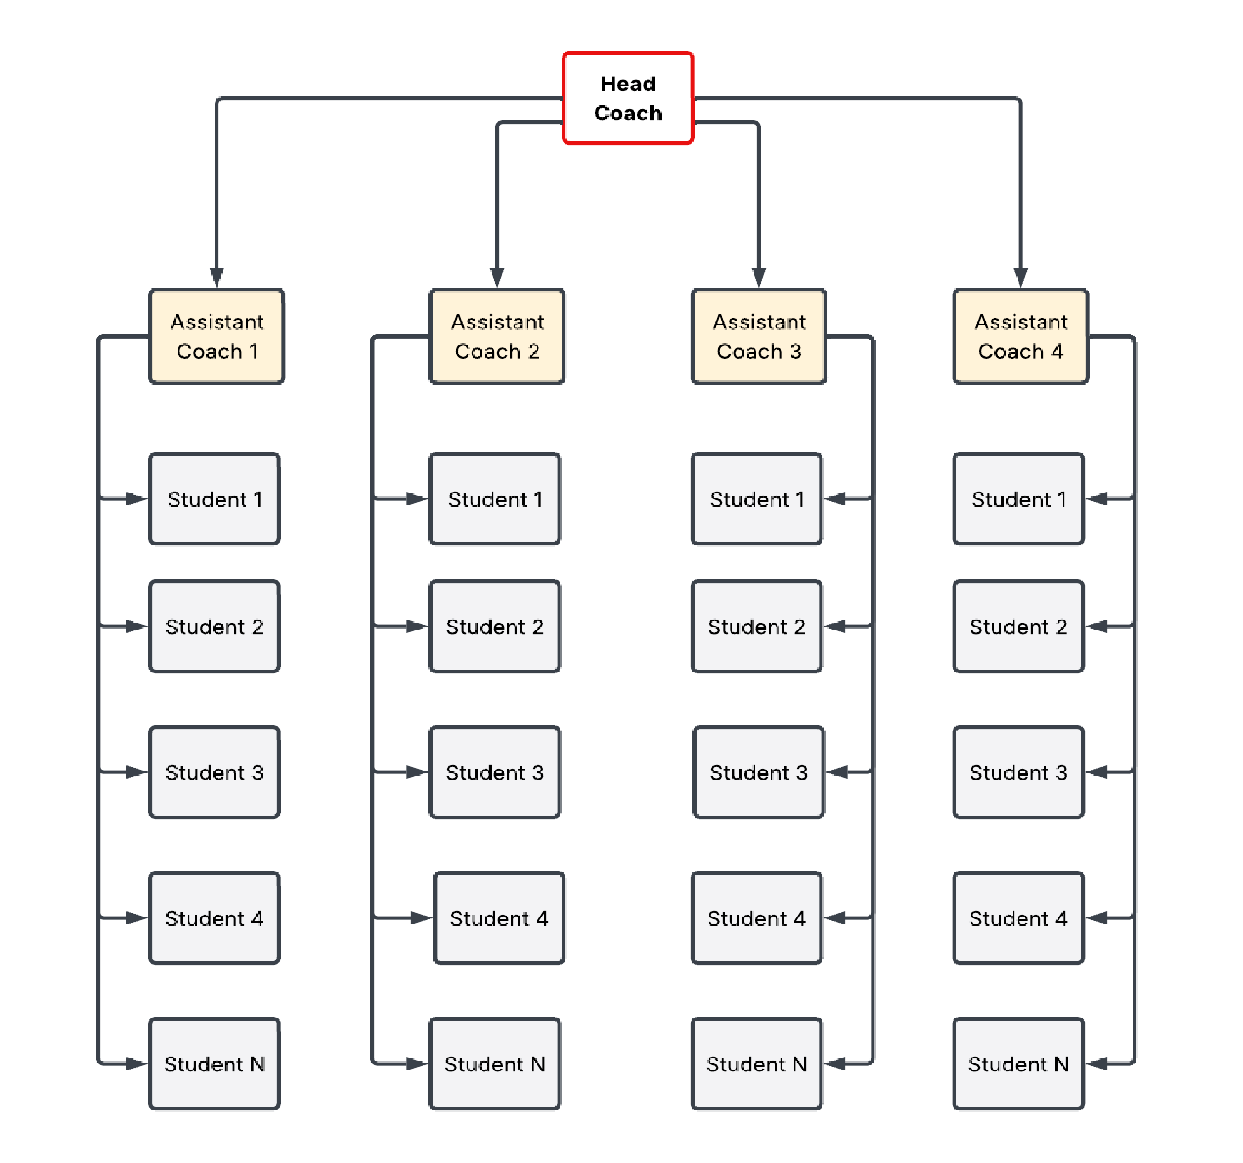

Figure 1. Rising Dragon Taekwondo Organizational Structure

Business Environment
Rising Dragon Taekwondo runs one main dojo and five partner schools across Davao City, all led by a Head Coach who has overseen the organization since 2014. Coaches are assigned to locations based on their personal availability rather than a fixed master schedule, and schedule updates are communicated through chat groups. The Head Coach personally interacts with more than twenty students daily and more than a hundred weekly, and relies on individual reports submitted by instructors from each location because no centralized system connects the six locations.

The school uses a straightforward enrollment process. Once a family agrees to enroll, the student can begin classes without lengthy onboarding. Students may be billed monthly or per session, and their information is recorded on paper forms. Payments are accepted through GCash, bank transfers, or cash, while payment records and due dates are tracked manually. Overdue reminders are sent through a shared group chat, and one parent respondent reported sometimes forgetting due dates and not always noticing these reminders right away. Attendance is not formally recorded; coaches rely on visual recognition of their enrolled students. Belt promotions are decided by the coach's evaluation of technique, discipline, and improvement, and are noted on paper records, with parents informed through chat messages. The Head Coach reports no promotion disputes. Students provide their own uniforms, belts, and protective gear, while the school keeps limited shared training equipment, such as mats and paddles, which is checked visually rather than through a formal inventory.

Although the informal system has not caused major losses or disputes so far, it has left the business dependent on manual coordination. The Head Coach identifies scheduling as the most stressful and time-consuming part of the operation, because coordinating coach availability across six locations requires constant communication, and notes that scheduling affects the school's other operations. Parent notifications about payments and promotions are also sent through chat messages.

Description of the Existing System

Scheduling and Instructor Coordination
The school does not currently use formal scheduling software. The Head Coach and the other coaches coordinate class schedules through chat groups, and there is no fixed master schedule. Assignments are made according to each coach's personal availability, with the aim of matching instructors to locations that fit their schedules. Because coaches adjust their availability regularly, schedule changes happen often, and updates are communicated through the chat groups. Arranging classes across the six locations therefore requires constant back-and-forth coordination to ensure that every session is covered. The Head Coach describes scheduling as the most stressful and time-consuming part of managing the school.

Belt promotion and Evaluation
Belt promotion at Rising Dragon Taekwondo is decided by the coaches' own evaluation. During regular classes, the coach assesses a student's skills, and the Head Coach describes basing this assessment on observed technique, discipline, and overall improvement. Once the coach judges a student ready, that decision takes precedence over anything a student may have tracked informally; the Head Coach notes that some students may track their own progress, but the coach's evaluation is what determines promotion. Promotions are noted on paper records, and parents are informed through chat messages. The parent respondent reported that instructors regularly give feedback and that families leave progress assessment to the coaches. In some cases, students who have remained at one belt level for a long period are promoted and are usually directed toward becoming instructors rather than competitors. The Head Coach reports no disputes over promotion decisions and considers promotion tracking a minor concern at most.

Student Records, Payments, and Attendance
Student information is recorded manually on paper forms kept at the dojo. The school uses monthly and per-session billing, and payment due dates are tracked on paper records. Payments are accepted through GCash, bank transfer, or cash. When a payment is overdue, a reminder is sent; according to the parent respondent, reminders are sent in the group chat, and the parent sometimes forgets due dates and does not always notice the reminders right away. The Head Coach reported no major payment miscounts or lost transactions. Attendance is not formally recorded. Instead, coaches rely on visual recognition: they know their enrolled students and count who is present during each session. The Head Coach reported that attendance can usually be recalled from memory and that it has not been a major problem.

Communication and Reporting Across Locations
There is no centralized system linking the main dojo and the five partner schools. To get an overall picture of the six locations, the Head Coach relies on individual reports submitted by instructors at each location and manually compiles information from various sources. Student, attendance, and payment information are not available through one shared branch-linked system. The interviews did not ask whether this manual compilation has caused errors or delays, so none is claimed here. A combined view of those records across the six locations therefore depends on the Head Coach's manual compilation.

Data Flow Diagram
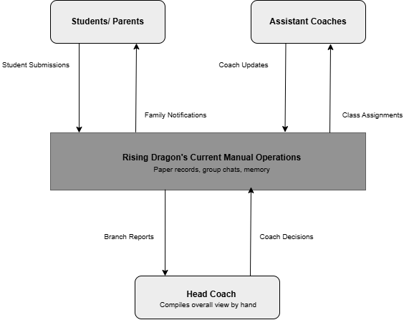

Figure 2: Context Diagram of the Existing Rising Dragon Taekwondo System

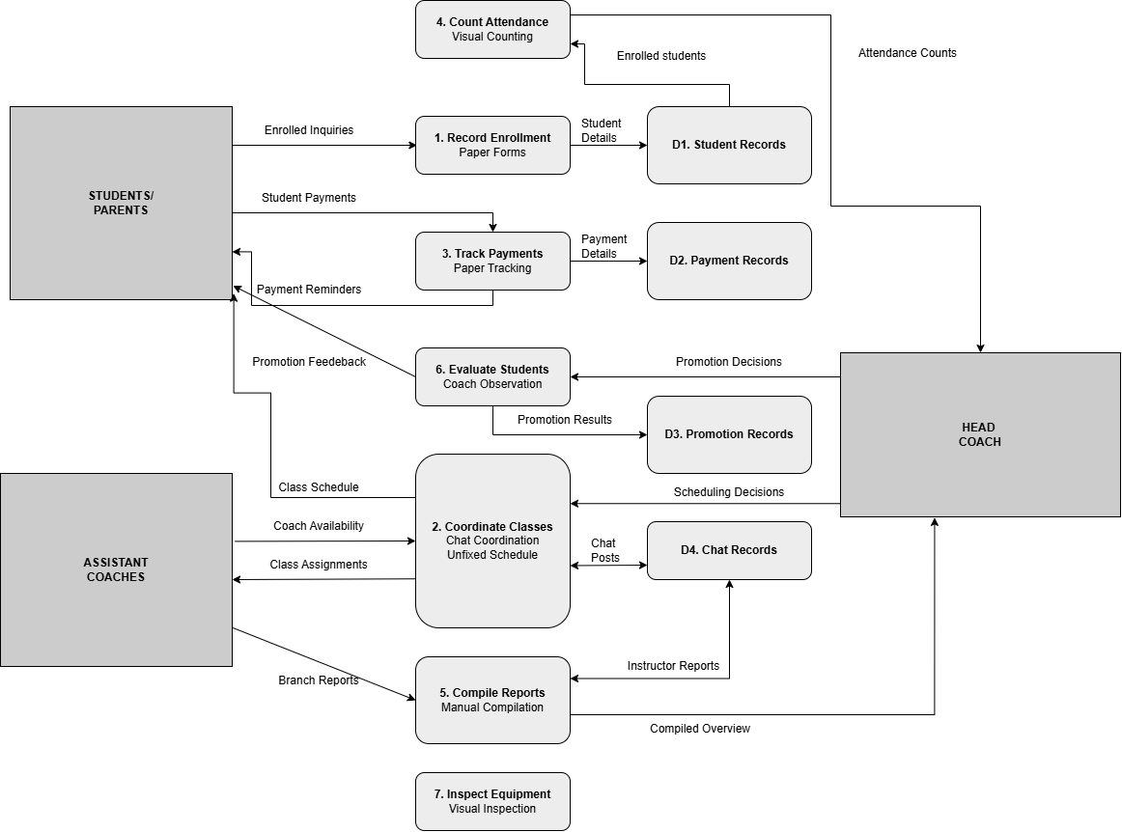

Figure 3: Level-0 Data Flow Diagram of the Existing Rising Dragon Taekwondo
System

Chapter 2

THE PROBLEM

Statement of the Problem
Rising Dragon Taekwondo currently operates six locations across Davao City using a largely manual and informal system. Because there is no centralized software, the Head Coach and the other coaches rely on paper records, group chats, and memory to manage daily operations. Students may be billed monthly or per session, while payment records and due dates are handled manually. The interviews, conducted with the Head Coach and, separately, with a parent respondent, found that this approach has not caused major financial losses or disputes. Based on the interviews, the study identifies three operational problems of differing severity. The primary problem is the time and effort required to coordinate coach schedules across six locations. The second is the lack of centralized attendance records and branch reporting, which requires the Head Coach to compile information from separate instructor reports. The third is that payment reminders sent through a shared group chat can be overlooked; one parent reported sometimes missing them. The interviews did not identify major attendance failures or payment losses. These findings come from only two respondents and should be read with that limitation in mind.

Problem 1: Coach Scheduling Across Six Locations Takes Significant Time and Effort
Of the three problems, scheduling is the highest priority. The Head Coach identified it as the most stressful or most difficult task in answer to four separate questions: which task takes the most time or causes the most stress, which task is hardest because of the six-location setup, which area causes the most trouble on a regular basis, and which single area a new system should fix. The Head Coach described scheduling as the most time-consuming and stressful part of managing the school and said that a system that helps with scheduling would make things much easier for everyone. The parent respondent also said they would appreciate clearer schedules.

In the current process, there is no fixed master schedule. Each coach has their own availability, and assignments are made by matching coaches to the locations that fit their schedules. Schedules change regularly as coaches adjust their availability, and these changes are communicated through chat groups. The Head Coach explained that arranging classes across the main dojo and the five partner schools requires constant back-and-forth coordination and a lot of time to make sure that all sessions are covered.
The Head Coach reported that there have not been any serious scheduling conflicts or double-bookings so far, which the Head Coach suggested is likely due to close coordination through chat. Double-booking a coach or leaving a location uncovered is therefore a possible risk rather than a problem that has already occurred, and the current approach manages that risk through constant effort. The interviews did not address the school's growth, but because the current approach depends on constant communication, it may become harder to sustain if the school adds more locations, coaches, or students.

Problem 2: Attendance and Branch Information Are Not Centralized
There is no centralized system linking the main dojo and the five partner schools. In the Head Coach's own words, “I rely on individual reports submitted by instructors from each location. There is no centralized system, so I manually compile information from various sources.” Attendance is not formally recorded; instead, coaches rely on visual recognition, knowing their enrolled students and counting who is present during each session. Because attendance is not formally recorded, no written attendance history exists that can be checked later. More broadly, the Head Coach must compile student, attendance, and payment information across the six locations from instructor reports and manual records rather than review them in one shared branch-linked system.
This problem is less severe than Problem 1, and it should not be read as a demonstrated failure. The Head Coach said that attendance can usually be recalled from memory and that it has not been a major problem or a priority. The interviews did not ask whether the instructors' reports have ever been incomplete, inconsistent, or late, and no such incident was reported, so none is claimed here. The problem lies in the absence of a centralized record and in the manual effort needed to gather and combine information from separate sources.

Problem 3: Payment Reminders Sent Through the Shared Group Chat Can Be Overlooked
Payment due dates for both monthly and per-session charges are tracked using paper records. When a payment is overdue, a reminder is sent through the shared group chat. One parent respondent described how this can be missed: “Sometimes I forget payment due dates. Although reminders are sent in the group chat, I don't always catch them right away.” The parent added that they would appreciate more reliable payment reminders, possibly through individual messages rather than only group chats.
This problem is the most limited of the three. The Head Coach reported no major payment miscounts or lost transactions, and the interviews do not show that the school has lost money or that payment processing has failed. The concern is limited to how easily a reminder can be overlooked in a group chat. Because it was raised by a single parent, it is presented as an indication of a possible gap rather than as a verified or widespread problem.
Taken together, the three problems differ in severity. Problem 1 is the highest priority because it was repeatedly identified by the Head Coach as the most stressful and time-consuming task. Problems 2 and 3 describe weaknesses in how information is gathered and communicated, but the interviews did not establish major attendance failures or payment losses. Because the findings are based on only two respondents, the Head Coach and one parent, they indicate where the school's operational difficulties are most likely to lie and should not be generalized to all staff or families.

Feasibility Study Operational Feasibility
The proposed centralized management system is intended to give the school a single place for the scheduling, student, payment, attendance, and promotion information that is currently handled through paper records and chat groups. The school already uses digital tools: coaches and parents communicate through Messenger and group chats, and the school accepts GCash payments, so some familiarity with digital tools can be expected. However, ease of use and staff acceptance have not yet been tested and should be confirmed through user testing. The Head Coach identified scheduling as the most time-consuming task, so the proposed system is expected to reduce time spent on coordination, but this benefit has not been measured. Because attendance is not currently recorded, an attendance feature would add a new step to class routines rather than save time, so the expected time savings apply mainly to scheduling and branch-level compilation.

Technical Feasibility
The school already uses digital tools such as Facebook Messenger for communication and accepts GCash for payments, which suggests that staff and families have access to smartphones and the internet. A web-based or mobile-friendly system would therefore be a reasonable fit, since it can run on devices that users already own. The system does not require complex hardware or expensive servers, as it can be hosted on a cloud platform that is easy to maintain.

Economic Feasibility
Currently, the school does not use management software, and its main expenses are venue rental, utilities, and coach fees, which are tracked informally through manual records. The interviews did not collect cost or savings figures, and the Head Coach reported no notable payment problems, so this study does not claim that the proposed system will recover lost income. The expected benefits are mainly operational: less time spent coordinating schedules and clearer payment reminders for parents. Development and hosting costs, and any resulting savings, remain to be estimated.

Schedule Feasibility
The proposed system can be developed and implemented within a reasonable timeframe, such as one academic semester. The Head Coach described scheduling as stressful and time-consuming and said that a system that helps with scheduling would make things much easier, which suggests openness to a new tool; the willingness of the Assistant Coaches was not directly assessed, since they were not interviewed. Student records must accommodate both monthly and per-session billing, as well as branch assignment, enrollment date, and guardian contact details needed by the system's other modules. This data structure is manageable within the proposed scope.

Chapter 3

THE SOLUTION

Methodology
The proponents use the Agile Methodology to develop the proposed Rising Dragon Taekwondo Management System. Agile is a software development approach in which the system is built in small, repeated cycles called iterations or sprints. Instead of planning and documenting the entire system before any code is written, the team builds one module at a time, tests it, reviews it, and refines it before moving on to the next (Pressman & Maxim, 2020).

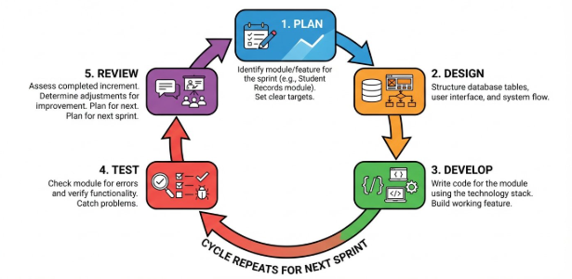
Agile suits this project for two reasons. First, the school’s operations were still being understood as the project began, and the requirements became clearer as the work progressed, so the team needed an approach that allows adjustments without redoing the whole system. Second, the three problems identified in Chapters 1 and 2 differ in severity, with scheduling as the highest priority, so the modules can be built and refined one at a time in order of priority. The findings also come from only two respondents, and Chapter 2 notes that ease of use and staff acceptance have not yet been tested, which makes repeated review and refinement appropriate.

Figure 4. Agile Development Methodology

Figure 4 shows the cycle that each iteration follows. In the Plan phase, the team identifies the module or feature to be built and sets clear targets. In the Design phase, it structures the database tables, user interface, and system flow for that module. In the Develop phase, it writes the code for the module using the agreed technology stack. In the Test phase, it checks the module for errors and verifies that it works as intended. In the Review phase, it assesses the completed increment and determines the adjustments needed. These adjustments are carried into the next iteration, which either refines the same module or begins the next one, so the system is improved continuously.
The order of the modules follows their priority and their dependencies on one another, as set out in the Implementation Plan. This section describes the development approach only. It does not report any completed testing, user feedback, or user evaluation of the system.

System Objectives
The proposed system aims to address the three problems identified in Chapters 1 and 2 through the following specific objectives:
The proposed solution is a role-based web system for the Head Coach and Assistant Coaches. It brings branch setup, weekly coach availability, scheduling and time-away coverage, student records, attendance history, branch reporting, monthly and per-session payment tracking, reminders, and approved promotions into one system. Student and payment records are associated with branches. Branch Comparison provides branch-level student counts alongside class and attendance metrics, while Class Session Records provide session-level attendance detail; payment records remain available through their respective Payments pages. The system also provides role-specific dashboard metrics, notifications, and account settings. It records payments but does not process transactions.
- To centralize scheduling across the six locations by allowing Assistant Coaches to submit weekly availability and report time away, while the Head Coach manages class schedules, checks coach availability and conflicts, and arranges coverage or cancellation for affected classes (Problem 1).
- To record the attendance status—Present, Late, Absent, or Excused—for each scheduled class and retain a searchable history. For an eligible per-session student, a coach can also record a walk-in check-in after the class starts; the check-in creates the related unpaid session charge (Problem 2).
- To centralize branch-linked student, attendance, and payment information across the six locations and provide the Head Coach with selected-period branch reports. Branch Comparison shows branch student counts, class activity, recorded attendance statuses, attendance rates, and recording coverage; Class Session Records provide session-level attendance details. Detailed student and payment records remain accessible through their respective branch-linked modules. A missing expected attendance entry is labeled “Not recorded” and is not treated as absent (Problem 2).
- To track both monthly and per-session charges using academy-wide rates configured by the Head Coach; create monthly bills on each student’s enrollment-date cycle after the first monthly payment is recorded; and retain each bill’s amount, due date, payment status, payment date, and method, including an advance payment against a selected upcoming monthly bill (Problem 3).
- To provide personalized payment reminder emails through Gmail SMTP as an individual alternative to reminders in the shared group chat. The system sends automatically at the configured before-due, due-date, and after-due intervals while a bill remains unpaid; the Head Coach can also send an eligible reminder manually, review sent or failed attempts, and retry a failed email (Problem 3).
- To provide user and role management that distinguishes Head Coach and Assistant Coach permissions, including role-appropriate access to student, attendance, schedule, payment, and settings functions.
- To maintain student records—including guardian contact details and email, branch, belt level, enrollment date, and billing plan—as the basis for attendance, payment reminders, and branch reports.
- To record an approved belt promotion and update the student’s belt history, while leaving the decision on promotion readiness to the coaches.
- To allow the Head Coach to add and maintain branch records so schedules, student records, attendance, and branch reports can be associated with the correct location.
- To provide each role with relevant dashboard metrics and a shared notification menu whose items open the related schedule, attendance, payment, or reminder record (supporting all three problems).

Objective 1 addresses Problem 1, the highest priority, because the Head Coach repeatedly identified scheduling as the most stressful and time-consuming task. Objectives 2 and 3 address Problem 2 by creating a written attendance history and centralizing branch-linked student, attendance, and payment information; Objective 3 also provides attendance-focused branch comparisons and session records. Objectives 4 and 5 support the payment workflow and address Problem 3: the system tracks monthly and per-session charges and provides individual email reminders as an alternative to the shared group chat. Objectives 6 to 9 support operation of the system through role-based access, student records, promotions, and branch setup. Objective 10 adds role-specific dashboard details and direct links from notifications to relevant records. These are proposed responses, not demonstrated outcomes: the interviews did not establish major attendance failures, payment losses, or serious double-bookings, and findings come from only two respondents, the Head Coach and one parent.

System Requirements
The requirements below are proposed for the system. Because the system is web-based, they are stated in general terms. No device specifications have been measured or confirmed on the school’s devices, and no prices or performance figures are set. The feasibility study in Chapter 2 found that staff and families already use digital tools such as Messenger and GCash, which suggests access to smartphones and the internet.

Hardware Requirements
Hardware | Proposed Specification | Purpose
Internet-capable phone or computer | A smartphone, laptop, or desktop computer with a supported modern web browser | Used by the Head Coach and Assistant Coaches to access the web-based system
Internet connection | Internet access at the locations where the system is used; no speed requirement is set | Needed to reach the web-based system and to send reminder emails
Device Compatibility | An internet-capable phone or computer with a supported modern web browser; compatibility with the staff’s existing devices must be checked | Accessing the web-based system; no minimum model or hardware specification has been set
Table 1. Hardware Requirements

Table 1 lists the general hardware requirements. Because the system is web-based, staff need an internet-capable phone or computer with a supported modern web browser and an internet connection. No fixed minimum device specifications have been established. Compatibility with the staff’s existing devices should be checked during implementation and evaluation; no new hardware purchase is assumed. Parents and guardians need a device that can receive email.

Software Requirements
Software | Specification | Purpose
Operating system | Any operating system that supports a modern web browser | Platform on which the system is accessed
Web browser | A supported modern web browser, such as Google Chrome, Mozilla Firefox, Microsoft Edge, or Safari | Accessing the web-based system
Frontend framework | Next.js | Building the user interface of the system
Backend platform | Supabase (PostgreSQL), including Supabase Auth | Cloud database, authentication, and backend services
Hosting platform | Vercel | Deploying the web-based system so it can be accessed online
Email service | Gmail account with Gmail SMTP | Sending personalized payment reminder emails to parents and guardians
Table 2. Software Requirements

Table 2 lists the proposed software required to run and access the system. The system is web-based, so staff use a web browser and do not need to install a native application. Next.js is used to build a responsive interface that works on both smartphones and laptops. Supabase provides the hosted database, the backend services, and authentication, so the school does not need to maintain its own server. Reminder emails are sent through Gmail SMTP, and Vercel hosts the system online. Using the system requires only a web browser and an internet connection from the staff.
Developer tools note: Visual Studio Code, Git and GitHub, and Facebook Messenger or Google Meet are used by the proponents only for development and team coordination. They are not required by school staff to use the system and are therefore not listed in Table 2.

Entity-Relationship Diagram

The proposed entity-relationship model represents users and branches; students linked to branches and billing plans; coach availability; recurring class templates and dated class sessions; branch closures; coach time-away reports and affected schedules; attendance entries linked to students and class sessions; promotions linked to students and coaches; payment records linked to students; reminder records linked to payments; and academy-wide payment settings.

[Insert Entity-Relationship Diagram here]

Figure 5. Entity-Relationship Diagram of the Proposed Rising Dragon Taekwondo Management System

Use Case Diagram

Figure 6 presents how the Head Coach and Assistant Coaches use the proposed system. Both roles can log in, view role-appropriate dashboard details and notifications, view permitted schedules, and manage their own profile and password. Assistant Coaches submit weekly availability and time-away reports, view the student roster permitted for their assignments, and record attendance for their assigned classes, including eligible per-session walk-ins. The Head Coach manages branches and coach accounts, reviews availability and time-away reports, maintains the master schedule, reviews system-wide student and attendance information, records monthly and per-session payments and advance payments, configures academy-wide fees and reminder intervals, sends or retries eligible payment reminders, records approved promotions, and generates branch reports. Automated monthly billing and scheduled reminder emails run as system processes rather than user actions. Parents and guardians do not log in; reminder emails go to the registered guardian email address.

[Insert Use Case Diagram here]

Figure 6. Use Case Diagram of the Proposed Rising Dragon Taekwondo Management System

Scopes and Limitations

The system is designed for the Head Coach and Assistant Coaches of Rising Dragon Taekwondo and covers the six locations: the main dojo and five partner schools in Davao City. It is web-based and accessed by staff through smartphones or computers. Parents and guardians do not log in; payment reminder emails are sent to the registered parent or guardian email address. The system centralizes coach availability, schedules, time-away reports, student records, attendance, payment records, reminders, promotions, and branch reporting. Student and payment records are linked to branches and can be reviewed through their respective modules. Branch Comparison provides student counts with class and attendance metrics, while Class Session Records show session-level attendance. Access to functions and records follows each user's role. Table 3 separates the core functions that address the identified problems from supporting system functions.
Type | Feature | What It Covers | Related Problem
Core | Scheduling and Availability | Assistant Coaches submit weekly availability and report time away. The Head Coach maintains schedules across the six locations, checks coach availability and conflicts, manages branch closures, and arranges coverage or cancellation for affected classes. | Problem 1 (highest priority)
Core | Attendance Tracking | Record Present, Late, Absent, or Excused for scheduled class sessions and retain attendance history. An eligible per-session walk-in check-in after class starts records attendance and creates an unpaid session charge. | Problem 2
Core | Branch Reporting | The Head Coach selects branches and a date range and switches between Branch Comparison and Class Session Records. Branch Comparison shows active student counts and new students in the period alongside class activity, attendance-status counts and rates, and recording coverage. Class Session Records show session-level attendance details. Detailed student and payment records remain available through their respective branch-linked modules. A missing attendance entry is shown as not recorded. Reports can be printed or saved as PDF. | Problem 2
Core | Payment due-date tracking and reminder emails | Use an academy-wide monthly fee and per-session rate; generate enrollment-date-cycle monthly bills after an initial payment; create per-session charges from walk-in check-ins; track payment date, method, and status; record advances against upcoming monthly bills; and send scheduled or Head Coach-initiated Gmail SMTP reminders. Payment History shows successful paid records; Reminder History shows sent and failed attempts and supports retry. The system does not process payments. | Problem 3
Supporting | User and Role Management | Login and role-based permissions for the Head Coach and Assistant Coaches, personal profile and password settings, role-specific dashboard details, and a shared notification menu that links to the relevant record. | Supports all features
Supporting | Student Records | Student and guardian details, belt level, enrollment date, branch, and monthly or per-session billing plan, with role-appropriate roster access. Records support attendance, payments, reminders, promotions, and branch reports. | Supports attendance, reminders, and reports
Supporting | Promotions | Recording an approved belt promotion and updating the student’s belt history. | Not tied to the three problems
Supporting | Branch Setup | The Head Coach can add branch records that identify the locations used by the system’s schedules, student records, attendance, and reports. | Supports all features
Table 3. Core and Supporting Features of the Proposed System

Student Records, Promotions, Dashboard Metrics, and Notifications support the core workflows. Student records supply the information used by attendance, billing, reminders, and reports; student and payment records are associated with branches so the Head Coach can review information across locations. Promotions record a decision already made by a coach. Branch Comparison includes student counts alongside class activity and attendance, and Class Session Records provide a session-level view. Detailed student and payment information remains in the respective branch-linked modules; payment details are not attendance-report metrics.

The system will not cover the following:
- Payment processing. The system will not accept or process cash, GCash, or bank-transfer payments. It only tracks due dates and paid or unpaid status and sends reminders.
- Promotion decisions. The system will not decide whether a student is ready for promotion. The coaches make that decision, and the system records the approved promotion.
- Equipment and inventory management. Equipment issues have not been significant, and shared equipment will continue to be checked visually.
- A parent-facing interface, SMS reminders, a native mobile app, and offline use.

The following limitations apply:
Branch-report attendance coverage is based on the currently active monthly-plan roster, limited to students whose enrollment date is on or before each class date. A per-session student is included in the expected roster only after a check-in is recorded. The system does not retain historical roster snapshots, so later enrollment, transfer, or archive changes can affect how past coverage is represented. A missing attendance entry is labeled “Not recorded,” never inferred to be “Absent.”

- The problems come from interviews with only two respondents, the Head Coach and one parent. The Assistant Coaches were not interviewed. The problems differ in severity, and the interviews did not identify lost attendance records, serious double-bookings, payment losses, or promotion disputes. Paper enrollment has also been reliable. The findings should not be generalized to all staff or families.
- The expected reduction in scheduling effort and in the time spent compiling reports has not been measured, and staff acceptance and ease of use have not been tested. Because attendance is not currently recorded, attendance tracking adds a new step to class routines.
- Automated reminders are sent only for unpaid bills for active students with a valid registered guardian email, at the schedule configured by the Head Coach. The Head Coach can also send an eligible reminder manually. Delivery still depends on the accuracy of the address, Gmail, hosting, and other external services; the system cannot guarantee that a message is received, read, or acted on. The interviews did not establish whether parents regularly check email.
- Payments are made outside the system. The Head Coach records when a payment is received, its date and method, or records payment against a selected upcoming monthly bill in advance. Paid or unpaid status reflects what the Head Coach records; the system does not verify transactions or process cash, GCash, or bank transfers.
- The system requires an internet connection and relies on external services such as Supabase, Gmail, and Vercel, whose availability is outside the team’s control.

Security Plan

The security plan combines protections implemented in the application with safeguards that must be verified in the hosting environment. The application requires authentication, separates permissions by role, and performs privileged data access in server-side code. Hosting, backup, and email-account safeguards depend on external service configuration and should be verified before operational use.
- The system will store student names, guardian names, contact details and email addresses, belt levels, and enrollment dates. Only the information needed for the system’s functions will be collected, access will be limited to logged-in users with an assigned role, and the information will be handled in line with applicable Philippine data privacy requirements, such as the Data Privacy Act of 2012 (Republic Act No. 10173, 2012).
- The system will be accessed over encrypted (HTTPS) connections, and regular backups will be arranged using the options available on the database platform so that records can be restored if they are lost.
- Access follows two roles. The Head Coach can manage coach accounts, branches, student records, schedules, attendance, payments, promotions, reports, and academy-wide settings. Assistant Coaches can view the student information permitted for their assigned classes and branches, submit their own weekly availability and time-away reports, record attendance for their assigned classes, and manage only their own personal details and password. They do not manage student records, payments, branches, coach accounts, or academy-wide settings. Role checks are enforced in server-side actions and data access, not only in the interface. A coach who leaves can be deactivated so access is removed while past records are retained.
- Login will be handled through Supabase Auth, so that passwords are managed by an established authentication service rather than by the system’s own code. Database credentials, SMTP credentials, and other secret keys will be kept in protected configuration on the server side, not in source code or the GitHub repository, and keys with elevated database access will not be exposed to the user interface.
- Reminder emails will be sent from a dedicated Gmail account with 2-Step Verification turned on, using an app password or another method supported by Google instead of the account’s main password. The SMTP credentials will be replaced if they are exposed. Reminders will go only to the registered email of the parent or guardian linked to the student, staff will verify an address when it is recorded, and each message will contain only what the parent or guardian needs to know about the payment due.
- The system does not accept or process payments and does not ask for or store GCash, bank, or card account details. Payment records retain the student, billing plan, amount, due date, payment status, payment date, and payment method; only the Head Coach can record or change payment information. A recorded payment reflects the Head Coach’s entry and is not independently verified by the system.

Implementation Plan

The implementation plan follows the Agile iterations described in the Methodology. Phases 2 to 8 each go through the Plan, Design, Develop, Test, and Review cycle. The order of the modules reflects their priority and dependencies. User and Role Management comes first because every other feature depends on knowing who the user is. Branch Setup is included with this phase so the Head Coach can register the locations that later modules use. Scheduling comes next because it is the highest-priority problem. Student Records come before the modules that depend on them, and Branch Reporting comes last because it draws on the data of the other modules. No dates, costs, or completion guarantees are set here.

Phase | Focus | Main Activities
1 | Project setup | Configure the development environment, create the code repository, and initialize the Supabase database.
2 | User and Role Management and Branch Setup | Develop login and role-based access for the Head Coach and Assistant Coaches, and allow the Head Coach to add branch records for the school’s locations.
3 | Scheduling and Availability (Problem 1) | Develop availability submission, coach-to-branch assignments in a master schedule, and the conflict check on assignments.
4 | Student Records | Develop the adding and viewing of student information, including guardian contact details and email.
5 | Attendance Tracking (Problem 2) | Develop scheduled-session attendance recording using Present, Late, Absent, and Excused; add eligible per-session walk-in check-in and retrieve saved attendance history.
6 | Payment tracking and reminder emails (Problem 3) | Configure academy-wide monthly and per-session rates and reminder intervals; generate enrollment-date-cycle bills and attendance-generated session charges; track regular and advance payments; and send scheduled and Head Coach-initiated Gmail SMTP reminders. Test reminder delivery with test email addresses before using guardian addresses.
7 | Promotions | Develop the recording of an approved belt promotion and the update of the student’s belt history.
8 | Branch Reporting (Problem 2) | Generate date-range branch comparisons and class-session records from student, schedule, and attendance data, including status counts and recording coverage, with printable or PDF output.
9 | Integration, security review, and system testing | Check that the modules work together, review role-based access and the handling of credentials and email settings, and correct the issues found.
10 | Rollout and evaluation | Orient the Head Coach and Assistant Coaches to the system, enter existing student information from the paper forms, and use the system alongside the current paper records and chat groups until the school is ready to rely on it. Carry out the evaluation described in System Evaluation and refine the system based on the results.
Table 4. Phases of the Implementation Plan

System Evaluation

The evaluation plan below explains how the completed system could be evaluated. No evaluation has been carried out for this chapter, and no responses, scores, or results are reported. The respondents would be the Head Coach and the four Assistant Coaches who would use the system, and the number of respondents will depend on their availability. The evaluation could use the following methods:
- Scenario-based functional testing, in which respondents carry out tasks for each major workflow: submit weekly availability and report time away; assign a conflict-checked class and arrange coverage; create or update a student record and retrieve it by branch; record scheduled attendance using the available statuses and check in an eligible per-session walk-in; retrieve attendance history; compare branches and review class-session records for a selected period; review branch-linked student and payment information; configure monthly and per-session rates and reminder intervals; record a monthly payment, a per-session payment, or an advance payment against an upcoming monthly bill; verify that scheduled reminders go only to an unpaid bill's registered guardian email and that paid bills are excluded; manually send or retry an eligible reminder using a test email address; record an approved promotion; and confirm that dashboard metrics, notification links, and role permissions work as intended.
- A functional requirements questionnaire and a non-functional requirements questionnaire, answered after the scenarios.
- A usability questionnaire, which is a separate instrument.
- With the Head Coach’s agreement, a comparison of the Head Coach’s own estimates of the time spent on scheduling and on compiling reports before and after using the system. Chapter 2 notes that these benefits have not been measured, so such a comparison would rest on estimates.

Both requirement questionnaires use a five-point scale: 5 – Strongly Agree, 4 – Agree, 3 – Neutral, 2 – Disagree, and 1 – Strongly Disagree. The Obj. column refers to the specific objectives listed under System Objectives.

Respondent role: ☐ Head Coach ☐ Assistant Coach
Date: ______________________

No. | Statement | Obj. | 5 | 4 | 3 | 2 | 1
A. User and Role Management
1 | The system allows the Head Coach and Assistant Coaches to log in with their own accounts. | 6
2 | Each user can access only the functions that match their role. | 6
3 | An Assistant Coach can view students and mark attendance only for the branch where the coach is scheduled on that date. | 6
B. Student Records
4 | The system allows student information, including guardian contact details and email, to be recorded and viewed with the student's branch assignment. | 7
C. Scheduling and Availability
5 | Assistant Coaches can submit their availability through the system. | 1
6 | The Head Coach can view coach availability and assign coaches to the six locations in a single master schedule. | 1
7 | The system prevents a coach from being assigned to conflicting classes on the same date and time. | 1
8 | The Head Coach and the Assistant Coaches can view the schedule of the six locations in one place. | 1
9 | The system reduces the need for back-and-forth coordination through chat groups. | 1
D. Attendance Tracking
10 | The system allows attendance to be recorded for a scheduled class session. | 2
11 | Previously recorded attendance can be viewed later. | 2
E. Branch Reporting
12 | The Head Coach can generate a branch report. | 3
13 | The Head Coach can compare branch-level student counts and class activity and review class-session attendance totals and recording coverage for a selected period; missing entries are identified as not recorded. | 3
F. Payment Tracking and Reminder Emails
14 | The system records monthly bills and per-session charges and lets the Head Coach record payment status, date, and method. | 4
15 | The system automatically sends personalized reminders at the configured before-due, due-date, and after-due intervals, and the Head Coach can manually send an eligible reminder. | 5
16 | The reminder emails are personalized for the student and the parent or guardian concerned. | 5
G. Promotions
17 | The system allows an approved belt promotion to be recorded and updates the student’s belt history. | 8
H. Branch Setup
18 | The Head Coach can add a branch record for a school location. | 9
I. Payment Settings, Advance Payments, Dashboard, and Notifications
19 | The Head Coach can configure the academy-wide monthly and per-session rates and the before-due and after-due reminder intervals. | 4, 5
20 | The Head Coach can record an advance payment against a selected upcoming monthly bill. | 4
21 | Each role sees the appropriate dashboard metrics, and selecting a notification opens the related record or page. | 6, 10
Table 5. Functional Requirements Questionnaire

Respondent role: ☐ Head Coach ☐ Assistant Coach
Date: ______________________

No. | Statement | Obj. | 5 | 4 | 3 | 2 | 1
A. Security and Access Control
1 | The system requires users to log in before they can use its functions. | 6
2 | Users can access only the information and functions allowed for their role. | 6
3 | Student and guardian information is visible only to authorized users. | 7
4 | The system does not ask for or store GCash, bank, or card account details. | 4, 5
B. Reliability
5 | The system works as expected when used for scheduling, attendance, payments, and reports. | 1–5
6 | Information entered into the system is saved correctly and is still available when viewed later. | 1–5
7 | The system records the result of each payment reminder email attempt and displays its status in reminder history. | 5
C. Accuracy and Consistency
8 | Attendance histories and branch reports match saved attendance records, and missing entries are identified as not recorded rather than assumed absent. | 2, 3
9 | The reminder emails show the correct student and payment due date. | 5
D. Performance
10 | The system responds quickly enough for use in the school’s daily operations. | 1–9
E. Availability and Compatibility
11 | The system can be accessed when it is needed. | 1–9
12 | The system works on the smartphones and laptops that the school’s staff use. | 1–9
Table 6. Non-Functional Requirements Questionnaire

The usability of the system will be measured with a separate usability questionnaire

Respondent role: ☐ Head Coach ☐ Assistant Coach
Date: ______________________

Instructions: Rate how much you agree with each statement about the system you evaluated by marking one box per row. Please answer every item.
Rating scale
1 – Strongly Disagree | 2 – Disagree | 3 – Not sure | 4 – Agree | 5 – Strongly Agree

No. | Statement | 1 | 2 | 3 | 4 | 5
1 | I think that I would like to use this system frequently.
2 | I found the system unnecessarily complex.
3 | I thought the system was easy to use.
4 | I think that I would need the support of a technical person to be able to use this system.
5 | I found the various functions in this system were well integrated.
6 | I thought there was too much inconsistency in this system.
7 | I would imagine that most people would learn to use this system very quickly.
8 | I found the system very cumbersome to use.
9 | I felt very confident using the system.
10 | I needed to learn a lot of things before I could get going with this system.
Table 7. System Usability Scale (SUS)

System Prototypes
The following descriptions summarize the system screens and explain how their main workflows support the identified problems. Screens and permissions vary by user role.

Login Window
The Login window lets the Head Coach and Assistant Coaches sign in with their own accounts. The system verifies credentials through Supabase Auth and applies the account’s role to the available functions.
[Insert screenshot of the Login Window here]
Figure 7. Login Window

User and Role Management Window
The User and Role Management window lets the Head Coach create, update, and deactivate Assistant Coach accounts and assign primary branches. Role-based access separates Head Coach functions from Assistant Coach functions. Each coach can update only their own name, contact number, and password in Settings.
[Insert screenshot of the User and Role Management Window here]
Figure 8. User and Role Management Window

Student Records Window
The Student Records window lets the Head Coach create and maintain student details, including guardian contact information and email, belt level, enrollment date, billing plan, and branch. Both roles can search and filter the student roster within their permitted access; Assistant Coaches receive read-only roster access without guardian contact fields. Student records support attendance, monthly and per-session billing, reminders, promotions, and branch reports.
[Insert screenshot of the Student Records Window here]
Figure 9. Student Records Window

Scheduling and Availability Window
In Scheduling and Availability, Assistant Coaches submit recurring weekly availability and report dates when they will be away. The Head Coach manages class schedules across branches, checks coach availability and assignment conflicts, handles branch closures, and reviews time-away reports to assign an available substitute or cancel affected classes. The schedule shows the resulting dated class sessions to staff according to their role.
[Insert screenshot of the Scheduling and Availability Window here]
Figure 10. Scheduling and Availability Window

Attendance Tracking Window
The Attendance Tracking window lets a coach record Present, Late, Absent, or Excused for each student expected in a scheduled class. An eligible per-session student can be checked in as a walk-in after class starts; this records the check-in and creates the corresponding unpaid session charge. Saved entries form a student and class attendance history that can be reviewed later. Missing entries remain unrecorded; the system does not convert them to Absent.
[Insert screenshot of the Attendance Tracking Window here]
Figure 11. Attendance Tracking Window

Branch Directory and Reporting Window
The Branch Directory and Reporting window lets the Head Coach select a date range and branch filters, then switch between Branch Comparison and Class Session Records. Branch Comparison summarizes active student counts and new students in the period, scheduled and cancelled classes, recorded Present, Late, Absent, and Excused statuses, attendance rates, and recording coverage. Class Session Records show the attendance details for individual sessions. A missing expected status is identified as not recorded, rather than absent. The Head Coach can print or save the reports as a PDF. Student and payment details remain accessible through their respective branch-linked modules, bringing the branch-level information together without manually compiling separate instructor reports.
[Insert screenshot of the Branch Reporting Window here]
Figure 12. Branch Directory and Reporting Window

Payment Tracking and Reminders Window
The Payment Tracking and Reminders window supports monthly and per-session billing. The Head Coach configures one academy-wide monthly rate, a per-session rate, and reminder intervals. After the initial monthly payment record is entered, the system generates monthly bills on each student’s enrollment-date cycle; short months use their last calendar day when the enrollment day does not exist. A per-session walk-in check-in creates an unpaid session charge. The Head Coach records payment date and method, or records an advance payment against a selected upcoming monthly bill. Payment History lists successful paid records with their billing plan and payment details. For an unpaid bill, a scheduled process can send a personalized Gmail SMTP email to the registered guardian address at configured intervals; the Head Coach can also send an eligible reminder manually. Reminder History displays sent and failed attempts and supports retrying a failed email. The system records payments but does not process transactions.
[Insert screenshot of the Payment Tracking and Reminders Window here]
Figure 13. Payment Tracking and Reminders Window

Promotions Window
The Promotions window is intended for the Head Coach to record an approved belt promotion, including the previous belt, the new belt, the date, and the evaluating coach, and to update the student’s belt history. The page separates active promotion work from Promotion History and provides search, branch, and belt filters.
[Insert screenshot of the Promotions Window here]
Figure 14. Promotions Window

Dashboard Metrics and Notifications Window
The dashboard displays role-specific summary metrics, such as active students, today’s classes, attendance that still needs recording, and—for the Head Coach—payments due or overdue. Selecting a metric opens its own detail page. A notification bell is available in the shared header for both roles; selecting an item directs the user to the related class, attendance record, payment, or reminder.
[Insert current screenshot of the Dashboard metric details or Notifications menu here]

Figure 15. Dashboard Metrics and Notifications Window

Settings Window
Settings lets every coach update their own name, contact number, and password. The Assistant Coach settings page is limited to personal account details and account security. The Head Coach can also configure the academy-wide monthly and per-session fees and the before-due and after-due reminder intervals. Notifications are accessed from the shared header rather than from Settings.
[Insert current screenshot of the Settings page here]

Figure 16. Settings Window

References

Pressman, R. S., & Maxim, B. R. (2020). Software engineering: A practitioner’s approach (9th ed.). McGraw Hill.

Republic Act No. 10173. (2012). Data Privacy Act of 2012. Official Gazette of the Republic of the Philippines. https://officialgazette.gov.ph/2012/08/15/republic-act-no-10173/

