实验项目组4
《概率论与数理统计A》上机实验报告
成绩

实验名称 |  | 实验项目组4（概率论与数理统计A）
院系 |  | 数理学院 | 专业 | 数据科学与大数据技术 | 班级 | 大数据2002
姓名 |  | 任雨蒙 | 学号 | 5120206376 | 日期 | 2022/6/21
实验  目的 | 1. 掌握Python统计软件的使用；  2. 掌握利用Python软件求样本的均值、方差、置信区间；会用Python软件进行假设检验、单因素方差分析以及一元线性回归分析；  3. 会解读输出结果。

注：以下所有题目需附上Python 代码

- 利用Python求下列概率
(1) 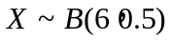，求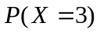
- class berNouLli:
- def __init__(self, x: int, p: float, n: int) -> None:
- self.x: int = x
- self.p: float = p
- self.n: int = n

- @property
- def pmf(self) -> float:
- f: float = self.factorial(self.n) / (self.factorial(self.x) * self.factorial((self.n - self.x))) * (
- self.p ** self.x * (1 - self.p) ** (self.n - self.x))
- return f

- def factorial(self, n: int) -> int:
- if n == 1 or n == 0:
- return 1
- else:
- return n * self.factorial(n - 1)

- if __name__ == "__main__":
- newObj: berNouLli = berNouLli(3, 0.5, 6)
- print(newObj.pmf)
结果：0.3125
(1) 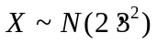，求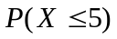
- # -*- coding: utf-8 -*-
- # @Time : 2022/6/14 15:40
- # @Author : renyumeng
- # @Email : 2035328756@qq.com
- # @File : Solve.py
- # @Project : ProbabilityTheoryAndMathematicalStatisticsExperiments
- import sympy
- import numpy as np

- class Normal:
- def __init__(self, sub_val: int, mu: int, sigma: int) -> None:
- self.x: sympy.Symbol = sympy.Symbol('x')
- self.m: int = mu
- self.sig: int = sigma
- self.val: int = sub_val
- self.pi: sympy.pi = sympy.pi

- @property
- def Nf(self) -> sympy.Symbol:
- f: sympy.exp = sympy.exp(-((self.x - self.m) ** 2) / (2 * self.sig ** 2))
- inter_f: sympy.Symbol = (1 / (sympy.sqrt(2 * self.pi) * self.sig)) * (
- sympy.integrate(f, (self.x, -np.inf, self.x)))
- return inter_f

- @property
- def sub_x(self) -> float:
- ans_func: sympy.Symbol = self.Nf
- sub_val: sympy.Symbol = ans_func.subs(self.x, self.val)
- return sub_val.evalf()

- if __name__ == "__main__":
- newObj: Normal = Normal(5, 2, 3)
- print(newObj.sub_x)
结果：0.841344746068543
(2) X~P(3)，求
- # -*- coding: utf-8 -*-
- # @Time : 2022/6/14 16:30
- # @Author : renyumeng
- # @Email : 2035328756@qq.com
- # @File : 3.py
- # @Project : ProbabilityTheoryAndMathematicalStatisticsExperiments
- import math
- from typing import Union

- class Poisson:
- def __init__(self, x: int, _lamb: Union[int, float]) -> None:
- self.X: int = x
- self.lamb: Union[int, float] = _lamb

- def Pf(self, k: int) -> float:
- f: float = self.lamb ** k * math.exp(-self.lamb) / (self.factorial(k))
- return f

- @property
- def get_poisson(self) -> float:
- ans: Union[int, float] = 0
- for k in range(0, self.X + 1):
- ans += self.Pf(k)
- return ans

- def factorial(self, n: int) -> int:
- if n == 1 or n == 0:
- return 1
- else:
- return n * self.factorial(n - 1)

- if __name__ == "__main__":
- newObj: Poisson = Poisson(5, 3)
- print(newObj.get_poisson)
结果：0.9160820579686966
(3) X~U(3,9)，求
- # -*- coding: utf-8 -*-
- # @Time : 2022/6/14 16:50
- # @Author : renyumeng
- # @Email : 2035328756@qq.com
- # @File : 4.py
- # @Project : ProbabilityTheoryAndMathematicalStatisticsExperiments
- from typing import Union

- class Uniform:
- def __init__(self, a: Union[int, float], b: Union[int, float], x: Union[int, float]) -> None:
- self.a: Union[int, float] = a
- self.b: Union[int, float] = b
- self.x: Union[int, float] = x

- @property
- def Uf(self) -> Union[int, float]:
- if self.x < self.a:
- return 0
- elif self.x >= self.b:
- return 1
- else:
- return (self.x - self.a) / (self.b - self.a)

- if __name__ == "__main__":
- newObj: Uniform = Uniform(3, 9, 5)
- print(newObj.Uf)

结果：0.3333333333333333
2.令Poisson分布的参数为4。为了可视化二项分布的泊松近似，我们分别生成实验次数为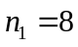和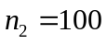的冻结二项分布。请在第一张图片上做出Poisson分布的pmf以及二项分布的pmf（）；在第二张图片上做出Poisson分布的pmf以及二项分布的pmf（）； (图形的起始点为生成的冻结Poisson分布的下侧0.001分位数，图形的终点为生成的冻结Poisson分布的下侧0.999分位数).
- # -*- coding: utf-8 -*-
- # @Time : 2022/6/14 21:22
- # @Author : renyumeng
- # @Email : 2035328756@qq.com
- # @File : Solve.py
- # @Project : ProbabilityTheoryAndMathematicalStatisticsExperiments
- import sympy
- import numpy as np
- import math
- from typing import Union, List, TypeVar, Dict
- from abc import abstractmethod, ABC
- import matplotlib.pyplot as plt

- class berNouLliRule(ABC):
- @abstractmethod
- def pmf(self, x):
- pass

- class PoissonRule(ABC):
- @abstractmethod
- def Pf(self, k):
- pass

- class berNouLli(berNouLliRule):
- def __init__(self, p, n):
- self.p = p
- self.n = n

- def pmf(self, x):
- f = self.factorial(self.n) / (self.factorial(x) * self.factorial((self.n - x))) * (
- self.p ** x * (1 - self.p) ** (self.n - x))
- return f

- def factorial(self, n):
- if n == 1 or n == 0:
- return 1
- else:
- return n * self.factorial(n - 1)

- class Poisson(PoissonRule):
- def __init__(self, _lamb):
- self.lamb = _lamb

- def Pf(self, k):
- f = self.lamb ** k * math.exp(-self.lamb) / (self.factorial(k))
- return f

- def get_poisson(self, X, is_equal=True):
- ans = 0
- if is_equal:
- ans = self.Pf(X)
- else:
- for k in range(0, X + 1):
- ans += self.Pf(k)
- return ans

- def factorial(self, n):
- if n == 1 or n == 0:
- return 1
- else:
- return n * self.factorial(n - 1)

- class Solve:
- T = TypeVar("T", int, str)

- def __init__(self, n: int, _lambda: Union[int, float]) -> None:
- self.n: int = n
- self._lambda: Union[int, float] = _lambda
- self.freezy_bernoulli: berNouLli = berNouLli(self.get_p, self.n)
- self.freezy_poisson: Poisson = Poisson(self._lambda)

- @property
- def get_p(self) -> float:
- return self._lambda / self.n

- @property
- def get_x(self) -> List[int]:
- temp_lst: List[int] = list(range(0, self.n + 1))
- return temp_lst

- @property
- def get_all_data(self) -> {str: Union[str, List[float]]}:
- x: List[int] = self.get_x
- _all_data: {str: Union[str, List[float]]} = {
- 'x': x,
- 'poisson': [],
- 'bernoulli': []
- }
- for i in range(len(x)):
- _all_data['poisson'].append(self.freezy_poisson.get_poisson(i))
- _all_data['bernoulli'].append(self.freezy_bernoulli.pmf(i))
- return _all_data

- @staticmethod
- def draw_picture(path: str, data: Dict[str, Union[List[int], list]], x_data: T, *y_data: str) -> None:
- L1, = plt.plot((data[x_data]), data[y_data[0]])
- L2, = plt.plot(data[x_data], data[y_data[1]])
- plt.legend([L1, L2], ['泊松分布', '二项分布'])
- plt.xlabel('试验次数')
- plt.ylabel('概率')
- plt.savefig(path)
- plt.show()

- if __name__ == '__main__':
- plt.rcParams['font.sans-serif'] = ['SimHei']
- eightNewObj: Solve = Solve(8, 4)
- eight_all_data: {str: Union[str, List[float]]} = eightNewObj.get_all_data
- Solve.draw_picture('实验8次.png', eight_all_data, 'x', 'poisson', 'bernoulli')
- hundredNewObj: Solve = Solve(100, 4)
- hundred_all_data: {str: Union[str, List[float]]} = hundredNewObj.get_all_data
- Solve.draw_picture('实验100次.png', hundred_all_data, 'x', 'poisson', 'bernoulli')
结果：
实验八次：
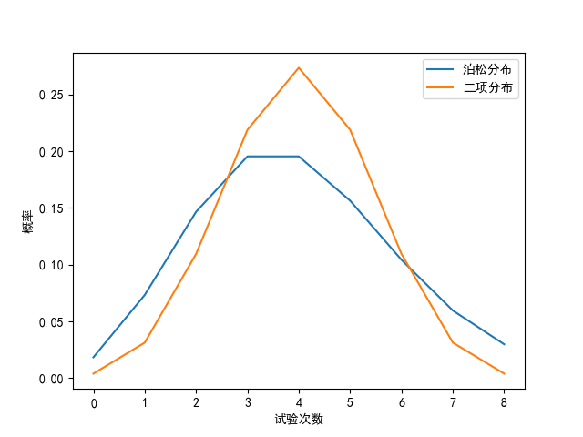
实验100次：
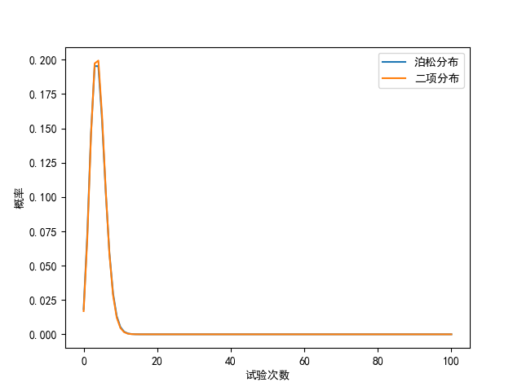
3. Scipy库中stats模块下的describe函数可以实现对数据的描述性统计，其输出为样本容量、最大值最小值、样本均值、样本方差、偏度、峰度。请随机生成服从正态分布的随机数，并对生成的随机数据进行描述性统计。另外，利用样本方差计算公式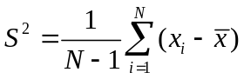编写一段代码，检查describe函数输出的样本方差是否与利用上述公式输出的结果一致。
- # -*- coding: utf-8 -*-
- # @Time : 2022/6/17 15:05
- # @Author : renyumeng
- # @Email : 2035328756@qq.com
- # @File : Solve.py
- # @Project : ProbabilityTheoryAndMathematicalStatisticsExperiments
- import numpy as np
- import scipy.stats as sts

- class Solve:
- def __init__(self, N) -> None:
- self.n: int = N
- self._random_num: np.ndarray = self.get_normal_num
- self._describe_num: tuple = self.get_describe
- self.mean: float = self.get_mean
- self._describe_variance: float = self._describe_num[-3]
- self.func_variance: float = self.get_variance

- def __str__(self) -> str:
- return f"""使用describe函数得到的方差{self._describe_variance}\n使用公式计算出的方差：{self.func_variance}"""

- @property
- def get_normal_num(self) -> np.ndarray:
- _normal_num: np.array = sts.norm.rvs(loc=0, scale=1, size=self.n)
- return _normal_num

- @property
- def get_describe(self) -> tuple:
- _describe_ans: tuple = sts.describe(self._random_num)
- return _describe_ans

- @property
- def get_mean(self) -> float:
- _mean: float = self._random_num.mean()
- return _mean

- @property
- def get_variance(self) -> float:
- temp_array: np.ndarray = self._random_num.copy()
- _mean: float = self.mean
- ans: float = 0
- for i in range(len(temp_array)):
- ans += (temp_array[i] - _mean) ** 2
- ans /= (self.n - 1)
- return ans

- if __name__ == "__main__":
- newSolve: Solve = Solve(10)
- print(newSolve)
结果：
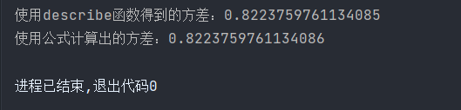
一致
4. 给定如下一个样本
data = [87,77,92,68,80,78,84,77,81,80,80,77,92,86,76,80,81,75,77,72,81,72,84,86,80,68,77,87,
76,77,78,92,75,80,78]
对上述样本进行正态性检验；若为正态分布，求其置信水平为95%的置信区间。
- # -*- coding: utf-8 -*-
- # @Time : 2022/6/17 15:34
- # @Author : renyumeng
- # @Email : 2035328756@qq.com
- # @File : Solve.py
- # @Project : ProbabilityTheoryAndMathematicalStatisticsExperiments
- from math import sqrt
- from typing import List, Union
- import scipy.stats
- from scipy.stats import kstest

- class Solve:
- def __init__(self, data: list = None) -> None:
- if data is None:
- data: List[Union[int, float]] = [87, 77, 92, 68, 80, 78, 84, 77, 81, 80, 80, 77, 92, 86, 76, 80, 81, 75, 77,
- 72, 81, 72, 84, 86,
- 80, 68, 77, 87,
- 76, 77, 78, 92, 75, 80, 78]
- self.data: List[Union[int, float]] = data
- self.n: int = self.get_n
- self.mean: float = self.get_mean
- self.std: float = self.get_std
- self.p_value: float = self.normality_test
- self.scale: float = self.get_scale

- @property
- def get_n(self) -> int:
- return len(self.data)

- @property
- def get_scale(self) -> float:
- return self.std / sqrt(self.n)

- @property
- def get_mean(self) -> float:
- return sum(self.data) / self.n

- @property
- def get_std(self) -> float:
- temp_array: List[int] = self.data.copy()
- _mean: float = self.mean
- ans: Union[int, float] = 0
- for i in range(len(temp_array)):
- ans += (temp_array[i] - _mean) ** 2
- ans /= self.n
- ans = sqrt(ans)
- return ans

- @property
- def normality_test(self) -> float:
- test_state, p_value = kstest(self.data, 'norm', args=(self.mean, self.std))
- return p_value

- @property
- def judge_norm(self) -> str:
- if self.p_value > 0.05:
- return 'p值大于0.05，为正态分布'
- return 'p值小于或等于0.05，不是正太分布'

- def confidence_interval(self, x: float) -> tuple:
- CI: tuple = scipy.stats.norm.interval(x, loc=self.mean, scale=self.scale)
- return CI

- def __str__(self):
- return self.judge_norm

- if __name__ == "__main__":
- newSolve: Solve = Solve()
- print(newSolve)
- print(f'置信区间为：{newSolve.confidence_interval(0.95)}')
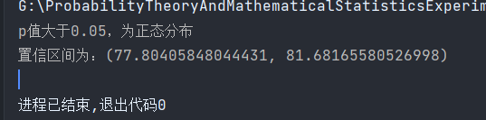
5、假设汽车某种尾气排放服从N(20,). 现某汽车公司测试10辆汽车的排放结果如下：
15.6 16.2 22.5 20.5 16.4 19.4 16.6 17.9 12.7 13.9 。
问题：（1）汽车尾气排放是否满足标准;（2）环保标准规定汽车的新排放标准：平均值<20，
问汽车尾气排放是否满足新标准？
- # -*- coding: utf-8 -*-
- # @Time : 2022/6/17 16:01
- # @Author : renyumeng
- # @Email : 2035328756@qq.com
- # @File : Solve.py
- # @Project : ProbabilityTheoryAndMathematicalStatisticsExperiments
- import scipy.stats as sts
- from typing import List

- data: List[float] = [15.6, 16.2, 22.5, 20.5, 16.4, 19.4, 16.6, 17.9, 12.7, 13.9]
- t, p_twoTail = sts.ttest_1samp(data, 20, nan_policy='propagate', alternative='two-sided')
- print(t, p_twoTail)
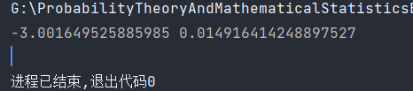

6、某生产商想比较两种汽车轮胎A和B的磨损质量。在比较中，选A和B型轮胎组成一对后任意安装在7辆汽车的后轮上，然后让汽车运行指定的英里数，记录下每只轮胎的磨损量。
数据如下：
汽车 1 2 3 4 5 6 7
轮胎A 9.6 10.8 11.3 10.7 8.2 9.0 11.2
轮胎B 8.2 9.4 11.8 9.1 9.3 11.0 13.1
对两种轮胎的磨损质量进行方差齐性检验，并检验两种轮胎的平均磨损质量是否存在显著差异？
- # -*- coding: utf-8 -*-
- # @Time : 2022/6/21 14:32
- # @Author : renyumeng
- # @Email : 2035328756@qq.com
- # @File : Solve.py
- # @Project : ProbabilityTheoryAndMathematicalStatisticsExperiments
- from typing import List, Union, Dict

- class Solve:
- def __init__(self, _data: Dict[str, List[Union[int, float]]] = None) -> None:
- if _data is None:
- _data: Dict[str, List[Union[int, float]]] = {
- 'A': [9.6, 10.8, 11.3, 10.7, 8.2, 9.0, 11.2],
- 'B': [8.2, 9.4, 11.8, 9.1, 9.3, 11.0, 13.1]
- }
- self.data: Dict[str, List[Union[int, float]]] = _data
- self.each_sum: Dict[str, Union[int, float]] = self.get_each_sum # A，B每一个的和
- self.sum_sum: float = self.get_sum_sum # 所有的和
- self.sum_square: float = self.get_sum_square # 所有的平方和
- self.n: int = self.get_length # 所有的个数

- self.St: float = self.get_s_total
- self.Sa: float = self.get_among
- self.Se: float = self.get_error

- self.f_all: {str, Union[int, float]} = self.get_free
- self.fT: int = self.f_all['fT']
- self.fA: int = self.f_all['fA']
- self.fe: int = self.f_all['fe']

- @property
- def get_each_sum(self) -> Dict[str, Union[int, float]]:
- each_sum: Dict[str, Union[int, float]] = {}
- for key in self.data:
- each_sum[key] = sum(self.data[key])
- return each_sum

- @property
- def get_sum_sum(self) -> float:
- ans: Union[int, float] = 0
- for key in self.each_sum:
- ans += self.each_sum[key]
- return ans

- @property
- def get_sum_square(self) -> float:
- ans: Union[int, float] = 0
- for key in self.data:
- temp_data = self.data[key]
- ans += Solve.get_square(temp_data)
- return ans

- @property
- def get_length(self) -> int:
- length: int = 0
- for key in self.data:
- length += len(self.data[key])
- return length

- @property
- def get_s_total(self) -> float:
- return self.sum_square - ((self.sum_sum ** 2) / self.n)

- @property
- def get_free(self) -> {str, Union[int, float]}:
- total_free: int = self.n - 1
- among_free: int = len(self.data) - 1
- error_free: int = total_free - among_free

- return {
- 'fT': total_free,
- 'fA': among_free,
- 'fe': error_free
- }

- @property
- def get_error(self) -> float:
- return self.St - self.Sa

- @property
- def get_among(self) -> float:
- ans: float = 0
- for key in self.each_sum:
- temp_dict = self.each_sum[key]
- ans += temp_dict ** 2 / (len(self.data[key]))
- ans -= self.sum_sum ** 2 / self.n
- return ans

- @property
- def get_f_proportion(self) -> float:
- return (self.Sa / self.fA) / (self.Se / self.fe)

- @staticmethod
- def get_square(data: List[Union[int, float]]) -> float:
- ans: float = 0
- for i in range(len(data)):
- ans += data[i] ** 2
- return ans

- if __name__ == "__main__":
- newSolve: Solve = Solve()
- print(f"F比为：{newSolve.get_f_proportion}")
结果：

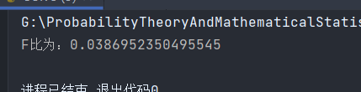
求出的F比为：0.0386952350495545
7、用4种饲料喂猪，共19头猪分为四组，每组用一种饲料。一段时间后称重。猪体重增加数据如下。比较四种饲料对猪体重增加的作用有无显著不同。若四种饲料对猪体重增加的作用有显著不同，请进行多重比较。
表5 四种饲料的作用
A | B | C | D
133.8 | 151.2 | 193.4 | 225.8
125.3 | 149.0 | 185.3 | 224.6
143.1 | 162.7 | 182.8 | 220.4
128.9 | 143.8 | 188.5 | 212.3
135.7 | 153.5 | 198.6 | 223.5
- # -*- coding: utf-8 -*-
- # @Time : 2022/6/21 15:29
- # @Author : renyumeng
- # @Email : 2035328756@qq.com
- # @File : Solve.py
- # @Project : ProbabilityTheoryAndMathematicalStatisticsExperiments
- import pandas as pd
- import statsmodels.api as sm
- from statsmodels.formula.api import ols
- from statsmodels.stats.multicomp import MultiComparison

- df = pd.DataFrame({
- 'A': [133.8, 125.3, 143.1, 128.9, 135.7],
- 'B': [151.2, 149.0, 162.7, 143.8, 153.5],
- 'C': [193.4, 185.3, 182.8, 188.5, 198.6, ],
- 'D': [225.8, 224.6, 220.4, 212.3, 223.5, ]
- })
- df_melt = pd.melt(df, var_name='Treat', value_name='value')

- model = ols(formula='value ~ C(Treat)', data=df_melt).fit()
- anova_table = sm.stats.anova_lm(model, typ=2)
- print(anova_table)

- mc = MultiComparison(df_melt['value'], df_melt['Treat'])

- tukey_result = mc.tukeyhsd(alpha=0.05)
- print("均值的多重比较")
- print(tukey_result)
结果：
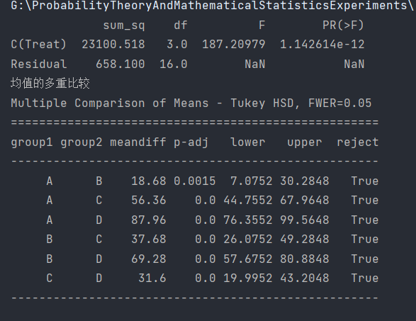

8、火灾损失与住户到最近消防站距离之间的关系数据如下：
distance = [0.7, 1.1, 1.8, 2.1, 2.3, 2.6, 3, 3.1, 3.4, 3.8, 4.3, 4.6, 4.8, 5.5, 6.1]
loss = [14.1, 17.3, 17.8, 24, 23.1, 19.6, 22.3, 27.5, 26.2, 26.1, 31.3, 31.3, 36.4, 36, 43.2]
其中distance就是指住户到最近消防站的距离，其单位是千米，而loss是用户遭受的火灾损失，单位是千元。
代码：
- # -*- coding: utf-8 -*-
- # @Time : 2022/6/21 16:06
- # @Author : renyumeng
- # @Email : 2035328756@qq.com
- # @File : second.py
- # @Project : ProbabilityTheoryAndMathematicalStatisticsExperiments
- import numpy as np
- import matplotlib.pyplot as plt
- import statsmodels.api as sm
- from statsmodels.sandbox.regression.predstd import wls_prediction_std

- x1 = [i for i in range(15)]
- yTrue = [0.7, 1.1, 1.8, 2.1, 2.3, 2.6, 3, 3.1, 3.4, 3.8, 4.3, 4.6, 4.8, 5.5, 6.1]
- yTest = [14.1, 17.3, 17.8, 24, 23.1, 19.6, 22.3, 27.5, 26.2, 26.1, 31.3, 31.3, 36.4, 36, 43.2]

- X = sm.add_constant(x1)
- model = sm.OLS(yTest, X)
- results = model.fit()
- yFit = results.fittedvalues
- prstd, ivLow, ivUp = wls_prediction_std(results)
- print("\nOLS model: Y = b0 + b1 * x")
- print('Parameters: ', results.params)
- plt.plot(x1, yTest, 'o', label="data")
- plt.plot(x1, yFit, 'r-', label="OLS")
- plt.plot(x1, ivUp, '--', color='orange', label="upConf")
- plt.plot(x1, ivLow, '--', color='orange', label="lowConf")
- plt.legend(loc='best')
- plt.title('OLS linear regression ')
- plt.show()

- 画出散点图，求相关系数；
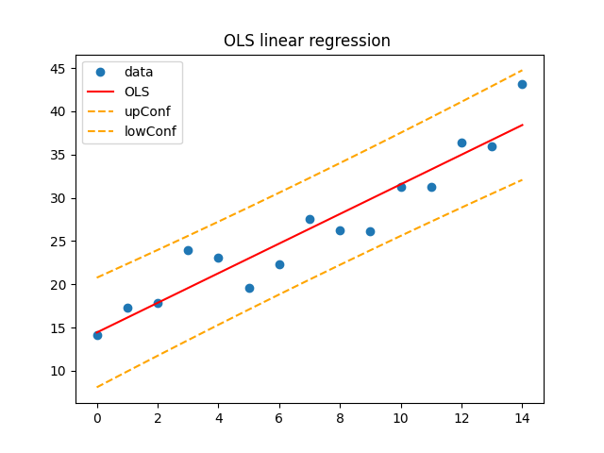
相关系数： [14.42333333,1.71285714]
- 写出回归方程的形式，计算回归系数，并对回归模型进行假设检验；
回归方程：Y = 14.42333333 + 1.71285714 * x
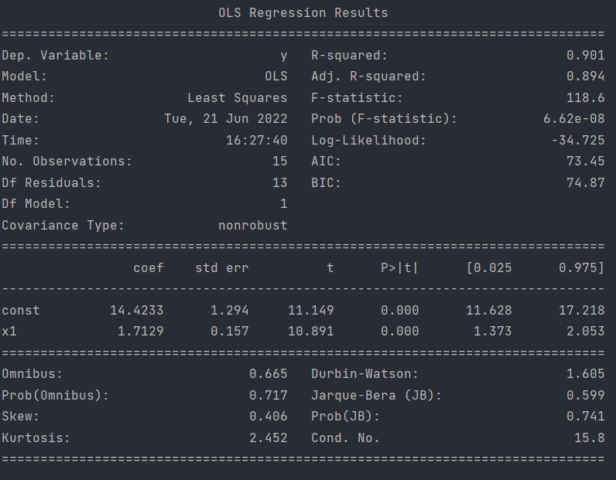
- 写出总体回归系数的95%可信区间；
[20.8,44,8],[8,32]
（4）写出决定系数。
0.901

