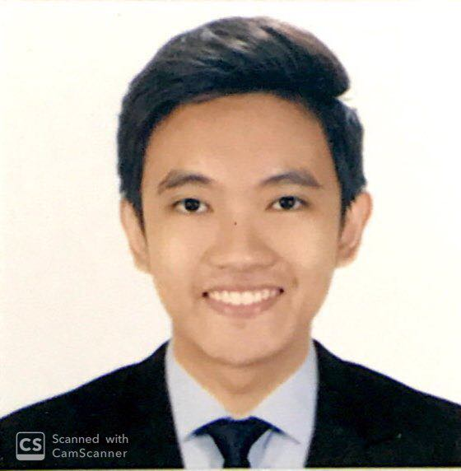
MICHAEL RENZ GUECO BUAN
Unit 2423, EGI Taft Towers
Taft, Manila 1004 Greenfields, San Fernando City
+639565329122 (02)649-1310
michaelrenzbuan@dlsu.edu.ph

OBJECTIVE
To join an organization where I can use my skills in people management and public speaking, and attain a high level of performance in delegating tasks and delivering work.

EDUCATION

2018-present de la salle university
Bachelor of Science degree in Chemical Engineering.

2012-2018 OPERATION BROTHERHOOD MONTESSORI CENTER
High School Diploma, March 2018. Valedictorian.

WORK EXPERIENCE

March – September Project Head, Pianta house of plants
2018 Spearheaded plant workshops & activities; assisted in promoting the business through social media platforms.

CO-CURRICULAR ACTIVITIES

2018-present Chemical Engineering Society (Chen)
Co-headed in planning and implementation of ChEn Goes Live! As a Junior Officer; currently positioned as an Associate Vice President of the Linkages committee.

2018-present AIESEC in DLSU-M
Currently positioned as Information Developer for Project Management of the Incoming Global Volunteer department.

SEMINARS ATTENDED

August 2018 leadership seminar
O. B. Montessori Center

MICHAEL RENZ G. BUAN
page 2

PERSONAL BACKGROUND

Fluent in English and Filipino. Knowledgeable in Microsoft programs and a handful of photo-editing and video-editing programs. Interests: Science & Technology, environmental topics, classical and informative books, music, and theatrical arts. Adaptable, goal-oriented and quality oriented.

REFERENCES

vergel bungay
Chemical Engineering Professor
vergel.bungay@dlsu.edu.ph

