DATE: 21st of January 2020

TO: Aileen Christel U. Ongkauko

FROM: Donnabelle Pasquin

SUBJECT: SUPPLEMENTAL BUDGET for DEV-OPS Team Travel Budget

Madam:

This is to request for a Supplemental Budget approval of Php 19, 350.00 for Mobiledizer Application System Demo and Presentation.

|  |  |  |  |
| --- | --- | --- | --- |
| Item Description | Quantity | Cost Per Unit | Unit Cost |
| *Travel Budget Allowance for (Terrence Christian Tejada)  > Cagayan De Oro (Jan 27, 2020)  - Transportation(airfare)  - Meal Allowance  - Transportation(land)  > Cebu (Feb 3, 2020)  - Transportation(airfare)  - Meal Allowance  - Transportation(land) | 1  1  1  1  1  1 | Php 8,000.00  Php 175.00  Php 2,400.00  Php 6,000.00  Php 175.00  Php 2,400.00 | Php 8,000.00  Php 175.00  Php 2,400.00  Php 6,000.00  Php 175.00  Php 2,400.00 |
| TOTAL COST |  |  | **Php 19,150.00** |

Thank you,

Donnabelle Pasquin

**CIO, LFUGGOC**

Approved by:

Aileen Christel U. Ongkauko

**Group President, LFUGGOC**

**Land Transportation**

|  |  |  |  |
| --- | --- | --- | --- |
| Jan 27, 2020 | CDO | Home - AirportManila | 700 |
|  |  | CDO Airport - PCN office | 500 |
|  |  | PCN office – CDO Airport | 500 |
|  |  | Manila Airport – Home | 700 |
|  |  | **Total** | **2400** |
| Feb 3, 2020 | Cebu | Home - Airport | 700 |
|  |  | airport - PCN Office | 500 |
|  |  | PCN Office - airport | 500 |
|  |  | airport - Home | 700 |
|  |  | **Total** | **2400** |
|  |  |  |  |
|  |  | **Grand Total** | **4800** |
|  |  |  |  |
|  |  |  |  |
|  |  |  |  |
|  |  |  |  |
|  |  |  |  |
|  |  |  |  |
|  |  |  |  |
|  |  |  |  |
|  |  |  |  |
|  |  |  |  |
|  |  |  |  |

**Manila to CDO**



**CDO to Manila**

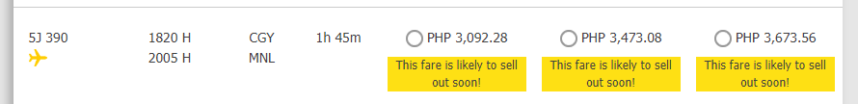

**Manila to Cebu to Manila**

