We are excited to announce that Budget Portal is now available.

To access Budget Portal

1. Go to My Portal then login your credentials

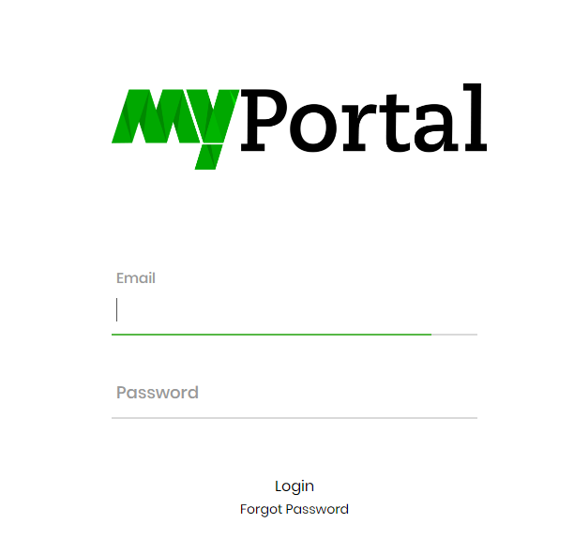

2. In the “Portal Links” you will see “Budget Portal”

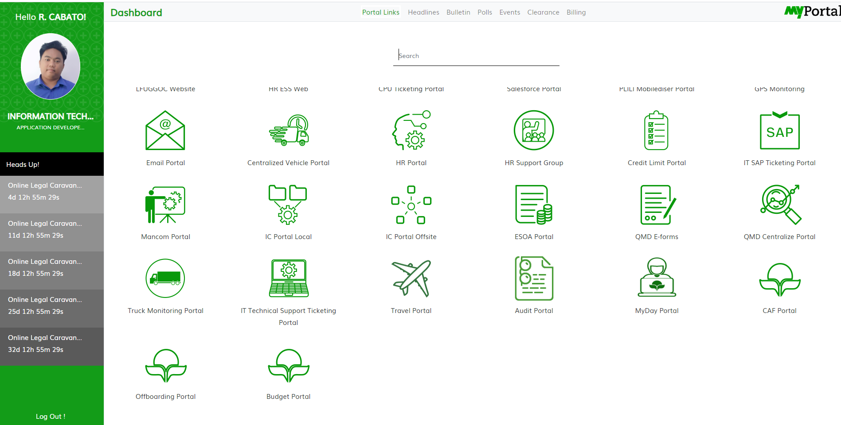

3. Click the “Budget Portal”.  
***Note: Login credentials of Budget Portal is same with My Portal.***

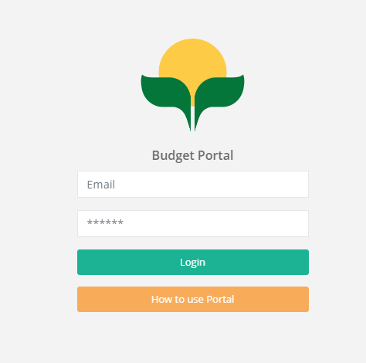

4. There’s also a “User Guide” in the login page “How to use Portal”.

