IT 110 - LAB ACTIVITY 9
Reusable Screens, Shared Widgets and Asynchronous UI States
Project: Student Portal (continuation of Lab Activity 8)
Primary output: Activity 8 project extended with report_form_screen.dart, reusable widgets and six screenshots
Activity 9 Summary
Activity 9 extended the existing Student Portal project instead of rebuilding it. The Activity 8 Home and Login screens were kept as they were, and a new /report route was added in app.dart so the Report Form screen (lib/screens/report_form_screen.dart) opens from a button on the Home screen and can be left again with the Back button. The new screen is a real report form for the group's approved system, with five fields (report title, category, location, priority and description), field-level validation for every required input, and a simulated submission whose data is stored in services/report_service.dart and modelled by models/student_report.dart. It demonstrates the four asynchronous UI responses - Loading, Success, Empty and Error - with a spinner and a disabled submit button while a request is pending, a confirmation with the saved report on success, a no-data panel with a first-report action when nothing exists yet, and a clear failure message with a working Retry. The form reuses the shared AppButton and AppTextField widgets from lib/widgets/ in more than one context, so the styling and behaviour stay consistent with the Activity 8 screens, and because all data access goes through the service layer, the simulated responses can later be replaced by the real REST API and PostgreSQL database without changing the screens.
Updated GitHub Repository
Repository: https://github.com/renzestopito-del/semester_project
Branch: main
Activity 8: f1dccad - Initial Flutter Web project (October 15, 2026)
Activity 9: ab1fc44 - Add report form screen with loading, success, empty and error states
Commit link: https://github.com/renzestopito-del/semester_project/commit/ab1fc44
Functional Verification Checklist
Test | Observed outcome / evidence
Home -> Report Form navigation | PASS. The Home screen shows an 'Open Student Report Form' button that calls Navigator.pushNamed(context, AppRoutes.report); the /report route is registered in the MaterialApp routes map of lib/app.dart. The Activity 8 Home and Login screens are unchanged and still work. (Screenshots 1 and 2)
Invalid form produces field-level validation | PASS. The form is wrapped in a Form with a GlobalKey<FormState>. Every AppTextField has a validator (title required and at least 5 characters, location required, description required and at least 20 characters, capped at 500). The request is never sent and each field shows its own message under the input. (Screenshot 7)
Valid submit -> Loading -> Success | PASS. The state changes to ReportUiState.loading before the request starts; the spinner banner appears and the Submit Report button is disabled for the 3-second simulated request. When the service answers, the confirmation and the saved report card are shown. (Screenshots 3 and 4)
No available report records -> Empty | PASS. Pressing 'View Reports' before any report has been created returns an empty list and shows the 'No reports available yet.' panel with the 'Create Your First Report' and 'Refresh Reports' actions. Filtering with a keyword that matches nothing gives the same Empty response. (Screenshot 5)
Simulated failure -> Error -> Retry | PASS. Turning on the 'Simulate a server error (demo only)' switch and submitting a valid form makes the service throw ReportServiceException; the screen shows the failure explanation with Retry (repeats the request) and Edit Report (returns to the filled form). (Screenshot 6)
Shared button or field widget used in two contexts | PASS. AppButton (lib/widgets/app_button.dart) is used in home_screen.dart and in report_form_screen.dart; AppTextField (lib/widgets/app_text_field.dart) is used for the title, location and description fields and for the report-list filter. (Screenshot 2)
How each Activity 9 requirement is met
Requirement | Where it is satisfied
Continue the same Activity 8 project and repository | Same semester_project folder and same GitHub repository; the Activity 8 files (home_screen.dart, login_screen.dart, app_button.dart, app_text_field.dart) are preserved and the Activity 9 work is a second commit (ab1fc44) on the same main branch.
New lib/screens/report_form_screen.dart connected to the Home screen | New file added under lib/screens/; route AppRoutes.report added in lib/app.dart; the Home screen gained one AppButton that pushes that route.
Reuse existing UI components | AppButton and AppTextField from lib/widgets/ are reused in the new form; no interface code was duplicated.
Working form with validation and feedback | Title, Category, Location, Priority and Description fields with field-level validators, a submit action, an inline error banner, and a confirmation panel with next actions.
Four asynchronous UI responses | ReportUiState.loading / success / empty / error in lib/screens/report_form_screen.dart, backed by the simulated lib/services/report_service.dart.
Six authentic screenshots | Screenshots 1 to 6 below (plus the extra validation screenshot 7), captured from the running Flutter Web application in Chrome and the VS Code Explorer of this project.

Screenshots
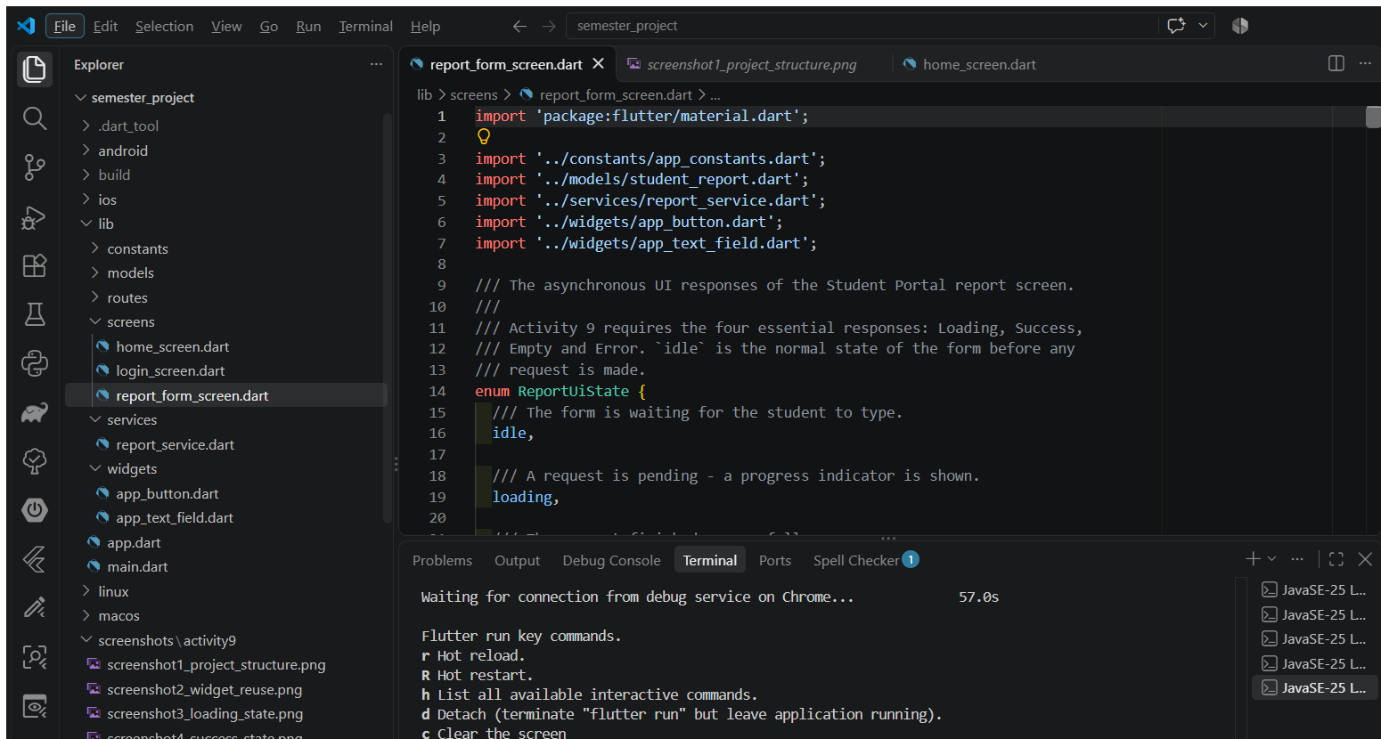
Screenshot 1 - Updated screen/widget structure. The VS Code Explorer shows the project folder semester_project with the Activity 8 files still in place (home_screen.dart, login_screen.dart, app_button.dart, app_text_field.dart) and the new lib/screens/report_form_screen.dart added beside them.
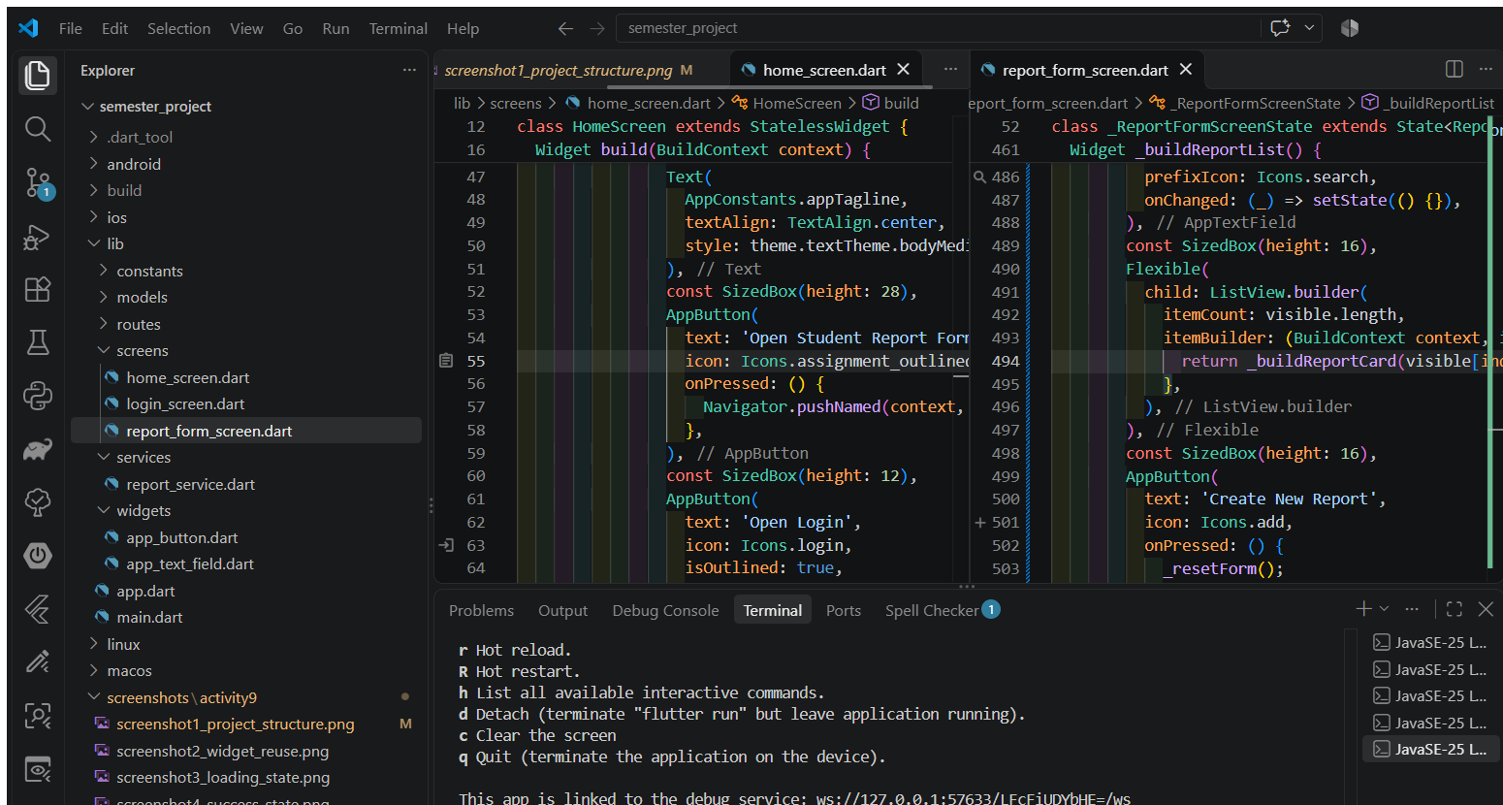
Screenshot 2 - Shared widget reused in two contexts. The left editor shows AppTextField and AppButton being used inside report_form_screen.dart, while the right editor shows the same AppButton from lib/widgets/app_button.dart being used in the existing home_screen.dart.
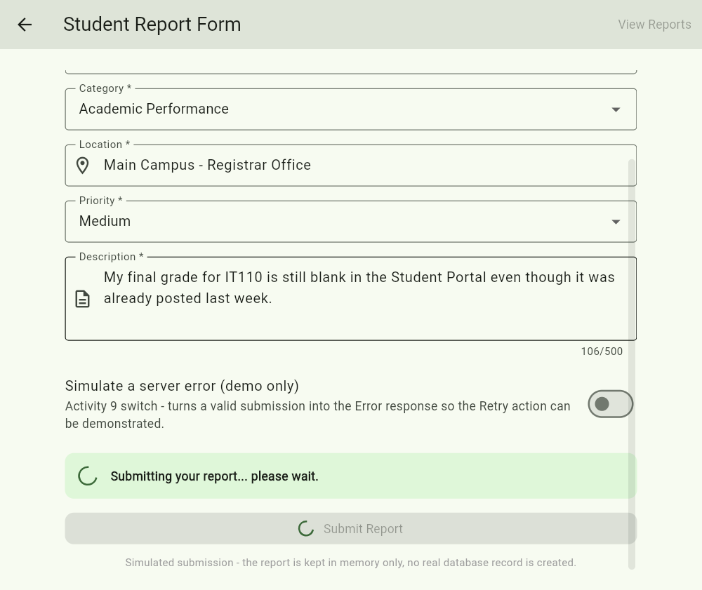
Screenshot 3 - LOADING. Triggering action: a student fills in a valid report and presses Submit Report, and while the request is pending the screen shows a spinner message and keeps the submit button disabled so the same report cannot be submitted twice.
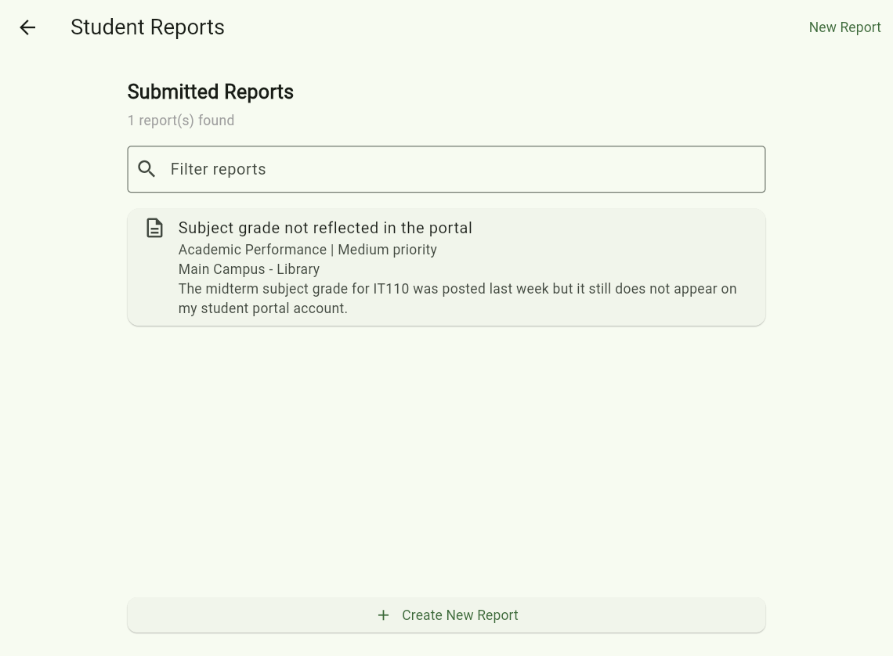
Screenshot 4 - SUCCESS. Triggering action: the student waits for the pending submission to finish, and the screen replaces the form with a confirmation, the saved report and the 'Submit Another Report' and 'View All Reports' actions.
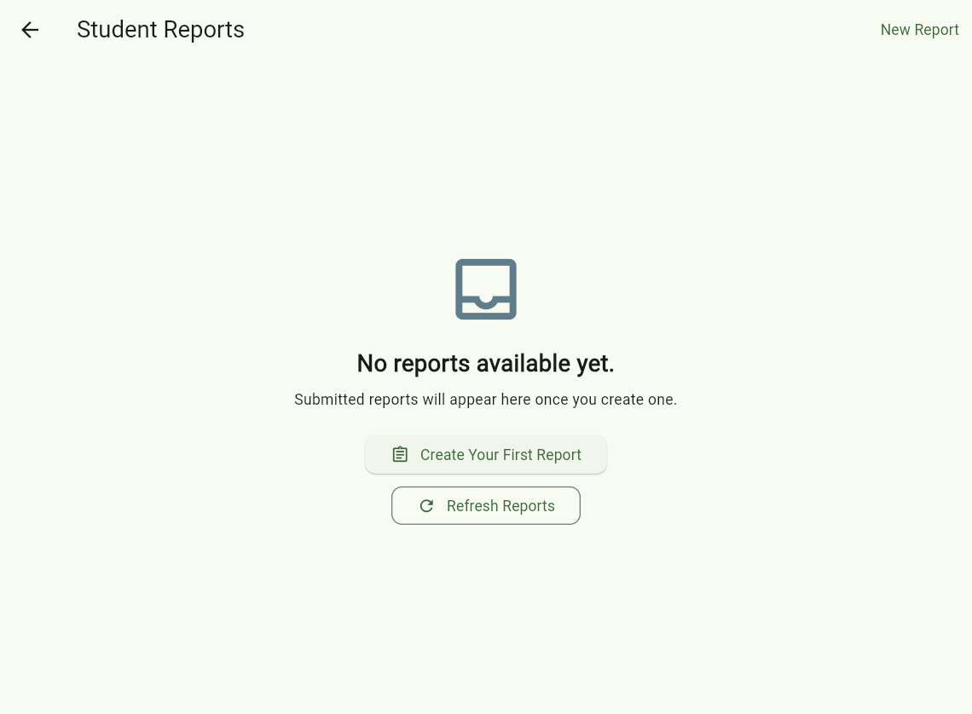
Screenshot 5 - EMPTY. Triggering action: the student presses 'View Reports' before creating any report, so the screen returns an empty list and shows the no-data message with the 'Create Your First Report' and 'Refresh Reports' actions.
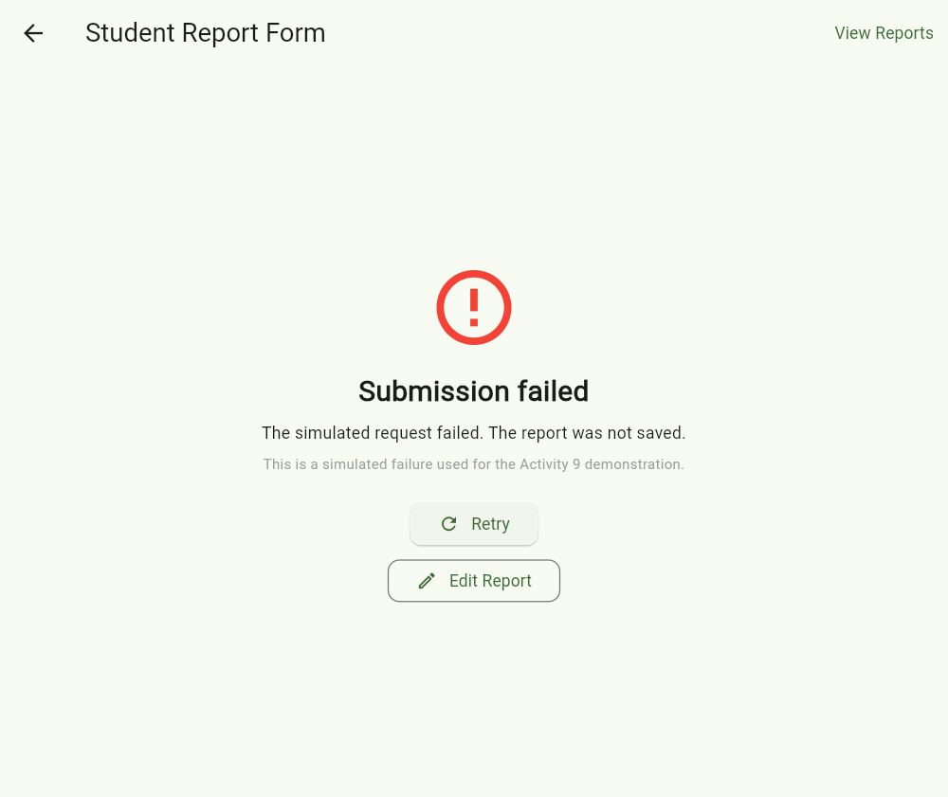
Screenshot 6 - ERROR. Triggering action: the student turns on the 'Simulate a server error (demo only)' switch and submits a valid report, and the screen shows a clear failure explanation together with the Retry and Edit Report actions.
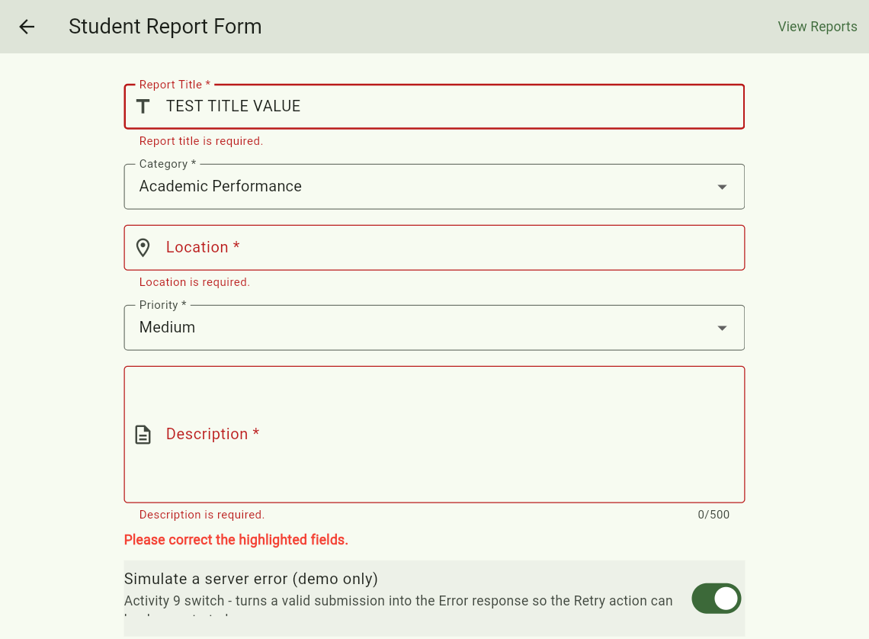
Screenshot 7 - FIELD-LEVEL VALIDATION (extra evidence). Triggering action: the student presses Submit Report with empty fields; the request is not sent and every invalid input shows its own message under the field together with the 'Please correct the highlighted fields.' banner.
Note: all four asynchronous responses were produced by the simulated service (Future.delayed with an in-memory list). No real database record was created, and the screen labels every simulated response as such.

Post-Laboratory Reflection
1. How does report_form_screen.dart extend your Activity 8 project without replacing its existing Home and Login screens?
report_form_screen.dart is a new file added beside the Activity 8 files - nothing in home_screen.dart or login_screen.dart was replaced or rewritten. The only change to the old navigation is a new named route, /report, added to the existing routes map in app.dart, so / still opens HomeScreen and /login still opens LoginScreen. The Home screen only gained one extra AppButton that calls Navigator.pushNamed(context, AppRoutes.report), so the report form opens on top of Home and the Back button returns to the previous screen. Because the new screen uses the same MaterialApp theme and the same shared widgets, it keeps the Activity 8 look and feel.
2. Which shared widget did your group reuse, and what benefit does that provide?
The main shared widget we reused is AppButton from lib/widgets/app_button.dart. It is used in home_screen.dart (Open Student Report Form / Open Login) and again in report_form_screen.dart (Submit Report, Retry, Edit Report, Submit Another Report, View All Reports). We also reused AppTextField from lib/widgets/app_text_field.dart for the title, location and description fields and for the reports filter.
The benefit is one implementation for consistent styling and behavior, less duplicated code, and one place to fix bugs. AppButton already supports isLoading (spinner inside the button) and a nullable onPressed (disabled state), so the Loading response needed no new button; AppTextField already supports validator, onChanged, maxLines and maxLength, so field-level validation came for free.
3. How does your report form prevent invalid input and duplicate submissions?
Invalid input: the form is wrapped in a Form with a GlobalKey<FormState>, and every AppTextField has a validator - title required and at least 5 characters, location required, description required, at least 20 characters and capped at 500 - while the category and priority dropdowns only accept the fixed values in AppConstants. On submit, formKey.currentState.validate() runs all validators; if any fail, the request is never sent and each field shows its own message under the input.
Duplicate submissions: the state is set to ReportUiState.loading before the request starts, and while loading the Submit Report button receives onPressed: null (disabled) and shows the loading spinner, and the View Reports action is disabled too. Since the button cannot be pressed again while the request is in flight, the same report cannot be sent twice.
4. How did you reproduce the Loading, Success, Empty, and Error responses? Which were simulated?
All four responses are simulated - ReportService uses Future.delayed(Duration(seconds: 3)) and an in-memory list. There is no REST API or database yet, and the screen says so ("Simulated response - no real database record was created").
- Loading - press Submit Report; the form stays visible with a spinner banner and the disabled submit button until the delay ends.
- Success - after the delay the service returns the saved report, and the confirmation card with the submitted details is shown.
- Empty - press View Reports before creating any report, so the in-memory list is empty and the 'No reports available yet' panel with Create Your First Report appears (or filter the list with a keyword that matches nothing).
- Error - turn on 'Simulate a server error (demo only)' and submit a valid form; the service throws ReportServiceException and the error panel with Retry and Edit Report is shown.
5. What must be changed when the real REST API and PostgreSQL database are connected later?
- Replace the Future.delayed bodies in report_service.dart with real HTTP calls (POST /api/reports, GET /api/reports) and parse the JSON using the StudentReport model, keeping the same method names and return types.
- Map HTTP status codes, timeouts and SocketException into ReportServiceException so the existing Error state and Retry still work, and keep 200 + [] as the Empty state.
- Add the API base URL and the auth token from the login session, and remove the demo 'Simulate a server error' switch and the 'simulated' labels.
- Backend/database work: a reports table (id, student_id, title, category, location, priority, description, created_at), server-side validation, and CORS for Flutter Web.
- Update the tests to use a mocked HTTP client instead of the simulated delay.

