Exercise 2.B Creating a Learning Project
Screenshots for tasks 1-4:

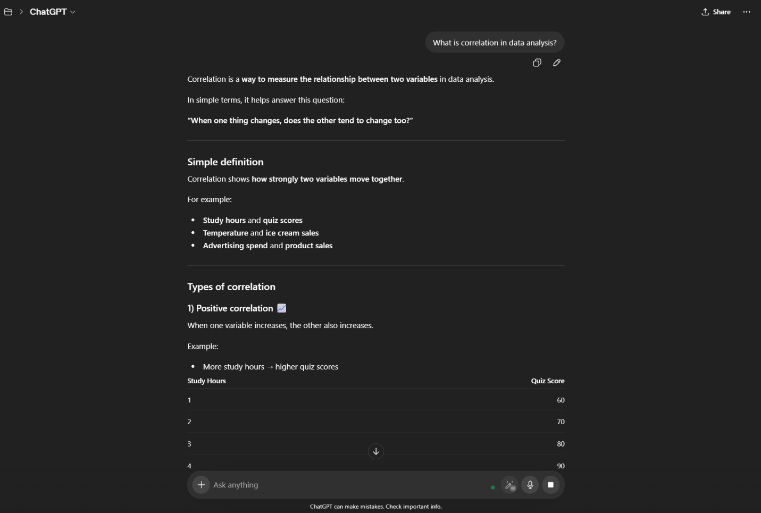
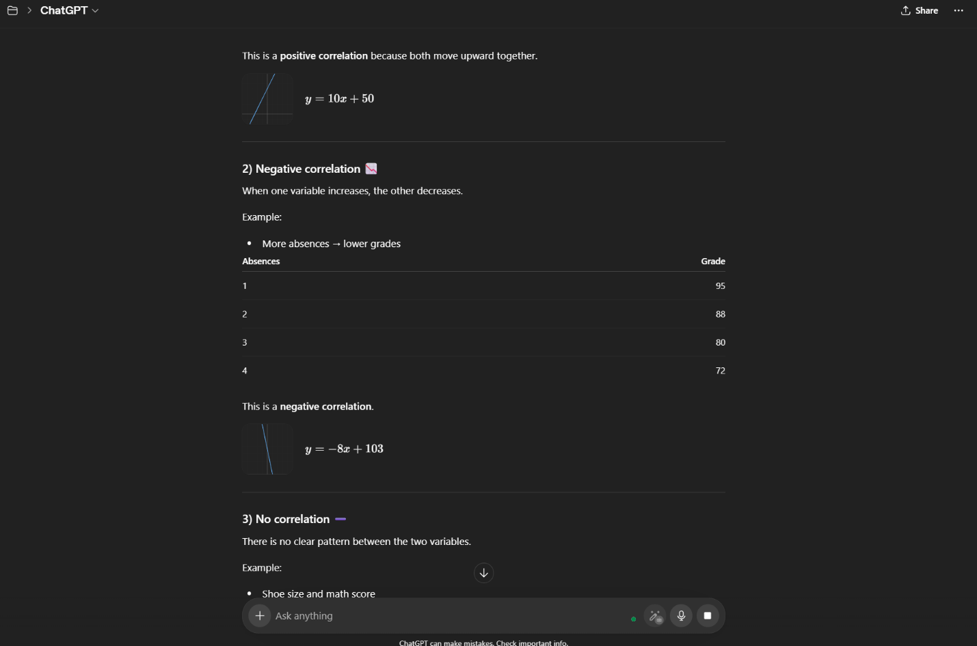
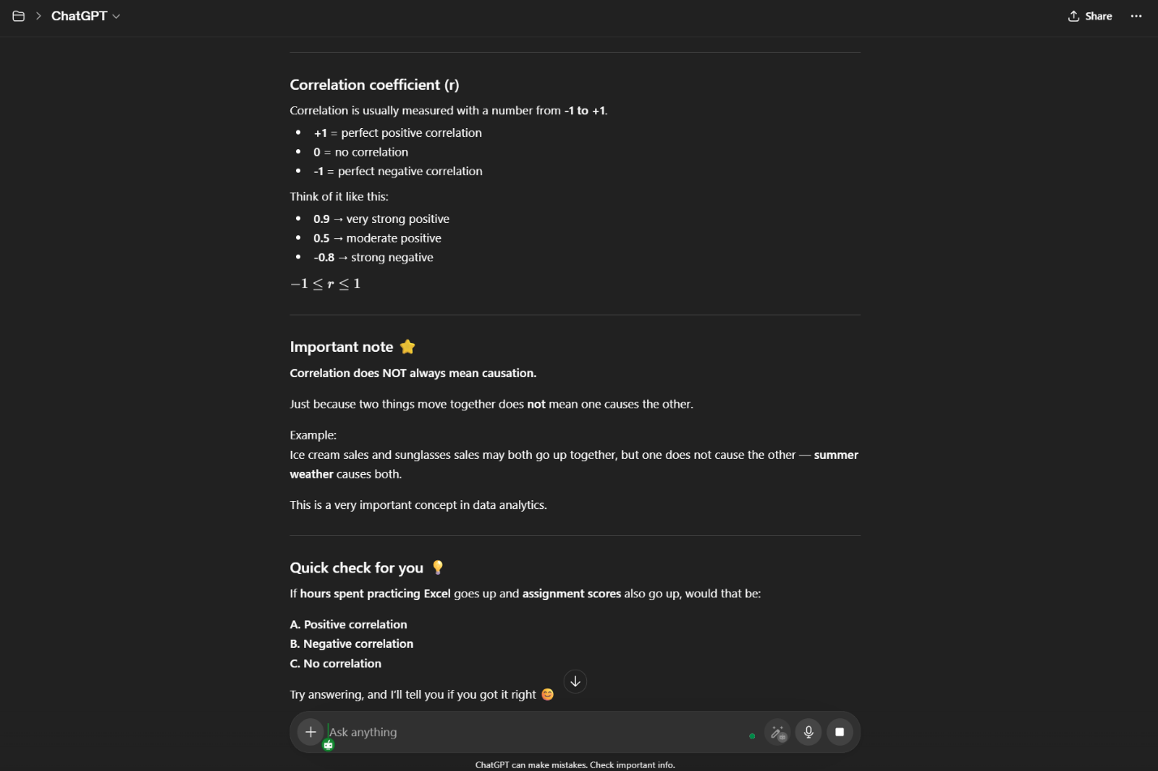
Explanation:
Because the persistent explanation was added, the response was a lot easier to understand. Additionally, it provided a straightforward example with small numbers, which helped to clarify the idea of correlation. The instructions also affected the answer by prompting AI to ask a follow-up question to make sure I understood.

