Exercise 2.A Improving Weak Prompts
Weak prompt 1:
Explain regression
Better prompt:
Give a basic explanation of regression to someone who is new to data analytics. Give a brief definition of regression, describe its application, and provide a single, straightforward numerical example. Make sure your explanation is clear and concise.
Screenshot:
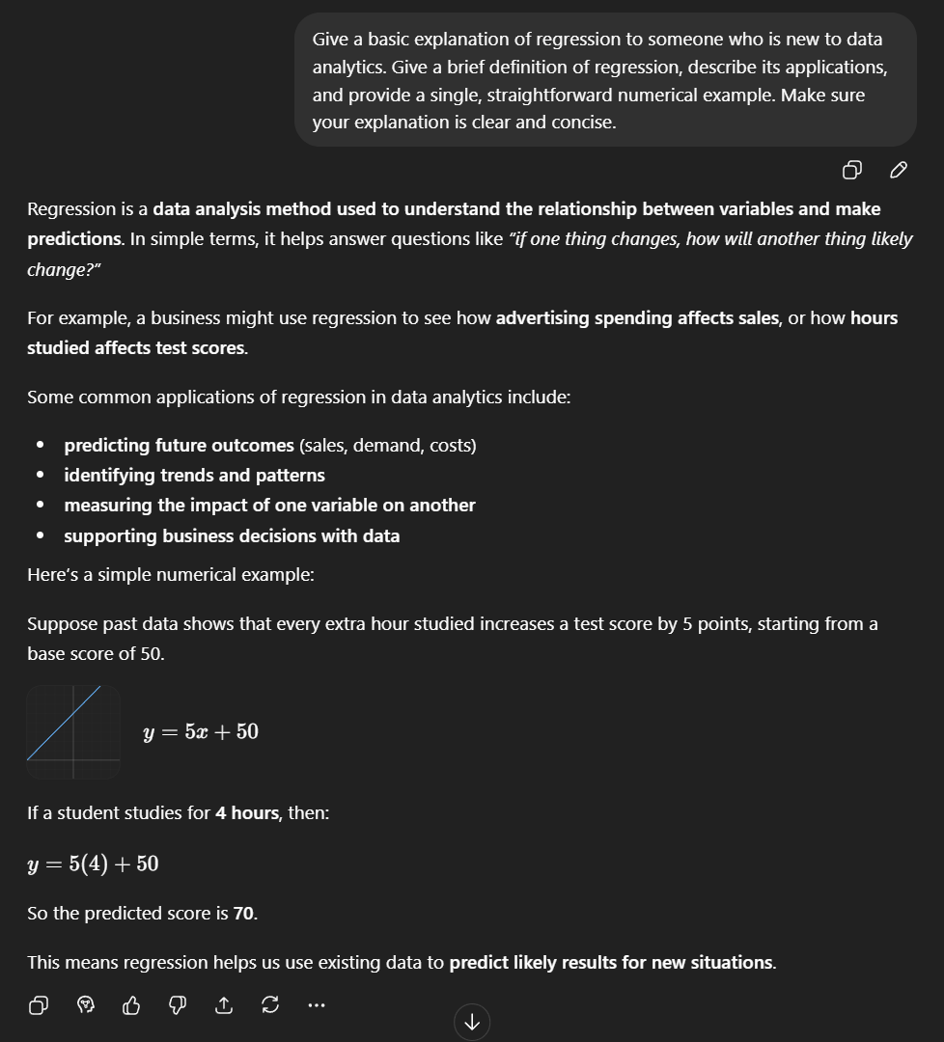

Why it’s stronger:
Because it emphasizes that the audience is a beginner, the explanation needs to be simple, it should explain the purpose and give examples.
Weak prompt 2:
Help me understand SQL
Better prompt:
As a beginner in data analytics, please help me understand SQL. Describe SQL, explain its benefits, and utilize a small table to demonstrate a basic SELECT statement. Then, to be sure I understand, ask me one more question.
Screenshot:
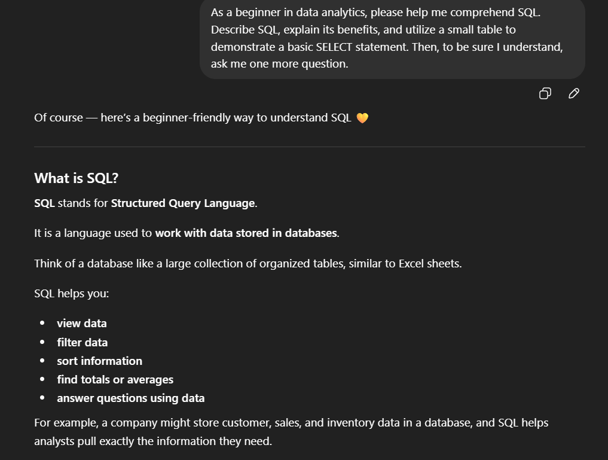
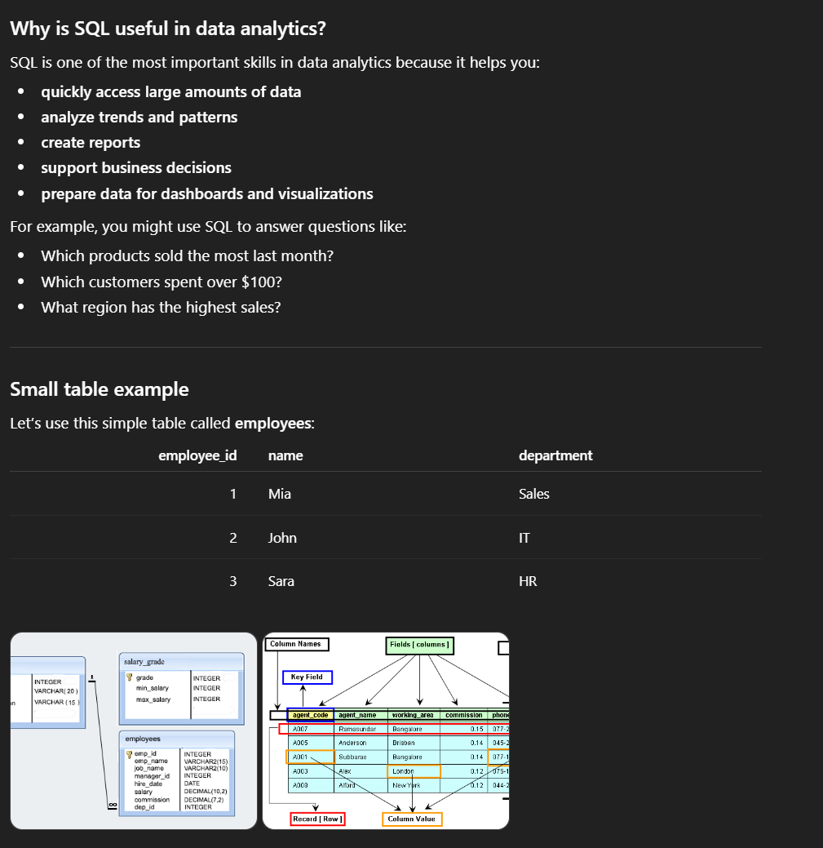
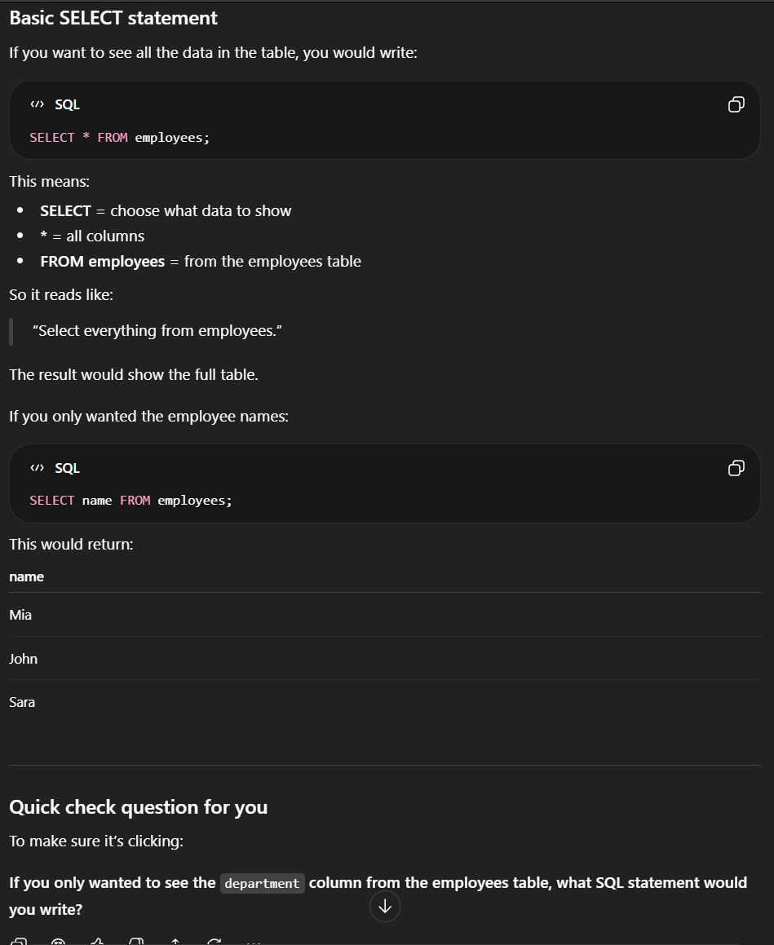
Why it’s stronger:
It gave context that you are beginner so it would explain it at a beginner-level. It explains the purpose of SQL. It is asking for a specific command example and a follow-up question.
Weak prompt 3:
Create a dataset
Better prompt:
For a student learning data analytics, create a small practice dataset with10 rows and 3 columns. Utilize the Student Name, Study Hours, and Quiz Score fields. Format the outcome as a table and make the numbers realistic.
Screenshot:
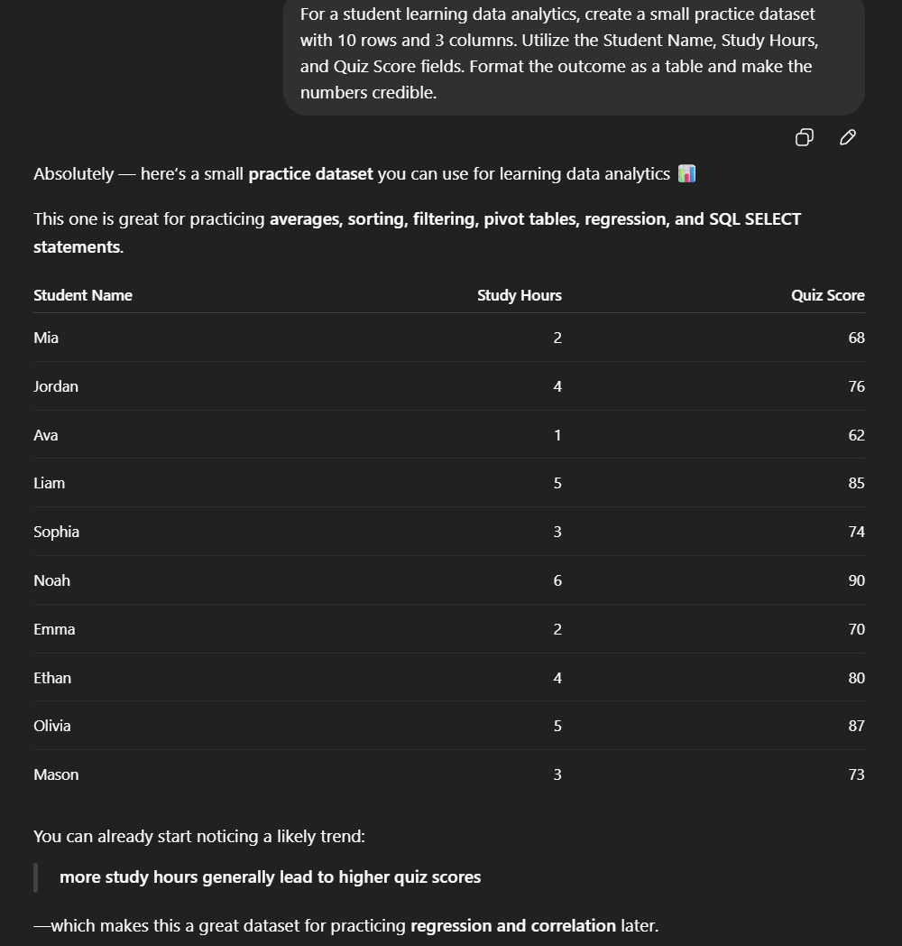
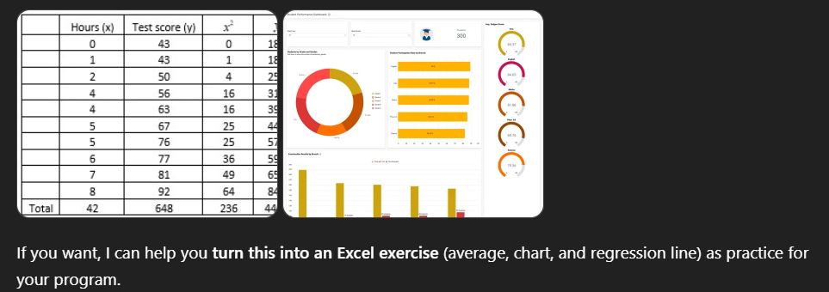
Why it’s stronger:
It is better because it provides specific instructions on how many rows and columns the data set needs to have and a specific topic it should be about. It also has specific information on who it is for and how to format it.

