Signature Forgery Detection: The Use of Combining Convolutional Networks and Generative Adversarial Networks

Carl Renz Colico
College of Computer Studies Camarines Sur Polytechnic Colleges cacolico@my.cspc.edu.ph

Abstract

In the digital era, forgery techniques have evolved, posing challenges to documents, bank, accounts, and other identified authentication. Augmented, computer vision systematically advanced machine learning models that offers rigorous methods that analyze intricate patterns and anomalies this ensures that authentic works are distinguishable from deceptive imitations. This study used Convolutional Networks model that upholds integrity methods of addressing nuanced complexities that is combined with a forgery art methods Generative Adversarial for enhancing the capability to discern authentic creations. The dataset that been used are classified into two folders containing several images of genuine and forged signatures.

Introduction

In the perpetually advancing sphere of forgery, contemporary methodologies inscribe with the advent of forgery detection methodology have been progressively inadequate. In retaliation, advancing one of most revolutionized created technology, Artificial Intelligence (AI). The emergence of this evolution becomes crucial, as these not only confront daily existing challenges in today’s forgeries related issues in many large bodies of organization such as governments, banks, the prosecution service, national forensic service and other national service that use it for identity verification purposes. It is commonly known as the unique identifier for the brain because each person's handwriting is distinct. However, signatures can be forged easily, and there is a shortage of forgery specialists in the Philippines. With the help of artificial intelligence, this shortage can be addressed. By exposing the AI to numerous authentic and forged handwriting samples through machine learning, it can learn to recognize certain patterns.
Within the dataset of program that consists of labeled folder data sets:
(1) Genuine signatures that labeled as __gen
(2) Forged signatures that labeled as __forg

Each of the folder contains 10 images of signatures, and the images are saved in common formats like JPEG. This structure allows for easy identification and comparison of genuine and forged signatures for each classification. The learning paradigm of this two-model learning approach start with generative adversarial network where the generator creates forged signatures that will try to fool the discriminator until the generator becomes better at creating highly realistic forgeries. The data processed will continue with convolutional neural network that will filter pre-learned the recognition structure data of those data sets images by classifying their signatures through supervised algorithm. The process will then continue to the network of generative adversarial that is unsupervised it will only learn to distinguish real and fake signatures without considering their labels the existing genuine and forged signatures will generate new synthetic forged signatures that will process and learn predictions on synthetic signatures by convolutional network. This structured learning approach helps in detecting forged signature in a real-world applications.
CSAC 212: Introduction to Artificial Intelligence 2023, College of Computer Studies, Camarines Sur Polytechnic Colleges

2 Related work

The literature and studies that are relevant to this study are gathered in this section from a variety of sources, including Google Scholar, Academia, IEEE Xplore, ScienceDirect, and Research-Gate. These studies are important because they direct the researchers in developing the current study further. The studies that follow offer more details that aid the reader in comprehending this study.

One of the most widely used and recognized biometric hallmarks, signatures have been used since ancient times to confirm the identities of people, whether they be on documents, forms, bank checks, or personal identification cards [5]. According to Plamondon and Srihari Because handwriting is so commonly used in human transactions, machine recognition of handwriting has practical applications, such as reading handwritten notes on a PDA, postal addresses on envelopes, amounts on bank checks, handwritten fields on forms, etc. Handwriting has remained a common way to record information and communicate in daily life even with the advent of A.I. new technologies [10]. This overview explains the characteristics of handwritten language and how it is converted into electronic.

In the research study of Munich and Perona [8] it was revealed that a camera based or computer vision based system for visual signature identification focusing on parameterization, it was found that its verification performance has a better accuracy than traditional biometrics. Another study of LeCun et et.al [7] suggest that with the change of deep learning in year of discoveries the data sets propogation of algorithm now can compute representation layers of deep convolutional networks in the process of images, video, audio and speech.

Another study of Gideon et al. A signature can be only accepted if its from the intended person, a solution based on Convolutional Neural Network (CNN) is presented where many research has its many of uses. It trained the model with a dataset of signatures and predictions are made as to predict its authencity. This gives that this type of neural network is a common models in concepts of image processing and language [3]. Goodfellow et al. conducted a similar study that uses generative adversarial networks (GANs’) that are used to solve generative image of the model problems, generating realistic high-resolution images that present as a problem that set unique challenges and future research opportunities [4]. This set of models of algorithm both utilized computer vision and A.I to assist humans solving generating problems through processing images and detecting filter of patterns.

Further studies of Dey et al. represent a SigNet that outperforms the state-of-the-art results of the benchmark signature of datasets. They said that one of the hardest tasks in biometrics and document forensics is offline signature verification as this one requires modeling minute but crucial details between authentic and forged signatures opening up new revenues for research [2]. Depierre et. al says that computer vision is being now a popular state-of-the-art subset field in A.I as it analyze potential automizing capabilities [1]. A critical study of analysis conducted by Waelen [13] explored the potential ethical and societal implication of computer vision, impacting the datafication practices that could lead to the leakage of privacy from using cameras and facial recognition. Jasmin et al.[6] conducted a study that detect forged handwriting through analyzation of Support Vector Machine (SVM).The current study focuses on detecting forgery in a person’s signature or cases where original handwriting was altered or additional characters were added.

Similar study by Qu et.al present a study that feature a verification system based on stroke-hand features. The signatures are analysed dynamically by spatial and time-domain characteristics [11]. This study present an advent method of advanced feature that can be added in the future-knowledge of forgery concepts. On the other hand, P et.al [9] another study that used real time signature forgery. It was find that undergoing verification is not only difficult but also time consuming. The probability of two signatures even twins or the same person is very less to be the same. To guard against fraud or theft, a system that can distinguish synthetic, genuine and fake signatures is needed.

Studies above clearly show a significant connection with the study. Artificial intelligence and neural networks are widely utilized in digitizing work, particularly those tasks that are performed manually. The use of neural networks in conjunction with computer vision has been definitively proven to effectively identify and differentiate objects from their surroundings.

3 Methodology

This section details the step-by-step process of implementing AI training using neural networks, specifically focusing on convolutional, adversarial neural networks that can analyze signatures from the dataset and the generative adversarial capability of GAN will learned from that existing dataset that will also analyzed both the forged and genuine signatures. An adversarially trained ‘discriminator’ is trained to detect the “fake’’ images accurately as possible. The ‘generator’ is trained to produce outputs that cannot be distinguished by discriminator from unlabeled images. The trained GAN will then be integrated into a program that will generate synthetic forgery sample before training the CNN model that will be both classifying the train data and test data where it will learned to classify between fake synthesized by the GAN and real images. They are classified into active and passive approaches. The results of detected and identified by these models is not yet identified but metrics evaluation of yield results will be the accuracy plot percentage/probability of the two signatures that will be both classified, graphical result will also be considered.

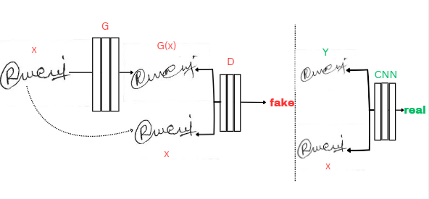
Figure 1. Structured training of a GAN and CNN

Training a GAN that consists of two-submodel. The discriminator, D will be feeding a non-labeled signatures images and train the discriminator model to recognize between fake (synthesizing image). The generator, G learns to fool the discriminator in creating fake samples and until the generator gets so good that D can no longer pick out between the real or fake sample from the domain set, once the discriminator can either determine whose real or fake it will update its model and generate a synthesized image (fake).

Training implementation as CNN’s, Convolutional Neural Network recognize the patterns of the image data implementing the generator and discriminator scenario. The CNN will be trained with two-datasets labeled model between genuine and forge signatures that will recognize signatures between real and fake and later on the generated synthesize image of GAN.

In this study, a supervised learning and unsupervised learning method will be used in training these models to show if genuine and forged signatures were correctly or incorrectly classified, also if the generated synthetic image of GAN will be by passed by and detect anomalies or subtle variations or we called metrics accuracy and loss by CNN.

Convolutional Neural Network (CNN) is a deep learning models that is primarily used in computer and natural language classification. The choice of platform will depend on factors like ease of use and availability of the pre-build libraries. The network model will be trained using the supervised learning, where the model will be trained on labeled data hierarchies such as edges, textures, patterns of the data.
Supervised Learning (SL) is a type of modeled training data that involves training the model on labeled data (discrete class labels). CNN models will be trained using supervised learning for it goal to classify the correct output for each output is unknown until the model learns to map the given data to correct output (genuine).
Generative Adversarial Network (GAN) is a generative type of model data that is primarily augmented in training dataset this model discovers underlying patterns in the input data (images) and generates new sample from it and help a CNN learn how to detect synthetic forgeries in a real-life world situation.
Unsupervised Learning (UL) is a type of modeled training data that does not involves the required labeled data for forgeries, as it learns by integrating only images samples to distinguish between real signatures and fake signatures. GAN is a type of unsupervised learning as it only generate realistic forged signatures that resemble the genuine signature style of the real signatures. It focuses on learning the distributions of the data and generating synthetic samples rather than making use of the explicit classification labels.

4 Datasets and Features

The Datasets
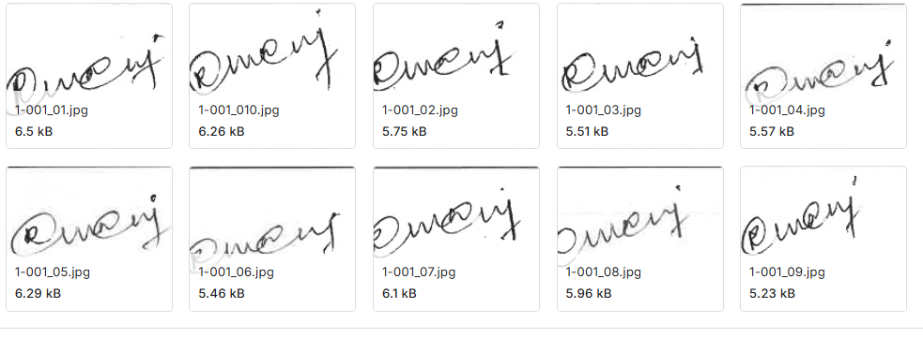
001_gen
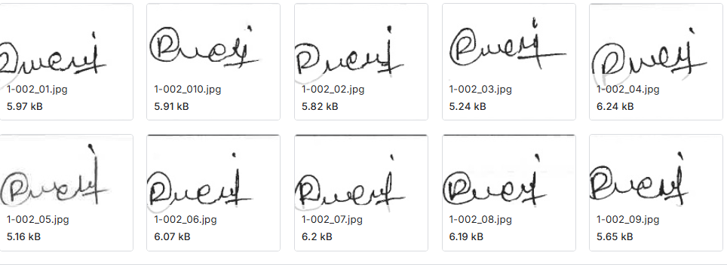
001_forg
Figure 2: Sample images from the dataset

The data sets utilized to this study were sourced from a well-known computer science and machine learning platform Kaggle Repositories [12]. Since the data sets obtained for the data was only the partial study’s requirements. The data is then split into two, ‘80%’ of the data were used for training while 20% of the data where used for testing. The data set is composed of images of signatures that has two types of folders one is for genuine and the other is forgery signature with a quantity of 10 images each folders having a total of 14.626k JPG images. The images vary in terms of aspect ratio, lighting conditions, stroke details, camera angle, background, curves, and noise.

The dataset is load by images and their label, where the label _forg folder name is created if the data is labeled 0 if 1 then it is label _gen. The image extension accepted is ‘png’, ‘jpg’, ‘jpeg’, and ‘bmp’. These are the image extension accepted within the datasets.

Classification | Number of Folders per 10 images | For Train and Validation | For actual test
Genuine Signatures | 7313 | 5850 | 1463
Forge Signature | 7313 | 5850 | 1463
Table 1: Dataset Information for CNN

The obtained data set will require preprocessing along with the created data set before being used in the neural network. Each image will be labeled, resized to 128x128 pixels for more detailed images, and will be categorized in terms of value. The signature images containing both real and genuine and forged signatures will be fed non-labeled into the discriminator. It will first classify them as genuine or forged that will classify them both as fake. The data set will be divided into three: training, validation, and testing. The distribution of the data set will depend on how well the program works using different methods such as hyper-parameters (Conv2D, MaxPooling2D, Flatten, Dense, Dropout, BatchNormalization, Input, LeakyReLU, Reshape, Conv2DTranspose) onto our training network.
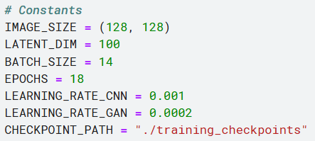

Figure 3. Constant of the Training Dataset.

The Training method has a batch size of 14 and Epochs of 18 with a learning Rate of CNN at 0.001 and GAN with 0.0002. Where these are save to a designated checkpoints.

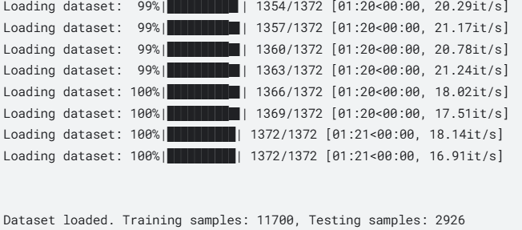

Figure 4. How the data set is split with the ‘’sklearn.model_selection import train_test_split’’

5 Experiments/Results/Discussion

The hyperparameters used in the training methods include ‘Conv2d’ that filters the input over the image to extract features of the signatures such as the textures, edges and patters of the signature image(s). ‘MaxPooling2D’ was also used to reduced spatial dimension avoiding the image to retain feauture and reduces invariation while in trained. ‘Flatten ’ a parameters in tensor that connects convolutional layers with dense layers. Then we have “Dense” that is used to fully connect our network layer to the previous layer, the activation function used in this training is ReLU and sigmoid. ‘Dropout’ a parameters that help the output to prevent the model of GAN to overfit and is helpful when tweaking the accuracy result in CNN. BatchNormalization a parameter that stabilizes the training of my GAN by normalizing intermediate outputs. Con2DTranspose a parameter used in GAn that upscale it feature maps where Discriminator: Uses Conv2D and Dense layers to classify real vs. fake images while Generator: Uses Reshape and Conv2DTranspose to synthesize images from latent vectors.

The above mention hyperparameters are the key components that build the generator and discriminator of Generative Adversarial Network (GAN) and the architecture build of Convolutional Neural Network (CNN). The generator is responsible for creating synthetic data from ‘random noise or vectors’ that aims to fool our discriminator while discriminator is distinguishing which is real and fake data (images). This two is trained together which then will progressively extract synthetic datasets (images) that will be then test to CNN.
OUTPUT
CNN on the other hand is evaluate as a discriminator that will evaluate which is real and is fake (created by Generator). Primarily the metrics of CNN output is the loss and accuracy values during testing and predictions. GAN outputs on the otherhand is train first showing how the models are performing during its training loop, overtime it will give us metrics of generator loss, discriminator accuracy and discriminator loss. The reason why generator just produce output loss is because what it just do is to fool the discriminator and produce synthetic data and does not classify things at all. To mention we did used ‘Binary Cross Entropy’ in this problem to measure the difference between two probability, the true labels and predicted probabilities this loss function model is common to used when the output is a probability of two classes (real vs. fake)
To solve and have the metrics output of loss and accuracy, we will use the following formula.
1. Discriminator Loss (D Loss) = $\frac{1}{2}(Real Loss+Fake Loss)$
This loss quantifies how well the Discriminator is doing in distinguishing real from fake images.
2. Generator Loss (G Loss) = Binary Cross Entropy (BCE) X (Discriminator Output,1).
This loss quantifies how good the Generator is at fooling the Discriminator. The better the Generator is, the lower the Generator Loss will be.
3. Discriminator Accuracy (D-accuracy) = $\frac{Number of Correct Predictions}{Total no. of Predictions}= \frac{C \left(real\right)+C(fake)}{N\left(real\right)+N(fake)}$ X 100
The D-accuracy job is to indicate how well the discriminator is doing in correctly classifying the real(0) and fake(1) one (generated by the generator).The D Loss reflects the error in the discriminator's predictions how far it is from the truth.
This means that if discriminator is low then the accuracy of discriminator is high then that means the generator is not good at fooling enough the discriminator. But if the Generator loss is lower and D-accuracy is lower then that means the generator is good in fooling the discriminator into thinking that the generated image is the real one.
4. CNN Loss = $[y ∙\log\left(y^{}\right)+\left(1-y\right)∙\log{(1-y^{})]}$
Where: y is the true label (0 for fake, 1 for real).
y^​ is the predicted probability (output from the CNN)
5. CNN Accuracy = $\frac{Number of Correct Predictions}{Total Number of Predictions} X 100$
After each epoch training of GAN the metrics of both loss and accuracy is calculated based on the CNN’s ability to correctly classify the synthetic images as real or fake.

Results
In the first 6 epochs of GAN training, the metrics score of loss and accuracy gain with the accuracy and loss curve:
GAN - D Loss: 0.7252, D Accuracy: 0.4047, G Loss: 0.7250
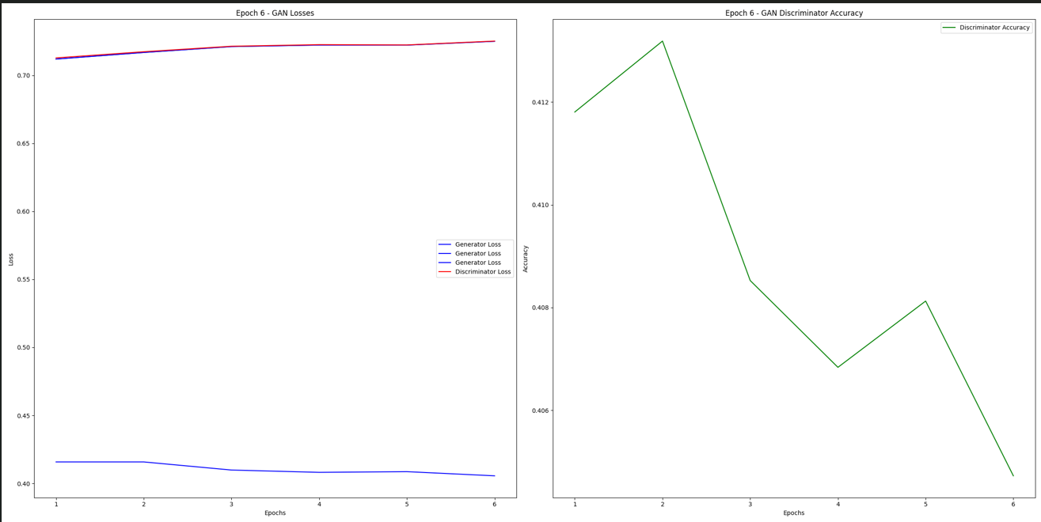
While CNN in its Test metric at Epoch 6 with the accuracy and loss curve:
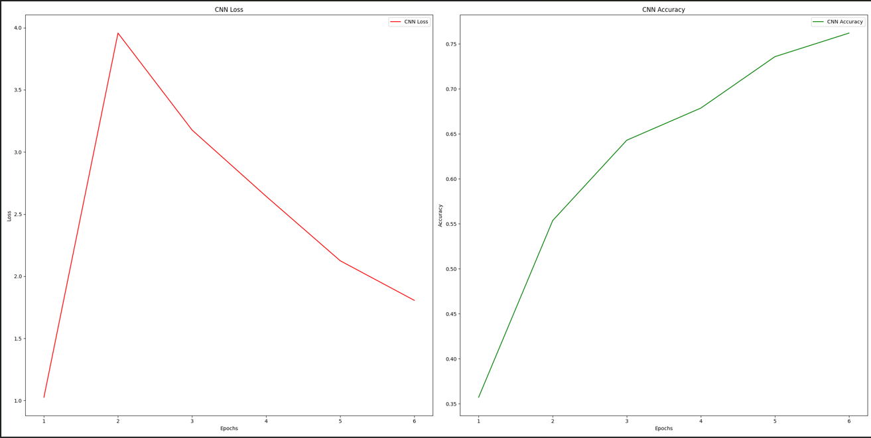

CNN - Loss: 1.8062, Accuracy: 0.7619

At Epoch 12 GAN training gained based on the metric score of:

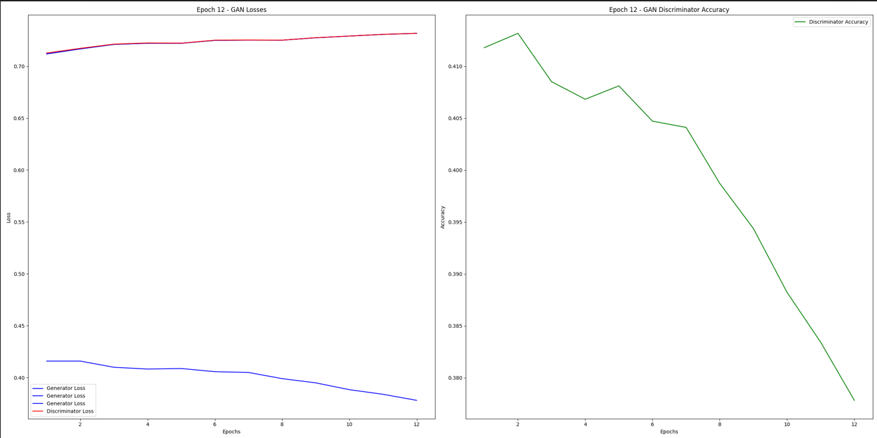
GAN - D Loss: 0.7318, D Accuracy: 0.3778, G Loss: 0.7317

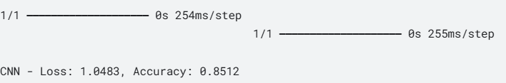
While Epoch 12 of CNN with GAN (synthetic image) test metric gained score of:

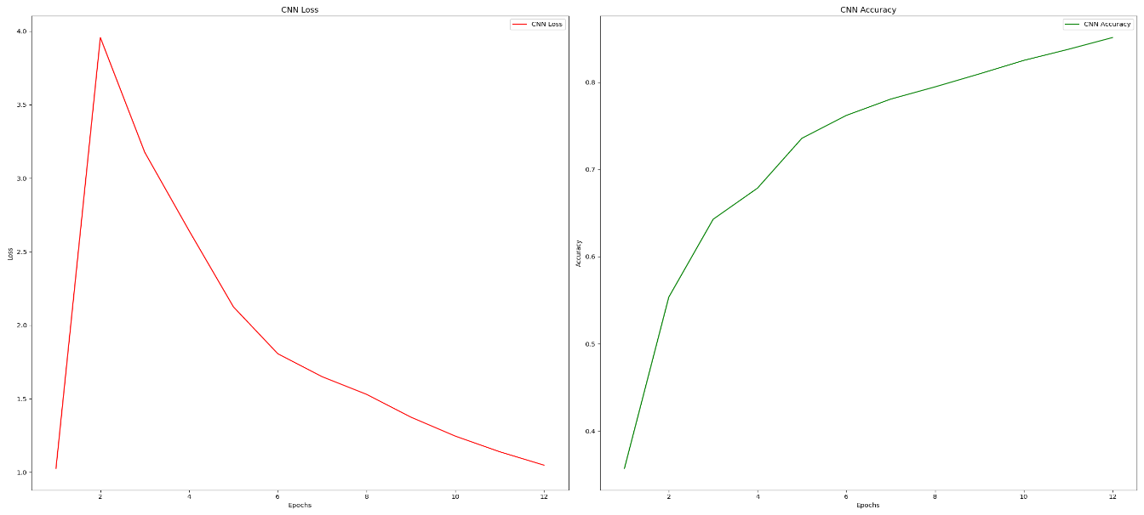
- This is why it has two bars steps one is the GAN (synthetic Image)

While at Last epoch 18 the GAN training has gained a metric score loss and accuracy of:

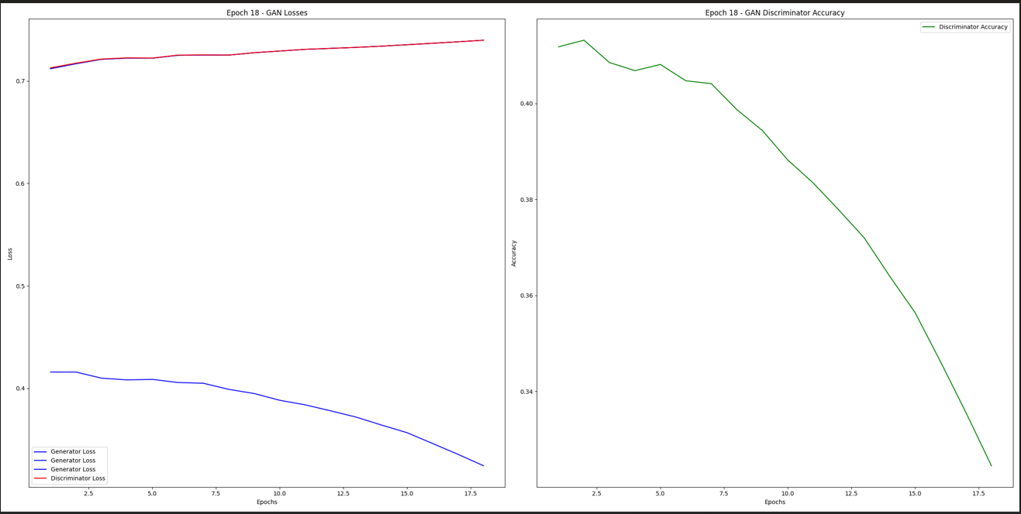
GAN - D Loss: 0.7382, D Accuracy: 0.3356, G Loss: 0.7382

CNN on the other hand at Last Epoch 18 gained a test metric score of loss and accuracy score of:
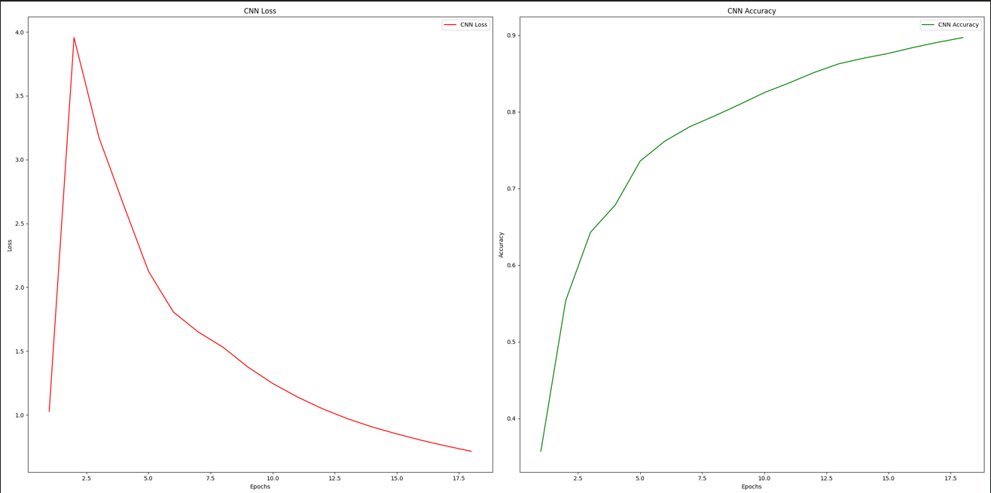
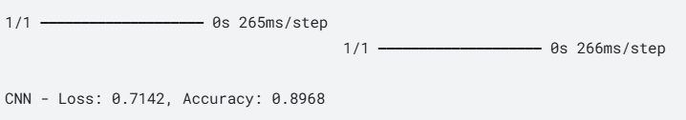

Discussion
From Epochs 1 to 6, the GAN and CNN models were in a period of unstable co-learning. For the GAN, the generator and discriminator experienced fluctuating losses and accuracy as they "competed" with each other. The CNN, on the other hand, showed an increase in test accuracy, reflecting a period of steady improvement. Its accuracy rose while the loss steadily decreased as the model learned from the labeled and synthetic data.
Between Epochs 6 and 12, the accuracy and loss metrics indicated that the discriminator became less confident in distinguishing real from synthetic samples created by the generator. Its accuracy dropped below 37.78%, suggesting that the generator had begun producing more realistic samples, making it harder for the discriminator to classify them correctly. Meanwhile, the CNN continued to improve its accuracy performance slightly, reaching 85.12%. This indicated that the CNN was still learning, and while its loss remained non-negligible, it did not significantly detract from the overall progress.
By the final epoch (Epoch 18), the GAN appeared to have reached equilibrium, as the losses of the generator and discriminator had balanced. This indicated that the generator was producing data that the discriminator found difficult to distinguish from real data, forcing the discriminator to "guess" randomly. This outcome suggested that the GAN had learned effectively, and the generator was producing plausible data. For the CNN, the final metrics showed that it had likely excelled at its classification task, achieving high test accuracy of 89.68%. The results demonstrated that the CNN effectively test(synthetic image from GAN) and trained on (labelled dataset from the dataset) generalized both the synthetic and labeled data in the dataset.

6 Summary/Conclusion

Signature detection using CNN and GAN where, CNN was trained with real and generated synthetic images of GAN, make a realistic scenarios where forgery detection is crucial in banking and document verification, where such individuals may attempt to fake signatures, just as the GAN generates synthetic image to imitate the real ones, the findings on this Project highlights the ability of CNN to differentiate real from fake images with a 89.68% of accuracy, this reveals that CNN is relevant in fields like banking, digital security, and online documentation. The findings on GAN generator likely did improved in producing more realistic images giving the discriminator to have low accuracy of 33.56% which led to high loss of discriminator with a 73.92%. This project work has been worked on Kaggle Notebook cloud this would have been trained more and tested more if not been limit with the available CPU of the user in the future work for this project these can much improved by making CNN to train with GAN, not only to be test GAN with CNN, making it to evaluate more and have more complexity results also to be added instead of metric score of loss and accuracy in the future work it could make the CNN predict the label for that image with a labeled synthetic, real or fake.

References

- Depierre, A., Dellandréa, E., & Chen, L. (2018, March 30). Jacquard: a large scale dataset for robotic grasp detection. arXiv.org. https://arxiv.org/abs/1803.11469
- Dey, S., Dutta, A., Toledo, J. I., Ghosh, S. K., Llados, J., & Pal, U. (2017, July 7). SIGNET: Convolutional Siamese Network for writer Independent Offline Signature Verification. arXiv.org. https://arxiv.org/abs/1707.02131
- Gideon, S. J., Kandulna, A., Kujur, A. A., Diana, A., & Raimond, K. (2018). Handwritten Signature Forgery Detection using Convolutional Neural Networks. Procedia Computer Science, 143, 978–987. https://doi.org/10.1016/j.procs.2018.10.336
- Goodfellow, I., Pouget-Abadie, J., Mirza, M., Xu, B., Warde-Farley, D., Ozair, S., Courville, A., & Bengio, Y. (2020). Generative adversarial networks. Communications of the ACM, 63(11), 139–144. https://doi.org/10.1145/3422622
- Jaiswal, S., Bhadauria, S. S., & Jadon, D. S. (1970, January 1). BIOMETRIC: CASE STUDY. Open Access Journals. https://www.rroij.com/open-access/biometric-case-study.php?aid=37655
- Jasmin, M. C. Q., Cruz, M. J. F. D., & Yumang, A. N. (2022). Detection of forged handwriting through analyzation of handwritten characters using support vector machine. 2022 IEEE International Conference on Artificial Intelligence in Engineering and Technology (IICAIET). https://doi.org/10.1109/iicaiet55139.2022.9936769
- LeCun, Y., Bengio, Y., & Hinton, G. (2015). Deep learning. Nature, 521(7553), 436–444. https://doi.org/10.1038/nature14539
- Munich, M., & Perona, P. (2003). Visual identification by signature tracking. IEEE Transactions on Pattern Analysis and Machine Intelligence, 25(2), 200–217. https://doi.org/10.1109/tpami.2003.1177152 Online and off-line handwriting recognition: a comprehensive survey. (2000, January 1). IEEE Journals & Magazine | IEEE Xplore. https://ieeexplore.ieee.org/document/824821/references#references
- P, G., G, S., K, K. R., J, K. N. K., & N, K. (2022). Real time signature forgery detection using machine learning. 2022 Second International Conference on Advances in Electrical, Computing, Communication and Sustainable Technologies (ICAECT). https://doi.org/10.1109/icaect54875.2022.9807905
- Plamondon, R., & Srihari, S. (2000). Online and off-line handwriting recognition: a comprehensive survey. IEEE Transactions on Pattern Analysis and Machine Intelligence, 22(1), 63–84. https://doi.org/10.1109/34.824821
- Qu, N. T., Saddik, N. a. E., & Adler, A. (2004). Dynamic signature verification system using stroked based features. Website. https://doi.org/10.1109/have.2003.1244730
- Signature Verification Dataset. (2024, June 2). Kaggle. https://www.kaggle.com/datasets/akashgundu/signature-verification-dataset
- Waelen, R. (2023). The power of computer vision : a critital analysis. https://doi.org/10.3990/1.9789036557948

