**(date)**

**Mr. JOSEPH RIZALDE E. GUILLO**

**Chairman**

**Mr. ERWIN F. DE CASTRO**

**Panel**

**Mr. NOEL VIRREY**

**Panel**

Dear Sir,

We kindly request permission to make a modification to our study, if feasible. During the previous defense, it was agreed upon that our Learning Management System would have a gamification feature to designate certain awards for the student users. However, our team is currently facing a dilemma regarding with the continuation of gamification feature due to the time in order to implement the feature within our system.

Our team won’t be able to provide a gamification feature but we will surely provide an LMS that will be able to let the users manage, deliver, and track learning activities and content for learners. We sincerely appreciate your consideration of this matter and eagerly await your response.

Yours faithfully,

Linsangan, John Renzo G.

Aala, Carl Justine C.

Perez, Patricia C.

Noted:

**Mr. EDDIE D. BUCAD JR.**

Faculty/Expert Adviser

Approved:

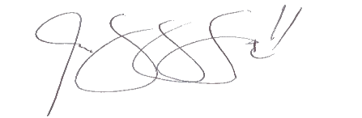

**Asst. Prof. SHIELA MARIE G. GARCIA**

Dean, CICS

Research Professor

[shielamarieggarcia@g.batstate-u.edu.ph](mailto:mariagracielabucad@g.batstate-u.edu.ph)