ALUMNI MONITORING AND DOCUMENT REQUESTING PORTAL FOR SENIOR HIGH SCHOOL

A System Development Study
Presented to
the Faculty of the college of Industrial Technology
BATANGAS STATE UNIVERSITY
The National Engineering University
JPLPC Malvar Campus
Malvar, Batangas

In Partial Fulfillment
of the Requirements for the Degree of
Bachelor of Industrial Technology
Major in Computer Technology

by:

Caraan, Ann Daniela R.
Dinglasan, Camila Mae C.
Hilario, Marielle Abby C.
Madamba, Nikki S.

May 2024

Chapter I

THE PROJECT AND ITS BACKGROUND

Project Context
In a constantly changing and competitive world, a person must be able to adapt and learn as well as be equipped with skills in order to progress well. Education is one of the most important things a person should have for it plays a great role in the success of one’s life. It is the most efficient system of influencing the quality of a person’s life as it enhances one’s knowledge and skills that can help develop that person both professionally and personally. A well-educated person is more likely to find a good career and contribute well to society.
A student is expected to become a successful person who exemplifies what it means to be a professional. Therefore, every academic institution’s goal is to produce competent and highly qualified graduates who can eventually be competitive in the ever-progressing society. A university must produce skillful graduates equipped with educational strength and knowledge. Tracking the success and status of their graduates is very important for their input on the quality of the school’s educational programs and research.
In line with this, tracer studies have been conducted globally as they give a reliable assessment and basis for improving curricular programs in a particular educational institution. At the same time, it provides immediate feedback in making the curriculum relevant and appropriate to the type of learners in the present generation (Libued, 2017). However, it was mentioned in a study by Fernandes and Fukey (2019) that graduates are unable to update their status with their alma mater due to the inevitable drift between the alumni and the institution. The relationship between alumni and the alma mater must be kept positive to ensure that the messages they share about the institution will be positive and current. The relationship must not only be one way so it is important for the institution to reach out and be updated with their alumni.
According to Union College (2022), alumni and parent engagement facilitates the relationship between the college and its alumni, parents, students, and friends through programming, volunteer opportunities, and communications and works closely with departments across campus. For numerous reasons, alumni connections are a crucial component of a school's advancement efforts. The most devoted supporters of an institution are its alumni. Graduates are generally in a position to utilize the institution's knowledge and expertise in their professional careers.
Additionally, alumni reach out to their alma mater when in need to request forms for academic requirements. Whether in work or in higher education such as in universities and colleges, both require the applicant to submit their educational record and documents. Graduates from public schools are able to request these without payment needed. Most educational institutions utilize the web for both service delivery and information dissemination thus opting for the graduates to request forms for their academic requirements online.
According to Sadiku et al. (2020), web-enabled schools are efficient in delivering school news, providing administrative support, and fostering relationships in the online community as the internet is widely being used today. With this, it is not unusual for educational institutions to rely on online forms. Online forms make it possible to gather feedback, create events, update announcements, and most importantly for online transactions that are more convenient. In line with this, online graduate request submission systems are knowingly being developed to facilitate graduate students in document and request submission, especially during the pandemic.
Being able to trace the alumni’s status and information is very important for the school to not only know the alumni’s whereabouts but also to evaluate their performance which will help position the school as a destination for successful people. Still, it is difficult to do this without the cooperation of the alumni to update their status and information to their alma mater. Based on the problem stated, the researchers aim to produce an alumni web-based system for a senior high school that tracks the graduate students of the school and is used as a platform where they can request their academic requirements from wherein their request forms are approved once they have updated their current status and information.

Background of the Study
The Alumni Web-based System is a system to track the current status of the alumni if they are working or have taken higher education. The administration office of Malvar Senior High School has the responsibility of handling the records of the alumni. The Malvar Senior High School has lots of graduate students every year, so this might be a hassle for the administration office to manage their graduates’ profiles and status. The system would gather information about the alumni of Malvar Senior High School including the contact number, email addresses, and the place they currently live. The data that is gathered will be automatically recorded in the system. The administration office will manage the answered survey by the graduates.
The primary goal of this study was to design, develop, and implement a tracer system that would not only benefit the said school by consistently monitoring and accurately processing the alumni record, but also keep track of all the information of the graduates. The system would use a survey that graduates would fill out to collect information, and it would offer the simplest, quickest, most efficient, and most accurate method of learning about alumni. It would then serve as a tool for evaluating the performance and efficacy of the institution. Different computer languages and server-side scripts like HyperText Markup Language (HTML), Cascading Style Sheets (CSS), JavaScript, Hypertext Preprocessor (PHP), and My Structured Query Language (MySQL) would be used to create the suggested system.
The system would act as the school’s instrument or tool for furthering its understanding of the academic program and the relationships between undergraduate education and graduates' professional success. Additionally, it would be beneficial for the institution to show that it complies with the criteria for accreditation demanded from a department's higher education institution. By understanding the placements and positions of their graduates in society, the institution would be able to assess the quality of education they provide, which might then be utilized as a standard to produce graduates who are more competent and competitive.

Objectives of the Study
The main purpose of the study is to develop a web-based system that tracks the graduate students of Malvar Senior High School in order to obtain their profile information and know their current status. Additionally, the web-based system is used as a platform where they can request for their academic requirements.
Specifically, it aims to:
- plan and analyze how to integrate the alumni tracer and alumni request form in a webpage as well as the different requirements to be used in developing the proposed system and ensure that what was specified is what was delivered.
- design a web-based system to trace the graduate students of the school and use it as a platform for them to request forms.
- develop a system that consists of an alumni and administrators' interface wherein there is a display page for user login and a home menu; importing and uploading of alumni information; a module for requesting forms of needed academic requirements; and a module for tracer survey form.
- test the system using the Test Case Method in order to determine and verify if the specified features are performing as expected and that it satisfies all related standards, guidelines, and requirements.
- evaluate the system using ISO-IEC 25010 software product quality measures in terms of the following:
5.1 functional suitability;
5.2 performance efficiency;
5.3 compatibility;
5.4 usability;
  - reliability; and
5.6 security
- propose an action plan for the implementation of the system.

Significance of the Study
The researchers aim to produce an alumni web-based system for a senior high school and the endeavor of this proposed system would prove useful for the following:
BatStateU - TNEU JPLPC-Malvar. This study will further increase the knowledge of tracer studies done in the university and could serve as a donation for Malvar Senior High School.
CIT Students & Faculty. This study could serve as an instructional program or basis for computer technology instructors and students to practice the programming languages used in the proposed system.
Malvar Senior High School. This study will help the school to track the current status of their graduate students.
Administration. This study helps to know and keep record information of whether or not their graduate students have taken higher education or went into employment.
Alumni. This study will help the graduate students to know how to facilitate the process of obtaining their necessary requirements.
Researchers. This study will assist them in applying the learnings of developing a web-based system and be able to improve their skills and understanding in this field pf programming and database application.
Future Researchers. This study will help provide knowledge to future researchers who want to continue this study. They can use this study as a guideline because it will give them ideas and concepts related to this.

Scope, Delimitation, and Limitation of the Study
The scope of the study is on designing, developing, and testing of the Alumni Web-based System. The system focuses on tracing the graduate students of a senior high school in order to obtain their profile information and know their current status if they have continued taking higher education or started working. Additionally, this study not only looks into the present status of the alumni but is also the platform used to request forms for academic requirements. However, the graduate students can only have their request forms approved after they have answered the tracer survey form and updated their status. The system is embedded with a tracer survey in order to collect data as well as a module for the request forms.
The proposed system is intended for Malvar Senior High School and will prove useful for their school, students, and administration as beneficiaries. This study comprises data collection regarding the present status of the batch of graduates in the school from the previous academic year. The web-based system uses a reliable database where the information obtained from the system's intended users is saved safely and will be accessible only to the administrator in charge of managing the system.
The system covers only the services for alumni and administration, therefore does not include other services for guidance, library, clinic, etc. The service for alumni includes the interface where the graduate students can answer the tracer survey form and request forms while the service for the administration includes the interface wherein they are able to access the functionalities of the system. The only person with complete access to the system is the administrator. The administrator of this system is able to evaluate the system's results both graphically and in tally form. Alumni from Malvar Senior High School and the system administrator are the only people with authority to view the system. The Alumni from other schools were not permitted to use the system that had been created. The web-based system is only for alumni information management of their current status and for requesting forms which will be viewed by the admin and will email them for approval or notify the alumni that their request form cannot be approved until they have completed the tracer survey form. This does not cover the feature of having a chatbot. The system was created to keep track of the Senior High School graduates and for them to conveniently request forms for academic requirements.
The researchers will test the system using the Test Case Method and evaluate it using the ISO-IEC 25010 software product quality measures to ensure system assurance. The following software product quality characteristics to be used in evaluating the system are functional suitability, performance efficiency, compatibility, usability, reliability, and security. The researchers did not include maintainability as the system only limits to being used by administration and not for other services so it cannot be modified to add new features and update existing features or adapt to changes as well as be used in more than one system. The researchers also did not include portability as the system cannot be transferred from one environment to another nor can it be installed or used to replace another software product. The researchers collected data for the system’s evaluation using a questionnaire that describes ISO-IEC 25010 software quality standards in terms of its functional suitability, performance efficiency, compatibility, usability, reliability and security. Correspondingly, the researchers will consider the Data Privacy Act Republic Act No. 10173, also known as Data Privacy Act of 2012, to ensure confidentiality and protect the integrity and security of the school as well as the personal data collected from the respondents involved in the study such as the alumni, administrators, faculty and staff (teachers, ICT, registrar).

Chapter II

REVIEW OF RELATED LITERATURE
This chapter presents the related concepts, articles, and studies that the researchers have browsed and deemed related to this study. The section covers various references used in developing the proposed web-based system as well as briefly discusses the related systems reviewed to provide a foundation for the researchers’ work.

Conceptual Literature
Website Designing and Development. Web design is the process of planning, conceptualizing, and arranging content online. Today, designing a website goes beyond aesthetics to include the website’s overall functionality. Web design also includes web apps, mobile apps, and user interface design (Gandy, 2021).
Web design is what creates the overall look and feel when one is using a website. It’s the process of planning and building the elements of a website, from structure and layout to images, colors, fonts, and graphics. Web design has numerous components that work together to create the finished experience of a website, including graphic design, user interface design, search engine optimization (SEO), and content creation. A well-designed website is a website that perfectly creates the experience that a visitor is looking for (Kramer, 2018).
According to Halvorsen (2015), web development is unquestionably of utmost importance, largely due to the sheer scale of the internet. Due to the exponential growth of online users, computer languages like JavaScript, Cascading Style Sheets, and HyperText Markup Protocol have taken on a lingua franca status.
HyperText Markup Language (HTML). Hypertext Markup Language, also known as HTML, is a markup language for the internet that specifies how web pages should be organized. Hypertext is organized text that frequently includes embeds like graphics to connect related content. Markup is a style manual for typesetting anything that will be printed in hardcopy or digital format. Language is the dialect that a computer system uses to decipher commands. Web pages' structure is decided by HTML. An interactive web page cannot be created with just this structure. Therefore, one has to employ aiding technologies like JavaScript and CSS to bring interaction and beauty to the HTML, respectively (Kolade Chris 2021).
According to the study of Fatkhurrozo, Muhammad, and Faichi (2015) entitled “Web-Based Interactive HTML Learning”, Interactive HTML Learning is a web-based system developed to increase the effectiveness of learning HTML language. The web-based system basically is an interactive way of learning through computer browser that will involve two ways communication. This will result of reducing learning curve of users. The main difference of this system than other than other system is this system will be using the interaction of two ways communication between the user and the system itself. Inputs inserted by the user will have respond from the learning system. Target user of this interactive HTML learning system is amateur users who has no experience in dealing with programming language. Users now will be able to learn HTML in interactive way and more effective with this system available
JavaScript. According to Brown (2016), JavaScript is a well-known interpreted programming language with object-oriented programming capabilities. It is included in or referenced by an HTML document for the code to be interpreted by the browser. JavaScript is one of the most popular programming languages and is quickly surpassing the popularity of not only other website languages but also traditional back-end programming languages based on the results of the survey from Stack Overflow which is a known question-and-answer site for developers and weekend hackers.
JavaScript has long been the de facto standard language for client-side web applications, and it is increasingly moving into general-purpose programming (Ryu & Sun 2017)
Hypertext Preprocessor (PHP). According to Alfonso, Malabanan, and Rivera (2021) With the help of the PHP Hypertext Preprocessor, web developers can create dynamic content that works with information-based. This language is used to speed up site development. When it comes to web development, PHP is one of the languages that is commonly suggested. It is also helpful for creating database-driven websites. The majority of web hosting companies allow their customers to utilize PHP since it is lightweight and incredibly quick, it was first intended to be used to produce dynamic web pages.
Web-based power systems analysis applications are delivered via web servers that run scripting languages such as PHP. The role of the web server is usually to pass results and data between a front-end web browser and specialized back-end computation software which carries out the actual simulations and analysis (Agamah & Ekonomou 2015).
Cascading Style Sheets (CSS). According to Alfonso, Malabanan, and Rivera (2021), The style sheet language CSS (Cascading Style Sheet) is used to determine the look and formatting of a document written in a mark-up language. The webpages are made to look better and presentable using CSS. Primarily, it enables the separation of document content from document presentation, including elements such as layout, colors, and font.
Cascading style sheets (CSS) are a web-based style sheet language used to present Web pages. CSS has progressed from CSS1 to CSS3, and CSS extensions such as CSS pre-processors have also arisen in recent years. CSS, like conventional software, has inherent complexity that grows with age, which is undesirable; therefore, metrics are required to quantify it in order to regulate it (Muketha, Omieno and Ndia 2019)
MySQL Database. According to Christudas (2019), MySQL is a popular open-source database management system as it manages a structured collection of data. This aids a user in adding, accessing, and processing the data stored in the database as it stores data in separate tables. The abbreviation SQL in MySQL means “Structured Query Language” which is the most common standardized language used to access databases.
MySQL was chosen as a database management system to store and manage student lecture data. Students can easily find student data, course data, class schedule data and announcement data for students. smoothly through a responsive web interface (Patama & Manurug 2023).
Tracer Study. According to the study of Balao-as M., et. al (2018) Tracer studies are a technique that is commonly utilized in most organizations, notably educational institutions, to track and retain records of their students after they have graduated from the institution. Knowing the placements and positions of the graduates in society allows an institution to assess the quality of education provided to them, which can then be used as a standard to produce graduates who are more educated and competitive.
A tracer study is a type of research technique frequently used in the field of education to evaluate the effects of educational institutions or programs on their graduates. It entails tracking and collecting data on program graduates' employment status, career paths, and overall experiences over a defined time period after they have completed their education. A tracer study is essential at every university since it allows for the evaluation of academic programs, the assessment of graduates' employability, the maintenance of alumni contacts, and general accountability. Universities can assess the value of their educational offerings, spot areas that need improvement, and adapt their curricula to the shifting needs of the labor market by analyzing the career paths and results of their graduates. Universities can improve students' abilities and competencies to meet industry requirements thanks to tracer studies, which offer useful insights about graduates' readiness for work. In the end, conducting tracer studies helps institutions maintain a high standard of instruction and prepare graduates for rewarding professions. Tracer studies are undertaken all around the world to evaluate and improve curricular programs in educational institutions. They offer vital feedback on the curriculum's relevance and appropriateness for current learners. These studies also serve as monitoring tools for assessing graduates' performance, efficiency, and capacity to meet employer expectations (Sensal et. al, 2023)
Tracer studies are carefully and methodically planned to gather information about their progress, job career, and competencies. The value of using tracer study findings to inform important, long-term development interventions cannot be overstated. Tracer studies are particularly useful when long-term and meaningful change from a development intervention is desired. For example, the long-term influence of an educational initiative may not be known until the project is completed. This is why tracer studies are frequently utilized in education. Tracer studies are less typical in health projects, which often have a much more immediate effect (Simister N. 2017).
According to ETF-Cedefop-ILO (2016), tracer studies are retrospective evaluations of graduates conducted using a standardized survey sometime after graduation (usually between 6 months and 3 years). Graduate surveys, alumni surveys, and graduate tracking are other names for tracer studies. Typically, the target demographic is a homogeneous group of students or trainees who graduated at the same time (generation or graduation cohort). Tracer studies are widespread in higher education, but they are becoming increasingly popular in vocational education. The overall goal is to assess the medium- to long-term impact of educational programs.
Graduate tracer studies (GTS) produce outcomes and advantages that are both intrinsic and extrinsic. Tracer study approaches offer straightforward and usable results that may be used correctly at the individual and institutional levels if they are created with rigor and natural distinctiveness (Egesah Omar Badiru and Mary Wahome, 2016).
Test Case Method. A test case is exactly what it sounds like: a scenario that measures functionality across a number of situations or activities in order to confirm the expected outcome. They can employ manual testing, automated testing, and test case management technologies, and they are applicable to any software application. When developing test cases, it's important to keep in mind that they should test a fundamental variable or action, such as whether or not a discount code is appropriate for the right product on an e-commerce website. Because of this, a software tester has more freedom when deciding how to test code and functionalities (McMullin 2021).
A test case is a collection of input and output that the tester will execute in order to expose any vulnerabilities in the software under test (SUT). For many years, this has been one of the most active topics in software testing research. It has been shown to utilize a variety of methodologies and technologies. In the last ten years, there has been some development in test case-generating research. Today, we are testing software for complex computations that interact with one another (Novi Satiani et al., 2019).

Research Literature
To make the study feasible, the researchers searched and reviewed several developed systems that are related to the study and used as a guide in developing the present system.
The study of Alfonso, Malaban, and Rivera (2021) entitled “Alumni Management System for BatStateU-JPLPC Malvar” aims to build communication between the alumni, students, and the administration. The developers created a database system that will manage alumni data of the university that can provide easy access to the system. The developers believe that developing the system will help not only the alumni but also the university itself to retrieve details about the alumni information.
The study of Biscocho et. al (2019) developed a system such as the “Online Graduate Tracer Study for Batangas State University-JPLPC Malvar Campus”, this system offers advantages in that it can offer the simplest, fastest, most reliable way to compare the alumni's current state. This system was created to gather the requirements required for the conduct of the tracer study, to make it simple for alumni to respond to all of the study's questions, to gather information from alumni that is pertinent and necessary to produce the desired output, and to reduce the amount of time wasted in the process of tracing employment. The method would be quite helpful in obtaining alumni's current status.
The study of Bista, et. al. (2013) developed the “An Alumni Portal and Tracking System” which is an alumni portal and tracking database so that the alumni can easily access the user-friendly system and can update their current status and information. The developed system lets the alumni view online alumni yearbooks. This system aims to let the university track its alumni more easily. The record of the alumni with the minimal requirement of centralized data collection will be collected, and maintain the records of the manual entry.
The study of Cabalan et. al 2014 developed a “Graduate Tracer System” which may identify graduates from specific departments to determine whether they are employed or unemployed. If they are employed, the project will assess whether their positions are relevant to their education and determine the percentage of unemployed or mismatched jobs. In addition to updating their profile, users can respond to survey questions. The admin can view the results and responses from the users' completed forms, print reports using the data provided by the user's responses, and add, amend, and delete questionnaire items from the admin side. The system may send emails to people who responded to the survey questionnaire and can import Excel files. The emails' contents may include notifications from the administrators or reminders about system updates.
Based on the study of Hilton (2016), an “Alumni Organizational Behavior and Human Performance” system was developed to help the researchers in gathering the employment status information of the alumni. This system was made available to verify the quality of higher education in that public university since the findings of the study could help the institution to identify its learning outcomes, and assess the strengths and weaknesses of its course programs with the relationship between the education and the employed work.
The study of Mendoza and Curioso (2013) entitled “Online Information and Alumni Tracking System for Cavite State University” stated that the Internet has become incredibly useful for the average person in many ways, thanks to the World Wide Web (WWW). An online presence, or simply a "site," suggests a physical location dispersed among several servers in several regions. There are many websites that specialize in matching people. Perhaps this is the only way to get back in touch with these people. One of a school's most crucial components is undoubtedly its alumni. The school keeps track of its graduates since they are essential to maintaining alumni involvement in the school.
The study of Norazmi and Ahmad (2015), developed a system such as “Web-Based Application System for Monitoring Alumni Active Status on Social Media” which aimed to stay in touch with its alumni. It is set as the contact information of the student that is provided after their graduation. It aims to know the current location, workplace, contact information, and activities of their alumni. Social Media was used by the university to communicate with its alumni. However, they are not active all the time which gives the idea for the university to develop an Alumni Active Status on Social Media to monitor them.
The developed system “Alumni InformCom Management with Distinct Classification of Data” was implemented by Sasikuman, et. al. (2017) which can manage and provide quick access to the college’s alumni data. College alumni keep in touch with their acquaintances, but it is more difficult to keep in reach with classmates. The development of business connections. The acquisition of knowledge in a new field contact between alumni. At the start of the semester, current students will be given a student login ID. They can use the system to get help with their projects or placement if they have access to it. Almost all the alumni’s needs can be met by this single method. Alumni groups are most often found in universities, but they can also be found in places where alumni can meet up. Although many existing mechanisms in colleges exist to keep track of alumni records, they are manual and time-consuming for current students to contact their alumni while still protecting their privacy.
The system “Alumni Hub” developed by Sengar, et. al. (2014), aims to build a user-interactive application that lets the interaction between the alumni and the institution be accessible. The computerized system is an online-based system and they used Java and MySQL to design the Alumni Management System. The system aimed to automatically list all the alumni information and status gathered from the student’s module to the alumni module. It helps to manage and maintain the records of the alumni by communicating them through an internet connection. The school can communicate with the alumni to share job opportunities while the alumni can share the activities in the institution.

Synthesis
This portion showed the differences and similarities of the developed systems of the different authors that were mentioned previously in the related literature to the proposed system of the present study of the researchers.
The study of Alfonso, Malaban, and Rivera (2021) entitled “Alumni Management System for BatStateU-JPLPC Malvar” is similar to the present study of the researchers because it also implements a system that will help the alumni and the institution to connect and both are systems that use database. Both studies implement a system that is internet-dependent. In addition, both studies implement a system that has user interfaces for the alumni and the administration. However, it differs as the previous study also includes in their user interface the current students of theirs thus making the system having a user interface for three panels such as the alumni, administrator, and their current students which is in contrast to the present study that proposes a system with only including the alumni and administration in the user interface. Thus, the present study only focuses on the interaction between the alumni and the school’s administration. Additionally, in the system of the previous study, the student can view details, job opportunities, and communicate with the other students as well as share activities with the alumni while the system of the present study will limit to having features for requesting forms and answering a tracer survey form.
The developed system “An Alumni Portal and Tracking System” of Bista, et. al. (2013) is connected to the proposed system in terms of collecting the information of the alumni. The alumni can update their information to ensure that it is up-to-date. However, the difference is that the developed system aims to publish an alumni yearbook as a stepping stone for their inter-alumni and alumni-student communication while the proposed system does not have this feature and only aims to track alumni in order to obtain their profile information and know their current status as well as have a platform to request forms for their academic records.
The studies of Cabalan et. al (2014) such as the “Graduate Tracer System” and Biscocho et. al (2015) such as the “Online Graduate Tracer Study for Batangas State University-JPLPC Malvar Campus” are related to the present study since their developed systems in their studies track their graduates and gather information of them that are relevant and needed which is the same function of the proposed system in the present study. However, the difference is that the study of Cabalan et. al (2014) differs in the implementation method while the study of Biscocho et. al (2015) provides a web-based system that only traces the status and information of the graduates and is not used as a platform to request forms in contrast to the proposed system that traces the status and information of the graduates and used as a way to request forms for academic records.
The study of Hilton (2016) that is entitled “Alumni Organizational Behavior and Human Performance“ is related to the present study since it has a similar purpose of profiling the status and information of the alumni. The previous study and the present study are also related in terms of being a web-based system for gathering information which makes it easier to organize the information of the alumni. However, both studies differ in how the previous study targets college students thus gathering their employment status and information while the present study targets senior high school students so they gather the graduates’ status and information of whether they are working or taking higher education.
The study of Mendoza and Curioso (2013) entitled “Online Information and Alumni Tracking System for Cavite State University” is similar to the present study as both keep and record all the information given by the alumni in their database. However, the difference between the previous study to the present study was that the system developed in the previous study provides exclusive services for graduates such as an alumni directory, a personal profile page in which they can see the information they filled and also a page dedicated for the top list of alumni who excels in their professions while the present study proposed a system that does not include those services as it limits only to profiling the graduates’ status and information as well as a platform to request forms for academic records.
The system “Web-Based Application System for Monitoring Alumni Active Status on Social Media” that was developed by Norazmi and Ahmad (2015) is connected to the proposed system since both aims to keep in touch with the alumni and both systems are web-based. However, the difference is that the user interface in the developed system includes alumni, lecturer, and administration which makes it for three panels while the proposed system only implements the user interface for the alumni and administration thus only two panels are included and not three as reviewed in the developed system.
The developed system “Alumni InformCom Management with Distinct Classification of Data” that was implemented by Sasikuman, et. al. (2017) is related to the proposed system in terms of managing alumni data and keeping in touch with alumni. However, the developed system used a support Vector Machine Classification for Algorithms as well as ASP.net for the front end and SLQ for the back end. In contrast, the proposed system used HTML, JavaScript, and PHP to create the web page and organize the content as well as connect to the database, CSS for the design and presentation of the content, and MySQL for database management.
The system “Alumni Hub” developed by Sengar, et. al. (2014) is similar to the proposed system in terms of having an alumni management system wherein they are also listing and managing the profile information and status of the graduate students. It is also similar to how they have used MySQL in creating the database as well as the fact that it is also an online-based platform. However, the difference is that the developed system functions as a way for the school to share job opportunities to their alumni while the proposed system does not have this function but only functions as a way for the alumni to request forms for their academic records.

Conceptual Framework
The development of the project is based on the paradigm of the study. The information and ideas gathered were used to improve and sustain the functionality and features of the Alumni Monitoring and Document Requesting Portal for Senior High School.
The information acquired from various sources is included in the input. To develop the proposed system; ideas from other related literature and studies such as theories, articles, and principles are applied. The input also includes the software and hardware requirements to be used to develop the system as well as the graduate tracer survey forms and request forms as contents needed in the system. Those that were mentioned as included in the input will be used to create the system, wherein the alumni and administrator will enter all of the information and data to be involved, which will be managed by the system’s database. In order to develop the system, the researchers followed through a process guided with procedures.
The process includes several procedures such as the following:
Planning is the step when the client and researchers meet to determine what the primary issue is in their environment and how the system could address the concern raised.
Analyzing is the process of methodically using statistical and/or logical approaches to describe, characterize, and assess data is called analysis. During this stage, the researchers will determine the issue in the selected field and devise a fix.
Designing, the data and information from other current systems relevant to the study are included in the design process, along with the design of the user interfaces. The researchers will design the system’s architecture, module interfaces, and possible components, interfaces, modules, and architecture of a system. Making the data that will be sent through the system is another aspect of it. The system interface features and design were developed by the researchers based on that.
Developing, the entire process of creating the system to meet the requirements of the selected recipient is called development. It contains the suggested solution for the study’s provided problem.
Testing is the procedure by which researchers and system supporters assess the system’s competency. The system’s functionality will be evaluated using the test case approach. Debugging will also be done to see if the system needs to be developed further.
Evaluating is the process of evaluation is a study carried out by the beneficiary, which assesses system functionality, usefulness, reliability, performance efficiency, and security before proceeding with its implementation.
Implementing in order to obtain the desired innovation from the previous system by implementing it into the client’s system. Creating the system using PHP & JavaScript for the programming language, MySQL for the database, and HTML & CSS for the user’s interface.
The output of the study will be a complete “Alumni Monitoring and Document Requesting Portal for Senior High School” which will be useful to the administration and students of Malvar Senior High School as well as to the school itself.
Figure 1 below presents the Conceptual Paradigm of the Study that illustrates the key concepts of the Input, Process, and Output of the study which is concretely discussed above to analyze and conceptualize the proposed system.

INPUT PROCESS OUTPUT
Knowledge Requirements
- Information gathered from books, journals, articles, and the internet.

Software Requirements
- HTML/CSS
- PHP
- JavaScript
- MySQL

Graduate Tracer Survey forms

Request forms

Hardware, Computer

- Planning
- Analyzing
- Designing
- Developing
- Testing
- Evaluation
- Implementing
“ALUMNI MONITORING AND DOCUMENT REQUESTING PORTAL FOR SENIOR HIGH SCHOOL”

Figure 1. Conceptual Paradigm of the Study
The relationship between variables is depicted in Figure 1 above, it will serve as a basis for generating accurate data for the study. The input, process, and output approach will be used in order to describe the relationship between variables.

Definition of Terms
To have better understanding of the study, the following are defined operationally and conceptionally.
Web-based system. The web-based system is an external application that is accessed through a web browser over the internet and uses an efficient database in which the information gathered from the system's intended users is securely stored (Muir, 2018). In this study, it refers to a platform of tracing graduates online who are able to respond to a survey form and for them to use as a way to request forms which is through online means.
Web design. Web design is the process of planning, conceiving, and organizing content for use on access to the internet (Gandy, 2021). In this study, it is used as a basis for developing the system and having it online-based.
Tracer. Tracer study is a study of tracer traces of graduates or alumni carried out to alumni after graduation (Teuku Muhammad Ardiansyah, 2021). In this study, a tracer is used to gather information about the status of the alumni.
Alumni. These are the persons who have attended or have graduated from a particular school, college, or university (Del Mundo et al., 2018). In this study, alumni are the graduates of Malvar Senior High for whom employment or educational status details would be gathered.
Alumni portal. It is an online medium used by alumni, students, teachers, and the management of the college to interact with each other for the benefit of each other (Pawar et al., 2015). In this study, it is used as the concept of a platform for students to conveniently request forms for academic requirements from the administration.
ISO-IEC 25010 Software Evaluation Criteria. It is the standards that address some of the well-known human biases that can adversely affect the delivery and perception of a software development project (Del Mundo et al., 2018). In this study, it pertains to the basis with which the developers evaluated the quality of the software in terms of the system’s functionality, performance efficiency, compatibility, usability, reliability, and security.

Chapter III

DESIGN METHODOLOGY
This chapter discusses the research method and what is applicable for it to use as a response to the objectives of the study. This section also covers the software and hardware requirements of the proposed system, the methods for developing software, the context flow chart, and the system structure to generate accurate data for the development of a web-based system.

Method of Research Used
The researchers proposed a system “Alumni Web-based System for Malvar Senior Highschool” that aims to help the alumni to easily request a form and also helps the school track the records of alumni. Researchers used several approaches to the development of this study; therefore, it is safe to claim that both descriptive and developmental research methods were applied. Developmental research was defined as the body of research literature and the systematic study of creating, producing, and assessing programs, processes, and products that must meet internal consistency and effectiveness criteria that are directly related to instructional development.
According to Deckert and Wilson (2023), Descriptive research collects data based on observations and characterizes things the "way they are" through the use of surveys, questionnaires, rubrics, interviews, or rankings. It can provide crucial background regarding a population, subject, or condition as a point of entry for new areas of research or new researchers. Descriptive research, which includes case studies and case series, developmental research, normative research, longitudinal studies, and epidemiological studies, employs qualitative or quantitative data.
Descriptive developmental research improves fundamental understanding while also facilitating the creation and refinement of comprehensive theories of early learning and development. Incorporating open scientific techniques into descriptive research improves the work's transparency, dependability, and replicability, (Kosie and Lew-Williams 2022).

Respondents of the Study
The respondents of the study include forty (40) Alumni, (2) Admin and (8) Faculty and Staff (Teachers, ICT, Registrar) of Malvar Senior High School who will answer the questionnaire if the proposed system delivers the best functionality.

Data Gathering Instrument
In this study, a questionnaire that is guided and based on ISO-IEC 25010 standards will be utilized to assess the system used to collect data about Alumni Web-Based System of Malvar High School. The questionnaire will be divided into two parts: the alumni’s demographic profile and the system assessment using ISO 25010 quality measures. The first part consists of the name of the student (optional), their taken strand, and their current status of whether they are studying or working. The second part includes questions for assessing the system with the count of (5) for functional suitability, (5) for performance efficiency, (5) for compatibility, (5) for usability, (5) for reliability, and (5) for security, therefore a total of 30 items.

Data Gathering Procedure
This study will be carried out in a series of steps in order to meet the study's objectives. Following approval of the topic and title, general and specific objectives for clarifying and directing the research were defined.
Construction of the Questionnaire. After conducting the research and gathering the data through relevant articles, thesis, and internet, the researchers prepared a set of questionnaires. The ISO 25010 questionnaire was used to evaluate the system’s capabilities. The questionnaires that will be given to the alumni of Malvar Senior High School will be the main source of data for this study. There are two parts to the questionnaire. Included in the checklist, it is divided into two sections: the first part focuses on the respondent profile, while the second part focuses on questions in regards to ISO 25010 quality measures to evaluate the system. In order to prevent any issues, the researchers make sure that the survey questions have been reviewed by their thesis adviser before distributing them.
Distribution of the Questionnaire. The questions will be delivered to Malvar Senior High students via survey questionnaires. The purpose of the study is briefly stated, and the methods for completing the questionnaire are discussed.
Retrieval of the Questionnaire To achieve a greater return percentage, the surveys will be collected on the same day they are distributed. The responses to the questionnaire will be tallied, tabulated, statistically handled, evaluated, and interpreted.
Tallying the Data. To acquire the respondents' scores and percentages of answers, the responses will be collected, scored, and tabulated using statistical methods.
Because the respondents' identities were not necessary, the researchers made certain that their responses remained confidential. The researchers gave respondents the opportunity to remain anonymous because they were aware that people's consciousness could affect how truthful and efficient they were in answering the survey.

Data Analysis
This study will employ basic descriptive statistical methods such as frequency and
percentage, mean, likert scales, mean ranges, and verbal interpretation.
Frequency and Percentage. The total number of study participants and their percentage value out of 100 have been used to calculate the frequency of a given value in the data.
Mean. It is the weighted mean of the sum of all values.
Likert Scales. The researchers will use four-point scales for the questionnaires that are distributed to respondents to determine their opinion about the proposed system.
Mean Ranges. The researchers will use mean range to determine the total mean scores and value.
Verbal Interpretation. The study established a description for each value that demonstrates its fundamental position or nature in terms of the challenges.
The researchers employed a four-point rating system to efficiently rate the respondents' assessments under the Alumni Web-Based System for Malvar Senior High School with (1) corresponding to lowest and (4) to the highest as shown in Table 1 below.
Table 1. Likert Rating Scale
Scale | Mean Range | Verbal Interpretation | Composite Mean
4 | 3.50 - 4.00 | Strongly Agree | Highly Functional, Highly Efficient, Highly Compatible, Highly Usable, Highly Reliable, and Highly Secured
3 | 2.50 - 3.49 | Agree | Functional, Efficient, Compatible, Usable, Reliable, and Secured
2 | 1.50 - 2.49 | Disagree | Moderately Functional, Moderately Efficient, Moderately Compatible, Moderately Usable, Moderately Reliable, and Moderately Secured
1 | 1.00 - 1.49 | Strongly Disagree | Not Functional, Not Efficient, Not Compatible, Not Usable, Not Reliable, and Not Secured
Table 1 above presents the four-point scale that rates and expresses the level of agreement of the respondents on each of the item question given in the questionnaire. The scale rates with 4 as the highest and 1 as the lowest. The mean range and verbal interpretation of the numerical scale are also shown in Table 1 as well as the equivalent description of its computed composite mean that describes ISO-IEC 25010 software quality standards in terms of its functional suitability, performance efficiency, compatibility, usability, reliability and security.

Requirements Specification
Specific system requirements are necessary to effectively maximize the proposed system’s potential, capability, and performance. The specifications listed below show the minimum and recommended requirements for implementation of the alumni web-based system to improve the accuracy of the system and meet the objectives.

Hardware Requirements
For the hardware requirements, computers, and an internet connection are required for users to access the developed system. Providing the appropriate hardware specs ensures that the system can efficiently manage the needs of the software and provide a seamless user experience. Completing the hardware criteria ensures compatibility with the specified deployment environment and provides simple integration with other hardware components. The hardware requirements cited are required for a better approach to the system. It can also help users to operate the developed system appropriately and accurately.
Table 2. Hardware Requirements Specifications
Hardware | Minimum | Recommended
Processor | Intel i3/Ryzen 3 | CPU quad-core or hexa-core intel i9/Threadripper Ryzen 9
Memory | 4GB RAM | 8 or 16GB RAM
SSD or Hard Disk Drive | 250GB HDD/SSD | 1TB HDD/SSD
Peripherals | PS/2 Mouse, Monitor,  Keyboard, System unit and Printer | Wireless Mouse, Monitor,  Keyboard, System unit and Printer

Table 2 presents the necessary tools and hardware specs. It also includes the functions for developers in order to achieve the system's objectives. It is necessary to have at least an Intel i3/Ryzen 3, at least 4GB of RAM, a hard drive with at least 250GB HDD/SSD of storage capacity, and peripherals such as a PS/2 mouse, monitor, keyboard, system unit, and printer.

Software Requirements
For the system's creation, the researchers required the following software requirements as shown in Table 3 below and they hoped that by using these software tools, they would be able to significantly improve the system's user interface while still ensuring the security and privacy of the system's data and information. For a more effective strategy and a more reliable system outcome, frontend and backend software requirements are required including HyperText Markup Language (HTML), Cascading Style Sheet (CSS), Hypertext Processor (PHP), and JavaScript.
Table 3. Software Requirements Specifications
Software | Minimum | Recommended
Operating System | Windows 8 | Windows 10 and Windows 11
Programming Language | PHP 8.1, JavaScript | PHP 8.2, JavaScript
User Interface/Frameworks | HTML, CSS | HTML, CSS
Data Base Management | MySQL 5.7 | MySQL 8.0
Web Browser | Google Chrome, Microsoft Edge, and Mozilla Firefox | Google Chrome, Microsoft Edge, and Mozilla Firefox

Table 3 shows the minimum and recommended software requirements to function the system properly. For the Operating System (OS), the minimum requirement is Windows 8, and the recommended operating system requirements are Windows 10 and Windows 11. The programming language that will be used is Hypertext Processor (PHP) 8.1 & 8.2 and JavaScript. The frameworks are Hypertext Markup Language (HTML) and Cascading Style Sheet (CSS). The database management system that will be used is My SQL 5.7 & 8.0 versions. Lastly, the specified web browser can be used for accessing the system such as Google Chrome, Microsoft Edge, and Mozilla Firefox.

Method Used in Developing the Software
The researchers used the Web Development Life Cycle (WDLC) to be able to create a web-based system. This method is specifically proposed for the development of web applications. WDLC is a hybrid of two former methodologies known as the Systems Development Life Cycle (SDLC) and Prototyping. It combines components from each methodology for a new approach that will decrease the time of development, add structure to an unstructured system, and keep the users involved throughout the development life cycle. Figure 2 below illustrates how WDLC works. The purpose of the cycle is to provide the researchers with the process of creating the system. It also aids the researchers in establishing the standards and proper procedures for maintaining the system’s quality and ensuring its successful implementation to prove useful for the alumni and administration at Malvar Senior High School.
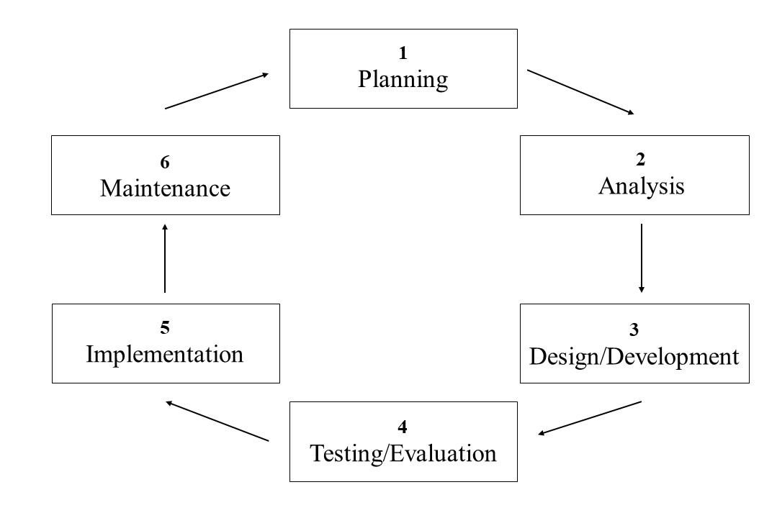
Figure 2. Web Development Life Cycle
The Web Development Life Cycle (WDLC) is illustrated in Figure 2 above which includes six phases such as Planning, Analysis, Design & Development, Implementation, Testing & Evaluation, and Maintenance.

Planning
The researchers started by identifying the purpose of the proposed system as well as determining the objectives of designing the web-based system. This phase involved creating a set of plans to guide the researchers through the phases of the study as well as gathering data and ideas from different sources of books and similar studies as references and basis for developing the proposed system. Consultations and different suggestions from the research adviser as well as from the beneficiaries were also implemented for further improvement plans and to decide the requirements for the development of the proposed web-based system.
Certain changes were made to the plans to conform to the suggestions yielded from the consultations. The researchers plan on developing the system based on the different phases reviewed in the web development life cycle to be fully efficient in time and work capability. The researchers also planned on conducting a survey to know the respondent’s opinion regarding the proposed system and also to know whether the proposed system would conform to the international standard.

Analysis
A detailed analysis came next after the planning phase. This phase was also the part of the study in which the researchers could identify the overall direction that the study would take based on the plans and consultations.
In this phase, an in-depth analysis was made according to the plans to further know the tools and languages to be used regarding system development which is mentioned in the design and development phase. The conceptual literature and research literature that were reviewed focused on what tools and languages would be used, how the system would be developed, how the tools and languages would be used regarding the system development, as well as aspects regarding flaws and errors that might come up with the system.

Design and Development
Based on the requirements and the detailed analysis given, the proposed system will be designed and developed through the tools as well as the front-end and back-end languages. In this phase, the tools used in developing the system are a desktop computer and laptop and would mainly be used for all the coding and debugging in the system development. The programming languages that would be used for the system development included JavaScript for some small web interface functions and HyperText Processor or PHP for the website’s general function as well as the database connection which are the recommended languages for web applications since the proposed system is web-based. It also included the use of HTML for the structure and user interface of the website and CSS for the design and layout. For database management, a relational database management system will be used such as MySQL.

Implementation
The proposed system will be implemented or transferred to Malvar Senior High School after testing, revisions, improvements, and necessary changes are made. In this phase, this presents that at the end of the study, a functional system with a user-friendly design will be implemented as well as be further tested and evaluated that would conform to the international standard 25010. The system will be implemented online and the website will be accessed through the school’s official website as its link is attached there.

Testing and Evaluation
In this phase, the detection of flaws and errors in the study is done. The testing process starts with a test plan that recognizes a test-related activity, such as the use of test case method for testing. The output of the testing phase would be a test report containing the results of the test cases done whether there are errors that occurred or not while evaluating the study. The researchers conducted surveys guided by the ISO/IEC 25010 software quality standards to determine whether the proposed system was successful and efficient. Respondents were to answer the survey questionnaire to assess the website’s quality in terms of functional suitability, performance efficiency, compatibility, usability, reliability, and security.
ISO/IEC 25010 is an international standard to ensure that the software is of high quality as it serves as a basis for a product quality evaluation system. It determines which quality characteristics will be taken into account when evaluating the properties of a software product. The researchers will test and evaluate the system using the test care method and the ISO-IEC 25010 software quality standards to ensure functionality and system quality assurance. The researchers assessed the system’s quality in terms of its functional suitability, performance efficiency, compatibility, usability, reliability and security.
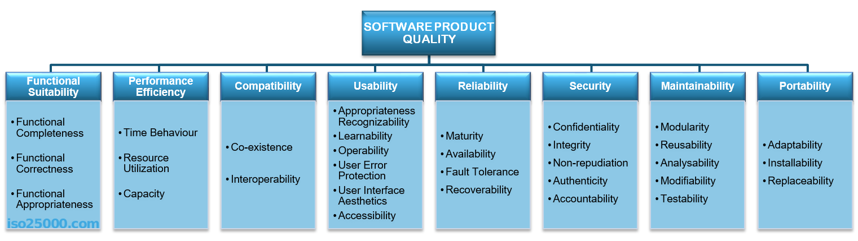
Figure 3. Product Quality Model Defined in ISO-IEC 25010 Standards
Figure 3 above shows the eight quality characteristics that the product quality model defined in ISO/IEC 25010 consists of. Those external and internal quality characteristics are functional suitability, performance efficiency, compatibility, usability, reliability, security, maintainability, and portability.

Table 4. Software Product Evaluation Standards by ISO-IEC 25010
Quality Characteristics | Description
Functional Suitability | The degree to which a product or system provides functions that meet stated and implied needs when used under specified conditions. This quality characteristic is composed of three sub-characteristics which are Functional Completeness, Functional Correctness, and Functional Appropriateness.
Performance Efficiency | The degree of performance relative to the number of resources used under stated conditions. This quality characteristic is composed of three sub-characteristics which are Time Behavior, Resource Utilization, and Capacity.
Compatibility | The degree to which a product, system or component can exchange information with other products, systems or components, and/or perform its required functions while sharing the same hardware or software environment. This quality characteristic is composed of two sub-characteristics which are co-existence and interoperability.
Usability | The degree to which a product or system can be used by specified users to achieve specified goals with effectiveness, efficiency and satisfaction in a specified context of use. This quality characteristic is composed of six sub-characteristics which are Appropriateness Recognizability, Learnability, Operability, User Error Protection, User Interface Aesthetics, and Accessibility.
Reliability | The degree to which a system, product or component performs specified functions under specified conditions for a specified period of time. This quality characteristic is composed of four sub-characteristics which are Maturity, Availability, Fault Tolerance, and Recoverability.
Security | The degree to which a product or system protects information and data so that persons or other products or systems have the degree of data access appropriate to their types and levels of authorization. This quality characteristic is composed of five sub-characteristics which are Confidentiality, Integrity, Non-repudiation, Authenticity, and Accountability.
Maintainability | The degree of effectiveness and efficiency with which a product or system can be modified to improve it, correct it or adapt it to changes in environment, and in requirements. This quality characteristic is composed of five sub-characteristics which are Modularity, Reusability, Analyzability, Modifiability, and Testability.
Portability | The degree of effectiveness and efficiency with which a system, product or component can be transferred from one hardware, software or other operational or usage environment to another. This quality characteristic is composed of three sub-characteristics which are Adaptability, Installability, and Replaceability.
Table 4 above presents the software product evaluation standards in accordance with the ISO/IEC 25010 Software Quality Model to be used as the basis for creating the survey questionnaire. The table shows the quality characteristics to be used as well as the respective descriptions for each one. There are six sections in the survey questionnaire consisting of the six quality characteristics for each section and that questionnaire will be answered by the respondents to assess the quality assurance of the system.

Maintenance
This phase is required to eliminate the errors in the study and in the proposed system while they are in operation, as well as include modifications if there are any needed once it has been implemented. In this phase, the researchers will ensure that the system is operational as well as that the alumni and administration are using it. If flaws and errors are detected during the testing and evaluation phase, the maintenance will be subjected to various procedures.

System Analysis and Design
The researchers used the WDLC after identifying the main features and requirements to be used in the web-based system. This part, explains the various phases in the system analysis and design are discussed in detail for the development of the study. After the researchers decided on the main features and requirements of the system, further examination was conducted to determine what the system needed, the researchers selected the most suitable tools and database to be used for the web-based system.
The researchers accomplished the final design of the system: In designing the system, MySQL is used as data storage and database for all the features and information, while PHP is used to connect the database in the study. The development of the system followed the design phase; with the aid of all needed tools and the database necessary for the website. The process of programming and encoding was done to end up with the “Alumni Web-Based System for Malvar Senior High School”.

Context Flow Diagram
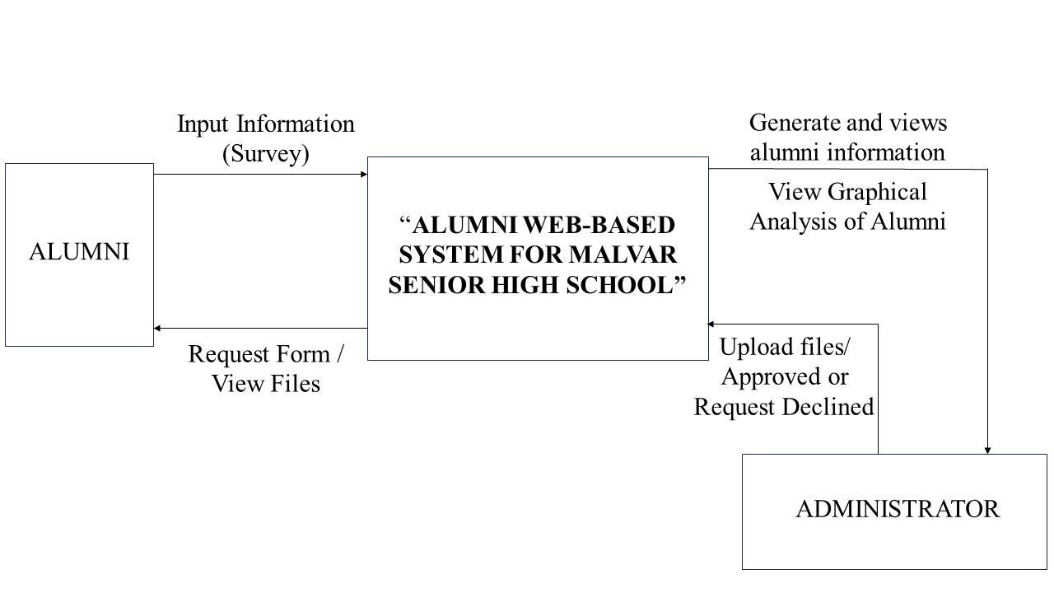
Figure 4. Context Flow Diagram of the Develop System
Figure 4 shows the context flow of the website. The administrator has full access to the system while the alumni can only view it. The registered alumni will be saved from the data based on the system. The alumni will input their information to the system where it will be generated as a report to view a summary of alumni information.

Data Flow Diagram
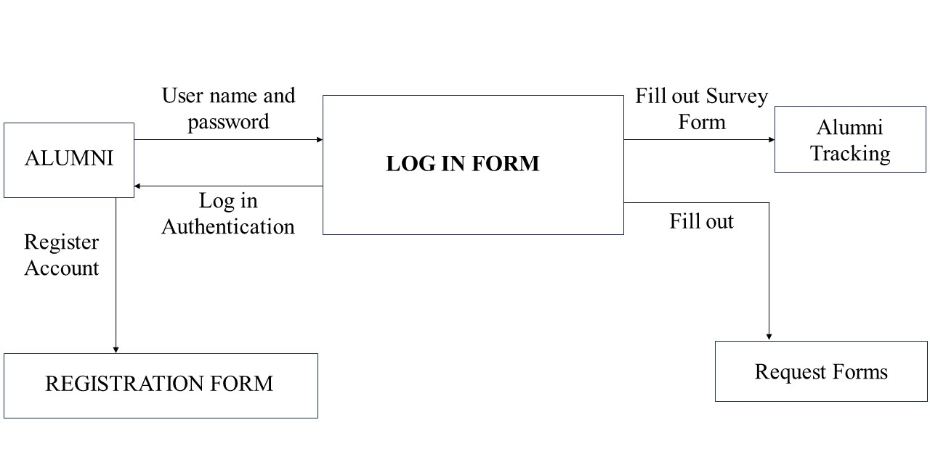
Figure 5. Data Flow Diagram for the Alumni
Figure 5 presents the Data Flow Diagram of the Alumni Web-based system for Malvar Senior High School. This figure shows the data flow for Alumni. Based on the diagram, we can see that upon registering and logging in, the alumni can view other features of the website, and view and download files.
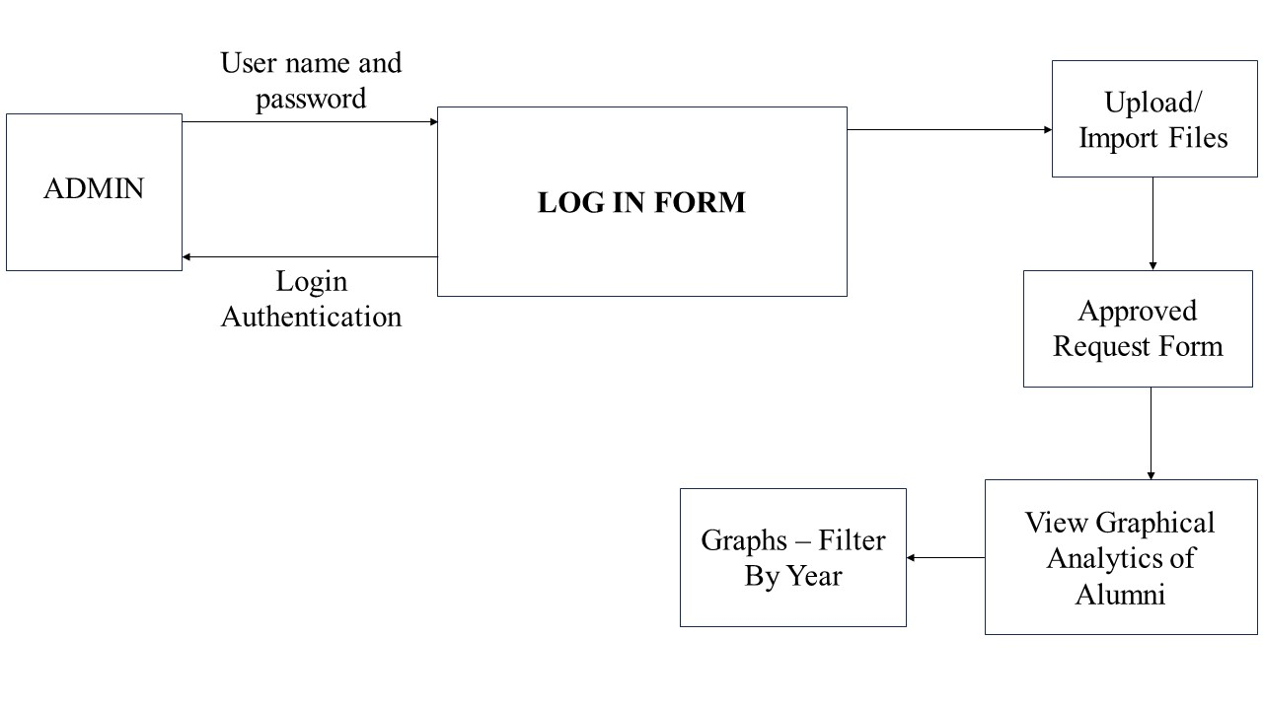
Figure 6. Data Flow Diagram for the Administrator
Figure 6 shows the data flow for the administrator. The administrator must input the correct username and password to have full access to the system. Upon login, the admin can modify and upload files that will be viewed by the alumni.

System Structure
The following figures given below served as the guide of the researchers in developing the web-based system. The researchers developed a user-friendly interface while keeping it presentable to the users.

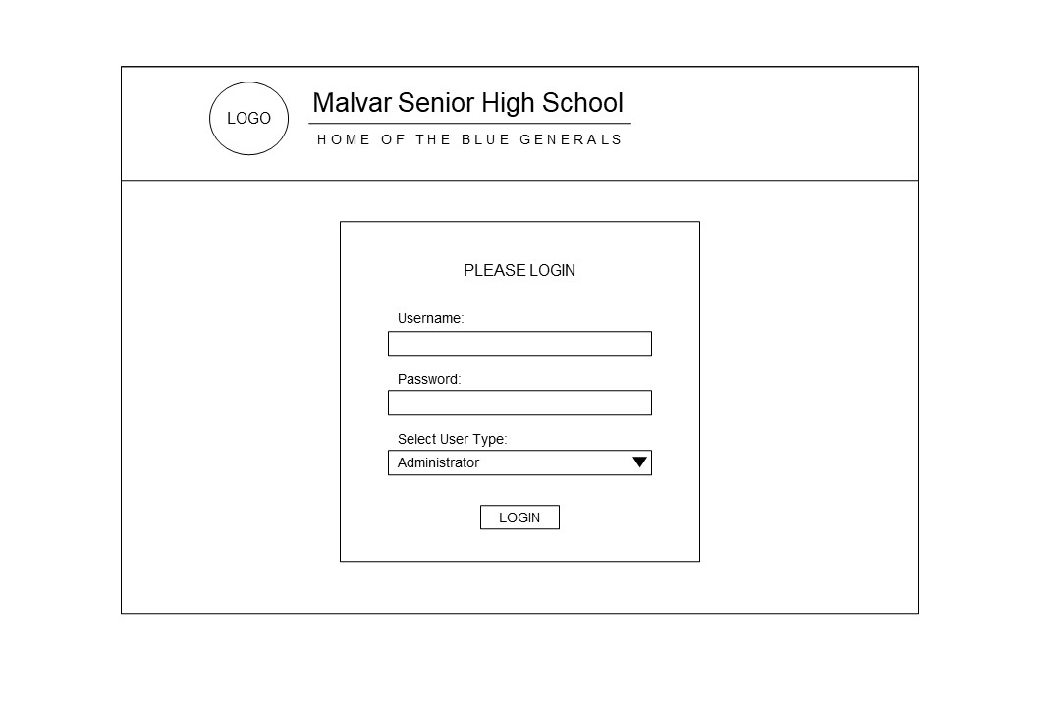
1
1

2
1

3
1

Figure 7. Login Form
Figure 7 shows the Login Form in the user’s interface. In this form, the user must fill out the textboxes with their username (1) and password (2) as well as select their user type (3) such as either administrator or alumni. After doing so, the user must click the login button (4) to access the system.
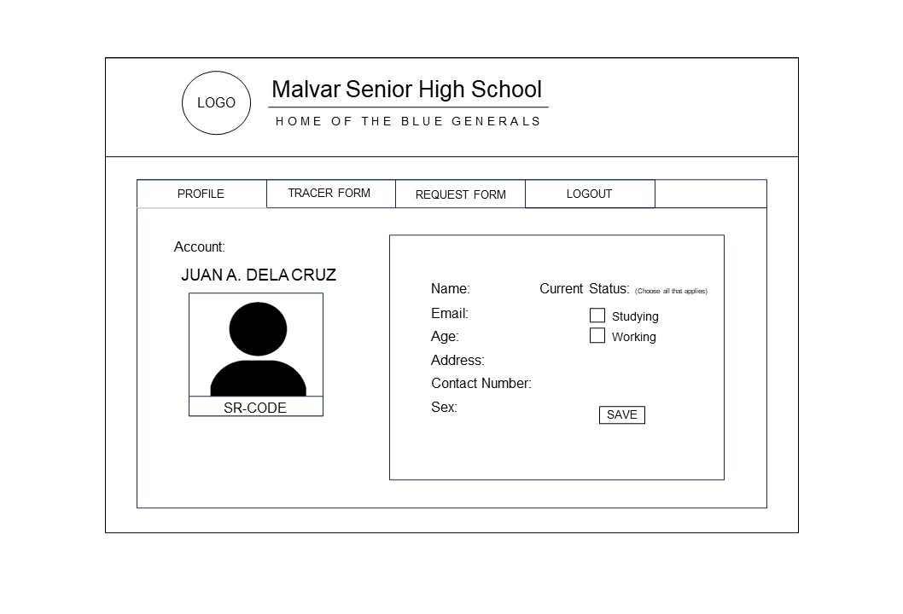
1
1

2
1

3
1

4
1

Figure 8. Alumni Profile Page
Figure 8 presents the profile page (1) in the alumni panel which contains the profile picture of the alumni and their sr-code (2) along with the personal information (3) that they can update and save using the save button (4).
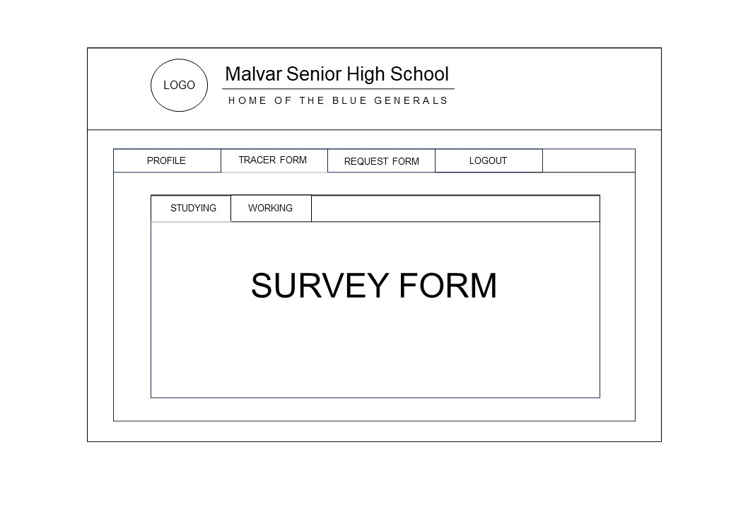
1
1

2
1

3
1

Figure 9. Alumni Tracer Form Page: Survey for Alumni Studying
Figure 9 illustrates the tracer form page (1) in the alumni panel which contains two sections such as for studying and working. The figure 9 shows the section of the page for alumni who are studying (2) and will answer the survey form (3) provided according to that status of theirs.

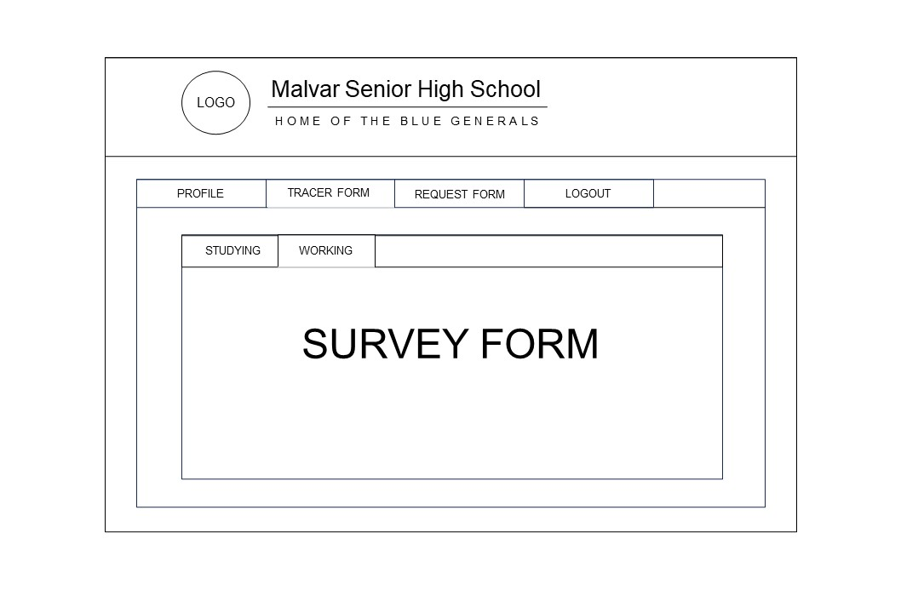
1
1

2
1

3
1

Figure 10. Alumni Tracer Form Page: Survey for Alumni Working
Figure 10 illustrates the tracer form page (1) in the alumni panel which contains two sections such as for studying and working. The figure 10 shows the section of the page for alumni who are working (2) and will answer the survey form (3) provided according to that status of theirs.
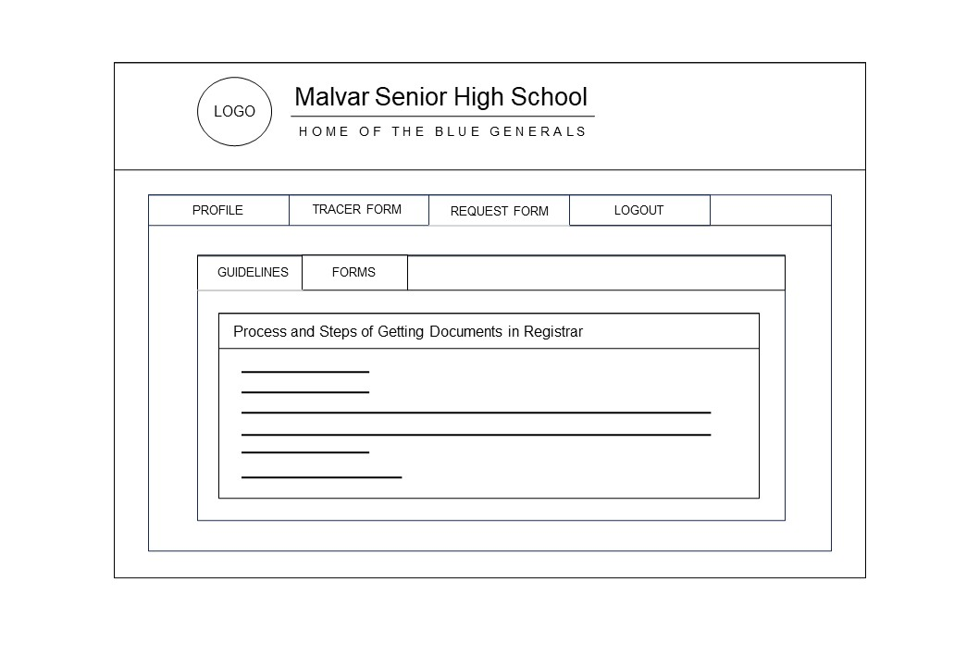
1
1

2
1

3
1

Figure 11. Alumni Request Form Page: Section for Guidelines
Figure 11 illustrates the request form page (1) in the alumni panel which contains two sections such as for guidelines and forms. The figure 11 shows the section of the guidelines (2) which presents the process and steps of getting the documents of the alumni in the registrar (3).
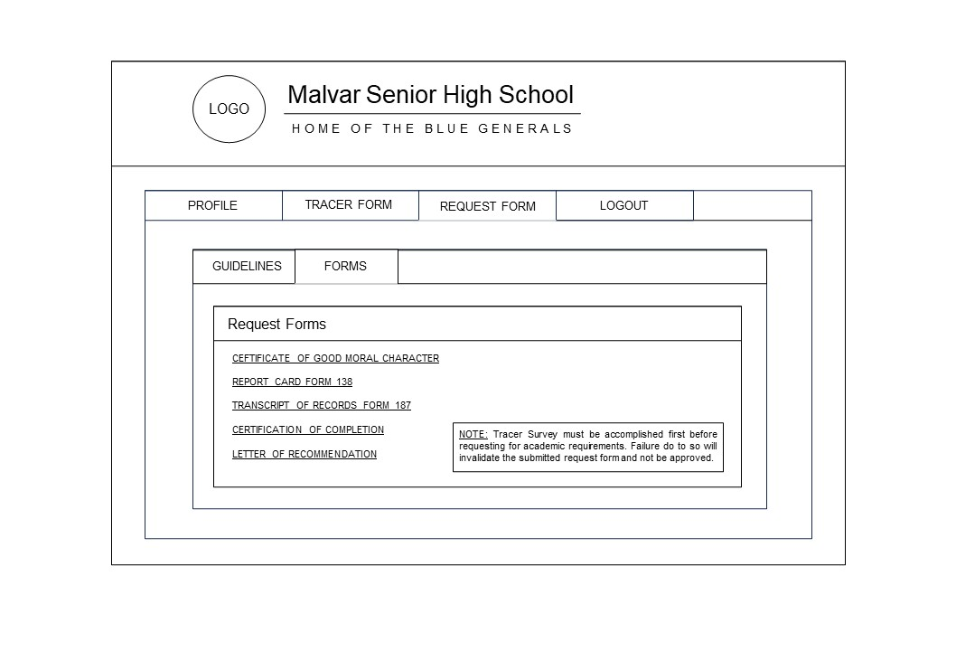
1
1

2
1

3
1

4
1

Figure 12. Alumni Request Form Page: Section for Forms
Figure 12 illustrates the request form page (1) in the alumni panel which contains two sections such as for guidelines and forms. The figure 12 shows the section of the forms (2) which present the attached request forms for academic records of the alumni (3). There is also an advisory (4) to remind the alumni that the tracer survey must be updated first before their request form can be approved.
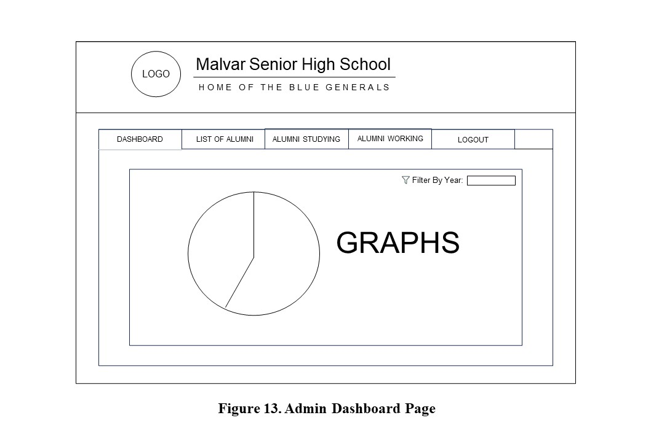
1
1

2
1

Figure 13. Admin Dashboard Page
Figure 13 presents the dashboard page (1) in the administrator panel which contains the analytic features of the system. In the data grid (2), there are the graphs that shows the percentage of the alumni who are working or studying which can be filtered by year. The dashboard also includes the history of request of the alumni so the administrators are able to see who have sent their request forms.
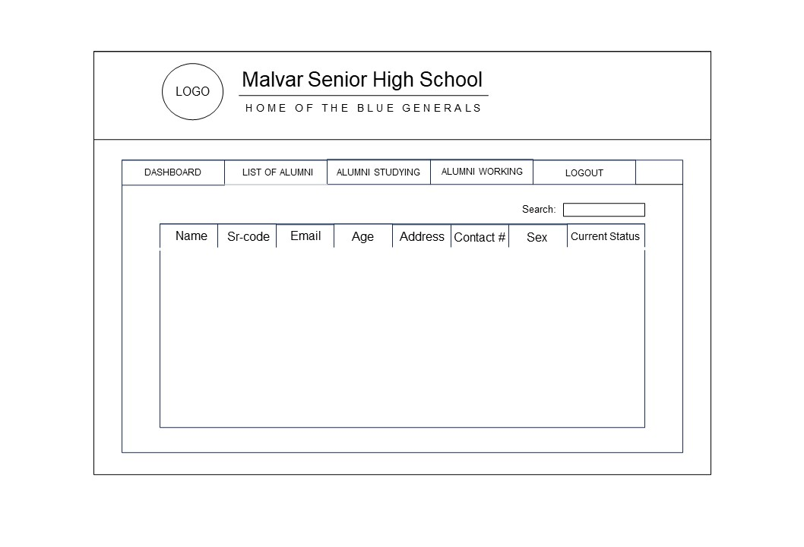
1
1

2
1

3
1

Figure 14. Admin List of Alumni Page
Figure 14 presents the list of alumni page (1) in the administrator panel which contains the list of the graduate students of the school in the administrator’s account. The search button (2) allows the user to find specific information about the alumni. The list (3) contains the personal information of the alumni such as their name, sr-code, email address, age, address, contact number, sex, and their current status of whether they are studying or working.
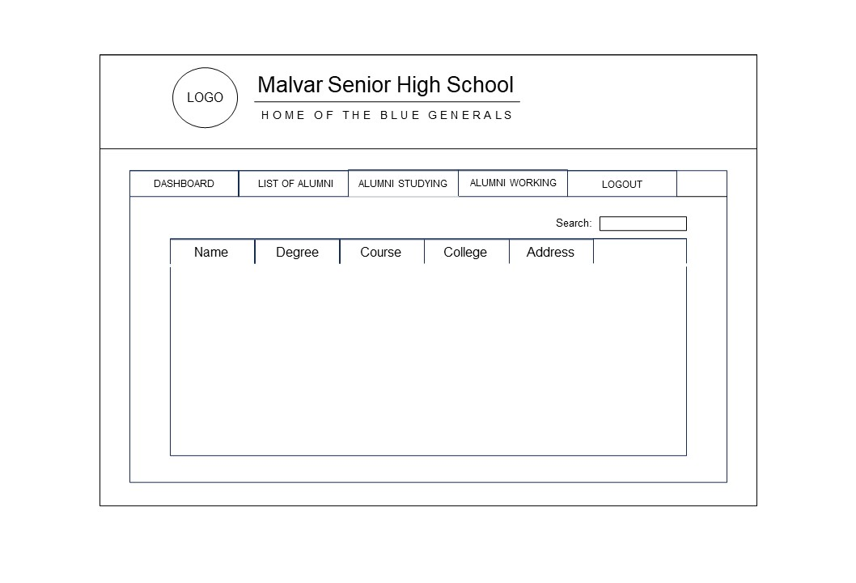
1
1

2
1

3
1

Figure 15. Admin Alumni Studying Page
Figure 15 presents the alumni studying page (1) in the administrator panel which contains the list of the graduate students who are studying. The search button (2) allows the user to find specific information about the alumni who is studying. The list (3) contains the key information of the alumni on their study such as their degree, course taken, the college they are studying in, and its address.

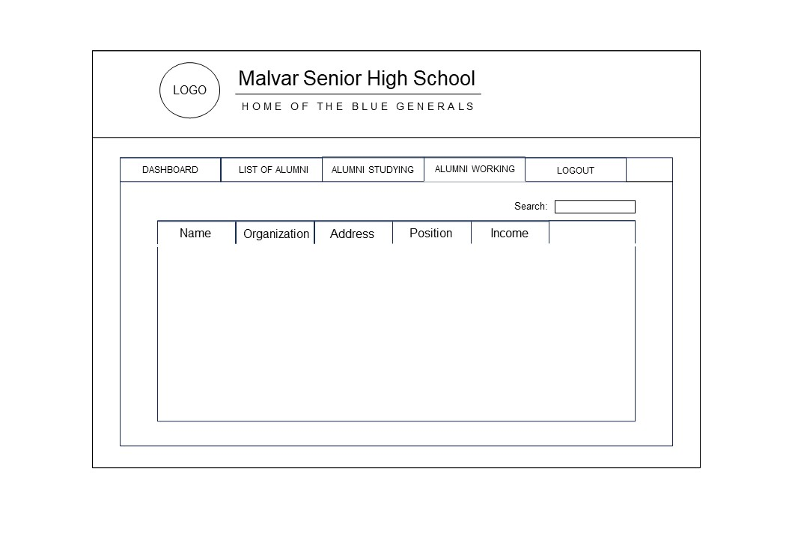
1
1

2
1

3
1

Figure 16. Admin Alumni Working Page
Figure 16 presents the alumni working page (1) in the administrator panel which contains the list of the graduate students who are working. The search button (2) allows the user to find specific information about the alumni who is working. The list (3) contains the key information of the alumni on their work such as the name of the organization/company they are in, its address, the alumni’s position in that place, and their income.

