DELETE

The delete statement removes rows from a table. It does not act on individual columns as you can only delete a row and not a column.

DELETE [ from ] table name
[ FROM clause ]
[ WHERE clause ]

[ from ] - optional
- makes the statement more ENGLISH like

table name - required
- identifies the table you want to delete rows from

FROM clause - optional
- identifies additional tables referenced in the
where clause
- lets you delete rows in table A based on data recorded in a different table ( table B )

WHERE clause - optional
- identifies which rows to delete from the table
- if not coded ALL rows are deleted

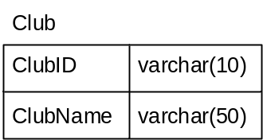


Deletes all the records in the Club table.

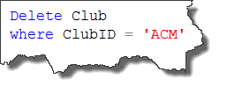
Deletes the record where the Club ID is ‘ACM’
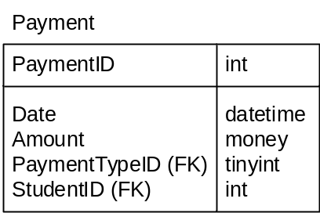

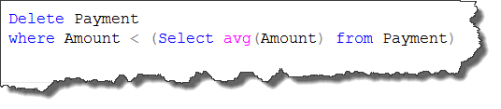
Deletes all the Payment records that are less than the average payment amount. This examples uses a subquery which will be covered in a later lesson.

