UPDATE

The Update statement is used to update existing data in a table. It can be used to update one or more columns. Data can be updated by providing new values for columns or using subqueries to provide the new data.

UPDATE table name
SET column = expression [ , column = expression . . . ]
[Where expression ]

table name - identifies the table to be updated
SET - identifies the column(s) to be updated and the expression which provides the new value for the column. The expression can be a subquery.

Where - optional. Identifies what records to be updated.

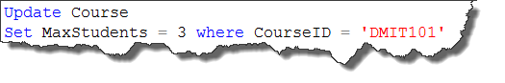
Updates the Course table and sets the MaxStudents to 3 for CourseID DMIT101.

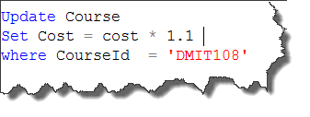
Updates the Course table and increases the cost of DMIT108 by 10%. This example uses a subquery which will be covered in a later lesson.

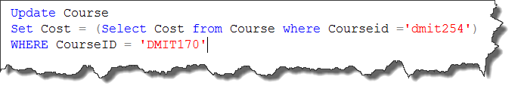
Updates the Course table and sets the cost of DMIT170 to be the same cost as DMIT254.More than one column can be updated in one update statement.

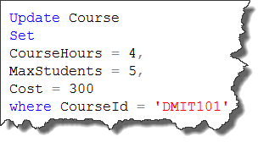
Updates CourseHours, MaxStudents and Cost columns for CourseID DMIT101.

