МОСКОВСКИЙ ГОСУДАРСТВЕННЫЙ ТЕХНИЧЕСКИЙ УНИВЕРСИТЕТ

им. Н.Э. Баумана

Факультет «Информатика и системы управления»

Кафедра «Систем обработки информации и управления»

ОТЧЕТ

**Лабораторная работа №__2__**

по дисциплине«Методы машинного обучения»

ИСПОЛНИТЕЛЬ: _Морозенков О.Н___

ФИО

группа ИУ5-23М __________________

подпись

"__"_________2022 г.

ПРЕПОДАВАТЕЛЬ: _Гапанюк Ю.Е._____

ФИО

__________________

подпись

"__"_________2022 г.

Москва - 2022

__________________________________________________________

**Цель лабораторной работы:** изучение продвинутых способов предварительной обработки данных для дальнейшего формирования моделей.

**Задание:**

1. Выбрать набор данных (датасет), содержащий категориальные и числовые признаки и пропуски в данных. Для выполнения следующих пунктов можно использовать несколько различных наборов данных (один для обработки пропусков, другой для категориальных признаков и т.д.) Просьба не использовать датасет, на котором данная задача решалась в лекции.
2. Для выбранного датасета (датасетов) на основе материалов лекций решить следующие задачи:
   1. устранение пропусков в данных;
   2. кодирование категориальных признаков;
   3. нормализацию числовых признаков.

import numpy as np  
import pandas as pd   
import matplotlib.pyplot as plt  
import seaborn as sns  
import scipy.stats as stats

data = pd.read_csv("./house_sales.csv")

data = data.drop('Id', 1)  
data.head()

/tmp/ipykernel_1499671/222650945.py:1: FutureWarning: In a future version of pandas all arguments of DataFrame.drop except for the argument 'labels' will be keyword-only.  
 data = data.drop('Id', 1)

MSSubClass MSZoning LotFrontage LotArea Street Alley LotShape \  
0 60 RL 65.0 8450 Pave NaN Reg   
1 20 RL 80.0 9600 Pave NaN Reg   
2 60 RL 68.0 11250 Pave NaN IR1   
3 70 RL 60.0 9550 Pave NaN IR1   
4 60 RL 84.0 14260 Pave NaN IR1   
  
 LandContour Utilities LotConfig ... PoolArea PoolQC Fence MiscFeature \  
0 Lvl AllPub Inside ... 0 NaN NaN NaN   
1 Lvl AllPub FR2 ... 0 NaN NaN NaN   
2 Lvl AllPub Inside ... 0 NaN NaN NaN   
3 Lvl AllPub Corner ... 0 NaN NaN NaN   
4 Lvl AllPub FR2 ... 0 NaN NaN NaN   
  
 MiscVal MoSold YrSold SaleType SaleCondition SalePrice   
0 0 2 2008 WD Normal 208500   
1 0 5 2007 WD Normal 181500   
2 0 9 2008 WD Normal 223500   
3 0 2 2006 WD Abnorml 140000   
4 0 12 2008 WD Normal 250000   
  
[5 rows x 80 columns]

data_features = list(zip(  
# признаки  
[i for i in data.columns],  
zip(  
 # типы колонок  
 [str(i) for i in data.dtypes],  
 # проверим есть ли пропущенные значения  
 [i for i in data.isnull().sum()]  
)))  
# Признаки с типом данных и количеством пропусков  
data_features

[('MSSubClass', ('int64', 0)),  
 ('MSZoning', ('object', 0)),  
 ('LotFrontage', ('float64', 259)),  
 ('LotArea', ('int64', 0)),  
 ('Street', ('object', 0)),  
 ('Alley', ('object', 1369)),  
 ('LotShape', ('object', 0)),  
 ('LandContour', ('object', 0)),  
 ('Utilities', ('object', 0)),  
 ('LotConfig', ('object', 0)),  
 ('LandSlope', ('object', 0)),  
 ('Neighborhood', ('object', 0)),  
 ('Condition1', ('object', 0)),  
 ('Condition2', ('object', 0)),  
 ('BldgType', ('object', 0)),  
 ('HouseStyle', ('object', 0)),  
 ('OverallQual', ('int64', 0)),  
 ('OverallCond', ('int64', 0)),  
 ('YearBuilt', ('int64', 0)),  
 ('YearRemodAdd', ('int64', 0)),  
 ('RoofStyle', ('object', 0)),  
 ('RoofMatl', ('object', 0)),  
 ('Exterior1st', ('object', 0)),  
 ('Exterior2nd', ('object', 0)),  
 ('MasVnrType', ('object', 8)),  
 ('MasVnrArea', ('float64', 8)),  
 ('ExterQual', ('object', 0)),  
 ('ExterCond', ('object', 0)),  
 ('Foundation', ('object', 0)),  
 ('BsmtQual', ('object', 37)),  
 ('BsmtCond', ('object', 37)),  
 ('BsmtExposure', ('object', 38)),  
 ('BsmtFinType1', ('object', 37)),  
 ('BsmtFinSF1', ('int64', 0)),  
 ('BsmtFinType2', ('object', 38)),  
 ('BsmtFinSF2', ('int64', 0)),  
 ('BsmtUnfSF', ('int64', 0)),  
 ('TotalBsmtSF', ('int64', 0)),  
 ('Heating', ('object', 0)),  
 ('HeatingQC', ('object', 0)),  
 ('CentralAir', ('object', 0)),  
 ('Electrical', ('object', 1)),  
 ('1stFlrSF', ('int64', 0)),  
 ('2ndFlrSF', ('int64', 0)),  
 ('LowQualFinSF', ('int64', 0)),  
 ('GrLivArea', ('int64', 0)),  
 ('BsmtFullBath', ('int64', 0)),  
 ('BsmtHalfBath', ('int64', 0)),  
 ('FullBath', ('int64', 0)),  
 ('HalfBath', ('int64', 0)),  
 ('BedroomAbvGr', ('int64', 0)),  
 ('KitchenAbvGr', ('int64', 0)),  
 ('KitchenQual', ('object', 0)),  
 ('TotRmsAbvGrd', ('int64', 0)),  
 ('Functional', ('object', 0)),  
 ('Fireplaces', ('int64', 0)),  
 ('FireplaceQu', ('object', 690)),  
 ('GarageType', ('object', 81)),  
 ('GarageYrBlt', ('float64', 81)),  
 ('GarageFinish', ('object', 81)),  
 ('GarageCars', ('int64', 0)),  
 ('GarageArea', ('int64', 0)),  
 ('GarageQual', ('object', 81)),  
 ('GarageCond', ('object', 81)),  
 ('PavedDrive', ('object', 0)),  
 ('WoodDeckSF', ('int64', 0)),  
 ('OpenPorchSF', ('int64', 0)),  
 ('EnclosedPorch', ('int64', 0)),  
 ('3SsnPorch', ('int64', 0)),  
 ('ScreenPorch', ('int64', 0)),  
 ('PoolArea', ('int64', 0)),  
 ('PoolQC', ('object', 1453)),  
 ('Fence', ('object', 1179)),  
 ('MiscFeature', ('object', 1406)),  
 ('MiscVal', ('int64', 0)),  
 ('MoSold', ('int64', 0)),  
 ('YrSold', ('int64', 0)),  
 ('SaleType', ('object', 0)),  
 ('SaleCondition', ('object', 0)),  
 ('SalePrice', ('int64', 0))]

## Устранение пропусков

# Доля (процент) пропусков  
[(c, data[c].isnull().mean()) for c in data.columns]

[('MSSubClass', 0.0),  
 ('MSZoning', 0.0),  
 ('LotFrontage', 0.1773972602739726),  
 ('LotArea', 0.0),  
 ('Street', 0.0),  
 ('Alley', 0.9376712328767123),  
 ('LotShape', 0.0),  
 ('LandContour', 0.0),  
 ('Utilities', 0.0),  
 ('LotConfig', 0.0),  
 ('LandSlope', 0.0),  
 ('Neighborhood', 0.0),  
 ('Condition1', 0.0),  
 ('Condition2', 0.0),  
 ('BldgType', 0.0),  
 ('HouseStyle', 0.0),  
 ('OverallQual', 0.0),  
 ('OverallCond', 0.0),  
 ('YearBuilt', 0.0),  
 ('YearRemodAdd', 0.0),  
 ('RoofStyle', 0.0),  
 ('RoofMatl', 0.0),  
 ('Exterior1st', 0.0),  
 ('Exterior2nd', 0.0),  
 ('MasVnrType', 0.005479452054794521),  
 ('MasVnrArea', 0.005479452054794521),  
 ('ExterQual', 0.0),  
 ('ExterCond', 0.0),  
 ('Foundation', 0.0),  
 ('BsmtQual', 0.025342465753424658),  
 ('BsmtCond', 0.025342465753424658),  
 ('BsmtExposure', 0.026027397260273973),  
 ('BsmtFinType1', 0.025342465753424658),  
 ('BsmtFinSF1', 0.0),  
 ('BsmtFinType2', 0.026027397260273973),  
 ('BsmtFinSF2', 0.0),  
 ('BsmtUnfSF', 0.0),  
 ('TotalBsmtSF', 0.0),  
 ('Heating', 0.0),  
 ('HeatingQC', 0.0),  
 ('CentralAir', 0.0),  
 ('Electrical', 0.0006849315068493151),  
 ('1stFlrSF', 0.0),  
 ('2ndFlrSF', 0.0),  
 ('LowQualFinSF', 0.0),  
 ('GrLivArea', 0.0),  
 ('BsmtFullBath', 0.0),  
 ('BsmtHalfBath', 0.0),  
 ('FullBath', 0.0),  
 ('HalfBath', 0.0),  
 ('BedroomAbvGr', 0.0),  
 ('KitchenAbvGr', 0.0),  
 ('KitchenQual', 0.0),  
 ('TotRmsAbvGrd', 0.0),  
 ('Functional', 0.0),  
 ('Fireplaces', 0.0),  
 ('FireplaceQu', 0.4726027397260274),  
 ('GarageType', 0.05547945205479452),  
 ('GarageYrBlt', 0.05547945205479452),  
 ('GarageFinish', 0.05547945205479452),  
 ('GarageCars', 0.0),  
 ('GarageArea', 0.0),  
 ('GarageQual', 0.05547945205479452),  
 ('GarageCond', 0.05547945205479452),  
 ('PavedDrive', 0.0),  
 ('WoodDeckSF', 0.0),  
 ('OpenPorchSF', 0.0),  
 ('EnclosedPorch', 0.0),  
 ('3SsnPorch', 0.0),  
 ('ScreenPorch', 0.0),  
 ('PoolArea', 0.0),  
 ('PoolQC', 0.9952054794520548),  
 ('Fence', 0.8075342465753425),  
 ('MiscFeature', 0.963013698630137),  
 ('MiscVal', 0.0),  
 ('MoSold', 0.0),  
 ('YrSold', 0.0),  
 ('SaleType', 0.0),  
 ('SaleCondition', 0.0),  
 ('SalePrice', 0.0)]

# Удаление колонок, содержащих пустые значения  
data.dropna(axis=1, how='any')

MSSubClass MSZoning LotArea Street LotShape LandContour Utilities \  
0 60 RL 8450 Pave Reg Lvl AllPub   
1 20 RL 9600 Pave Reg Lvl AllPub   
2 60 RL 11250 Pave IR1 Lvl AllPub   
3 70 RL 9550 Pave IR1 Lvl AllPub   
4 60 RL 14260 Pave IR1 Lvl AllPub   
... ... ... ... ... ... ... ...   
1455 60 RL 7917 Pave Reg Lvl AllPub   
1456 20 RL 13175 Pave Reg Lvl AllPub   
1457 70 RL 9042 Pave Reg Lvl AllPub   
1458 20 RL 9717 Pave Reg Lvl AllPub   
1459 20 RL 9937 Pave Reg Lvl AllPub   
  
 LotConfig LandSlope Neighborhood ... EnclosedPorch 3SsnPorch \  
0 Inside Gtl CollgCr ... 0 0   
1 FR2 Gtl Veenker ... 0 0   
2 Inside Gtl CollgCr ... 0 0   
3 Corner Gtl Crawfor ... 272 0   
4 FR2 Gtl NoRidge ... 0 0   
... ... ... ... ... ... ...   
1455 Inside Gtl Gilbert ... 0 0   
1456 Inside Gtl NWAmes ... 0 0   
1457 Inside Gtl Crawfor ... 0 0   
1458 Inside Gtl NAmes ... 112 0   
1459 Inside Gtl Edwards ... 0 0   
  
 ScreenPorch PoolArea MiscVal MoSold YrSold SaleType SaleCondition \  
0 0 0 0 2 2008 WD Normal   
1 0 0 0 5 2007 WD Normal   
2 0 0 0 9 2008 WD Normal   
3 0 0 0 2 2006 WD Abnorml   
4 0 0 0 12 2008 WD Normal   
... ... ... ... ... ... ... ...   
1455 0 0 0 8 2007 WD Normal   
1456 0 0 0 2 2010 WD Normal   
1457 0 0 2500 5 2010 WD Normal   
1458 0 0 0 4 2010 WD Normal   
1459 0 0 0 6 2008 WD Normal   
  
 SalePrice   
0 208500   
1 181500   
2 223500   
3 140000   
4 250000   
... ...   
1455 175000   
1456 210000   
1457 266500   
1458 142125   
1459 147500   
  
[1460 rows x 61 columns]

# Удаление колонок, содержащих пустые значения  
data.dropna(axis=1, how='any')

MSSubClass MSZoning LotArea Street LotShape LandContour Utilities \  
0 60 RL 8450 Pave Reg Lvl AllPub   
1 20 RL 9600 Pave Reg Lvl AllPub   
2 60 RL 11250 Pave IR1 Lvl AllPub   
3 70 RL 9550 Pave IR1 Lvl AllPub   
4 60 RL 14260 Pave IR1 Lvl AllPub   
... ... ... ... ... ... ... ...   
1455 60 RL 7917 Pave Reg Lvl AllPub   
1456 20 RL 13175 Pave Reg Lvl AllPub   
1457 70 RL 9042 Pave Reg Lvl AllPub   
1458 20 RL 9717 Pave Reg Lvl AllPub   
1459 20 RL 9937 Pave Reg Lvl AllPub   
  
 LotConfig LandSlope Neighborhood ... EnclosedPorch 3SsnPorch \  
0 Inside Gtl CollgCr ... 0 0   
1 FR2 Gtl Veenker ... 0 0   
2 Inside Gtl CollgCr ... 0 0   
3 Corner Gtl Crawfor ... 272 0   
4 FR2 Gtl NoRidge ... 0 0   
... ... ... ... ... ... ...   
1455 Inside Gtl Gilbert ... 0 0   
1456 Inside Gtl NWAmes ... 0 0   
1457 Inside Gtl Crawfor ... 0 0   
1458 Inside Gtl NAmes ... 112 0   
1459 Inside Gtl Edwards ... 0 0   
  
 ScreenPorch PoolArea MiscVal MoSold YrSold SaleType SaleCondition \  
0 0 0 0 2 2008 WD Normal   
1 0 0 0 5 2007 WD Normal   
2 0 0 0 9 2008 WD Normal   
3 0 0 0 2 2006 WD Abnorml   
4 0 0 0 12 2008 WD Normal   
... ... ... ... ... ... ... ...   
1455 0 0 0 8 2007 WD Normal   
1456 0 0 0 2 2010 WD Normal   
1457 0 0 2500 5 2010 WD Normal   
1458 0 0 0 4 2010 WD Normal   
1459 0 0 0 6 2008 WD Normal   
  
 SalePrice   
0 208500   
1 181500   
2 223500   
3 140000   
4 250000   
... ...   
1455 175000   
1456 210000   
1457 266500   
1458 142125   
1459 147500   
  
[1460 rows x 61 columns]

# Удаление колонок с высоким процентом пропусков (более 50%)  
data.dropna(axis=1, thresh=730)

MSSubClass MSZoning LotFrontage LotArea Street LotShape LandContour \  
0 60 RL 65.0 8450 Pave Reg Lvl   
1 20 RL 80.0 9600 Pave Reg Lvl   
2 60 RL 68.0 11250 Pave IR1 Lvl   
3 70 RL 60.0 9550 Pave IR1 Lvl   
4 60 RL 84.0 14260 Pave IR1 Lvl   
... ... ... ... ... ... ... ...   
1455 60 RL 62.0 7917 Pave Reg Lvl   
1456 20 RL 85.0 13175 Pave Reg Lvl   
1457 70 RL 66.0 9042 Pave Reg Lvl   
1458 20 RL 68.0 9717 Pave Reg Lvl   
1459 20 RL 75.0 9937 Pave Reg Lvl   
  
 Utilities LotConfig LandSlope ... EnclosedPorch 3SsnPorch ScreenPorch \  
0 AllPub Inside Gtl ... 0 0 0   
1 AllPub FR2 Gtl ... 0 0 0   
2 AllPub Inside Gtl ... 0 0 0   
3 AllPub Corner Gtl ... 272 0 0   
4 AllPub FR2 Gtl ... 0 0 0   
... ... ... ... ... ... ... ...   
1455 AllPub Inside Gtl ... 0 0 0   
1456 AllPub Inside Gtl ... 0 0 0   
1457 AllPub Inside Gtl ... 0 0 0   
1458 AllPub Inside Gtl ... 112 0 0   
1459 AllPub Inside Gtl ... 0 0 0   
  
 PoolArea MiscVal MoSold YrSold SaleType SaleCondition SalePrice   
0 0 0 2 2008 WD Normal 208500   
1 0 0 5 2007 WD Normal 181500   
2 0 0 9 2008 WD Normal 223500   
3 0 0 2 2006 WD Abnorml 140000   
4 0 0 12 2008 WD Normal 250000   
... ... ... ... ... ... ... ...   
1455 0 0 8 2007 WD Normal 175000   
1456 0 0 2 2010 WD Normal 210000   
1457 0 2500 5 2010 WD Normal 266500   
1458 0 0 4 2010 WD Normal 142125   
1459 0 0 6 2008 WD Normal 147500   
  
[1460 rows x 76 columns]

# Заполним пропуски возраста средними значениями  
def impute_na(df, variable, value):  
 df[variable].fillna(value, inplace=True)  
impute_na(data, 'LotFrontage', data['LotFrontage'].mean())

# Убедимся, что признак LotFrontage не имеет пустых значений  
data.isnull().sum()

MSSubClass 0  
MSZoning 0  
LotFrontage 0  
LotArea 0  
Street 0  
 ..  
MoSold 0  
YrSold 0  
SaleType 0  
SaleCondition 0  
SalePrice 0  
Length: 80, dtype: int64

## Кодирование категориальных признаков

from sklearn.preprocessing import LabelEncoder

le = LabelEncoder()  
cat_enc_le = le.fit_transform(data['SaleCondition'])

data['SaleCondition'].unique()

array(['Normal', 'Abnorml', 'Partial', 'AdjLand', 'Alloca', 'Family'],  
 dtype=object)

np.unique(cat_enc_le)

array([0, 1, 2, 3, 4, 5])

le.inverse_transform([0, 1, 2, 3, 4, 5])

array(['Abnorml', 'AdjLand', 'Alloca', 'Family', 'Normal', 'Partial'],  
 dtype=object)

data['LotConfig'].unique()

array(['Inside', 'FR2', 'Corner', 'CulDSac', 'FR3'], dtype=object)

#CountEncoder  
from category_encoders.count import CountEncoder as ce_CountEncoder

ce_CountEncoder1 = ce_CountEncoder()  
data_COUNT_ENC = ce_CountEncoder1.fit_transform(data[data.columns.difference(['SaleType'])])

data_COUNT_ENC.head()

1stFlrSF 2ndFlrSF 3SsnPorch Alley BedroomAbvGr BldgType BsmtCond \  
0 856 854 0 1369 3 1220 1311   
1 1262 0 0 1369 3 1220 1311   
2 920 866 0 1369 3 1220 1311   
3 961 756 0 1369 3 1220 65   
4 1145 1053 0 1369 4 1220 1311   
  
 BsmtExposure BsmtFinSF1 BsmtFinSF2 ... SalePrice ScreenPorch Street \  
0 953 706 0 ... 208500 0 1454   
1 134 978 0 ... 181500 0 1454   
2 114 486 0 ... 223500 0 1454   
3 953 216 0 ... 140000 0 1454   
4 221 655 0 ... 250000 0 1454   
  
 TotRmsAbvGrd TotalBsmtSF Utilities WoodDeckSF YearBuilt YearRemodAdd \  
0 8 856 1459 0 2003 2003   
1 6 1262 1459 298 1976 1976   
2 6 920 1459 0 2001 2002   
3 7 756 1459 0 1915 1970   
4 9 1145 1459 192 2000 2000   
  
 YrSold   
0 2008   
1 2007   
2 2008   
3 2006   
4 2008   
  
[5 rows x 79 columns]

data['MSZoning'].unique()

array(['RL', 'RM', 'C (all)', 'FV', 'RH'], dtype=object)

data_COUNT_ENC['MSZoning'].unique()

array([1151, 218, 10, 65, 16])

ce_CountEncoder2 = ce_CountEncoder(normalize=True)  
data_FREQ_ENC = ce_CountEncoder2.fit_transform(data[data.columns.difference(['SaleType'])])

data_FREQ_ENC['MSZoning'].unique()

array([0.78835616, 0.14931507, 0.00684932, 0.04452055, 0.0109589 ])

from category_encoders.helmert import HelmertEncoder as ce_HelmertEncoder

#HelmetEncoder  
ce_HelmertEncoder1 = ce_HelmertEncoder()  
data_HELM_ENC = ce_HelmertEncoder1.fit_transform(data[data.columns.difference(['SaleType'])], data['SaleType'])

data_HELM_ENC.head()

intercept 1stFlrSF 2ndFlrSF 3SsnPorch Alley_0 Alley_1 BedroomAbvGr \  
0 1 856 854 0 -1.0 -1.0 3   
1 1 1262 0 0 -1.0 -1.0 3   
2 1 920 866 0 -1.0 -1.0 3   
3 1 961 756 0 -1.0 -1.0 3   
4 1 1145 1053 0 -1.0 -1.0 4   
  
 BldgType_0 BldgType_1 BldgType_2 ... SalePrice ScreenPorch Street_0 \  
0 -1.0 -1.0 -1.0 ... 208500 0 -1.0   
1 -1.0 -1.0 -1.0 ... 181500 0 -1.0   
2 -1.0 -1.0 -1.0 ... 223500 0 -1.0   
3 -1.0 -1.0 -1.0 ... 140000 0 -1.0   
4 -1.0 -1.0 -1.0 ... 250000 0 -1.0   
  
 TotRmsAbvGrd TotalBsmtSF Utilities_0 WoodDeckSF YearBuilt \  
0 8 856 -1.0 0 2003   
1 6 1262 -1.0 298 1976   
2 6 920 -1.0 0 2001   
3 7 756 -1.0 0 1915   
4 9 1145 -1.0 192 2000   
  
 YearRemodAdd YrSold   
0 2003 2008   
1 1976 2007   
2 2002 2008   
3 1970 2006   
4 2000 2008   
  
[5 rows x 255 columns]

## Нормализация числовых признаков

def diagnostic_plots(df, variable):  
 plt.figure(figsize=(15,6))  
 # гистограмма  
 plt.subplot(1, 2, 1)  
 df[variable].hist(bins=30)  
 ## Q-Q plot  
 plt.subplot(1, 2, 2)  
 stats.probplot(df[variable], dist="norm", plot=plt)  
 plt.show()

data.hist(figsize=(20,20))  
plt.show()

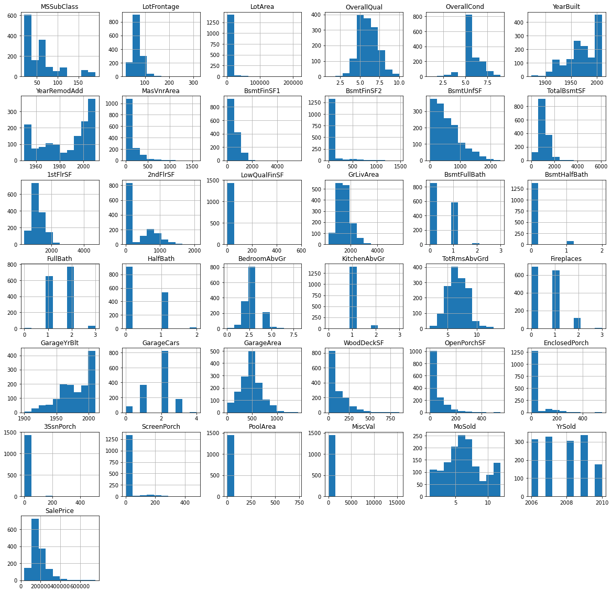

diagnostic_plots(data, '1stFlrSF')

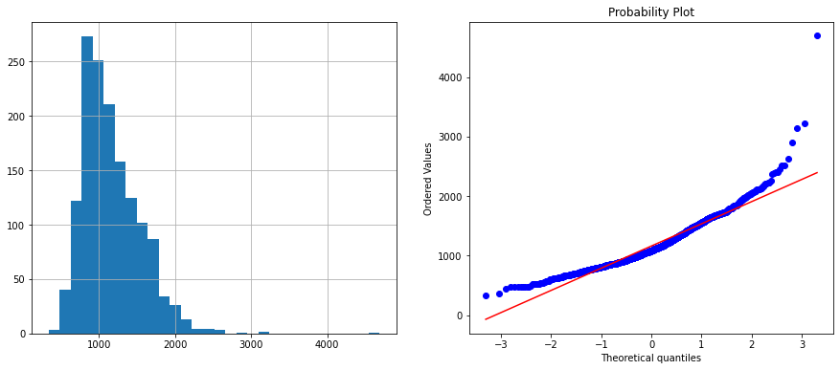

#Логарифмическое преобразование  
data['1stFlrSF'] = np.log(data['1stFlrSF'])  
diagnostic_plots(data, '1stFlrSF')

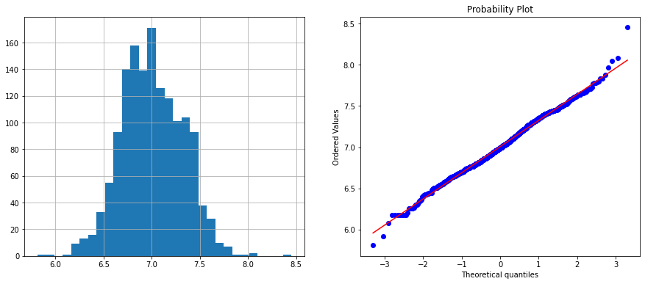

#Обратное преобразование  
data['1stFlrSF_reciprocal'] = 1 / (data['1stFlrSF'])   
diagnostic_plots(data, '1stFlrSF_reciprocal')

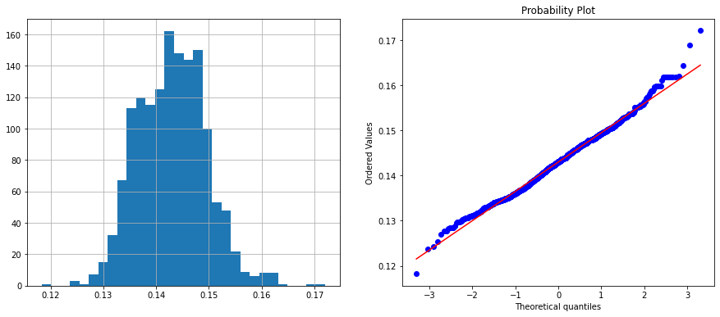

#Квадратный корень  
data['1stFlrSF_sqr'] = data['1stFlrSF']**(1/2)   
diagnostic_plots(data, '1stFlrSF_sqr')

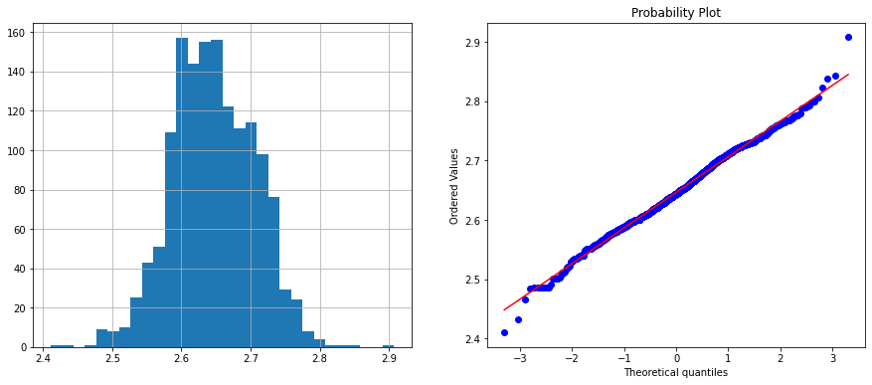

#Возведение в степень  
data['1stFlrSF_exp1'] = data['1stFlrSF']**(1/1.5)  
diagnostic_plots(data, '1stFlrSF_exp1')

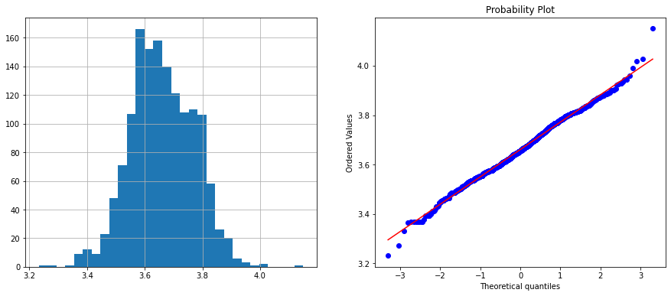

data['1stFlrSF_exp2'] = data['1stFlrSF']**(2)  
diagnostic_plots(data, '1stFlrSF_exp2')

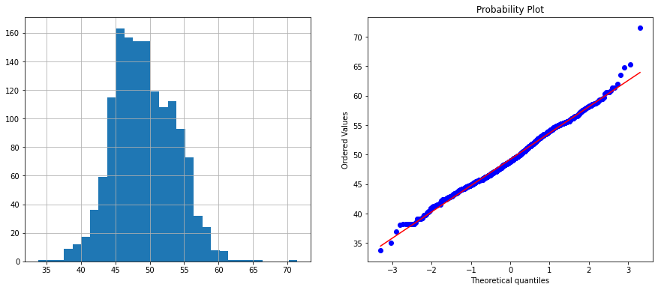

data['1stFlrSF_exp3'] = data['1stFlrSF']**(0.333)  
diagnostic_plots(data, '1stFlrSF_exp3')

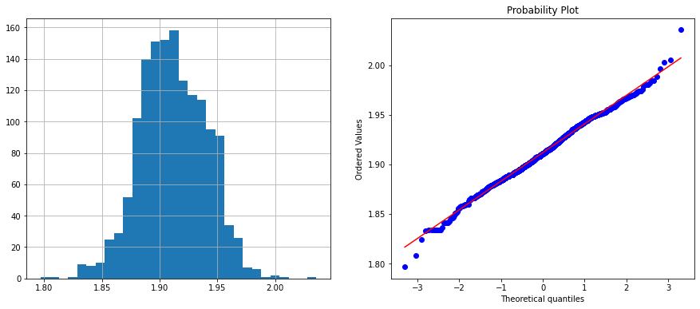

#Преобразованиея Бокса-Кокса  
data['1stFlrSF_boxcox'], param = stats.boxcox(data['1stFlrSF'])   
print('Оптимальное значение λ = {}'.format(param))  
diagnostic_plots(data, '1stFlrSF_boxcox')

Оптимальное значение λ = 0.46304765872484194

