МОСКОВСКИЙ ГОСУДАРСТВЕННЫЙ ТЕХНИЧЕСКИЙ УНИВЕРСИТЕТ

им. Н.Э. Баумана

Факультет «Информатика и системы управления»

Кафедра «Систем обработки информации и управления»

ОТЧЕТ

**Лабораторная работа №__3__**

по дисциплине«Методы машинного обучения»

ИСПОЛНИТЕЛЬ: _Морозенков О.Н___

ФИО

группа ИУ5-23М __________________

подпись

"__"_________2022 г.

ПРЕПОДАВАТЕЛЬ: _Гапанюк Ю.Е._____

ФИО

__________________

подпись

"__"_________2022 г.

Москва - 2022

__________________________________________________________

**Цель лабораторной работы:** изучение продвинутых способов предварительной обработки данных для дальнейшего формирования моделей.

**Задание:**

1. Выбрать один или несколько наборов данных (датасетов) для решения следующих задач. Каждая задача может быть решена на отдельном датасете, или несколько задач могут быть решены на одном датасете. Просьба не использовать датасет, на котором данная задача решалась в лекции.
2. Для выбранного датасета (датасетов) на основе материалов лекций решить следующие задачи:
   1. масштабирование признаков (не менее чем тремя способами);
   2. обработку выбросов для числовых признаков (по одному способу для удаления выбросов и для замены выбросов);
   3. обработку по крайней мере одного нестандартного признака (который не является числовым или категориальным);
   4. отбор признаков:
      * один метод из группы методов фильтрации (filter methods);
      * один метод из группы методов обертывания (wrapper methods);
      * один метод из группы методов вложений (embedded methods).

import numpy as np  
import pandas as pd  
import seaborn as sns  
import matplotlib.pyplot as plt  
from sklearn.impute import SimpleImputer  
from sklearn.impute import MissingIndicator  
import scipy.stats as stats  
from sklearn.model_selection import train_test_split  
from sklearn.preprocessing import StandardScaler  
from sklearn.preprocessing import MinMaxScaler  
from sklearn.preprocessing import RobustScaler  
from sklearn.linear_model import LogisticRegression  
from sklearn.svm import LinearSVC  
  
sns.set(style="ticks")  
%matplotlib inline

data = pd.read_csv("./house_sales.csv")

data.head()

Id MSSubClass MSZoning LotFrontage LotArea Street Alley LotShape \  
0 1 60 RL 65.0 8450 Pave NaN Reg   
1 2 20 RL 80.0 9600 Pave NaN Reg   
2 3 60 RL 68.0 11250 Pave NaN IR1   
3 4 70 RL 60.0 9550 Pave NaN IR1   
4 5 60 RL 84.0 14260 Pave NaN IR1   
  
 LandContour Utilities ... PoolArea PoolQC Fence MiscFeature MiscVal MoSold \  
0 Lvl AllPub ... 0 NaN NaN NaN 0 2   
1 Lvl AllPub ... 0 NaN NaN NaN 0 5   
2 Lvl AllPub ... 0 NaN NaN NaN 0 9   
3 Lvl AllPub ... 0 NaN NaN NaN 0 2   
4 Lvl AllPub ... 0 NaN NaN NaN 0 12   
  
 YrSold SaleType SaleCondition SalePrice   
0 2008 WD Normal 208500   
1 2007 WD Normal 181500   
2 2008 WD Normal 223500   
3 2006 WD Abnorml 140000   
4 2008 WD Normal 250000   
  
[5 rows x 81 columns]

data = data.drop('Id', 1)  
data.head()

/tmp/ipykernel_1506962/222650945.py:1: FutureWarning: In a future version of pandas all arguments of DataFrame.drop except for the argument 'labels' will be keyword-only.  
 data = data.drop('Id', 1)

MSSubClass MSZoning LotFrontage LotArea Street Alley LotShape \  
0 60 RL 65.0 8450 Pave NaN Reg   
1 20 RL 80.0 9600 Pave NaN Reg   
2 60 RL 68.0 11250 Pave NaN IR1   
3 70 RL 60.0 9550 Pave NaN IR1   
4 60 RL 84.0 14260 Pave NaN IR1   
  
 LandContour Utilities LotConfig ... PoolArea PoolQC Fence MiscFeature \  
0 Lvl AllPub Inside ... 0 NaN NaN NaN   
1 Lvl AllPub FR2 ... 0 NaN NaN NaN   
2 Lvl AllPub Inside ... 0 NaN NaN NaN   
3 Lvl AllPub Corner ... 0 NaN NaN NaN   
4 Lvl AllPub FR2 ... 0 NaN NaN NaN   
  
 MiscVal MoSold YrSold SaleType SaleCondition SalePrice   
0 0 2 2008 WD Normal 208500   
1 0 5 2007 WD Normal 181500   
2 0 9 2008 WD Normal 223500   
3 0 2 2006 WD Abnorml 140000   
4 0 12 2008 WD Normal 250000   
  
[5 rows x 80 columns]

# Удаление колонок с высоким процентом пропусков (более 25%)  
data.dropna(axis=1, thresh=1095)

MSSubClass MSZoning LotFrontage LotArea Street LotShape LandContour \  
0 60 RL 65.0 8450 Pave Reg Lvl   
1 20 RL 80.0 9600 Pave Reg Lvl   
2 60 RL 68.0 11250 Pave IR1 Lvl   
3 70 RL 60.0 9550 Pave IR1 Lvl   
4 60 RL 84.0 14260 Pave IR1 Lvl   
... ... ... ... ... ... ... ...   
1455 60 RL 62.0 7917 Pave Reg Lvl   
1456 20 RL 85.0 13175 Pave Reg Lvl   
1457 70 RL 66.0 9042 Pave Reg Lvl   
1458 20 RL 68.0 9717 Pave Reg Lvl   
1459 20 RL 75.0 9937 Pave Reg Lvl   
  
 Utilities LotConfig LandSlope ... EnclosedPorch 3SsnPorch ScreenPorch \  
0 AllPub Inside Gtl ... 0 0 0   
1 AllPub FR2 Gtl ... 0 0 0   
2 AllPub Inside Gtl ... 0 0 0   
3 AllPub Corner Gtl ... 272 0 0   
4 AllPub FR2 Gtl ... 0 0 0   
... ... ... ... ... ... ... ...   
1455 AllPub Inside Gtl ... 0 0 0   
1456 AllPub Inside Gtl ... 0 0 0   
1457 AllPub Inside Gtl ... 0 0 0   
1458 AllPub Inside Gtl ... 112 0 0   
1459 AllPub Inside Gtl ... 0 0 0   
  
 PoolArea MiscVal MoSold YrSold SaleType SaleCondition SalePrice   
0 0 0 2 2008 WD Normal 208500   
1 0 0 5 2007 WD Normal 181500   
2 0 0 9 2008 WD Normal 223500   
3 0 0 2 2006 WD Abnorml 140000   
4 0 0 12 2008 WD Normal 250000   
... ... ... ... ... ... ... ...   
1455 0 0 8 2007 WD Normal 175000   
1456 0 0 2 2010 WD Normal 210000   
1457 0 2500 5 2010 WD Normal 266500   
1458 0 0 4 2010 WD Normal 142125   
1459 0 0 6 2008 WD Normal 147500   
  
[1460 rows x 75 columns]

# Заполним пропуски средними значениями  
def impute_na(df, variable, value):  
 df[variable].fillna(value, inplace=True)  
impute_na(data, 'LotFrontage', data['LotFrontage'].mean())

data.describe()

MSSubClass LotFrontage LotArea OverallQual OverallCond \  
count 1460.000000 1460.000000 1460.000000 1460.000000 1460.000000   
mean 56.897260 70.049958 10516.828082 6.099315 5.575342   
std 42.300571 22.024023 9981.264932 1.382997 1.112799   
min 20.000000 21.000000 1300.000000 1.000000 1.000000   
25% 20.000000 60.000000 7553.500000 5.000000 5.000000   
50% 50.000000 70.049958 9478.500000 6.000000 5.000000   
75% 70.000000 79.000000 11601.500000 7.000000 6.000000   
max 190.000000 313.000000 215245.000000 10.000000 9.000000   
  
 YearBuilt YearRemodAdd MasVnrArea BsmtFinSF1 BsmtFinSF2 ... \  
count 1460.000000 1460.000000 1452.000000 1460.000000 1460.000000 ...   
mean 1971.267808 1984.865753 103.685262 443.639726 46.549315 ...   
std 30.202904 20.645407 181.066207 456.098091 161.319273 ...   
min 1872.000000 1950.000000 0.000000 0.000000 0.000000 ...   
25% 1954.000000 1967.000000 0.000000 0.000000 0.000000 ...   
50% 1973.000000 1994.000000 0.000000 383.500000 0.000000 ...   
75% 2000.000000 2004.000000 166.000000 712.250000 0.000000 ...   
max 2010.000000 2010.000000 1600.000000 5644.000000 1474.000000 ...   
  
 WoodDeckSF OpenPorchSF EnclosedPorch 3SsnPorch ScreenPorch \  
count 1460.000000 1460.000000 1460.000000 1460.000000 1460.000000   
mean 94.244521 46.660274 21.954110 3.409589 15.060959   
std 125.338794 66.256028 61.119149 29.317331 55.757415   
min 0.000000 0.000000 0.000000 0.000000 0.000000   
25% 0.000000 0.000000 0.000000 0.000000 0.000000   
50% 0.000000 25.000000 0.000000 0.000000 0.000000   
75% 168.000000 68.000000 0.000000 0.000000 0.000000   
max 857.000000 547.000000 552.000000 508.000000 480.000000   
  
 PoolArea MiscVal MoSold YrSold SalePrice   
count 1460.000000 1460.000000 1460.000000 1460.000000 1460.000000   
mean 2.758904 43.489041 6.321918 2007.815753 180921.195890   
std 40.177307 496.123024 2.703626 1.328095 79442.502883   
min 0.000000 0.000000 1.000000 2006.000000 34900.000000   
25% 0.000000 0.000000 5.000000 2007.000000 129975.000000   
50% 0.000000 0.000000 6.000000 2008.000000 163000.000000   
75% 0.000000 0.000000 8.000000 2009.000000 214000.000000   
max 738.000000 15500.000000 12.000000 2010.000000 755000.000000   
  
[8 rows x 37 columns]

def obj_col(column):   
 return column[1] == 'object'  
  
col_names = []  
for col in list(filter(obj_col, list(zip(list(data.columns), list(data.dtypes))))):  
 col_names.append(col[0])  
col_names.append('SalePrice')

X_ALL = data.drop(col_names, axis=1)

# Функция для восстановления датафрейма  
# на основе масштабированных данных  
def arr_to_df(arr_scaled):  
 res = pd.DataFrame(arr_scaled, columns=X_ALL.columns)  
 return res

# Разделим выборку на обучающую и тестовую  
X_train, X_test, y_train, y_test = train_test_split(X_ALL, data['SalePrice'],  
 test_size=0.2,  
 random_state=1)  
# Преобразуем массивы в DataFrame  
X_train_df = arr_to_df(X_train)  
X_test_df = arr_to_df(X_test)  
  
X_train_df.shape, X_test_df.shape

((1168, 36), (292, 36))

## StandardScaler

# Обучаем StandardScaler на всей выборке и масштабируем  
cs11 = StandardScaler()  
data_cs11_scaled_temp = cs11.fit_transform(X_ALL)  
# формируем DataFrame на основе массива  
data_cs11_scaled = arr_to_df(data_cs11_scaled_temp)  
data_cs11_scaled

MSSubClass LotFrontage LotArea OverallQual OverallCond YearBuilt \  
0 0.073375 -0.229372 -0.207142 0.651479 -0.517200 1.050994   
1 -0.872563 0.451936 -0.091886 -0.071836 2.179628 0.156734   
2 0.073375 -0.093110 0.073480 0.651479 -0.517200 0.984752   
3 0.309859 -0.456474 -0.096897 0.651479 -0.517200 -1.863632   
4 0.073375 0.633618 0.375148 1.374795 -0.517200 0.951632   
... ... ... ... ... ... ...   
1455 0.073375 -0.365633 -0.260560 -0.071836 -0.517200 0.918511   
1456 -0.872563 0.679039 0.266407 -0.071836 0.381743 0.222975   
1457 0.309859 -0.183951 -0.147810 0.651479 3.078570 -1.002492   
1458 -0.872563 -0.093110 -0.080160 -0.795151 0.381743 -0.704406   
1459 -0.872563 0.224833 -0.058112 -0.795151 0.381743 -0.207594   
  
 YearRemodAdd MasVnrArea BsmtFinSF1 BsmtFinSF2 ... GarageArea \  
0 0.878668 0.510015 0.575425 -0.288653 ... 0.351000   
1 -0.429577 -0.572835 1.171992 -0.288653 ... -0.060731   
2 0.830215 0.322174 0.092907 -0.288653 ... 0.631726   
3 -0.720298 -0.572835 -0.499274 -0.288653 ... 0.790804   
4 0.733308 1.360826 0.463568 -0.288653 ... 1.698485   
... ... ... ... ... ... ...   
1455 0.733308 -0.572835 -0.973018 -0.288653 ... -0.060731   
1456 0.151865 0.084610 0.759659 0.722112 ... 0.126420   
1457 1.024029 -0.572835 -0.369871 -0.288653 ... -1.033914   
1458 0.539493 -0.572835 -0.865548 6.092188 ... -1.090059   
1459 -0.962566 -0.572835 0.847389 1.509640 ... -0.921624   
  
 WoodDeckSF OpenPorchSF EnclosedPorch 3SsnPorch ScreenPorch \  
0 -0.752176 0.216503 -0.359325 -0.116339 -0.270208   
1 1.626195 -0.704483 -0.359325 -0.116339 -0.270208   
2 -0.752176 -0.070361 -0.359325 -0.116339 -0.270208   
3 -0.752176 -0.176048 4.092524 -0.116339 -0.270208   
4 0.780197 0.563760 -0.359325 -0.116339 -0.270208   
... ... ... ... ... ...   
1455 -0.752176 -0.100558 -0.359325 -0.116339 -0.270208   
1456 2.033231 -0.704483 -0.359325 -0.116339 -0.270208   
1457 -0.752176 0.201405 -0.359325 -0.116339 -0.270208   
1458 2.168910 -0.704483 1.473789 -0.116339 -0.270208   
1459 5.121921 0.322190 -0.359325 -0.116339 -0.270208   
  
 PoolArea MiscVal MoSold YrSold   
0 -0.068692 -0.087688 -1.599111 0.138777   
1 -0.068692 -0.087688 -0.489110 -0.614439   
2 -0.068692 -0.087688 0.990891 0.138777   
3 -0.068692 -0.087688 -1.599111 -1.367655   
4 -0.068692 -0.087688 2.100892 0.138777   
... ... ... ... ...   
1455 -0.068692 -0.087688 0.620891 -0.614439   
1456 -0.068692 -0.087688 -1.599111 1.645210   
1457 -0.068692 4.953112 -0.489110 1.645210   
1458 -0.068692 -0.087688 -0.859110 1.645210   
1459 -0.068692 -0.087688 -0.119110 0.138777   
  
[1460 rows x 36 columns]

# Построение плотности распределения  
def draw_kde(col_list, df1, df2, label1, label2):  
 fig, (ax1, ax2) = plt.subplots(  
 ncols=2, figsize=(12, 5))  
 # первый график  
 ax1.set_title(label1)  
 sns.kdeplot(data=df1[col_list], ax=ax1)  
 # второй график  
 ax2.set_title(label2)  
 sns.kdeplot(data=df2[col_list], ax=ax2)  
 plt.show()

draw_kde(['LotFrontage', 'LotArea', 'OverallCond'], data, data_cs11_scaled, 'До масштабирования', 'После масштабирования')

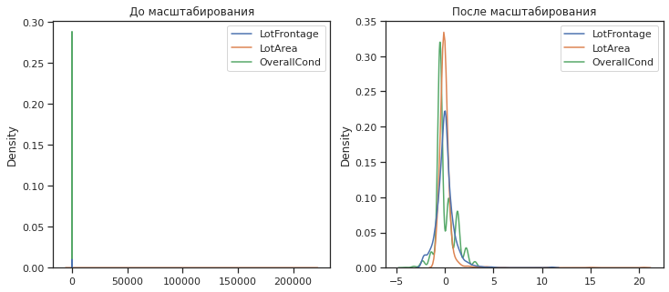

## Масштабирование "Mean Normalisation"

# Разделим выборку на обучающую и тестовую  
X_train, X_test, y_train, y_test = train_test_split(X_ALL, data['SalePrice'],  
 test_size=0.2,  
 random_state=1)  
# Преобразуем массивы в DataFrame  
X_train_df = arr_to_df(X_train)  
X_test_df = arr_to_df(X_test)  
  
X_train_df.shape, X_test_df.shape

((1168, 36), (292, 36))

class MeanNormalisation:  
   
 def fit(self, param_df):  
 self.means = X_train.mean(axis=0)  
 maxs = X_train.max(axis=0)  
 mins = X_train.min(axis=0)  
 self.ranges = maxs - mins  
  
 def transform(self, param_df):  
 param_df_scaled = (param_df - self.means) / self.ranges  
 return param_df_scaled  
   
 def fit_transform(self, param_df):  
 self.fit(param_df)  
 return self.transform(param_df)

sc21 = MeanNormalisation()  
data_cs21_scaled = sc21.fit_transform(X_ALL)  
data_cs21_scaled.describe()

MSSubClass LotFrontage LotArea OverallQual OverallCond \  
count 1460.000000 1460.000000 1460.000000 1460.000000 1460.000000   
mean 0.000962 -0.000452 -0.000119 -0.003900 -0.003058   
std 0.248827 0.075425 0.046653 0.153666 0.158971   
min -0.216081 -0.168431 -0.043200 -0.570491 -0.656678   
25% -0.216081 -0.034869 -0.013970 -0.126046 -0.085250   
50% -0.039610 -0.000452 -0.004973 -0.014935 -0.085250   
75% 0.078037 0.030199 0.004951 0.096176 0.057608   
max 0.783919 0.831569 0.956800 0.429509 0.486179   
  
 YearBuilt YearRemodAdd MasVnrArea BsmtFinSF1 BsmtFinSF2 ... \  
count 1460.000000 1460.000000 1452.000000 1460.000000 1460.000000 ...   
mean -0.003544 -0.008644 -0.000898 -0.001612 0.001276 ...   
std 0.218862 0.344090 0.113166 0.080811 0.109443 ...   
min -0.722876 -0.589740 -0.065702 -0.080216 -0.030304 ...   
25% -0.128673 -0.306407 -0.065702 -0.080216 -0.030304 ...   
50% 0.009008 0.143593 -0.065702 -0.012267 -0.030304 ...   
75% 0.204661 0.310260 0.038048 0.045980 -0.030304 ...   
max 0.277124 0.410260 0.934298 0.919784 0.969696 ...   
  
 GarageArea WoodDeckSF OpenPorchSF EnclosedPorch 3SsnPorch \  
count 1460.000000 1460.000000 1460.000000 1460.000000 1460.000000   
mean -0.000804 -0.000560 -0.001199 -0.001448 -0.000481   
std 0.150779 0.170297 0.121126 0.110723 0.057711   
min -0.334359 -0.128610 -0.086501 -0.041220 -0.007193   
25% -0.098463 -0.128610 -0.086501 -0.041220 -0.007193   
50% 0.004146 -0.128610 -0.040797 -0.041220 -0.007193   
75% 0.071847 0.099651 0.037814 -0.041220 -0.007193   
max 0.665641 1.035793 0.913499 0.958780 0.992807   
  
 ScreenPorch PoolArea MiscVal MoSold YrSold   
count 1460.000000 1460.000000 1460.000000 1460.000000 1460.000000   
mean -0.002194 0.000461 -0.000417 0.002802 -0.001969   
std 0.116161 0.054441 0.032008 0.245784 0.332024   
min -0.033571 -0.003277 -0.003222 -0.481009 -0.455908   
25% -0.033571 -0.003277 -0.003222 -0.117372 -0.205908   
50% -0.033571 -0.003277 -0.003222 -0.026463 0.044092   
75% -0.033571 -0.003277 -0.003222 0.155355 0.294092   
max 0.966429 0.996723 0.996778 0.518991 0.544092   
  
[8 rows x 36 columns]

cs22 = MeanNormalisation()  
cs22.fit(X_train)  
data_cs22_scaled_train = cs22.transform(X_train)  
data_cs22_scaled_test = cs22.transform(X_test)

data_cs22_scaled_train.describe()

MSSubClass LotFrontage LotArea OverallQual OverallCond \  
count 1.168000e+03 1.168000e+03 1.168000e+03 1.168000e+03 1.168000e+03   
mean -2.932396e-17 6.185596e-17 -2.008002e-18 2.690010e-17 2.934772e-17   
std 2.475340e-01 7.707084e-02 4.616115e-02 1.522067e-01 1.587482e-01   
min -2.160808e-01 -1.684311e-01 -4.319969e-02 -5.704909e-01 -5.138209e-01   
25% -2.160808e-01 -3.486947e-02 -1.422028e-02 -1.260464e-01 -8.524951e-02   
50% -3.961019e-02 -4.518024e-04 -4.865072e-03 -1.493531e-02 -8.524951e-02   
75% 7.803687e-02 3.019903e-02 5.045185e-03 9.617580e-02 5.760763e-02   
max 7.839192e-01 8.315689e-01 9.568003e-01 4.295091e-01 4.861791e-01   
  
 YearBuilt YearRemodAdd MasVnrArea BsmtFinSF1 BsmtFinSF2 \  
count 1.168000e+03 1.168000e+03 1.160000e+03 1.168000e+03 1.168000e+03   
mean 7.174151e-16 -1.499276e-15 -1.368637e-17 2.276528e-17 6.422041e-18   
std 2.195064e-01 3.431316e-01 1.112988e-01 8.212989e-02 1.098439e-01   
min -7.228757e-01 -5.897403e-01 -6.570151e-02 -8.021550e-02 -3.030380e-02   
25% -1.286728e-01 -2.897403e-01 -6.570151e-02 -8.021550e-02 -3.030380e-02   
50% 1.625472e-02 1.435930e-01 -6.570151e-02 -9.609550e-03 -3.030380e-02   
75% 2.119069e-01 3.102597e-01 4.070474e-02 4.890392e-02 -3.030380e-02   
max 2.771243e-01 4.102597e-01 9.342985e-01 9.197845e-01 9.696962e-01   
  
 ... GarageArea WoodDeckSF OpenPorchSF EnclosedPorch \  
count ... 1.168000e+03 1.168000e+03 1.168000e+03 1.168000e+03   
mean ... -2.566440e-18 3.721338e-17 4.336809e-19 -1.580262e-17   
std ... 1.486998e-01 1.659810e-01 1.237650e-01 1.136065e-01   
min ... -3.343588e-01 -1.286096e-01 -8.650078e-02 -4.121997e-02   
25% ... -9.740530e-02 -1.286096e-01 -8.650078e-02 -4.121997e-02   
50% ... 4.146178e-03 -1.286096e-01 -3.714063e-02 -4.121997e-02   
75% ... 7.184717e-02 9.965125e-02 3.781367e-02 -4.121997e-02   
max ... 6.656412e-01 8.713904e-01 9.134992e-01 9.587800e-01   
  
 3SsnPorch ScreenPorch PoolArea MiscVal MoSold \  
count 1.168000e+03 1.168000e+03 1.168000e+03 1.168000e+03 1.168000e+03   
mean 8.568168e-18 1.620659e-17 1.444142e-17 5.002182e-18 8.459747e-18   
std 6.122720e-02 1.203524e-01 5.066415e-02 3.560991e-02 2.444658e-01   
min -7.193129e-03 -3.357056e-02 -3.277323e-03 -3.222492e-03 -4.810087e-01   
25% -7.193129e-03 -3.357056e-02 -3.277323e-03 -3.222492e-03 -1.173724e-01   
50% -7.193129e-03 -3.357056e-02 -3.277323e-03 -3.222492e-03 -2.646326e-02   
75% -7.193129e-03 -3.357056e-02 -3.277323e-03 -3.222492e-03 1.553549e-01   
max 9.928069e-01 9.664294e-01 9.967227e-01 9.967775e-01 5.189913e-01   
  
 YrSold   
count 1.168000e+03   
mean -1.635222e-14   
std 3.313190e-01   
min -4.559075e-01   
25% -2.059075e-01   
50% 4.409247e-02   
75% 2.940925e-01   
max 5.440925e-01   
  
[8 rows x 36 columns]

draw_kde(['LotFrontage', 'LotArea', 'OverallCond'], data, data_cs21_scaled, 'До масштабирования', 'После масштабирования')

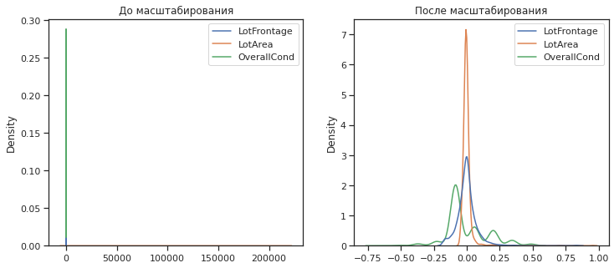

draw_kde(['LotFrontage', 'LotArea', 'OverallCond'], data_cs22_scaled_train, data_cs22_scaled_test, 'Обучающая', 'Тестовая')

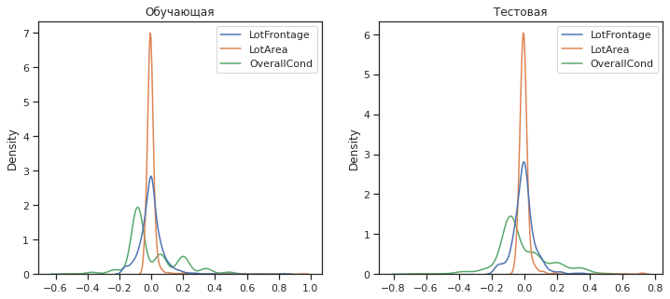

## MinMax-масштабирование

# Обучаем StandardScaler на всей выборке и масштабируем  
cs31 = MinMaxScaler()  
data_cs31_scaled_temp = cs31.fit_transform(X_ALL)  
# формируем DataFrame на основе массива  
data_cs31_scaled = arr_to_df(data_cs31_scaled_temp)  
data_cs31_scaled.describe()

MSSubClass LotFrontage LotArea OverallQual OverallCond \  
count 1460.000000 1460.000000 1460.000000 1460.000000 1460.000000   
mean 0.217043 0.167979 0.043080 0.566591 0.571918   
std 0.248827 0.075425 0.046653 0.153666 0.139100   
min 0.000000 0.000000 0.000000 0.000000 0.000000   
25% 0.000000 0.133562 0.029229 0.444444 0.500000   
50% 0.176471 0.167979 0.038227 0.555556 0.500000   
75% 0.294118 0.198630 0.048150 0.666667 0.625000   
max 1.000000 1.000000 1.000000 1.000000 1.000000   
  
 YearBuilt YearRemodAdd MasVnrArea BsmtFinSF1 BsmtFinSF2 ... \  
count 1460.000000 1460.000000 1452.000000 1460.000000 1460.000000 ...   
mean 0.719332 0.581096 0.064803 0.078604 0.031580 ...   
std 0.218862 0.344090 0.113166 0.080811 0.109443 ...   
min 0.000000 0.000000 0.000000 0.000000 0.000000 ...   
25% 0.594203 0.283333 0.000000 0.000000 0.000000 ...   
50% 0.731884 0.733333 0.000000 0.067948 0.000000 ...   
75% 0.927536 0.900000 0.103750 0.126196 0.000000 ...   
max 1.000000 1.000000 1.000000 1.000000 1.000000 ...   
  
 GarageArea WoodDeckSF OpenPorchSF EnclosedPorch 3SsnPorch \  
count 1460.000000 1460.000000 1460.000000 1460.000000 1460.000000   
mean 0.333554 0.109970 0.085302 0.039772 0.006712   
std 0.150779 0.146253 0.121126 0.110723 0.057711   
min 0.000000 0.000000 0.000000 0.000000 0.000000   
25% 0.235896 0.000000 0.000000 0.000000 0.000000   
50% 0.338505 0.000000 0.045704 0.000000 0.000000   
75% 0.406206 0.196033 0.124314 0.000000 0.000000   
max 1.000000 1.000000 1.000000 1.000000 1.000000   
  
 ScreenPorch PoolArea MiscVal MoSold YrSold   
count 1460.000000 1460.000000 1460.000000 1460.000000 1460.000000   
mean 0.031377 0.003738 0.002806 0.483811 0.453938   
std 0.116161 0.054441 0.032008 0.245784 0.332024   
min 0.000000 0.000000 0.000000 0.000000 0.000000   
25% 0.000000 0.000000 0.000000 0.363636 0.250000   
50% 0.000000 0.000000 0.000000 0.454545 0.500000   
75% 0.000000 0.000000 0.000000 0.636364 0.750000   
max 1.000000 1.000000 1.000000 1.000000 1.000000   
  
[8 rows x 36 columns]

cs32 = MinMaxScaler()  
cs32.fit(X_train)  
data_cs32_scaled_train_temp = cs32.transform(X_train)  
data_cs32_scaled_test_temp = cs32.transform(X_test)  
# формируем DataFrame на основе массива  
data_cs32_scaled_train = arr_to_df(data_cs32_scaled_train_temp)  
data_cs32_scaled_test = arr_to_df(data_cs32_scaled_test_temp)

draw_kde(['LotFrontage', 'LotArea', 'OverallCond'], data, data_cs31_scaled, 'До масштабирования', 'После масштабирования')

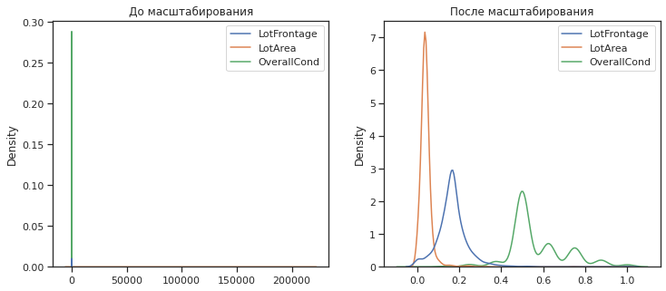

draw_kde(['LotFrontage', 'LotArea', 'OverallCond'], data_cs32_scaled_train, data_cs32_scaled_test, 'Обучающая', 'Тестовая')

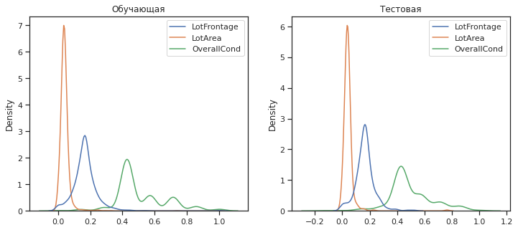

## Обработка выбросов для числовых признаков

data2 = pd.read_csv("./Car_sales.csv")

data2.head()

Manufacturer Model Sales_in_thousands __year_resale_value Vehicle_type \  
0 Acura Integra 16.919 16.360 Passenger   
1 Acura TL 39.384 19.875 Passenger   
2 Acura CL 14.114 18.225 Passenger   
3 Acura RL 8.588 29.725 Passenger   
4 Audi A4 20.397 22.255 Passenger   
  
 Price_in_thousands Engine_size Horsepower Wheelbase Width Length \  
0 21.50 1.8 140.0 101.2 67.3 172.4   
1 28.40 3.2 225.0 108.1 70.3 192.9   
2 NaN 3.2 225.0 106.9 70.6 192.0   
3 42.00 3.5 210.0 114.6 71.4 196.6   
4 23.99 1.8 150.0 102.6 68.2 178.0   
  
 Curb_weight Fuel_capacity Fuel_efficiency Latest_Launch \  
0 2.639 13.2 28.0 2/2/2012   
1 3.517 17.2 25.0 6/3/2011   
2 3.470 17.2 26.0 1/4/2012   
3 3.850 18.0 22.0 3/10/2011   
4 2.998 16.4 27.0 10/8/2011   
  
 Power_perf_factor   
0 58.280150   
1 91.370778   
2 NaN   
3 91.389779   
4 62.777639

data2.describe()

Sales_in_thousands __year_resale_value Price_in_thousands \  
count 157.000000 121.000000 155.000000   
mean 52.998076 18.072975 27.390755   
std 68.029422 11.453384 14.351653   
min 0.110000 5.160000 9.235000   
25% 14.114000 11.260000 18.017500   
50% 29.450000 14.180000 22.799000   
75% 67.956000 19.875000 31.947500   
max 540.561000 67.550000 85.500000   
  
 Engine_size Horsepower Wheelbase Width Length \  
count 156.000000 156.000000 156.000000 156.000000 156.000000   
mean 3.060897 185.948718 107.487179 71.150000 187.343590   
std 1.044653 56.700321 7.641303 3.451872 13.431754   
min 1.000000 55.000000 92.600000 62.600000 149.400000   
25% 2.300000 149.500000 103.000000 68.400000 177.575000   
50% 3.000000 177.500000 107.000000 70.550000 187.900000   
75% 3.575000 215.000000 112.200000 73.425000 196.125000   
max 8.000000 450.000000 138.700000 79.900000 224.500000   
  
 Curb_weight Fuel_capacity Fuel_efficiency Power_perf_factor   
count 155.000000 156.000000 154.000000 155.000000   
mean 3.378026 17.951923 23.844156 77.043591   
std 0.630502 3.887921 4.282706 25.142664   
min 1.895000 10.300000 15.000000 23.276272   
25% 2.971000 15.800000 21.000000 60.407707   
50% 3.342000 17.200000 24.000000 72.030917   
75% 3.799500 19.575000 26.000000 89.414878   
max 5.572000 32.000000 45.000000 188.144323

def diagnostic_plots(df, variable, title):  
 fig, ax = plt.subplots(figsize=(10,7))  
 # гистограмма  
 plt.subplot(2, 2, 1)  
 df[variable].hist(bins=30)  
 ## Q-Q plot  
 plt.subplot(2, 2, 2)  
 stats.probplot(df[variable], dist="norm", plot=plt)  
 # ящик с усами  
 plt.subplot(2, 2, 3)  
 sns.violinplot(x=df[variable])   
 # ящик с усами  
 plt.subplot(2, 2, 4)  
 sns.boxplot(x=df[variable])   
 fig.suptitle(title)  
 plt.show()

diagnostic_plots(data2, 'Sales_in_thousands', 'Sales_in_thousands - original')

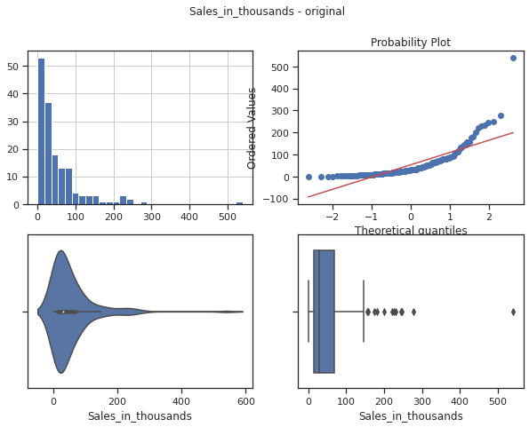

diagnostic_plots(data2, 'Fuel_capacity', 'Fuel_capacity - original')

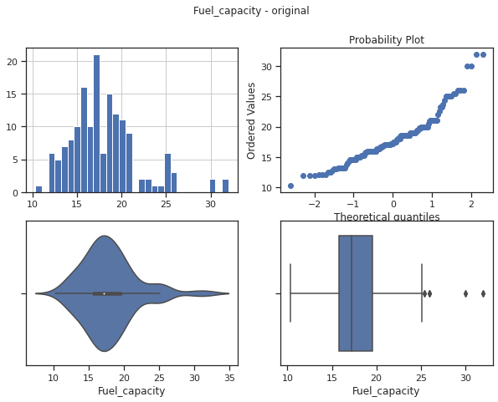

# Тип вычисления верхней и нижней границы выбросов  
from enum import Enum  
class OutlierBoundaryType(Enum):  
 SIGMA = 1  
 QUANTILE = 2  
 IRQ = 3

# Функция вычисления верхней и нижней границы выбросов  
def get_outlier_boundaries(df, col):  
 lower_boundary = df[col].quantile(0.05)  
 upper_boundary = df[col].quantile(0.95)  
 return lower_boundary, upper_boundary

## Удаление выбросов (number_of_reviews)

# Вычисление верхней и нижней границы  
lower_boundary, upper_boundary = get_outlier_boundaries(data2, "Sales_in_thousands")  
# Флаги для удаления выбросов  
outliers_temp = np.where(data2["Sales_in_thousands"] > upper_boundary, True,   
 np.where(data2["Sales_in_thousands"] < lower_boundary, True, False))  
# Удаление данных на основе флага  
data_trimmed = data2.loc[~(outliers_temp), ]   
title = 'Поле-{}, метод-{}, строк-{}'.format("Sales_in_thousands", "QUANTILE", data_trimmed.shape[0])  
diagnostic_plots(data_trimmed, "Sales_in_thousands", title)

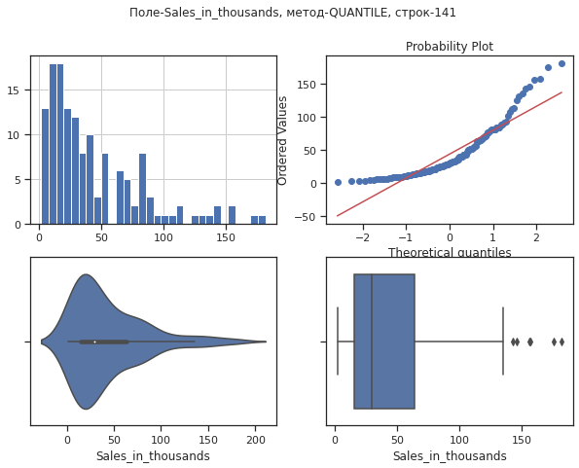

## Замена выбросов

# Вычисление верхней и нижней границы  
lower_boundary, upper_boundary = get_outlier_boundaries(data2, "Fuel_capacity")  
# Изменение данных  
data2["Fuel_capacity"] = np.where(data2["Fuel_capacity"] > upper_boundary, upper_boundary,  
 np.where(data2["Fuel_capacity"] < lower_boundary, lower_boundary, data2["Fuel_capacity"]))  
title = 'Поле-{}, метод-{}'.format("Fuel_capacity", "QUANTILE")  
diagnostic_plots(data2, "Fuel_capacity", title)

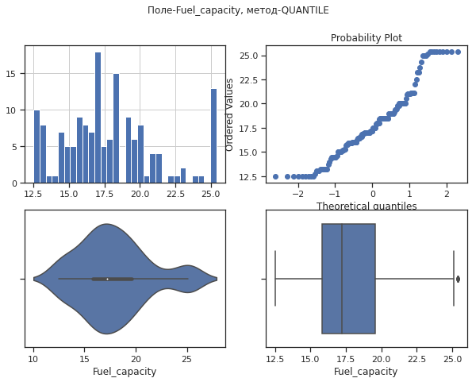

## Обработка нестандартного признака

data2.dtypes

Manufacturer object  
Model object  
Sales_in_thousands float64  
__year_resale_value float64  
Vehicle_type object  
Price_in_thousands float64  
Engine_size float64  
Horsepower float64  
Wheelbase float64  
Width float64  
Length float64  
Curb_weight float64  
Fuel_capacity float64  
Fuel_efficiency float64  
Latest_Launch object  
Power_perf_factor float64  
dtype: object

# Сконвертируем дату и время в нужный формат  
data2["Latest_Launch_Date"] = data2.apply(lambda x: pd.to_datetime(x["Latest_Launch"], format='%m/%d/%Y'), axis=1)

data2.head(5)

Manufacturer Model Sales_in_thousands __year_resale_value Vehicle_type \  
0 Acura Integra 16.919 16.360 Passenger   
1 Acura TL 39.384 19.875 Passenger   
2 Acura CL 14.114 18.225 Passenger   
3 Acura RL 8.588 29.725 Passenger   
4 Audi A4 20.397 22.255 Passenger   
  
 Price_in_thousands Engine_size Horsepower Wheelbase Width Length \  
0 21.50 1.8 140.0 101.2 67.3 172.4   
1 28.40 3.2 225.0 108.1 70.3 192.9   
2 NaN 3.2 225.0 106.9 70.6 192.0   
3 42.00 3.5 210.0 114.6 71.4 196.6   
4 23.99 1.8 150.0 102.6 68.2 178.0   
  
 Curb_weight Fuel_capacity Fuel_efficiency Latest_Launch \  
0 2.639 13.2 28.0 2/2/2012   
1 3.517 17.2 25.0 6/3/2011   
2 3.470 17.2 26.0 1/4/2012   
3 3.850 18.0 22.0 3/10/2011   
4 2.998 16.4 27.0 10/8/2011   
  
 Power_perf_factor Latest_Launch_Date   
0 58.280150 2012-02-02   
1 91.370778 2011-06-03   
2 NaN 2012-01-04   
3 91.389779 2011-03-10   
4 62.777639 2011-10-08

data2.dtypes

Manufacturer object  
Model object  
Sales_in_thousands float64  
__year_resale_value float64  
Vehicle_type object  
Price_in_thousands float64  
Engine_size float64  
Horsepower float64  
Wheelbase float64  
Width float64  
Length float64  
Curb_weight float64  
Fuel_capacity float64  
Fuel_efficiency float64  
Latest_Launch object  
Power_perf_factor float64  
Latest_Launch_Date datetime64[ns]  
dtype: object

# День  
data2['Latest_Launch_Day'] = data2['Latest_Launch_Date'].dt.day  
# Месяц  
data2['Latest_Launch_Month'] = data2['Latest_Launch_Date'].dt.month  
# Год  
data2['Latest_Launch_Year'] = data2['Latest_Launch_Date'].dt.year

## Отбор признаков

## Метод фильтрации (Корреляция признаков)

sns.heatmap(data.corr(), annot=True, fmt='.3f')

<AxesSubplot:>

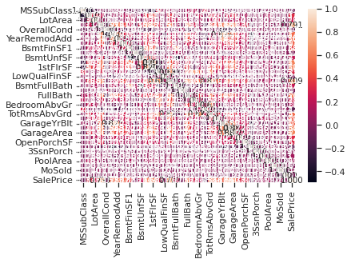

# Формирование DataFrame с сильными корреляциями  
def make_corr_df(df):  
 cr = data.corr()  
 cr = cr.abs().unstack()   
 cr = cr.sort_values(ascending=False)  
 cr = cr[cr >= 0.3]  
 cr = cr[cr < 1]  
 cr = pd.DataFrame(cr).reset_index()  
 cr.columns = ['f1', 'f2', 'corr']  
 return cr

# Обнаружение групп коррелирующих признаков  
def corr_groups(cr):  
 grouped_feature_list = []  
 correlated_groups = []  
  
 for feature in cr['f1'].unique():  
 if feature not in grouped_feature_list:  
 # находим коррелирующие признаки  
 correlated_block = cr[cr['f1'] == feature]  
 cur_dups = list(correlated_block['f2'].unique()) + [feature]  
 grouped_feature_list = grouped_feature_list + cur_dups  
 correlated_groups.append(cur_dups)  
 return correlated_groups

# Группы коррелирующих признаков  
corr_groups(make_corr_df(data))

[['GarageArea',  
 'SalePrice',  
 'OverallQual',  
 'GarageYrBlt',  
 'YearBuilt',  
 'FullBath',  
 'GrLivArea',  
 '1stFlrSF',  
 'TotalBsmtSF',  
 'YearRemodAdd',  
 'MasVnrArea',  
 'TotRmsAbvGrd',  
 'Fireplaces',  
 'GarageCars'],  
 ['GrLivArea',  
 'TotRmsAbvGrd',  
 'HalfBath',  
 'BedroomAbvGr',  
 'FullBath',  
 'SalePrice',  
 'MSSubClass',  
 '2ndFlrSF'],  
 ['BsmtFullBath',  
 'TotalBsmtSF',  
 'BsmtUnfSF',  
 '1stFlrSF',  
 'SalePrice',  
 'BsmtFinSF1'],  
 ['1stFlrSF',  
 'GrLivArea',  
 'TotalBsmtSF',  
 'MSSubClass',  
 'SalePrice',  
 'GarageArea',  
 'TotRmsAbvGrd',  
 'LotArea',  
 'LotFrontage'],  
 ['YearBuilt', 'EnclosedPorch'],  
 ['YearBuilt', 'GarageYrBlt', 'OverallCond'],  
 ['GrLivArea', 'SalePrice', 'OverallQual', 'OpenPorchSF'],  
 ['SalePrice', 'WoodDeckSF']]

## Метод из группы методов вложений

data3 = pd.read_csv("./WineQT.csv", sep=",")

X3_ALL = data3.drop(['quality'], axis=1)

# Разделим выборку на обучающую и тестовую  
X3_train, X3_test, y3_train, y3_test = train_test_split(X3_ALL, data3['quality'],  
 test_size=0.2,  
 random_state=1)

# Используем L1-регуляризацию  
e_lr1 = LogisticRegression(C=1000, solver='liblinear', penalty='l1', max_iter=500, random_state=1)  
e_lr1.fit(X3_train, y3_train)  
# Коэффициенты регрессии  
e_lr1.coef_

array([[ 8.12685010e-01, 1.13666762e+01, 7.82623669e+00,  
 2.73003859e-01, 2.20854445e+00, -8.14499398e-02,  
 -6.07359291e-02, -9.71364320e+00, 1.05928330e+01,  
 -3.02935401e+00, -3.49793957e+00, 4.48070237e-03],  
 [-1.70947991e-02, 3.42135554e+00, -1.21007833e-01,  
 8.32452278e-02, 3.20689559e+00, 1.03669460e-02,  
 -1.25693925e-02, -5.18479271e+00, 2.46658035e+00,  
 9.88462824e-01, -2.04766665e-01, -4.73535890e-04],  
 [-1.50633685e-01, 1.93721323e+00, 1.12321685e+00,  
 1.01141678e-02, 1.55206374e+00, -1.74615115e-02,  
 1.48826890e-02, 5.10001726e+00, -2.81228295e-02,  
 -2.62509731e+00, -9.26899115e-01, 5.26799951e-05],  
 [ 1.90322225e-01, -1.79843954e+00, -2.04300613e+00,  
 -4.72955643e-02, 2.58455381e+00, 1.21352411e-02,  
 -7.83754176e-03, -2.99949432e+00, 9.79232831e-01,  
 8.78802257e-01, 2.38635326e-01, 1.63131072e-04],  
 [-2.89452663e-02, -3.07001091e+00, 1.47490514e+00,  
 7.64831115e-02, -1.76133253e+01, 2.58137752e-02,  
 -2.04458316e-02, -3.51585085e+00, -1.28269840e+00,  
 2.73049298e+00, 8.81957513e-01, -5.47347256e-04],  
 [-5.95096357e-01, 3.04283371e+00, 3.41733495e+00,  
 -1.83182731e-01, -3.51167880e+01, -2.83696795e-02,  
 -2.51328328e-02, 7.93053290e+00, -9.85694602e+00,  
 3.86988223e+00, 1.26366792e+00, 6.15531404e-04]])

# Все признаки являются "хорошими"  
from sklearn.feature_selection import SelectFromModel  
sel_e_lr1 = SelectFromModel(e_lr1)  
sel_e_lr1.fit(X3_train, y3_train)  
sel_e_lr1.get_support()

array([ True, True, True, True, True, True, True, True, True,  
 True, True, True])

e_lr2 = LinearSVC(C=0.01, penalty="l1", max_iter=2000, dual=False)  
e_lr2.fit(X3_train, y3_train)  
# Коэффициенты регрессии  
e_lr2.coef_

array([[ 0.00000000e+00, 0.00000000e+00, 0.00000000e+00,  
 0.00000000e+00, 0.00000000e+00, 0.00000000e+00,  
 -4.11659803e-03, 0.00000000e+00, 0.00000000e+00,  
 0.00000000e+00, -8.74382321e-02, 2.16148014e-05],  
 [-3.25745178e-02, 0.00000000e+00, 0.00000000e+00,  
 0.00000000e+00, 0.00000000e+00, 0.00000000e+00,  
 -1.53916210e-03, 0.00000000e+00, 0.00000000e+00,  
 0.00000000e+00, -5.09487130e-02, -7.57779919e-05],  
 [ 5.39177199e-03, 0.00000000e+00, 0.00000000e+00,  
 0.00000000e+00, 0.00000000e+00, -1.01430758e-02,  
 9.74806502e-03, 0.00000000e+00, 2.69288264e-01,  
 0.00000000e+00, -1.39279561e-01, 6.67641089e-05],  
 [-3.23252579e-03, 0.00000000e+00, 0.00000000e+00,  
 -3.14349482e-03, 0.00000000e+00, 8.03325787e-03,  
 -6.31223332e-03, 0.00000000e+00, 0.00000000e+00,  
 0.00000000e+00, 0.00000000e+00, 1.50656398e-05],  
 [-3.14962509e-03, 0.00000000e+00, 0.00000000e+00,  
 0.00000000e+00, 0.00000000e+00, 3.10822416e-03,  
 -4.09569949e-03, 0.00000000e+00, -2.53593008e-01,  
 0.00000000e+00, 3.23916178e-02, -8.18828669e-05],  
 [-3.58405887e-02, 0.00000000e+00, 0.00000000e+00,  
 0.00000000e+00, 0.00000000e+00, 0.00000000e+00,  
 -3.69126692e-03, 0.00000000e+00, 0.00000000e+00,  
 0.00000000e+00, -4.94292064e-02, -5.74195751e-05]])

# Признаки с флагом False д.б. исключены  
sel_e_lr2 = SelectFromModel(e_lr2)  
sel_e_lr2.fit(X3_train, y3_train)  
sel_e_lr2.get_support()

array([ True, False, False, True, False, True, True, False, True,  
 False, True, True])