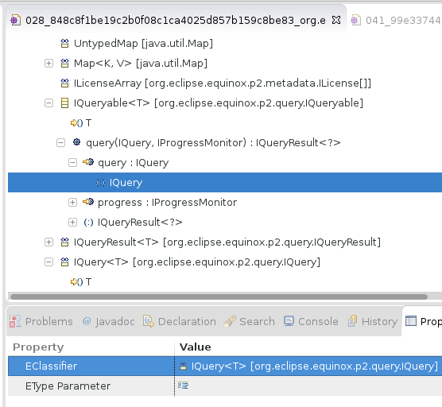

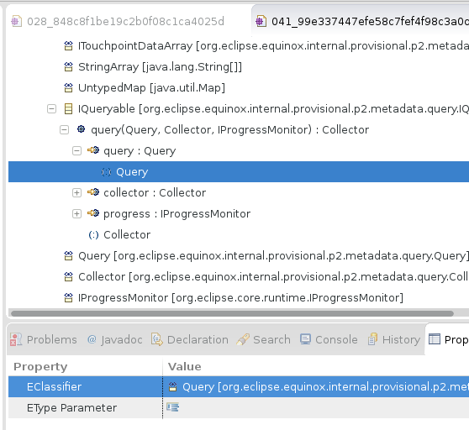

Validation error:

INTRODUCED: 028_848c8f1be19c2b0f08c1ca4025d857b159c8be83_org.eclipse.b3.aggregator_model_Aggregator.ecore
RESOLVED: 041_99e337447efe58c7fef4f98c3a0de446eeedb977_org.eclipse.b3.aggregator_model_Aggregator.ecore
source: org.eclipse.emf.ecore.model
severity: WARNING
message: The generic type associated with the 'IQuery' classifier should have 1 type argument(s) to match the number of type parameter(s) of the classifier
[org.eclipse.emf.ecore.impl.EGenericTypeImpl@57f11502 (expression: IQuery), org.eclipse.emf.ecore.impl.EReferenceImpl@528c868 (name: eTypeArguments) (ordered: true, unique: true, lowerBound: 0, upperBound: -1) (changeable: true, volatile: false, transient: false, defaultValueLiteral: null, unsettable: false, derived: false) (containment: true, resolveProxies: false)]

The operation parameter “query” of the operation “query” of class Iqueryable is of type “IQuery” in revision 28. Since IQuery is a generic type having one formal type parameter (called T in revision 28), an actual type parameter must be bound to the formal type parameter by the operation parameter “query”. This is not the case, the actual type parameter is not set.

Resolution of the validation error:
In revision 41, this validation error has been resolved. The class IQuery, which has been renamed to “Query” in revision 41, is not a generic type anymore, i.e. its formal type parameter T has been deleted.

Consistency-preserving edit rules:
I think there are several CPERs covering the following cases of creating an operation parameter:
- If the type of the new operation parameter is not a generic type, then we can simply create the operation parameter and immediately set its type (mandatory neughbor)
- If the type of the new operation parameter is a generic type, we immediately set its type and also an actual type parameter for the formal type parameter defined by the generic type.
- If the type of the new operation parameter is a generic type, we immediately set its type and we also convert that type to become a non-generic type, i.e. we delete its formal type parameter(s).

Note that option 3) can be used to resolve the validation error in our example.

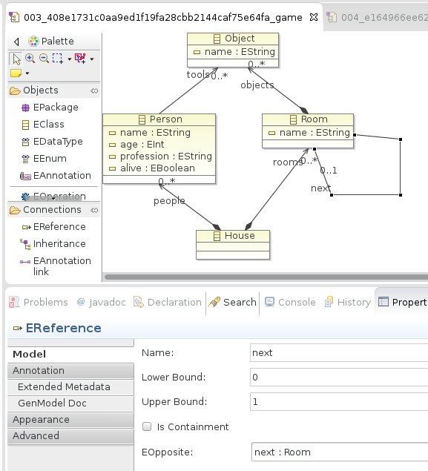

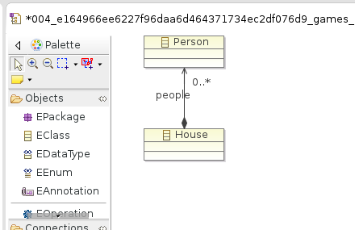

Validation error:
INTRODUCED: 003_408e1731c0aa9ed1f19fa28cbb2144caf75e64fa_games_murdercase_murdercase.ecore
RESOLVED: 004_e164966ee6227f96daa6d464371734ec2df076d9_games_murdercase_murdercase.ecore
source: org.eclipse.emf.ecore.model
severity: ERROR
message: The opposite may not be its own opposite
[org.eclipse.emf.ecore.impl.EReferenceImpl@14753c38 (name: next) (ordered: true, unique: true, lowerBound: 0, upperBound: 1) (changeable: true, volatile: false, transient: false, defaultValueLiteral: null, unsettable: false, derived: false) (containment: false, resolveProxies: true), org.eclipse.emf.ecore.impl.EReferenceImpl@14753c38 (name: next) (ordered: true, unique: true, lowerBound: 0, upperBound: 1) (changeable: true, volatile: false, transient: false, defaultValueLiteral: null, unsettable: false, derived: false) (containment: false, resolveProxies: true), org.eclipse.emf.ecore.impl.EReferenceImpl@65045a87 (name: eOpposite) (ordered: true, unique: true, lowerBound: 0, upperBound: 1) (changeable: true, volatile: false, transient: false, defaultValueLiteral: null, unsettable: false, derived: false) (containment: false, resolveProxies: true), org.eclipse.emf.ecore.impl.EReferenceImpl@65045a87 (name: eOpposite) (ordered: true, unique: true, lowerBound: 0, upperBound: 1) (changeable: true, volatile: false, transient: false, defaultValueLiteral: null, unsettable: false, derived: false) (containment: false, resolveProxies: true)]

Loop reference called “next” declares itself to be its opposite.

Resolution of the validation error:
Well, most parts of the model have been simply deleted in revision 4. So this is a typical undo I would say, and our method is not appropriate to resolve the inconsistency, is it?

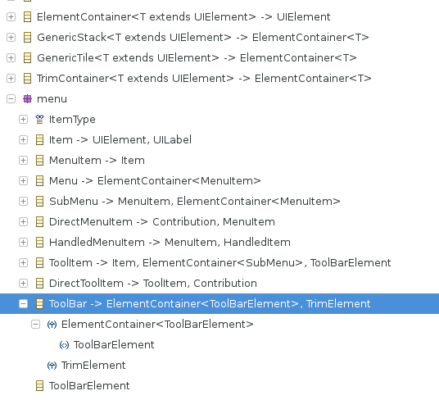
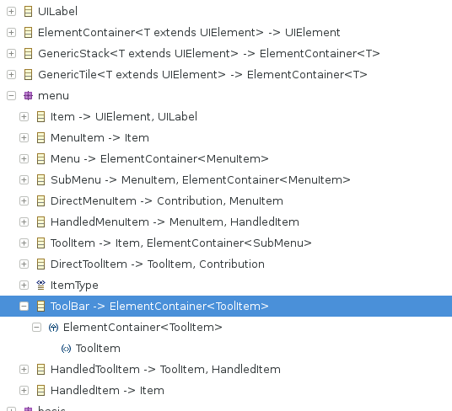

Validation error:

INTRODUCED: 075_88e351143ddc556848c299560dc8bda360bfeddb_bundles_org.eclipse.e4.ui.model.workbench_model_UIElements.ecore
RESOLVED: 077_5e3fc9559037bf2c9a287f2ee90271a147436df0_bundles_org.eclipse.e4.ui.model.workbench_model_UIElements.ecore
source: org.eclipse.emf.ecore.model
severity: ERROR
message: The generic type 'org.eclipse.emf.ecore.impl.EGenericTypeImpl@248bd85d{file:/home/kehrer/Downloads/GitExtractedModels/versions/e4/eclipse.platform.ui.e4/bundles/org.eclipse.e4.ui.model.workbench/model/UIElements.ecore/075_88e351143ddc556848c299560dc8bda360bfeddb_bundles_org.eclipse.e4.ui.model.workbench_model_UIElements.ecore#//ui/menu/ToolBar/@eGenericSuperTypes.0/@eTypeArguments.0}' is not a valid substitution for type parameter 'org.eclipse.emf.ecore.impl.ETypeParameterImpl@469f5c2a{file:/home/kehrer/Downloads/GitExtractedModels/versions/e4/eclipse.platform.ui.e4/bundles/org.eclipse.e4.ui.model.workbench/model/UIElements.ecore/075_88e351143ddc556848c299560dc8bda360bfeddb_bundles_org.eclipse.e4.ui.model.workbench_model_UIElements.ecore#//ui/ElementContainer/T}'
[org.eclipse.emf.ecore.impl.EGenericTypeImpl@545e06ab (expression: ElementContainer<ToolBarElement>), org.eclipse.emf.ecore.impl.EGenericTypeImpl@248bd85d (expression: ToolBarElement), org.eclipse.emf.ecore.impl.ETypeParameterImpl@469f5c2a (name: T), org.eclipse.emf.ecore.impl.EReferenceImpl@528c868 (name: eTypeArguments) (ordered: true, unique: true, lowerBound: 0, upperBound: -1) (changeable: true, volatile: false, transient: false, defaultValueLiteral: null, unsettable: false, derived: false) (containment: true, resolveProxies: false)]

