JSFIDDLE

**UMKC**

**KARTHIK REPALA**

**16144888**

**9/4/2013**

Karthik Repala

Creating a Web application using HTML,Java Script and CSS

Link to the JSFiddle: <http://jsfiddle.net/karthikrepala/8TJKc/2/>

"<http://jsfiddle.net/karthikrepala/8TJKc/4/>" If the above doesn't work.

The below picture is the Jsfiddle.net page which has three slots for including the codes of HTML,

Java Script and CSS and the final slot is the results slot.

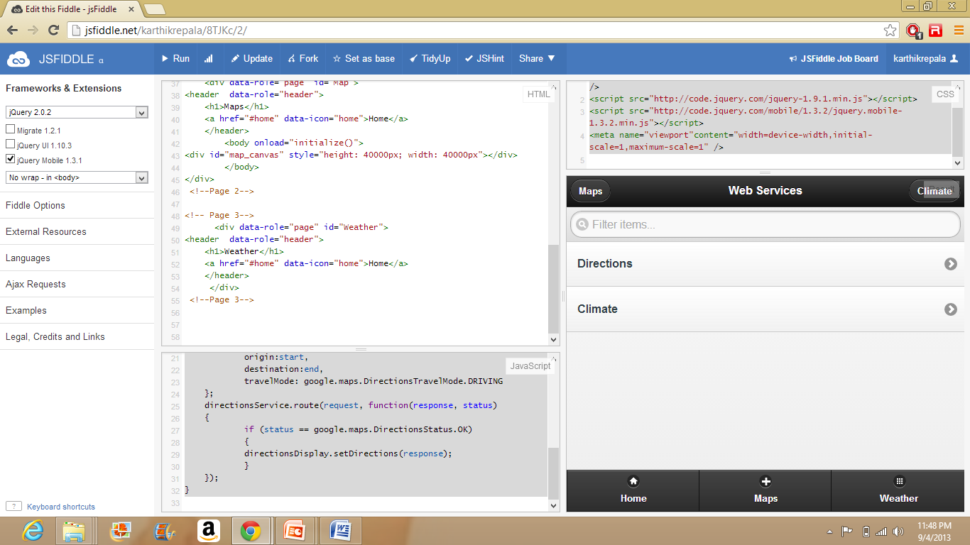

**Home Page of the Web App.**

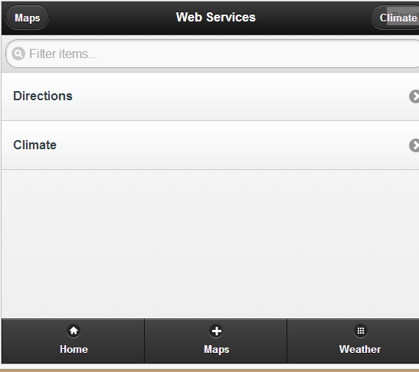

Directions Page shows the directions between Source A and Source B.

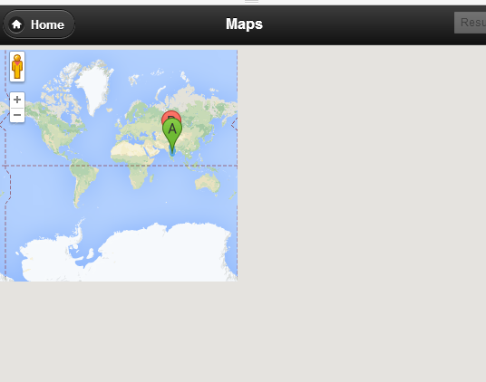

Source A is Hyderabad

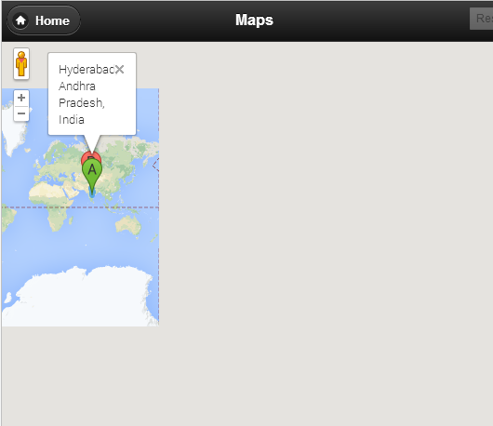

Source B is NewDelhi

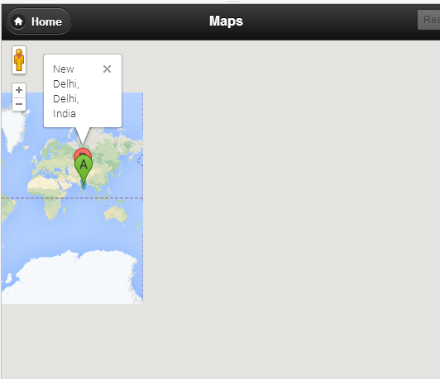

The below are the files of HTML, JavaScript and CSS.





