**Installing IIS server**

Go to Server Manger in My Computer of Remote Desktop.

Install a Web Server(IIS) Role under the Roles tab.

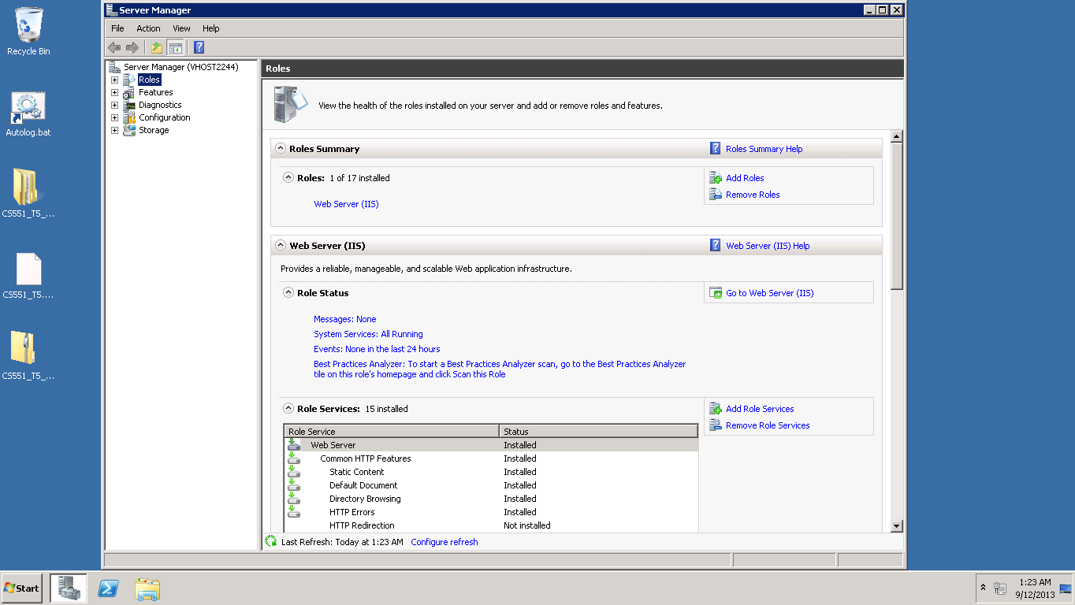

Check the firewall settings and make changes if necessary.

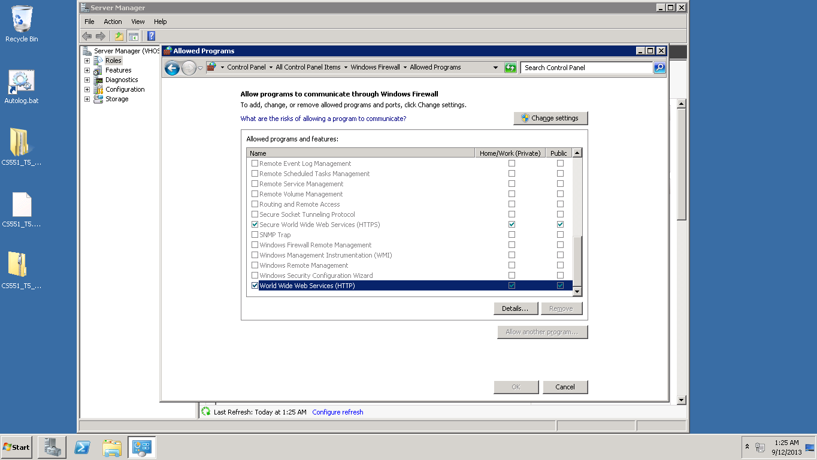

Additional configuration settings can be done in the MyComputer-->Manage Path.

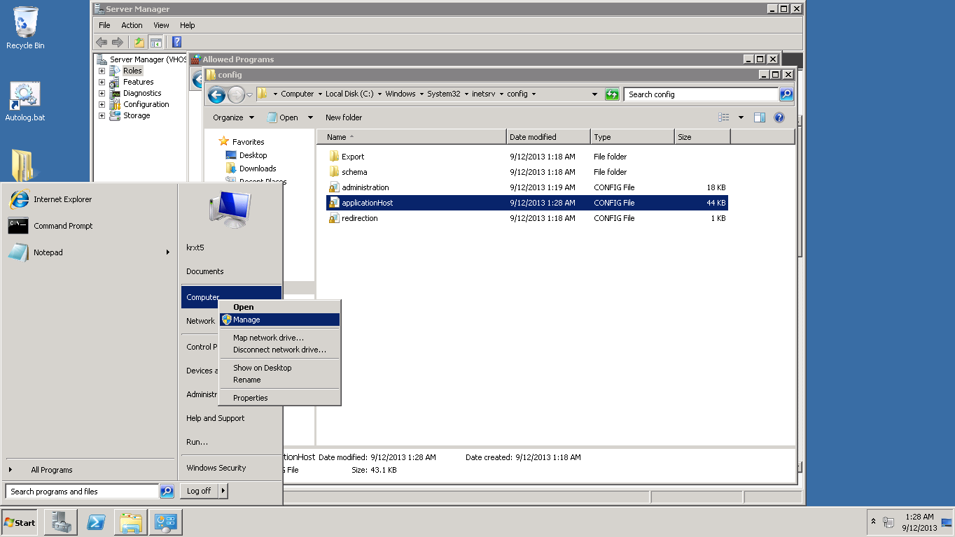

After roles are created,install the features under the Features Tab.

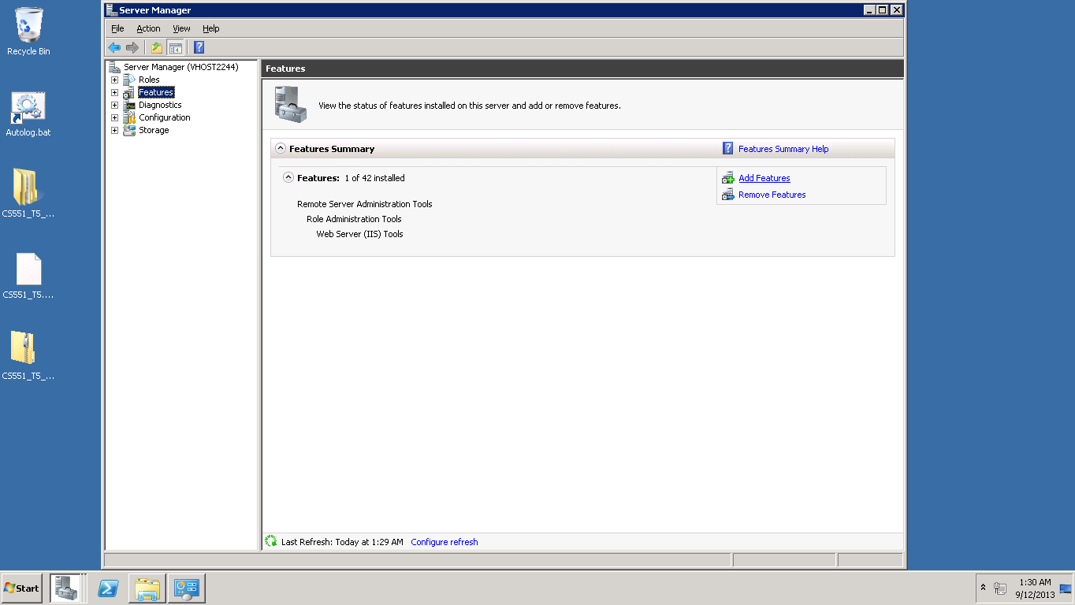

Select the .NET framework and click on install. The below screen shows the installation window.

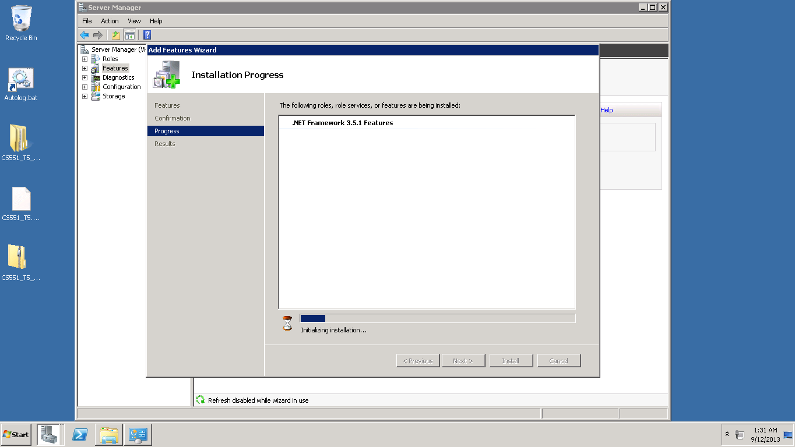

Go to Window Powershell folder and import the Module-Servermanager and add windows feature as .net framework.

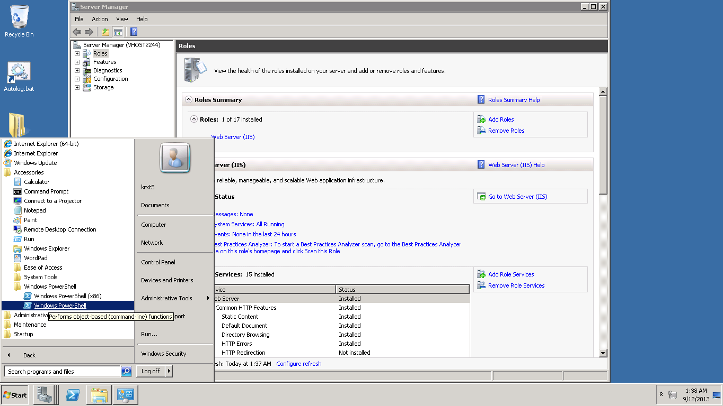

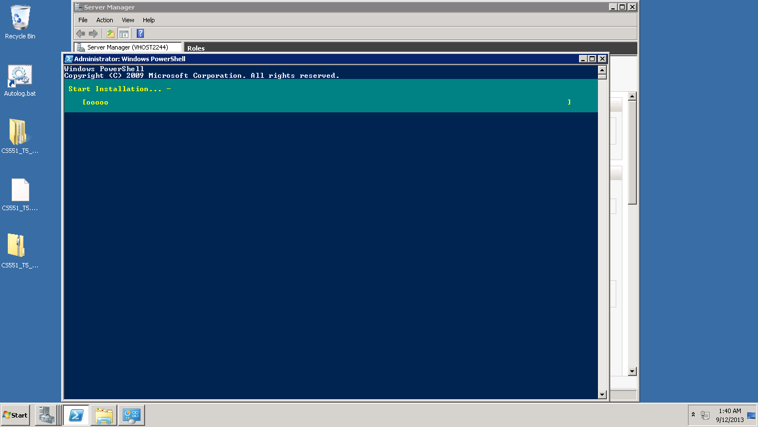

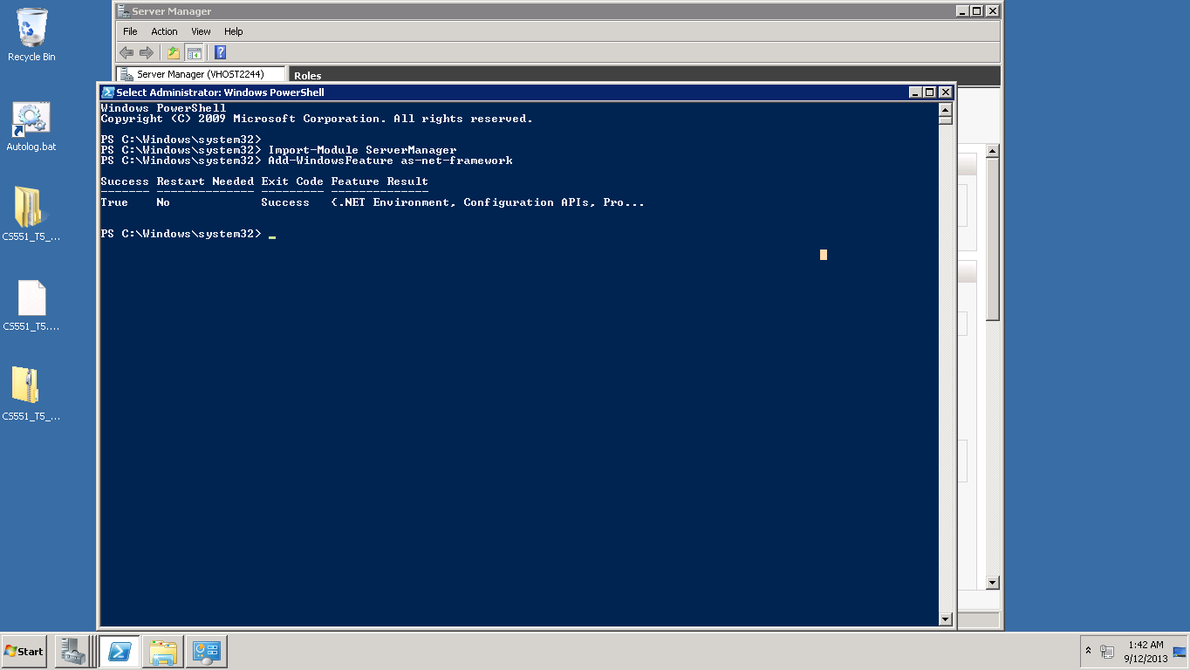

Add the IIS Configuration and .Net 4.5

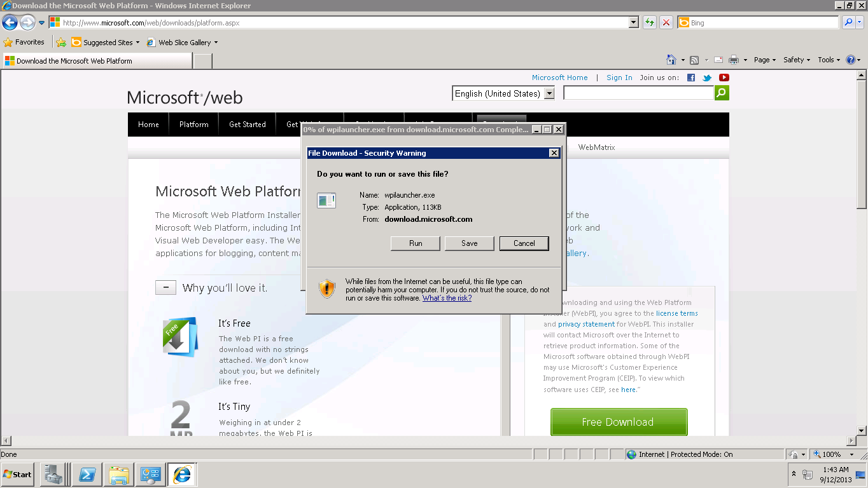

Add the ISS Configuration and Visual Studio and install them.

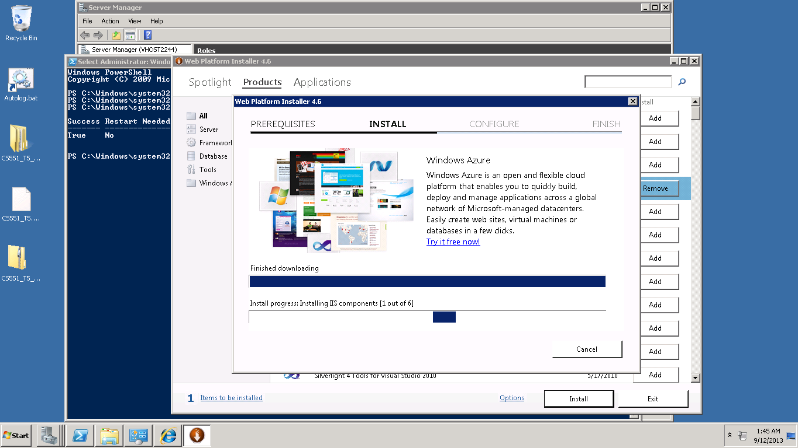

Upload the WCF service file into the IIS and convert the wcf service into an application.

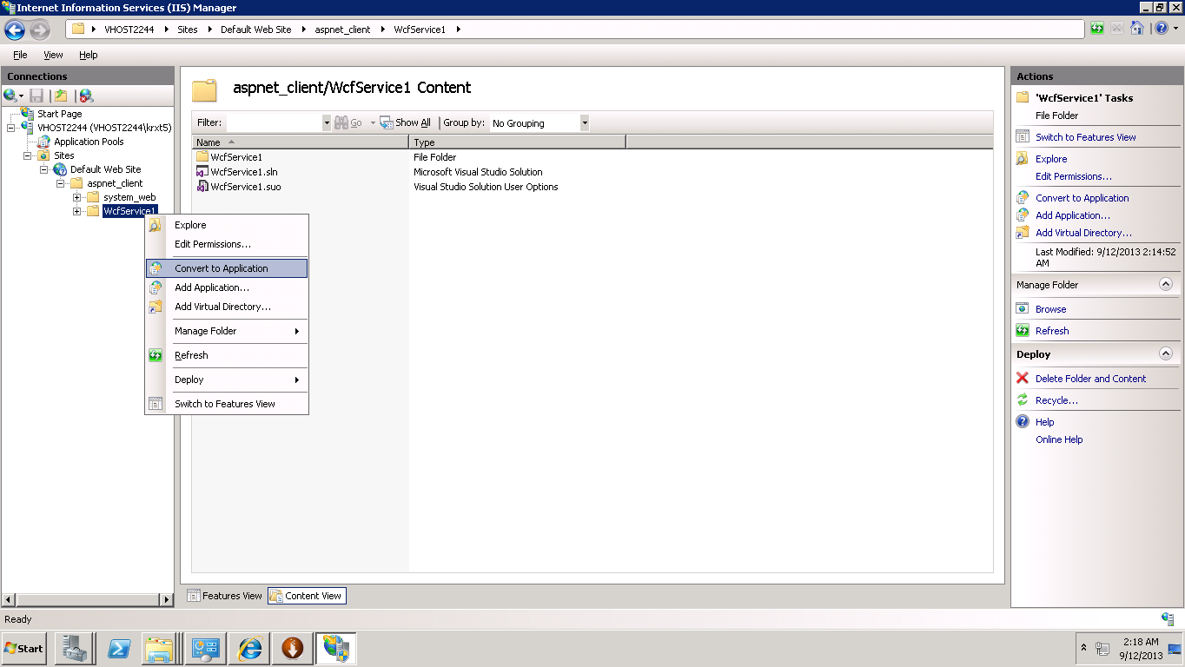

Create another User as IIS_IUSRS and give the Full Control Access.

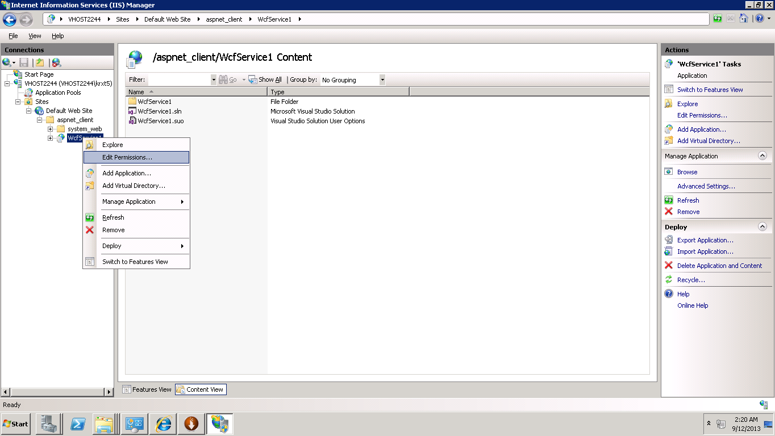

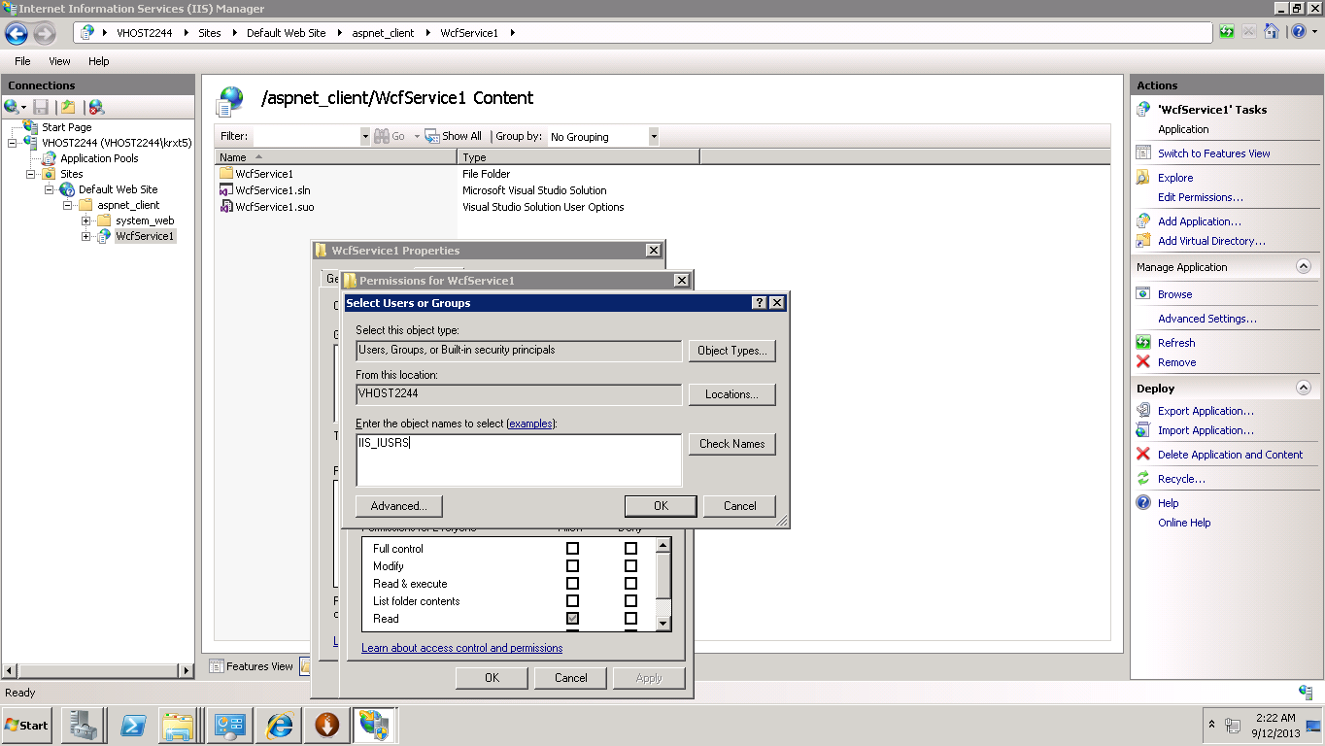

Change the service from default to ASP.NET v4.0

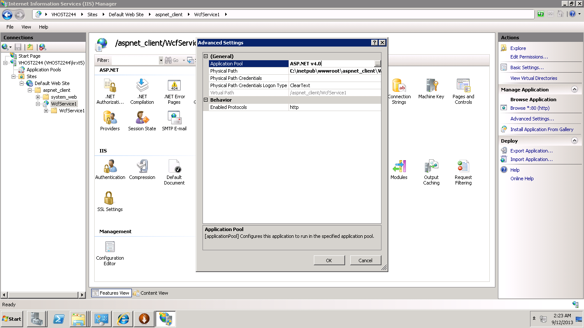

Open the Microsoft Visual Studio and import the project.

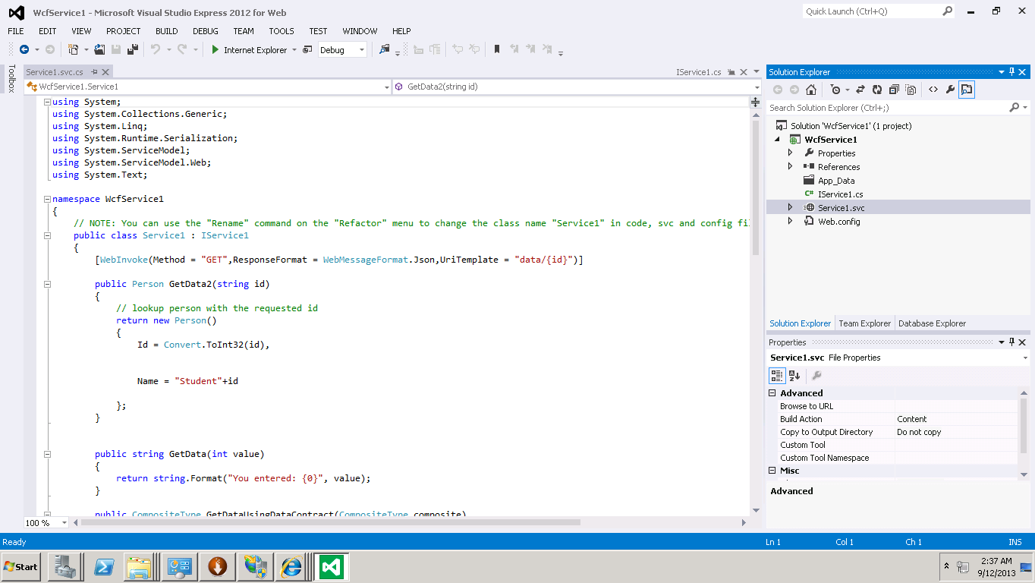

Right Click the Service1.svc file and select the browse option.

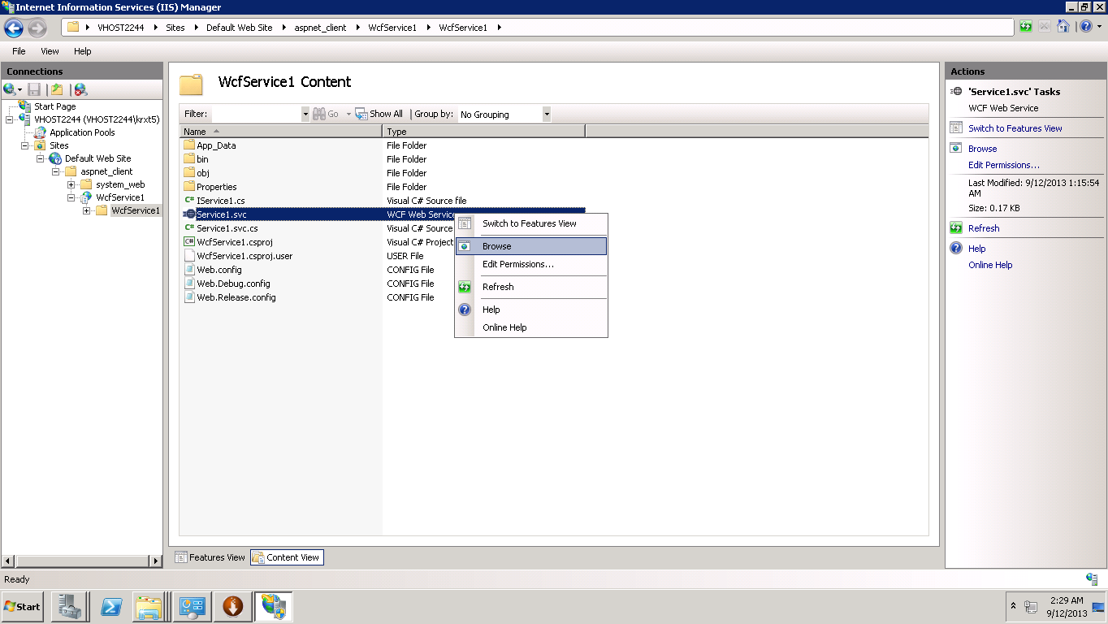

A json file will be downloaded in IE Browser.

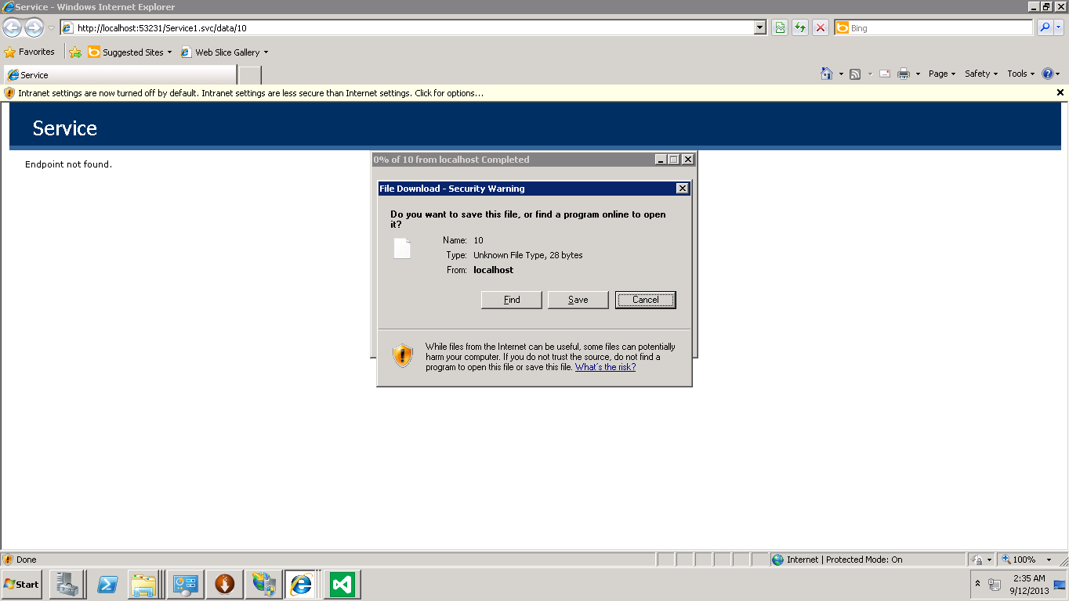

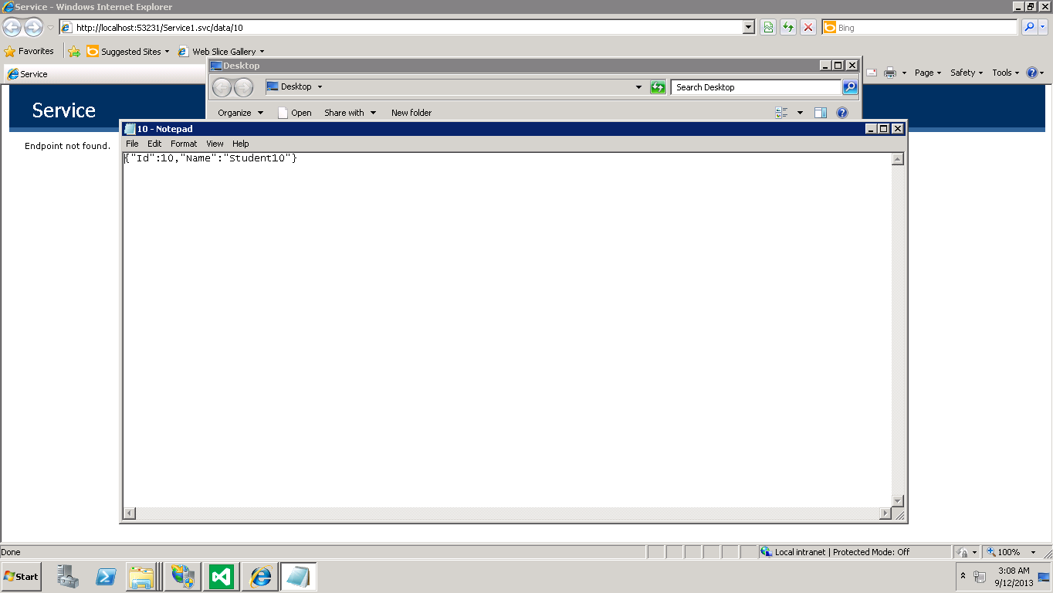

The above application can also be opened in the local machine.

Change the "local host" in the URL to the real hostname.

http:// vhost2244.site1.compute.ihost.com:53231/Service1.svc/data/10