# Assignment 0 – Installation and Setup

Requirements

* Create Particle account
* Install Particle Workbench
* Install Fritzing
* Add argon device to your Particle account

________________________________________

## Create Particle account

In this course, we will use an internet-enabled microcontroller, specifically the Particle Argon. In order to communicate with the Argon (e.g. to install new firmware code), we will use Particle’s cloud software.

* Open the internet browser of your choice and visit the site:   
  <https://www.particle.io/>
* Go to Login and create a new account

## Install Particle Workbench

Workbench is the IDE we will use to write firmware code as well as to install it on the device

* Open the internet browser of your choice and visit the site: <https://www.particle.io/workbench/>
* Download and install Particle Workbench

## Install Fritzing

Fritzing is a program to create visual layouts of device projects.

* Open the internet browser of your choice and visit the site:

<http://fritzing.org/download/>

* Download and install Particle Workbench

## Add Argon device to your Particle account

This step must be completed after you receive the Argon from the instructor. Each Argon device must be linked to Particle account.

* Follow the instructions to claim your Argon and link it to your account:

<https://docs.particle.io/quickstart/argon/#1-set-up-your-argon>

* Complete only step #1 (setting up Argon) and do not proceed any further.

**Important Notes**

1. During the setup process, the mobile app will ask if you want to set up mesh networking. Choose the option **Do not use in mesh networking**

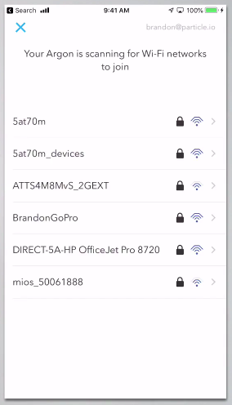

1. You may eventually need to connect it to multiple networks (e.g. at USC and where you live), but you will begin with a single Wifi network. When connecting to Wifi at USC, make sure to use **USC Guest Wireless**, not USC Secure Wireless

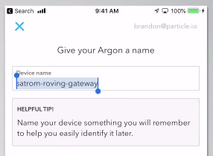

1. During setup, you will be asked to provide a name for your Argon. This is the name that you will use in your projects to reference your device throughout the semester so make note of it

## Deliverables

1. There is nothing to submit for this assignment.