# Assignment 2 – Light Sculpture

## Goals

* Connect LEDs to Argon
* Create engaging art piece

Overview

This assignment is to create a physical art sculpture using the Argon and LEDs. The specifics of what the sculpture looks like or what it does is entirely up to you. You can put LEDs on a box, on a card, inside straws or ping-pongs, etc. One suggestion is that you can use “extending” jumper wires (female-male) to have the LEDs away from the breadboard. If you want to use these, ask the instructor.

Some example are below.

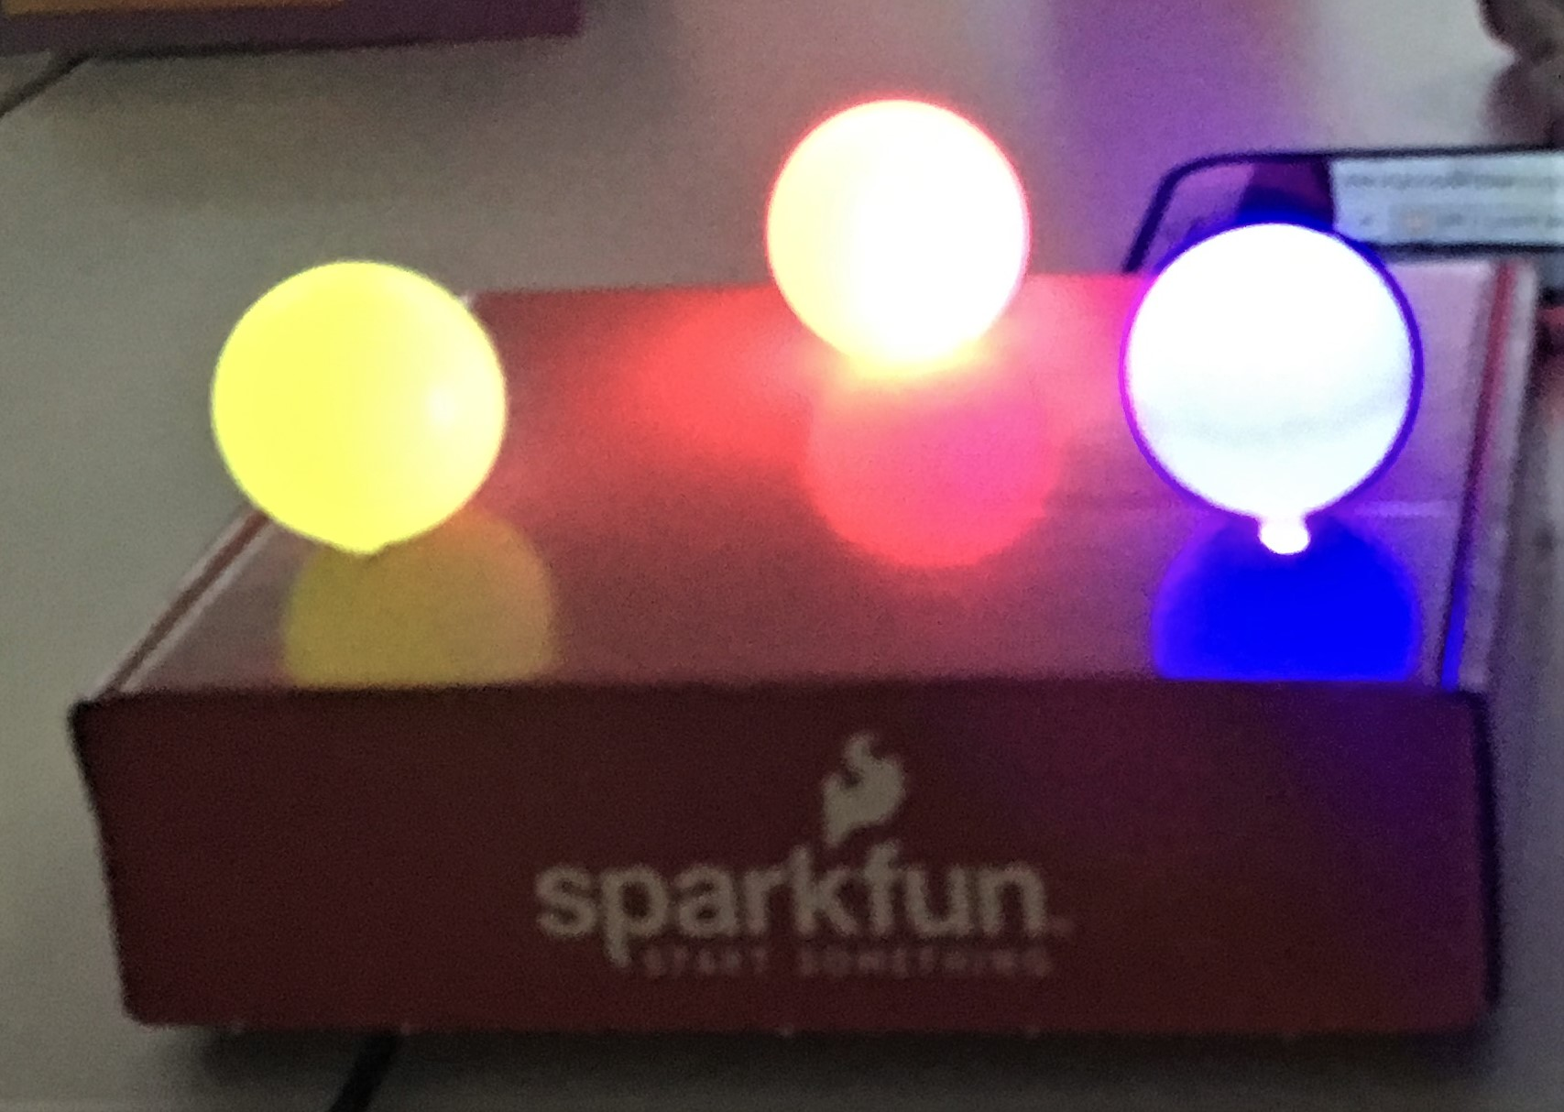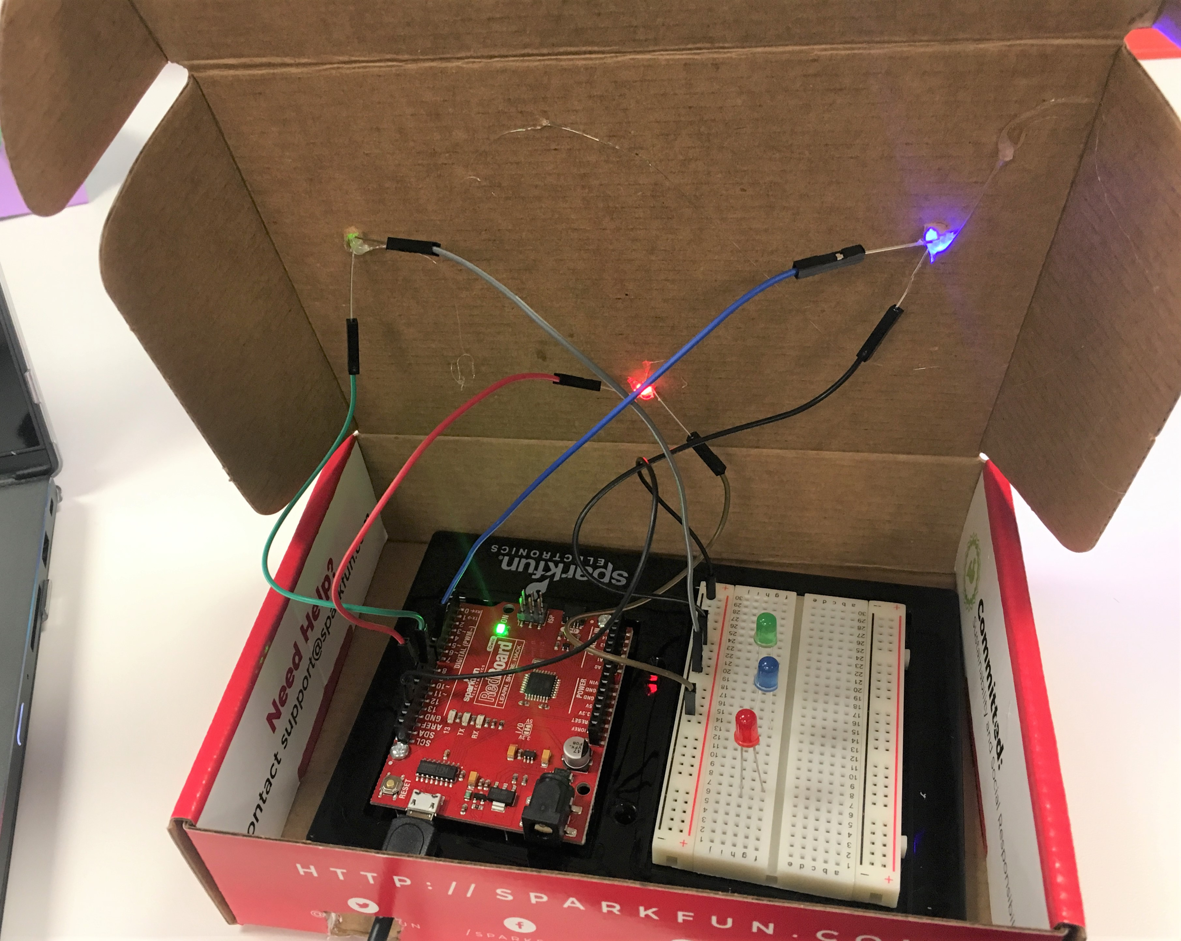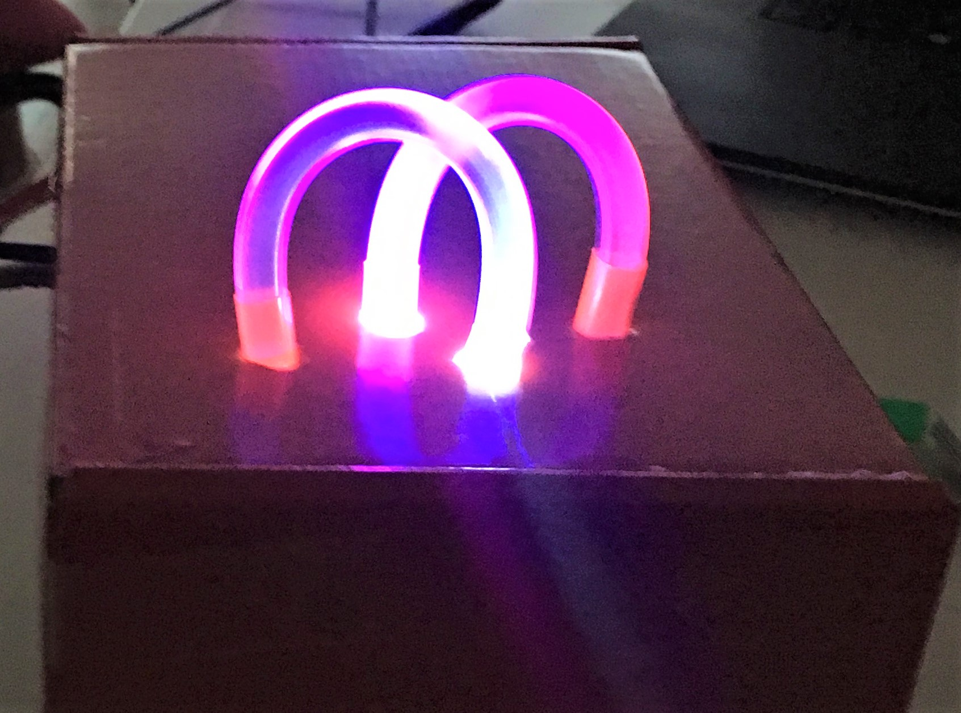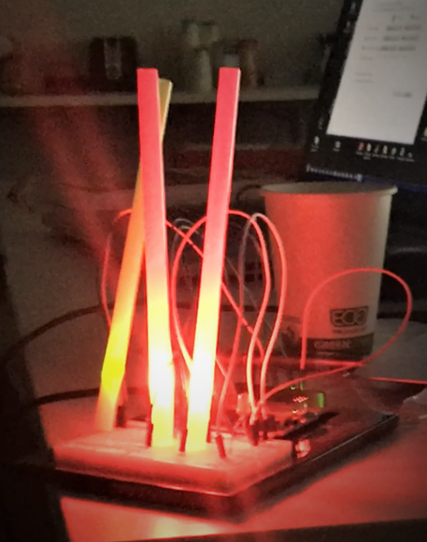

Components

* Argon
* Breadboard
* 3 x LEDs (or more)
* 3 x 330 Ohm resistors
* Jumper wire (standard male-male)
* Creative supplies for sculpture (e.g. cardboard box, straws, glue sticks, felt, paper, ping-pong balls, etc.)
* Optional: extension jumper wires (female-male)

Requirements

* Connect at least three LEDs to Argon
* Control LEDs on / off / blink from code

Required naming convention (replace # with the current assignment number)

* **Project Name** 
  + itp348_a#_lastname_firstname
* **Zip File** (include entire project folder)
  + itp348_a#_lastname_firstname.zip

## Deliverables

1. A compressed file containing your project. Follow the guidelines for full credit.

Here are the instructions for submission

1. Navigate to your project folder.
2. Include the *entire* folderin a zip file
3. Rename the zip file based on naming convention
4. Upload zip file to Blackboard site for our course
5. A photograph of your device connected to USB with the blue light on.

## Grading

|  |  |
| --- | --- |
| Item | Points |
| Three LEDs used | 10 |
| Appropriate resistors | 5 |
| 3d sculpture (not just lights on breadboard) | 5 |
|  |  |
| Total | 20 |