# Assignment 3 – Scanning Light

## Goals

* Connect LEDs to Argon
* Read analog input with a potentiometer
* Control scanning LEDS with potentiometer
* Use PWM to change LED intensity

Overview

This assignment is to create variable scanning / oscillating light pattern on 5 LEDs. The scanning rate will be controlled with a potentiometer. This pattern is often seen in TV and films such as [KITT from Knight Rider](https://www.youtube.com/watch?v=WxE2xWZNfOc) and the [Cylons from Battlestar Galatica](https://youtu.be/-z-HQBfnwiA?t=5).

The light pattern will oscillate from right to left and back again. As the potentiometer is turned, the lights will blink faster or slower. However, in addition to the rate changing, the intensity will also change (more bright to less bright.

Here is an example with 7 lights.

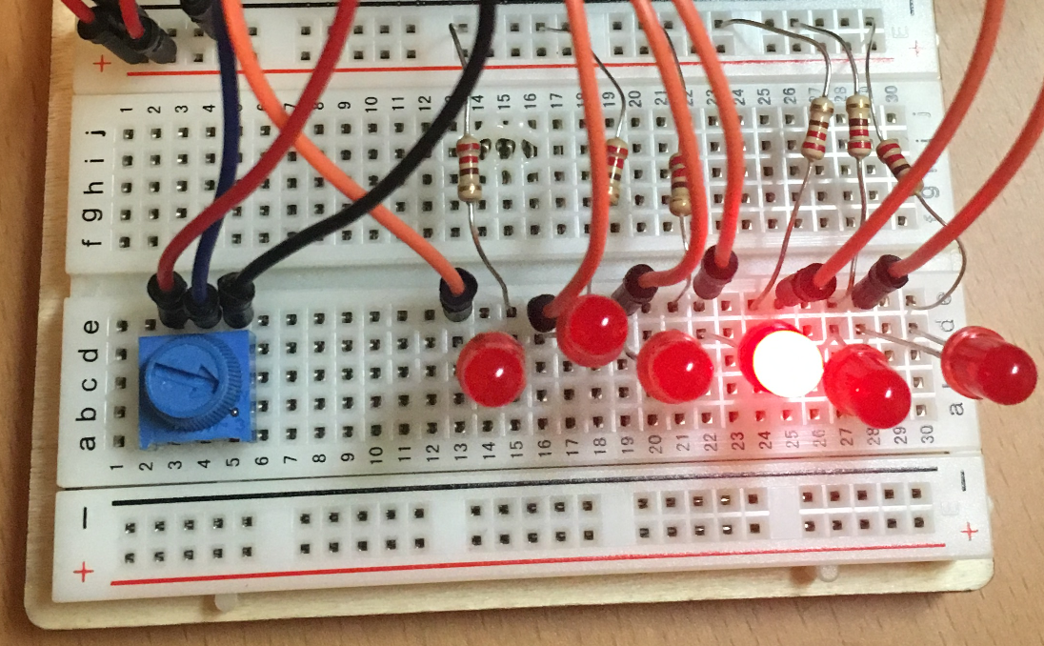

Components

* Argon
* Breadboard
* 5 x LEDs
* 5 x 330 Ohm resistors
* 1 x 10k Ohm potentiometer
* Jumper wire (standard male-male)

Requirements

* Connect five LEDs to Argon
* Control potentiometer
* Use the potentiometer to control both the oscillating rate and the brightness
  + When the potentiometer is turned fully clockwise, the lights should be bright and fully on
* When turned counter-clockwise, the lights should be very dim and blinking slowly

Challenge

* Use a for loop to iterate through the LEDs (hint: this will require the use of an array, which is like a C++ list)

Required naming convention (replace # with the current assignment number)

* **Project Name** 
  + itp348_a#_lastname_firstname
* **Zip File** (include entire project folder)
  + itp348_a#_lastname_firstname.zip

## Deliverables

1. A compressed file containing your project. Follow the guidelines for full credit.

Here are the instructions for submission

1. Navigate to your project folder.
2. Include the *entire* folderin a zip file
3. Rename the zip file based on naming convention
4. Upload zip file to Blackboard site for our course
5. A photograph of your device connected to USB with the blue light on.
6. A (very) short video demonstrating your project functioning

## Grading

|  |  |
| --- | --- |
| Item | Points |
| 5 LEDs used | 5 |
| Potentiometer controls scan rate | 10 |
| Potentiometer controls brightness | 10 |
|  |  |
| Total | 20 |

**Credits**

* Inspiration for project from [Dr. Peter Dalmaris](https://www.udemy.com/course/arduino-step-by-step-2017-getting-started-projects/)