# Assignment 6 – Shared Environment Monitor

[*Submit on Blackboard*](https://blackboard.usc.edu/)

## Goals

* Connect TMP36 and store sensor data
* Display data on OLED
* Publish events to Particle cloud
* Subscribe to events and process data

Overview

This assignment is to create a public temperature feed for ITP 348. You will read the temperature from their home and send the data as public event to the Particle cloud. You will then use an OLED to display two screens: 1) feed of the most recent temperatures from all students, and 2) your own temperature along with the average and max of all the temperatures.

Here is an example:

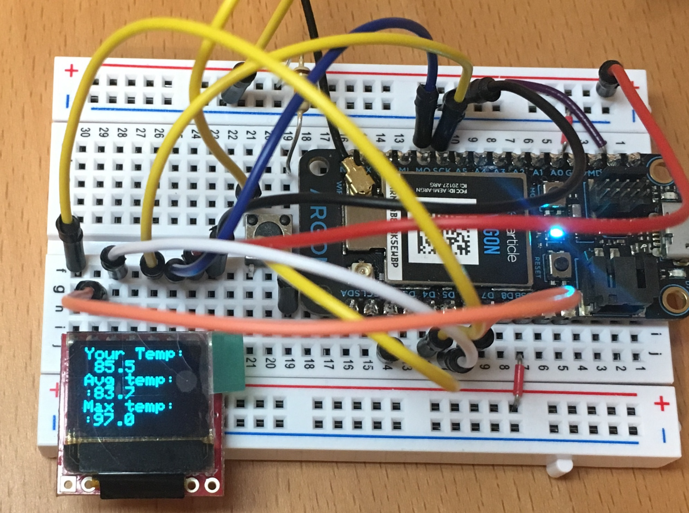

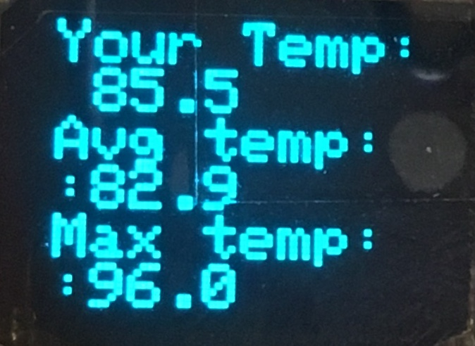 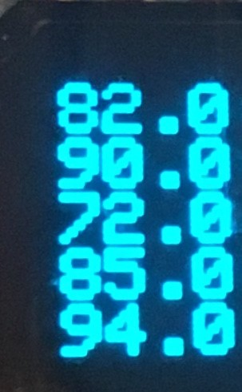

Components

* Argon
* Breadboard
* 1 x micro OLED
* 1 x TMP36
* 1 \ push button (plus any necessary resistors)
* Jumper wire (standard male-male)

Requirements

* Create a Fritzing breadboard prototype layout of your design. Once you’re satisfied with the design, connect the device
* It is recommended to code the device in stages, and test at each stage

**Global variables**

* You can create other variables as needed, but these are required
* **double temperatures[20]** to store the most recent public temperatures. Since the argon has limited memory, we are only storing the 20 most recent temperatures. Once the 20th temperature has been stored, we will overright the 1st position. This is a technique known as a **circular buffer**
* **int currentIndex** to store which position to be written next

**Stage 1: Temperature sensor**

* Connect the temperature sensor
* Use necessary conversion formulas to calculate temperature in Fahrenheit
* Display it on serial monitor to verify

**Stage 2: Publishing events**

* Publish the temperature as a **PUBLIC** event
* For the event name, you must use the following format  
  **ITP348-A6/XXX** *replace XXX with your 3 letter initial*
* Check the Particle console to make sure the event is publishing properly

**Stage 3: Subscribing and storing events**

* Subscribe to the event: **ITP348-A6** (this will include an event beginning with **ITP348-A6**)
* You will create what is called a “circular buffer.” Basically, when the first event arrives, you will store the name and temperature in index 0, and increment the **currentIndex**. This will continue until **currentIndex** reaches the max size of 20, and then it will reset to 0
* To store the temperature, you can use the C++ function **atof()**, which takes a **char \*** as input and returns a **double**. For example,

**double num = atof(data)**, *where data is a* **char \***

* It is recommended (not required) that you use the event handler to update the array of temperatures, but display the actual temperatures in **loop()**

**Stage 4: Displaying events on OLED**

* Connect a button and the OLED
* ****In **loop()**, use the button to switch between two “states” of your device.
* **Stats State**
  + The OLED should display your current temperature, the average of the most recent public temperatures, and the maximum of the most recent temperatures. These values should be automatically updated as new temperatures arrive
* **Temperature Feed State**
  + The OLED should display the most recent temperatures (you will only be able to fix up to 6). This should be automatically updated as new temperatures arrive.

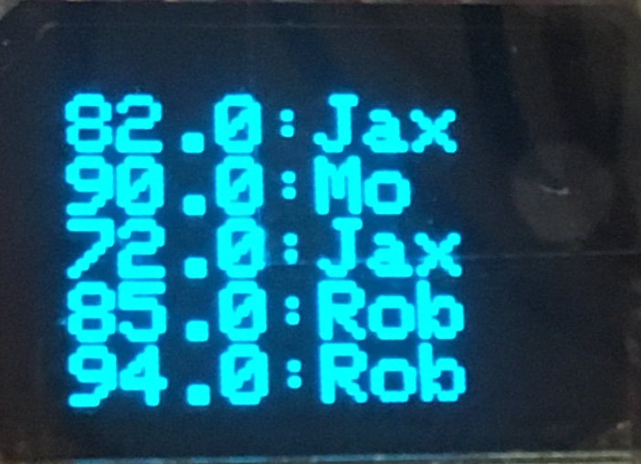Extra Credit

* In addition to storing and displaying the recent temperatures, also store and display the three letter usernames associated with each temperature (see picture). Here are some suggestions:
* Create **String names[20]** array to store the names of the most recent events
* In the event handler, in order to store the name, first convert the **char \*** to a **String**. Then use the [substring](https://www.arduino.cc/reference/en/language/variables/data-types/string/functions/substring/) method to select certain characters from the event name, which can be stored in the array

Required naming convention (replace # with the current assignment number)

* **Project Name** 
  + itp348_a#_lastname_firstname
* **Zip File** (include entire project folder)
  + itp348_a#_lastname_firstname.zip

## Deliverables

1. A compressed file containing your project. Follow the guidelines for full credit.

Here are the instructions for submission

1. Navigate to your project folder.
2. Include the *entire* folderin a zip file
3. Rename the zip file based on naming convention
4. Upload zip file to Blackboard site for our course
5. A photograph of your device connected to USB with the blue light on.
6. A (very) short video demonstrating your project functioning

## Grading

|  |  |
| --- | --- |
| Item | Points |
| Fritzing layout | 5 |
| Stage 1: temperature sensor | 10 |
| Stage 2: publishing event | 5 |
| Stage 3: subscribing to events | 10 |
| Stage 4: displaying data | 15 |
| Total | 45 |