ITP 348: Physical Computing

# Assignment 8: Fan Controller

# Goals

* Connect and power a DC motor
* Connect and power a hobby servo
* Connect and use a trim potentiometer to control servo positioning
* Connect and use a push button

# Setup

This assignment will use a DC motor and a servo to control a fan blade and rudder. Like airboats commonly used in the Florida Everglades, the combination of a fan and rudder help propel and steer the boat.



Figure 1: Tripadvisor.com

The rudder positioning will be controlled by a trim potentiometer and will reposition when a push button is activated.

# Components:

* Argon
* Breadboard
* 1 x TB6612FNG Motor Driver
* 1 x Hobby Gearmotor
* 1 x Servo - Generic
* 1 x Trimpot 10K Ohm with knob
* 1 x push button
* Jumper wire (standard male-male)
* Cardboard or construction paper for your rudders
* Paper clips
* Glue/adhesive

# Requirements

1. Create a fritzing breadboard prototype layout of your design. Once you’re satisfied, connect the device
2. Create a rudder using cardboard or construction paper and mount it to the servo using one of the included horns
3. Attach the fan blade to the DC motor
4. Position the rudder so that it is behind the motor and blade, out of the way of the path of the blade  
   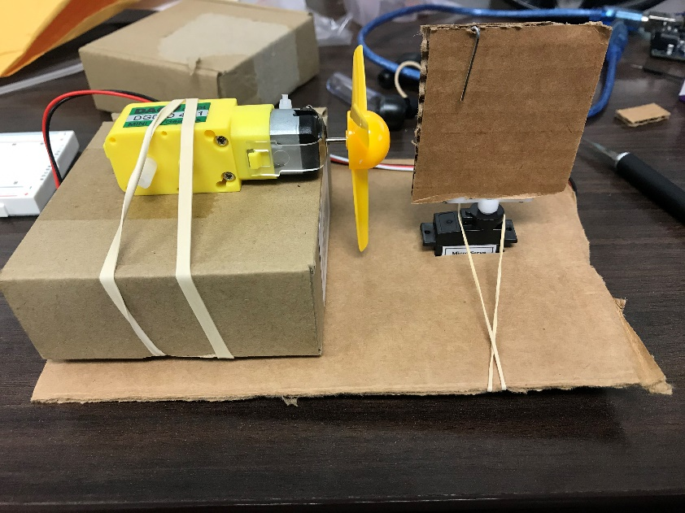
5. Wire the trimpot and push button
6. Wire the motor controller
7. Write the firmware:
   1. Have the motor spin the correct direction so that it blows air towards the rudder
   2. If the button is pressed:
      1. Measure the trimpot value
      2. Map the trimpot value to an angular value
         1. The servo should sweep up to 90 degrees in either direction
      3. Move the servo to the correct position

# Deliverables

**Project Name**

Replace the # with the assignment number

itp348_a#_lastname_firstname

**Zip File (include entire project folder)**

itp348_a#_lastname_firstname.zip

1. A compressed file containing your project. Follow the guidelines for full credit.
   1. Here are the instructions for submission
   2. Navigate to your project folder.
   3. Include the entire folder in a zip file
   4. Rename the zip file based on naming convention
   5. Upload zip file to Blackboard site for our course
2. A (very) short video demonstrating your project functioning

# Grading Rubric

|  |  |
| --- | --- |
| Item | Points |
| Fritzing Diagram | 5 |
| Motor and Motor controller wiring | 5 |
| Servo wiring | 5 |
| Push button and trimpot wiring | 5 |
| Control coding | 10 |
| Total | 30 |