**ITP 348: Robotics Chassis Setup**

**Items You will Need:**

1. Screwdriver
2. 2 DC Gear Motors
3. 1 Ball Caster and 1 Hex Jam Nut
4. 4 Standoffs and 8 Small Screws
5. Bottom and Top Plates with DC Motor Brackets
6. 2 Wheels and 2 Screws
7. 4 Long Screws and 4 Hex Jam Nuts

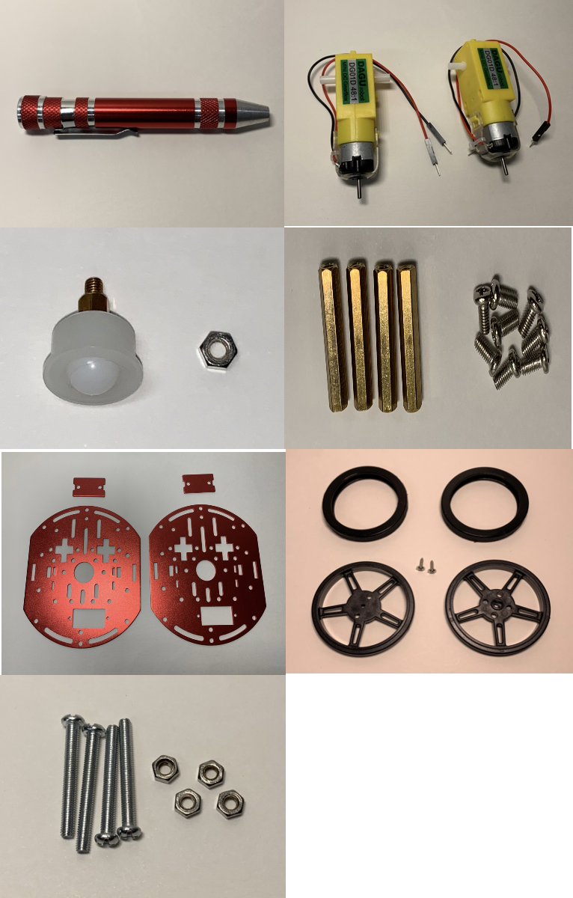

**2.**

**1.**

**3.**

**5.**

**4.**

**6.**

**7.**

**STEP 1:**

Screw the Ball Caster to the Bottom Plate

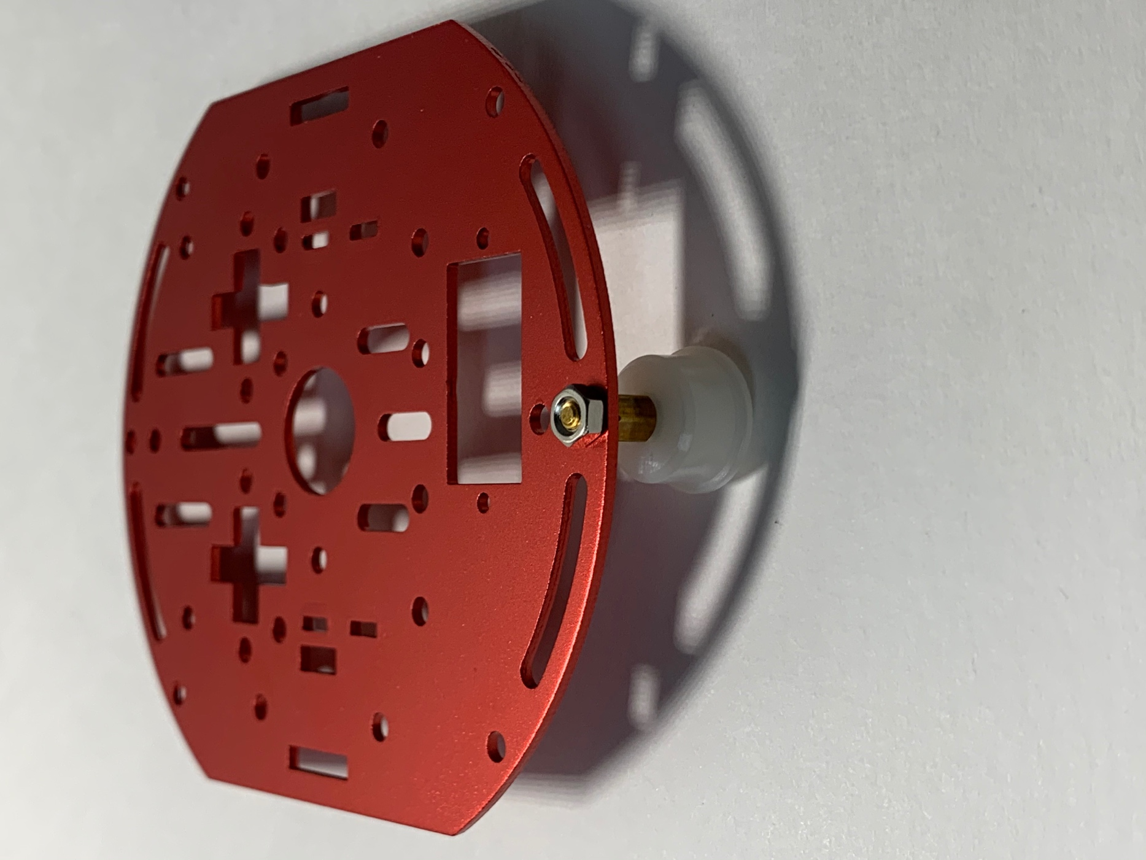

**STEP 2:**

Screw on 3 of the Standoffs to the Bottom Plate using 6 of the screws.

*Top View*

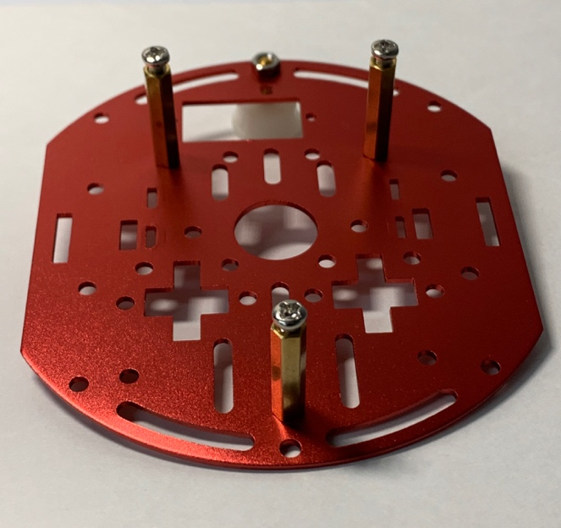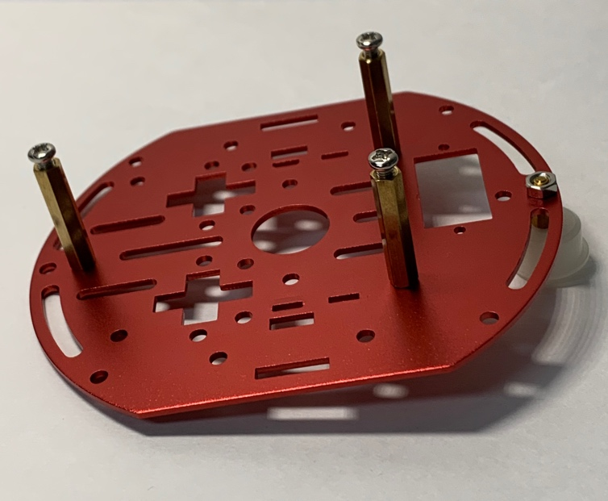

*Bottom View*

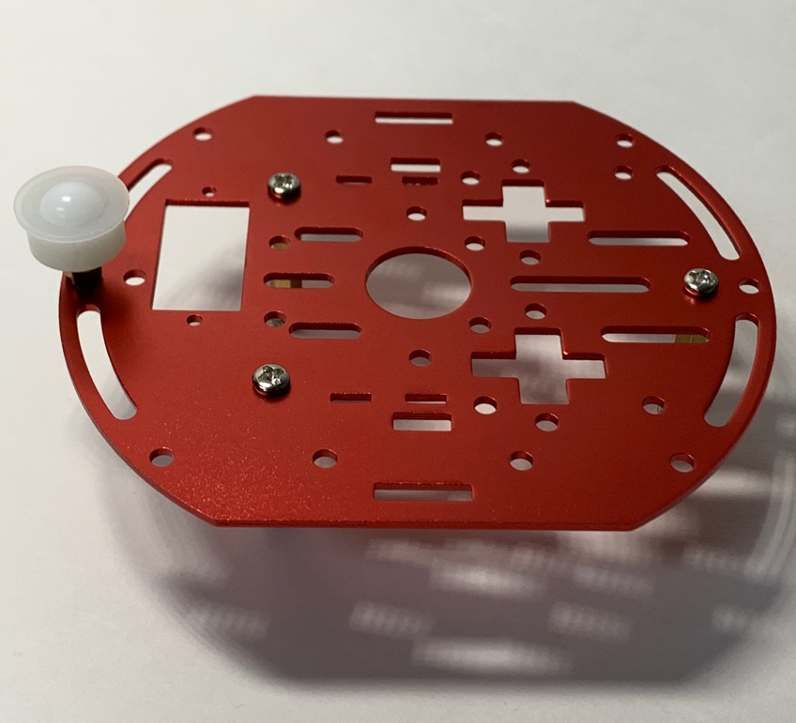

**STEP 3:**

Screw the DC Motor Brackets to the DC Motors using the Long Screws and Hex Nuts

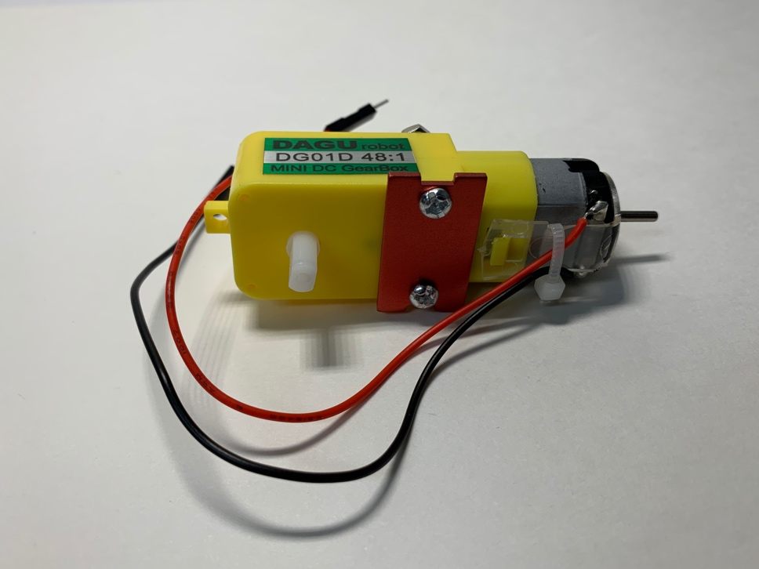

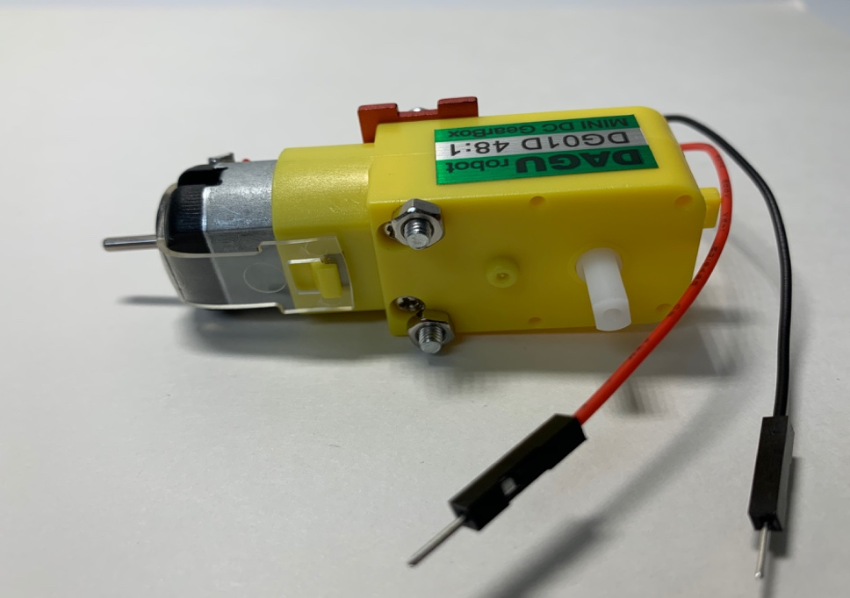

**STEP 4:**

Align the Top Plate with DC Motor Brackets and Standoffs attached to the Bottom Plate

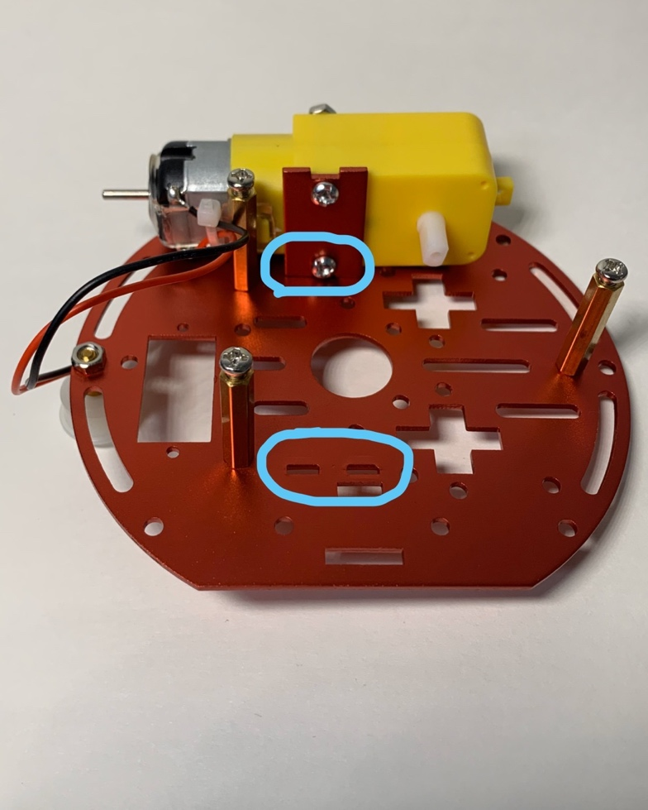

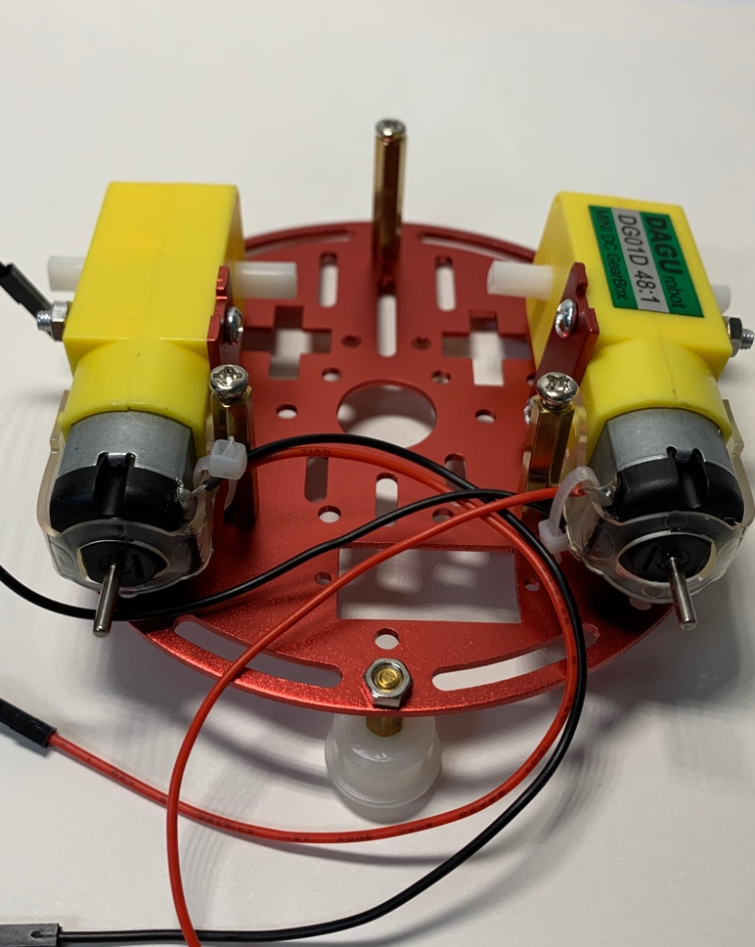

**STEP 5:**

Screw the Top Plate to the standoffs.

*Note: Make sure DC Motor wires are on the inside of the chassis pointing inwards not outward*

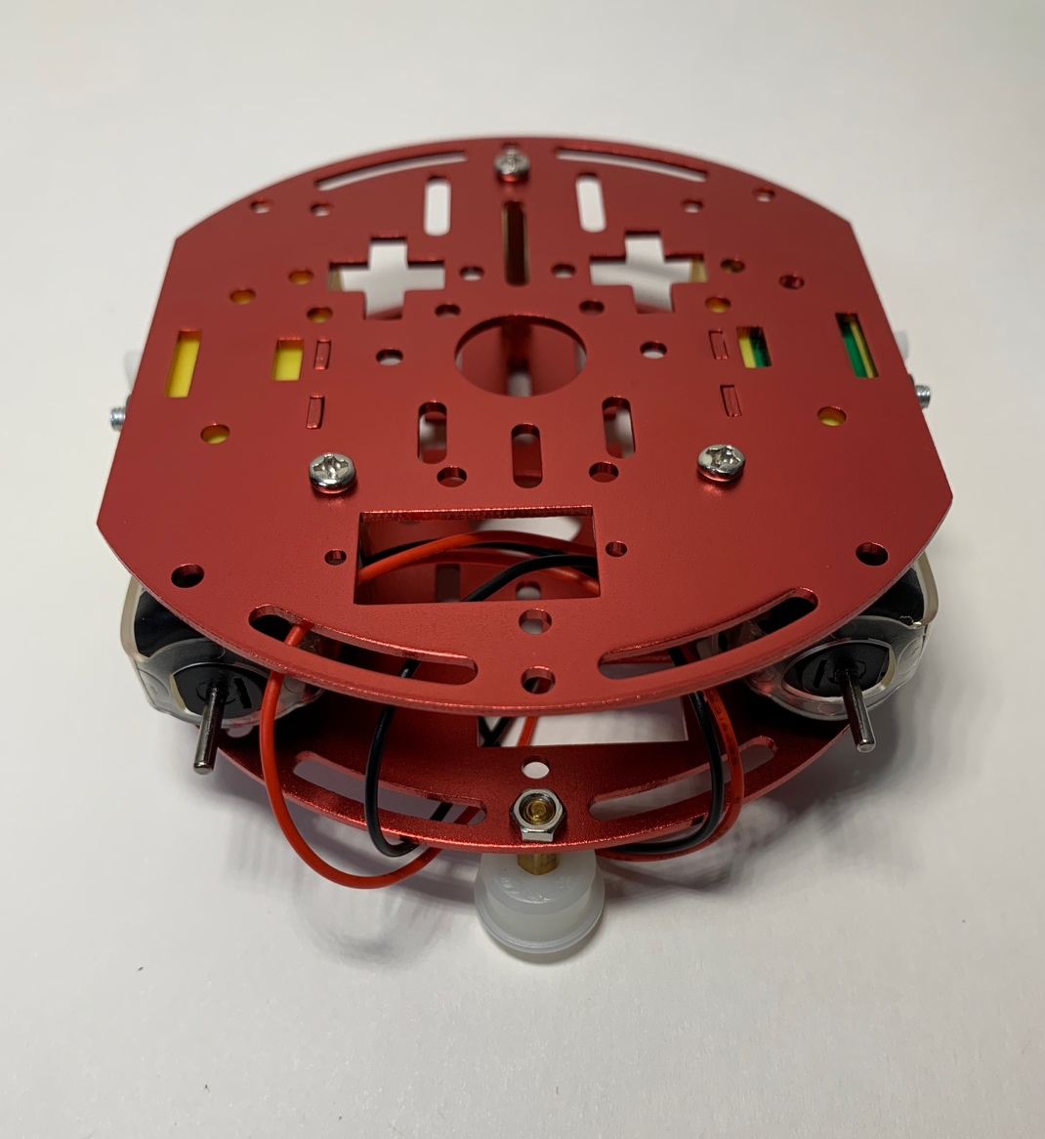

**STEP 6:**

Screw on Wheels to DC Motors and add the wheel rubber tires.

