**Synergy Solutions Executive Management**

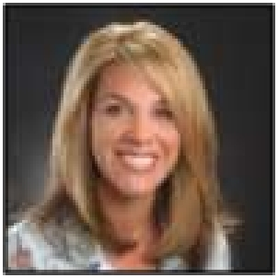

**Lori Fentem, President**

Lori Fentem is a Founder and serves as President of Synergy Solutions and in this role is responsible for the strategic direction of Synergy, including business development, marketing and branding, contract administration and the development of service offerings. Ms. Fentem’s career within the contact center channel spans three decades and spans all areas of customer interaction including care, sales and retention. Prior to founding Synergy Solutions in 1999, she spent eight years with top

ten teleservices outsourcer ProMark One/IDRC, with her last position being Senior Vice President of Business Development. Ms. Fentem was responsible for top-line revenue generation for all of ProMark One/IDRC's twenty four North American contact centers, as well as external marketing, and strategic client relationships. Ms. Fentem’s channel experience also includes sales and operations management roles in telephone based fundraising, market research, circulation sales and academic survey research.

Ms. Fentem serves on the American Teleservices Association (ATA) National Board of Directors and was a member of the ATA’s Self Regulatory Organization (SRO) Steering Committee. She also founded the Arizona Chapter of the ATA in

2003 and continues to serve as an Executive Member of the ATA Arizona Chapter Board. Ms. Fentem has also served as a member of the Vangent Health Solutions' Informis Advisory Board. She is considered an expert in the area of call center compliance and has been featured in numerous local and national media sources, including CNN, the New York Times, MSNBC, the Wall Street Journal, AP Radio Live, CNBC and the Arizona Republic. She is a member of the Entrepreneurs Organization (EO – formerly YEO) and has completed the Strategic Coach Program. She was named a

“Who's Who in Business” each year from 2002-2010 by Arizona's Woman magazine, recognized for her “Hot Growth” company by bizAZ magazine, was a Finalist for the Ernst & Young Entrepreneur of the Year Award, ranked in the “Top 50” by Female Entrepreneur magazine and in the “Top 100 Who’s Who in Business to Business Marketing” by B2B magazine. Ms. Fentem was honored as the first ever recipient of the ATA Fulcrum Award recognizing her volunteer efforts for the teleservices channel as well as the Spirit of Philanthropy Award for her role in originating the Call Centers Care movement within the ATA. Ms. Fentem regularly speaks at industry conferences on topics related to contact centers and she also speaks on aspects of being an entrepreneur to various student groups ranging from Middle School to Post Graduate programs. Ms. Fentem is a graduate of the University of Illinois.

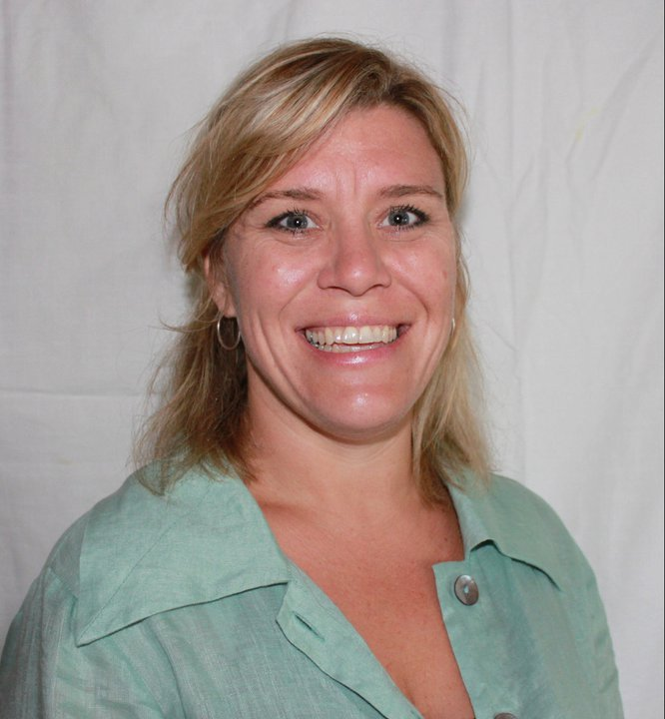**Christa Heibel, Chief Operating Officer**

Christa Heibel serves as Chief Operating Officer of Synergy Solutions and in this role she is responsible

for overall strategic leadership of the organization including strategic growth initiatives, corporate

governance, operational execution, and client service delivery. Ms. Heibel is recognized as an

expert in building integrated sales and marketing campaigns for both small and large businesses. She

is an outstanding leader with a career of demonstrated success in building organizations, establishing

best practices, rebranding and developing integrated solutions for clients in a variety of industries. Prior to joining Synergy, Christa served as the CEO of CH Consulting and in that capacity developed innovative solutions for leading companies ranging from Fortune 100 telecommunications companies, financial services, insurance providers to presidential campaigns. Prior to opening CH Consulting, Christa worked extensively in the software and telecom industries managing call centers, directing telemarketing teams, and consulting with major corporations on marketing and CRM.

Christa has been featured on National Public Radio’s program “Future Tense” and has written articles for Direct Magazine, DM News, and numerous other sales and marketing publications. She is part of the destinationCRM.com panel of on call experts. She has been the cover story for Minnesota Women Business magazine

In addition to her work leading the growth of Synergy Solutions, Christa owns and operates a small yoga and wellness studio. Christa attended the University of St. Thomas, St. Paul, MN.

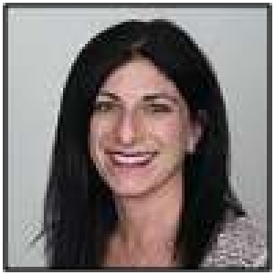

**Kimberly Jacoby, Controller**

Kimberly Jacoby is a member of the Synergy Solutions Senior Management team and serves in the role of Controller. In this capacity, she is responsible for the oversight of all Synergy financial operations including budget development and control, financial reporting and analysis, cash flow, AP/

AR and taxes. She also oversees Synergy’s efforts with regards to state and federal compliance

registrations as well as all bonding and insurance requirements. Ms. Jacoby has worked in the teleservices industry since 1997 and prior to joining Synergy in 2000, she was employed by ProMark One/IDRC and eventually through acquisition, Telespectrum Worldwide. At Telespectrum, Ms. Jacoby served as Accounting Manager with responsibility for monitoring and reporting on the financial performance of 24 North American call centers and was also heavily involved in the processing of SEC filings for the publicly traded Telespectrum. Ms. Jacoby serves as the Finance Chair for the Arizona Chapter of the American Teleservices Association. Ms. Jacoby holds a BS in Business Management and Accounting from the University of Arizona.

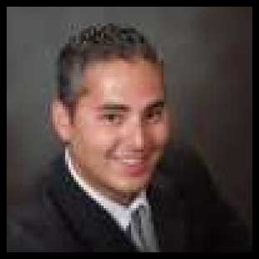

**Isaac Shloss, Director of Information Technology**

Isaac Shloss has an extensive background in network/telephony administration, end user support,

software development, and IT service management in the Call Center industry. He is currently

responsible for the strategic design and support of all areas of technology within Synergy including

telecommunications, Voice-over-IP, hardware/software, client deliverables, Internet, email, LAN and

WAN infrastructure, system maintenance, data and information security, as well as technological

innovation. Mr. Shloss is also responsible for the management and development of all technical personnel within Synergy. Prior to his role with Synergy, he managed the IT department for a top 10 US teleservices provider, where he built the technological and telecommunications architecture needed to expand the small, regionally based company to a large, multinational enterprise. Mr. Shloss was an early pioneer and administrator of Siemens OpenScape Contact

Center Campaign Director for more than 5 years before joining the product’s development team as Vice President of Customer Care and Support. There, he focused on converting client’s business needs into standard product features.

Mr. Shloss has been a Microsoft Certified Systems Engineer since 1999, specializing in TCP/IP and Microsoft SQL Server. Mr. Shloss attended Purdue University.