**EARTH COMET COLLISION ANIMATION SCREENSHOT GALLERY**

COMP 4471 – COMPUTER GRAPHICS

KEVIN MACDONALD

ALEX REPEC

**BASIC FEATURES:**

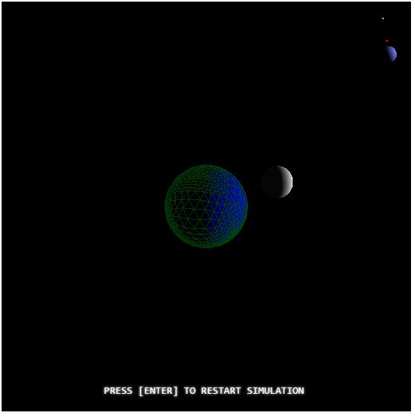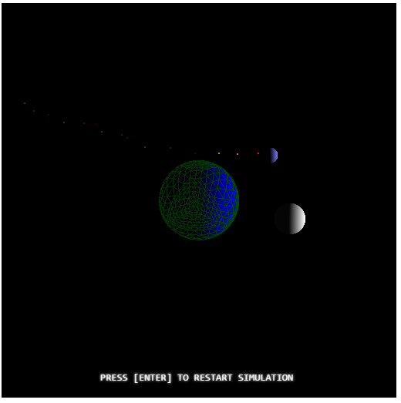

The Earth is centered at the origin. It can be seen that it is rotating by a green surface grid that has been added. The Moon is present and can be seen orbiting the planet. A comet appears in the top right corner and is in a straight line trajectory to the Earth.

**ADDITIONAL FEATURES - GRAPHICAL IMPACT:**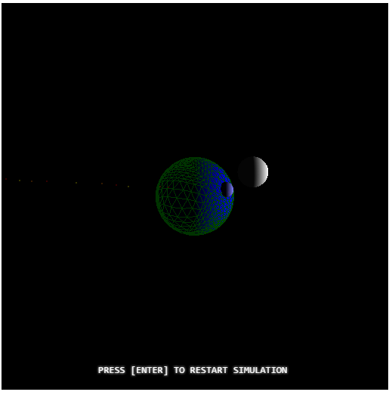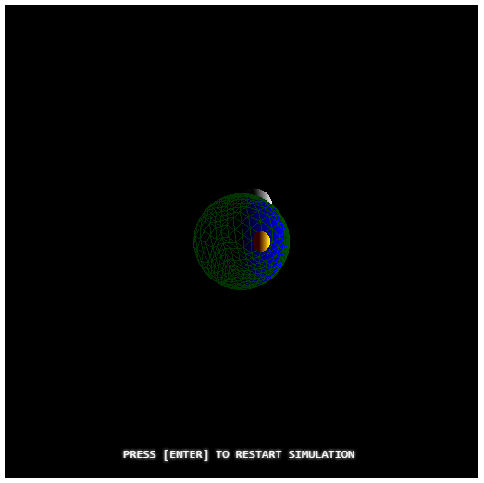

Once the comet impacts the Earth, a bubble-like explosion occurs where it impacts on the surface. This explosion will rotate with the Earth until it dissipates.

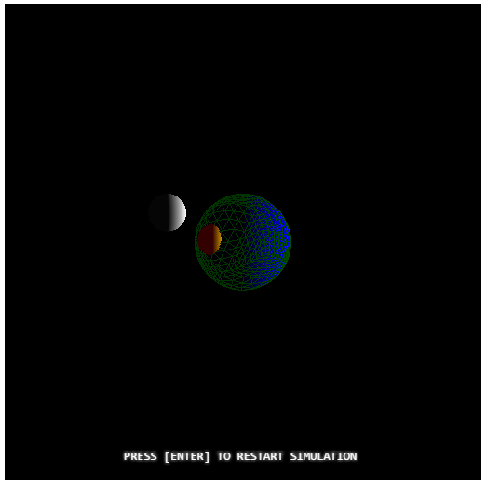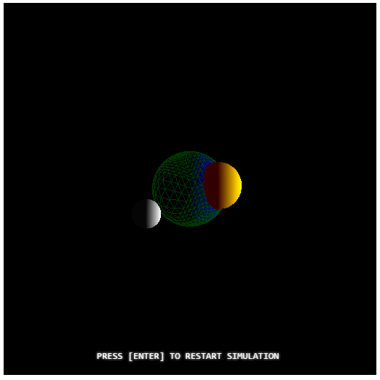

The bubble-like explosion will increase in size as it rotates, up to a point, and then it will disappear.

**ADDITIONAL FEATURES – PARTICLE COMET TAIL:** 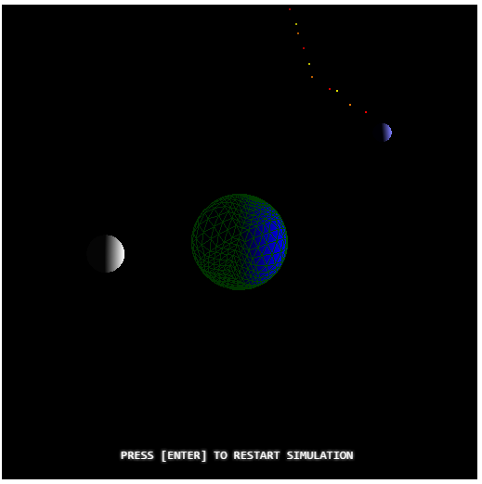

A particle trail is present behind the comet, with the particles facing away from the sun. The particles move according to the sun’s position, which is to the right, with the particles facing away to the left.

**ADDITIONAL FEATURES – LIGHTING FROM THE SUN:**

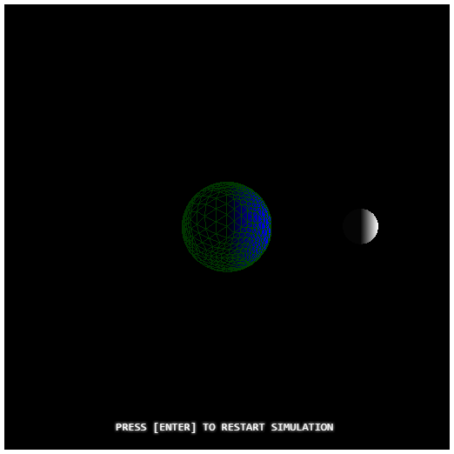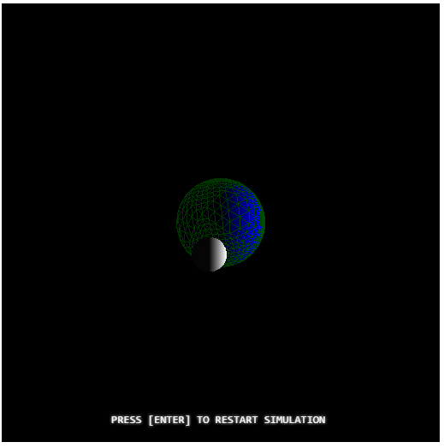

The sun is located to the right, off the screen. Lighting can be seen on both the Moon and the Earth where it faces the sun. Lighting can also be seen on the comet and the explosion, when it occurs.