**Gender and Business Environment Reform:  
What is “Best Practice”?**

# Executive Summary

# Contents

1. Executive Summary 1

2. Contents 1

3. Introduction 1

4. Definitions 1

5. Approaches to Gender Analysis and Programming 1

5.1 Best Practice 2

6. Summary of Evidence 3

6.1 Women’s Legal Rights and Outcomes 3

6.2 Childcare 4

6.3 Formalisation 4

7. Case Study: Bangladesh Investment Climate Facility 5

8. Innovation and Learning 5

9. Conclusion 5

10. References 5

11. Methodology 6

# Introduction

Background of the project, how things have drifted from the original TOR.

Case study is based on a provisional proposal subject to change.

# Definitions

This report follows the *Supporting Business Environment Reforms* definition of business environment reform:

For the purposes of this guidance the Donor Committee for Enterprise Development defines the business environment as a complex of policy, legal, institutional, and regulatory conditions that govern business activities. It is a sub-set of the investment climate and includes the administration and enforcement mechanisms established to implement government policy, as well as the institutional arrangements that influence the way key actors operate (e.g., government agencies, regulatory authorities, and business membership organisations including businesswomen associations, civil society organisations, trade unions, etc.).

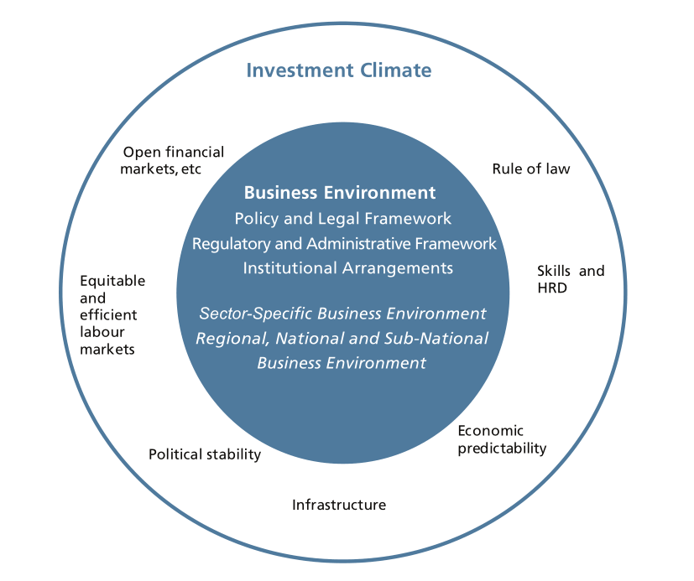

Source: DCED, 2008, p2

The definition of Women’s Economic Empowerment is adopted from the International Center for Research on Women (Golla, 2011, p??):

A woman is economically empowered when she has both the ability to succeed and advance economically and the power to make and act on economic decisions.

* To succeed and advance economically, women need the skills and resources to compete in markets, as well as fair and equal access to economic institutions.
* To have the power and agency to benefit from economic activities, women need to have the ability to make and act on decisions and control resources and profits.

Gender terminology aims to be consistent with the various definitions laid out by DFID (2007, p24, 50–51)

# Approaches to Gender Analysis and Programming

Levels at which analysis can be gendered: best practice and getting to best practice

## Introduction

While the evidence on the effectiveness of gender-sensitive business environment reforms is still limited, the World Bank has articulated a clear and detailed model of best practice. While this is tremendously useful, it is also important to recognise that the current state of gender analysis falls considerably short of this ideal. According to the IEG’s meta-evaluation of World Bank Group projects, less than a quarter target gender.

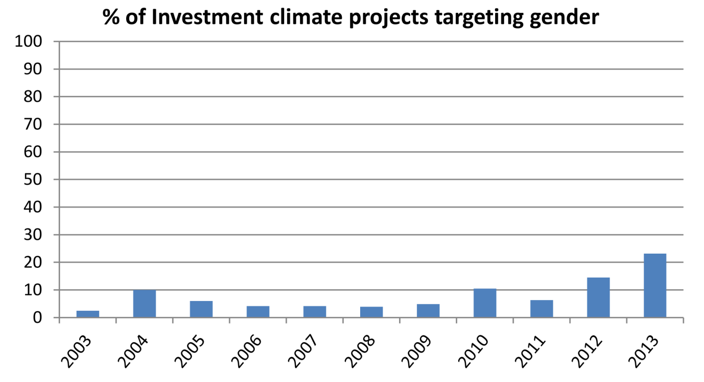

Source: IEG, 2014, figure 1.7, p45

Despite the apparent upward trend, the authors caution that a focus on the number of programmes may hide the fact that those that target gender are smaller in scale and ambition than average:

A close analysis of projects targeting gender reveals that many are small in size and mostly focused on capacity-building activities or on filling an information gap relative to gender-based barriers in the business enabling environment.[1]

Consequently, it is necessary to understand not only best practice, but the different levels of ambition that can be brought to business environment reform projects. In some cases an incremental approach will be necessary in which the short-term goal may fall short of best practice, but gradually introduce a progressively gendered approach over time. For this reason, we divide project methodology according to the extent to which gender-sensitive analysis is used:

| **Level of Ambition** | | **Examples** |
| --- | --- | --- |
| **Baseline** | Transparent communication of benefits for women, requiring gender-disaggregated results reporting | Measuring and reporting the disproportionate benefit to formal-sector female employment of SEZ creation and expansion.  Measuring and reporting the relative benefits to women of programming that has not been based on any gender analysis to enable future study of the extent to which different approaches alter outcomes for women. |
| **Intermediate** | Incorporating gender analysis into programme design | Legal reviews to incorporate gender analysis, e.g. labour law that disproportionately affects women.  Export sector diversification measures to incorporate labour, investor and entrepreneur gender analysis to ensure that overall the programme meets gender goals. |
| **Best practice** | Adding programme components that stem fundamentally from gender-aware analysis of the economy and society | Interventions such as childcare subsidy and insurance for maternity costs and leave, which challenge and expand perception of what is considered business environment reform |

Source: BERF analysis based on literature review

## Levels of Ambition in Gender Programming

### Baseline

gender disaggregation of most/all projects, and why that is important given state of evidence

Lack of evidence on gender-sensitive business environment reform, problems with World Bank evaluation. Usefulness of gender disaggregation regardless of goals.

Given the lack of evidence that gender-sensitive programming has more beneficial effects for women than previous approaches, gender-disaggregated results reporting is highly desirable for all projects regardless of whether results are expected to have a desirable gender balance.

### Intermediate

Earlier incorporation: design phase. Limitations: assumption that activity choice is implicitly gendered. Why it’s better, why it’s not so great

In an important sense, what has traditionally been considered a “business environment reform activity” has been defined by men’s experiences as entrepreneurs and workers, and the constraints to doing business that they have encountered. Once women’s experiences are properly articulated and understood, the focus shifts — and even the variety of projects that are considered to be “business environment reform activities” expands.

### Best Practice

The main authority on best practice in gender-sensitive business environment reform is *Gender Dimensions of Business Environment Reform* (2010) by Simani et al, published by the World Bank. This book contains:

1. a summary of the economic rationale for gender-sensitive business environment reform,
2. a “core module” describing the general methodology for all programmes, and
3. additional guidance on eight specific sectors of business environment reform (such as public–private dialogue, business entry and operations, etc.).

Each section of guidance covers all aspects of programme implementation, from diagnostics and programme design through to implementation, monitoring and evaluation.

The book proposes a diagnostics-driven approach, based on a comprehensive analysis of the social and economic role of women in the local context, and tends to downplay rules of thumb or learning from different countries. This reflects the current state of evidence (see next section). However, the diagnostic guidance is comprehensive, including recommended data sources, checklists of key questions and sample questionnaires for each sector. Diagnostic steps are also prioritised to facilitate light-touch analysis where time or resources are tight.

Summary of core module in *Gender Dimensions of Business Environment Reform[2]*

|  |  |
| --- | --- |
| **Core Diagnostics** | * Understand the roles of men and women in the economy * View investment climate reform in the broader social and economic context * Analyze the legal status of men and women * Identify laws, regulations, procedures and business obstacles that are perceived differently by men and women * Ensure women are represented in consultations |
| **Solution Design** | * Test political and cultural acceptability * Involve women in developing solutions * Link with existing government strategies * Draw on in-country expertise |
| **Implementation and M&E** | * Establish baselines * Integrate gender-focused indicators into M&E systems |

Sources of data for gender diagnostics

The book complements *Supporting Business Environment Reforms* by the DCED (2008), which provides the standard methodological framework for implementing business environment reform projects, but lacks adequate guidance on gender considerations. The DCED is in the process of writing a gender annex to their 2008 guidance, which should be available in late 2016.

## Addressing versus bypassing barriers

Job creation (SEZs) vs removing barriers to female employment

EIG distinction on p48 (table).

## Communicating about gender

Profile of gender in communications

EIG p46: “politically unpalatable affirmative action”

# Summary of Evidence

Evaluation of investment climate reform more generally is not yet able to verify or measure the impact of projects. For example, an IEG evaluation of 819 World Bank investment climate projects concluded that:

Broader impact [of the investment climate projects studied] on investment, job formation, and growth is still not clear. Neither is the overall effect of these solutions when taking a holistic country-level view. Further, the social purpose of regulation and therefore the social impact of regulatory reform is not properly identified and measured.[3]

At this stage available evidence is limited to:

1. Associations (often correlations where causation is hard to establish) between aspects of the business environment (most often laws) and a variety of economic and social indicators, and
2. Output- or outcome-level evaluation of projects, measuring success by indicators such as laws enacted, or cost or time savings for firms.

## Women’s Legal Rights and Outcomes

A World Bank study covering 100 countries over 50 years found that progress in areas of legal equality such as the ability to access and own property, sign legal documents on one’s own behalf and the existence of equality provisions in the constitution are associated with improvements in indicators in girls’ education, health outcomes, women’s participation in elected office and female employment, especially in the formal sector and as employers. Correlations are found both between countries and in a single country over a period of time, although this methodology cannot test for causation. The same study finds that the success of reform appears to depend on the level of wealth and rule of law of the target country.

|  |  |
| --- | --- |
| Lower income countries with weaker rule of law: | Greatest success in improving girls’ education and lowering infant mortality |
| Higher income countries with stronger rule of law: | Greatest success in female labour force participation and off-farm employment |

The World Bank’s ongoing *Women, Business and the Law* project documents differential legal treatment by gender in 173 countries, as well as relevant reforms, and social and economic outcomes that are likely to be associated with these laws and changes. Although some of these legal conditions have not traditionally been a common focus of business environment reform projects, virtually all could be argued to fall under the DCED definition of features of the business environment.

This body of evidence is reflected in recent and current programming, with an estimated three quarters of gender-sensitive business environment reform projects focusing on policy and the legal framework.

## Childcare

Access to affordable childcare is one of the most important constraints preventing more women accessing formal sector employment. Analysis that is gender aware will make extension of childcare a core business environment priority.

Childcare is one area in which there is relatively strong evidence both that childcare support is associated with greater female participation in the workforce, and that government-led programmes have been successful in increasing the provision and use of childcare.[4] More than twice as many women receive wages in countries where childcare is subsidized or publicly provided.[5] It is also an area that has received relatively little attention from donors. The two main reform areas are:

* laws relating to maternity and paternity leave (how much is a statutory requirement and how is the cost divided between employers and government), and
* fiscal policy towards childcare, i.e. whether childcare services receive any form of tax incentive or subsidy.

Mexico’s Estancias[6] programme is unusual in that it was created with the explicit aim of increasing women’s labour force participation, rather than to aid child development (although it still contains health and educational components). The project achieved an 18% increase in employment among beneficiary mothers, who on average increased their hours of work by six per week.[7]

## Formalisation

Policy to promote the formalisation of small businesses is a controversial component of business environment reform. Tax authorities and existing formal enterprises (who tend to gain disproportionate influence in private sector consultations) can form a formidable alliance in favour of expanding the formal sector to ever-smaller operators, whereas richer countries often provide significant exemptions from tax and regulatory requirements for small operators, especially individuals, to encourage business formation and avoid placing an unrealistic burden on the self-employed. This issue becomes even more complex when a proper gender analysis is included.

However, in many countries formalisation brings access to important benefits such as maternity leave and paid breastfeeding breaks. Whilst these may be critical to female participation in the workforce, if they are employer-funded they can also act as a disincentive to the employment of women of childbearing age.[8]

The ODI point to examples of attempts to address this issue, such as NGOs in India (SEWA) and Bangladesh (BRAC) who offer self-paid maternity insurance for medical costs to informal-sector workers, noting that this could be expanded to include time off. In India, a cash transfer model was trialled in 2010 which aimed to partially offset wage loss.[9]

# Case Study: Bangladesh Investment Climate Fund Phase 2

How does this differentially affect women?

What can be done?

What questions should a diagnostic ask? Where is information available to support analysis?

|  |  |  |
| --- | --- | --- |
| Pillar | Activities | Gender considerations |
| Modernise and reform the regulatory framework | Regulatory modernisation such as updating the Industrial Policy, Competition Act and other investment climate areas that relate to the Doing Business indicators |  |
| Process simplification for government to business services such as inspection reform |  |
| Institution building to take forward reform sustainably: by supporting the Public-Private Dialogue platform, Private Sector Development Policy Coordination Committee (within the government of Bangladesh), Board of Investment |  |
| Improve industrial infrastructure | Access to industrial land: take forward the zones agenda, technical assistance to complement the PSDSP 2 loan to the government; improve social compliance in zones, land bank of government land; support investment promotion agencies to facilitate land registration for investors |  |
| Access to energy: provide implementation support to Investment Promotion Financing Facility of the World Bank, remove post-license regulatory barriers for power plant investments, update pricing policy for gas exploration and development, reform of gas project steering committee processes |  |
| Enhance export diversification and sector competitiveness | Sectoral competitiveness: undertake comprehensive sector competitiveness benchmarking, streamline sector-specific regulatory constraints (deepening of existing work in agribusiness while expanding to two new sectors), ensure efficient contract enforcement in target sectors, investment promotion |  |
| Trade competitiveness: review and rationalise fiscal and non-fiscal incentives, trade competitiveness and trade policy diagnostics, streamline trade facilitation and logistics |  |

# Innovation and Learning

One of the key lessons to come out of recent projects is to establish an openness to sub-national experimentation in implementation, and try to encourage or provide mechanisms for early successes to be reported and rolled out more widely. This is perhaps unsurprising, given the limitations in existing evidence, and the need for projects to be tailored to local contexts. The GREAT Women[10] project in the Philippines and the ALCP[11] in Georgia have both been able to identify successful innovations and to find avenues to re-apply that knowledge in other geographic areas within the project cycle.

# Conclusion

# References

Include summaries of key documents?

BILS, 2009, *Women’s Participation in Trade Unions in Bangladesh: Status, Barriers and Overcoming Strategies*, Dhaka: ILO, August 2009

Davidson, Euan, Anastasia de Santos, Yoon Lee, Nathan Martinez, Caroline Smith, and Takele Tassew, 2014, *Bangladesh Inclusive Growth Diagnostic*, June 2014, USAID and DFID

DCED, 2008, *Supporting Business Environment Reforms: Practical Guidance for Development Agencies*, Donor Committee for Enterprise Development

DFID, 2008, *The Gender Manual: A Practical Guide*, London: Department for International Development, Equity and Rights Team

Golla, Anne Marie, Anju Malhotra, Priya Nanda, and Rekha Mehra, 2011, *Understanding and Measuring Women’s Economic Empowerment: Definition, Framework and Indicators*, Washington: International Center for Research on Women

Gonzales, Christian, Sonali Jain, Chandra, Kalpana Kochhar and Monique Newiak, 2015, *Fair Play: More Equal Laws Boost Female Labor Force Participation*, IMF Staff Discussion Note, February 2015, SDN/15/02

Hallwood-Driemeier, Mary, Tazeen Hasan and Anca Bogdana Rusu, 2013, *Women’s Legal Rights over 50 Years: What is the Impact of Reform?*, Finance and Private Sector Development Team, Development Research Group, World Bank, September 2013

IEG, 2014?, *Investment Climate Reforms: An Independent Evaluation of World Bank Group Support to Reforms of Business Regulations*, World Bank Group

Rahman, Rushidan I and Rizwanul Islam, 2013, *Female Labour Force Participation in Bangladesh: Trends, Drivers and Barriers*, New Delhi: ILO, ILO Asia–Pacific Working Paper Series, October 2013. ISSN: 2227-4391/2227-4405

Samman, Emma, Elizabeth Presler-Marshall and Nicola Jones, 2016, *Women’s Work: Mothers, Children and the Global Healthcare Crisis*, London: ODI, March 2016 (report and policy brief)

Simani, Sevi, Clare Manuel and Mark Blackden, 2010, *Gender Dimensions of Business Environment Reform: A Guide for Policy Makers and Practitioners*, Washington DC: World Bank. Accessed on 30/5/16 from <https://www.wbginvestmentclimate.org/uploads/Gender%20Dimensions%20of%20Investment%20Climate%20Reform.pdf>

World Bank Group, 2015, *Women, Business and the Law 2016: Getting to Equal*, Washington DC: World Bank. DOI: 10.1596/978-1-4648-0677-3

# Methodology

1. IEG, 2014, p45.
2. See pp 14–5.
3. IEG, 2014, pp140–1.
4. E.g. in South Africa, see Samman et al, 2016, p70.
5. World Bank Group, 2015, p17.
6. Estancias Infantiles para Apoyar a Madres Trabajadores, see for instance Samman et al, 2016, p72.
7. This statistic is misreported in the ODI policy brief; the correct figure can be found in the full report.
8. “In Uganda, research has shown that well-intentioned labour reform to provide two months maternity leave (one month paid) would have been prohibitive for many smaller employers and would have discouraged them from hiring women of child bearing age.” (Simani, 2010, p192)
9. Samman et al, 2016, p70
10. Gender-Responsive Economic Actions for the Transformation of Women, <http://www.pcw.gov.ph/gwp/>. In this instance beneficiaries raised the issue that national health insurance was not available to female-headed households, which the programme addressed and then expanded nationally.
11. Alliances Lesser Caucasus Programme, http://alcp.ge/