**Gender and Business Environment Reform:  
What is “Best Practice”?**

# Executive Summary

# Contents

1. Executive Summary 1

2. Contents 1

3. Introduction 1

4. Definitions 1

5. Approaches to Gender Analysis and Programming 2

5.1 Best Practice 4

6. Summary of Evidence 5

6.1 Women’s Legal Rights and Outcomes 6

6.2 Childcare 6

6.3 Formalisation 7

7. Case Study: Bangladesh Investment Climate Facility 7

8. Innovation and Learning 13

9. Conclusion 13

10. References 13

11. Methodology 14

# Introduction

Background of the project, how things have drifted from the original TOR.

Case study is based on a provisional proposal subject to change.

# Definitions

This report follows the *Supporting Business Environment Reforms* definition of business environment reform:

For the purposes of this guidance the Donor Committee for Enterprise Development defines the business environment as a complex of policy, legal, institutional, and regulatory conditions that govern business activities. It is a sub-set of the investment climate and includes the administration and enforcement mechanisms established to implement government policy, as well as the institutional arrangements that influence the way key actors operate (e.g., government agencies, regulatory authorities, and business membership organisations including businesswomen associations, civil society organisations, trade unions, etc.).

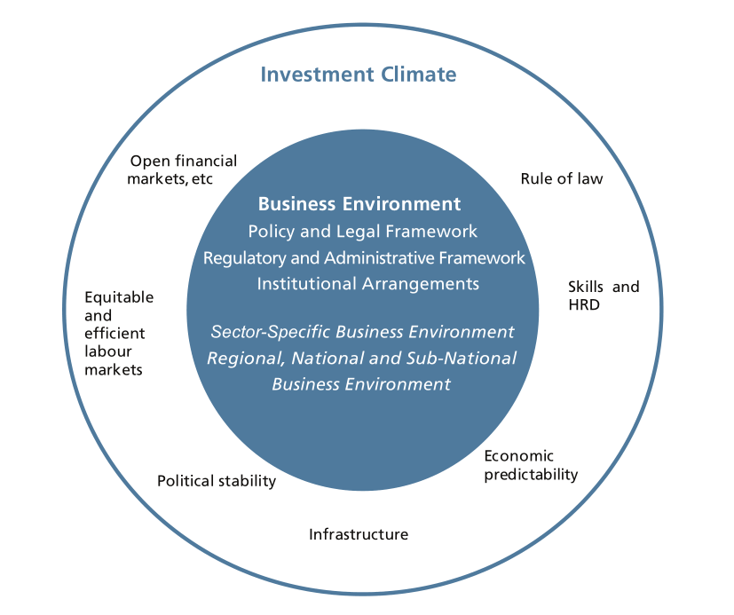

Source: DCED, 2008, p2

The definition of Women’s Economic Empowerment is adopted from the International Center for Research on Women (Golla, 2011, p4):

A woman is economically empowered when she has both the ability to succeed and advance economically and the power to make and act on economic decisions.

* To succeed and advance economically, women need the skills and resources to compete in markets, as well as fair and equal access to economic institutions.
* To have the power and agency to benefit from economic activities, women need to have the ability to make and act on decisions and control resources and profits.

Gender terminology aims to be consistent with the various definitions laid out by DFID (2007, p24, 50–51)

# Approaches to Gender Analysis and Programming

Levels at which analysis can be gendered: best practice and getting to best practice

## Introduction

While the evidence on the effectiveness of gender-sensitive business environment reforms is still limited, the World Bank has articulated a clear and detailed model of best practice. This is tremendously useful, but it is also important to recognise that the current state of gender analysis falls considerably short of this ideal. According to the IEG’s meta-evaluation of World Bank Group projects, less than a quarter target gender, even after considerable recent improvement.

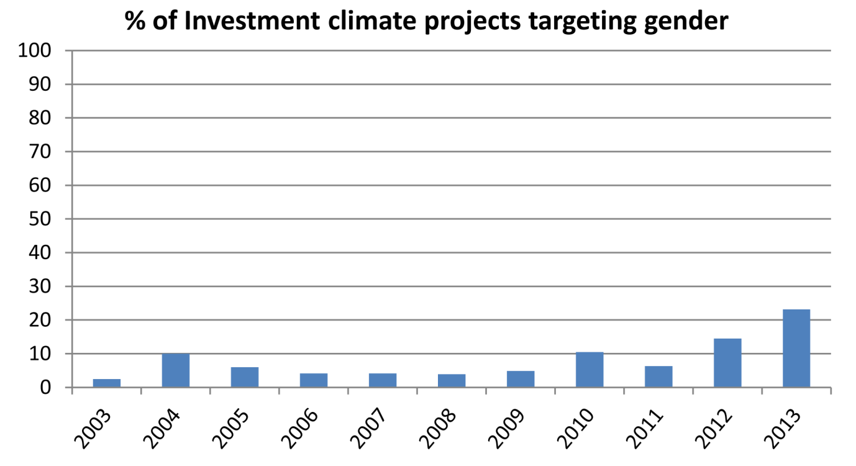

Source: IEG, 2014, figure 1.7, p45

Despite the apparent upward trend, the authors caution that a focus on the number of programmes may hide the fact that those that target gender are smaller in scale and ambition than average:

A close analysis of projects targeting gender reveals that many are small in size and mostly focused on capacity-building activities or on filling an information gap relative to gender-based barriers in the business enabling environment.[1]

Consequently, it is necessary to understand not only best practice, but the different levels of ambition that can be brought to business environment reform projects. In some cases an incremental approach will be necessary in which the short-term goal may fall short of best practice, but gradually introduce a progressively gendered approach over time. For this reason, we divide project methodology according to the extent to which gender-sensitive analysis is used:

Table : Levels of ambition on gender-sensitive business environment reform

|  |  |  |
| --- | --- | --- |
| **Level of Ambition** | | **Examples** |
| **Baseline** | Transparent communication of benefits for women, requiring gender-disaggregated results reporting. | Measuring and reporting the disproportionate effect on formal-sector female employment of SEZ creation and expansion.  Measuring and reporting the relative benefits to women of programming that has not been based on any gender analysis, to enable future study of the extent to which different approaches alter outcomes for women. |
| **Intermediate** | Incorporating gender analysis during programme design. | A review of business environment laws to incorporate gender analysis, e.g. to examine and resolve parts of a labour law that disproportionately affect women.  An export sector diversification project incorporates labour, investor and entrepreneur gender analysis, to guide sector selection so that overall the programme meets gender goals. |
| Conducting targeted primary research to enhance gender analysis. | Use *Gender Dimensions*’ sector specific questionnaires to assess female experiences of the business environment and differences between official policy and common practice, e.g. the sample questionnaire for business owners on business taxation on pp125–6. |
| **Best practice** | Gender analysis precedes selection of challenges to address or projects to design so that a business environment reform portfolio can be partly led by the discovered needs of women.  This is likely to involve adding programme components that stem fundamentally from gender-aware analysis of the economy and society. | Interventions such as childcare subsidy and insurance for maternity costs and leave, which challenge and expand perception of what is considered business environment reform |

Source: BERF analysis based on literature review

## Levels of Ambition in Gender Programming

### Baseline

Given the lack of evidence that gender-sensitive programming has more beneficial effects for women than supposedly “gender-neutral” approaches, gender-disaggregated results reporting is highly desirable for all projects regardless of whether results are expected to have a desirable gender balance. This will enable future analysis to test whether gender analysis improves outcomes for women, and if so, which approaches are the most effective.

### Intermediate

Earlier incorporation: design phase. Limitations: assumption that activity choice is implicitly gendered. Why it’s better, why it’s not so great

In order to achieve a set of outcomes that is consistent with DFID’s gender objectives, it is important that for each business environment reform project, a gender analysis is conducted which determines how the problem differentially affects women, and how proposed solution designs can be adjusted to have a greater impact for female entrepreneurs, investors and workers. Even if this analysis is conducted once the basic parameters of a project have been determined (i.e. the specific business environment reform problem to be addressed and even a solution strategy), the World Bank’s *Gender Dimensions* approach can still provide valuable insight into the diagnostic questions that might be considered and sources of data and strategies for primary research that could be used.

*Gender Dimensions* makes clear both that

* Important data has not been collected for many economies, especially concerning female attitudes to aspects of the business environment, even though it may be inexpensive to obtain. Starting gender analysis early in the process therefore creates opportunities to gain greater insight from targeted primary research (following comprehensive guidance provided in *Gender Dimensions*).
* Even where there is insufficient time to conduct new primary research, there is still a wide variety of information readily available that can be used as the basis for a high-quality gender analysis. Where published reports do not provide gender disaggregation, it is worth contacting the authors in case they can provide a disaggregated dataset.

### Best Practice

In an important sense, what has traditionally been considered a “business environment reform activity” has been defined by men’s experiences as entrepreneurs and workers, and the constraints to doing business that they have encountered. Once women’s experiences are properly articulated and understood, the focus shifts — and the variety of projects that are considered to be “business environment reform activities” expands, even though the definition has not changed.

Best practice programming requires full recognition of this and willingness for some programme components to be selected according to the findings of a comprehensive and solution-neutral gender analysis.

The main authority on best practice in gender-sensitive business environment reform is *Gender Dimensions of Business Environment Reform* (2010) by Simani et al, published by the World Bank. This book contains:

1. a summary of the economic rationale for gender-sensitive business environment reform,
2. a “core module” describing the general methodology for all programmes, and
3. additional guidance on eight specific sectors of business environment reform (such as public–private dialogue, business entry and operations, etc.).

Each section of guidance covers all aspects of programme implementation, from diagnostics and programme design through to implementation, monitoring and evaluation.

The book proposes a diagnostics-driven approach, based on a comprehensive analysis of the social and economic role of women in the local context, and tends to downplay rules of thumb or learning from different countries. This reflects the current state of evidence (see next section). However, the diagnostic guidance is comprehensive, including recommended data sources, checklists of key questions and sample questionnaires for each sector. Diagnostic steps are also prioritised to facilitate light-touch analysis where time or resources are tight.

Table : Summary of the core module in Gender Dimensions of Business Environment Reform

|  |  |
| --- | --- |
| **Core Diagnostics** | * Understand the roles of men and women in the economy * View investment climate reform in the broader social and economic context * Analyze the legal status of men and women * Identify laws, regulations, procedures and business obstacles that are perceived differently by men and women * Ensure women are represented in consultations |
| **Solution Design** | * Test political and cultural acceptability * Involve women in developing solutions * Link with existing government strategies * Draw on in-country expertise |
| **Implementation and M&E** | * Establish baselines * Integrate gender-focused indicators into M&E systems |

Source: *Gender Dimensions* pp 14–15.

The book complements *Supporting Business Environment Reforms* by the DCED (2008), which provides the standard methodological framework for implementing business environment reform projects, but lacks adequate guidance on gender considerations. The DCED is in the process of writing a gender annex to their 2008 guidance, which should be available in late 2016. This is expected to include a wealth of new information about donors’ experience with gender-sensitive programming that was not available in 2010.

Table : Sources of information to assess cross-cutting diagnostic questions

| **Issue or question** | **Sources of information** |
| --- | --- |
| Women’s non-market work | National statistics  Enterprise Surveys (www.enterprisesurveys.org)  Household surveys, including, where available, time-use modules  Surveys of micro and small enterprises  Foreign Investment Advisory Service (FIAS) informality surveys  Data from chambers of commerce and business associations  Time-use surveys and case studies of men’s and women’s workloads with respect to domestic and economic activities |
| ICR in social and cultural context | National statistics  Enterprise Surveys (www.enterprisesurveys.org)  Household surveys, including, where available, time-use modules  Surveys of micro and small enterprises and financial institutions  Data from chambers of commerce, business associations, and the private sector  CEDAW reports and “shadow” reports  Focus group discussions (FGDs) and interviews with women in business (business forums)  Country studies and time-use surveys  Reports of academic and research institutions  Participatory Poverty Assessments  Poverty and Social Assessments  Country studies by international nongovernmental organizations (NGOs), and academic or research institutions  Country CEDAW reports, including “shadow” CEDAW reports prepared by NGOs  Country gender assessments  Focus group discussions, forums of businesswomen  Proverbs, stories, interviews |
| Legal status of men and women | Ministry of foreign affairs (international commitments)  Ministry of justice or legal databases (constitutional and legislative framework); lawyers specializing in gender issues (for example, the local branch of FIDA-International Federation of Women Lawyers)  Reports of international NGOs on women’s rights  Country reports on CEDAW and “shadow” CEDAW reports |
| Laws, regulations, obstacles perceived differently by men and women | Enterprise Surveys (World Bank); World Economic Forum Gender Gap reports  Global Entrepreneurship Monitor reports  CEDAW reports  Reports of national and international NGOs on the status of women  Interviews and focus groups with business associations and organizations |

Source: *Gender Dimensions* Core Module, Step 1 (pp13–31)

## Communicating about gender

In many societies, issues surrounding the role of women in society and the economy are intrinsically linked to firm cultural norms. Such norms themselves may be difficult to influence, and any organisation openly attempting to do so — especially a non-domestic organisation — may be taking a reputational risk in doing so.

In their meta-analysis of World Bank business environment reform projects, the IEG discusses the risk that targeting women being perceived as “politically unpalatable affirmative action” (EIG, 2014, p46).

Unlike many other issues of importance to women, making the business environment more conducive to opportunities for women can be acknowledged as an attempt to empower women, or its objectives can be communicated in more neutral terms. The purely economic rationale for gender-sensitive reform is presented in the first section of *Gender Dimensions* (pp3–11). In most cases it is entirely possible to design programmes that disproportionately benefit women or solve women’s priority concerns without presenting them having women’s empowerment as their objective. This decision should be consistent with an individual donor’s overall gender strategy for a country as it has important implications beyond business environment reform.

## Innovation and Learning

One of the key lessons to come out of recent projects is to establish an openness to sub-national experimentation in implementation, and try to encourage or provide mechanisms for early successes to be reported and rolled out more widely. This is perhaps unsurprising, given the limitations in existing evidence, and the need for projects to be tailored to local contexts. The GREAT Women[2] project in the Philippines and the ALCP[3] in Georgia have both been able to identify successful innovations and to find avenues to re-apply that knowledge in other geographic areas within the project cycle.

## ~~Addressing versus bypassing barriers~~

~~Job creation (SEZs) vs removing barriers to female employment~~

~~EIG distinction on p48 (table).~~

~~A distinction relating to the previous subsection that is important at the individual project level is the difference between a programme targeting a particular group (such as female SME managers) for an intervention and a programme reducing barriers that analysis shows are particularly troublesome for women.~~

# Summary of Evidence

Evaluation of investment climate reform more generally is not yet able to verify or measure the impact of projects. For example, an IEG evaluation of 819 World Bank investment climate projects concluded that:

Broader impact [of the investment climate projects studied] on investment, job formation, and growth is still not clear. Neither is the overall effect of these solutions when taking a holistic country-level view. Further, the social purpose of regulation and therefore the social impact of regulatory reform is not properly identified and measured.[4]

At this stage available evidence is limited to:

1. Associations (often correlations where causation is hard to establish) between aspects of the business environment (most often laws) and a variety of economic and social indicators, and
2. Output- or outcome-level evaluation of projects, measuring success by indicators such as laws enacted, or cost or time savings for firms.

## Women’s Legal Rights and Outcomes

A World Bank study covering 100 countries over 50 years assessed progress in areas of legal equality such as the ability to access and own property, sign legal documents on one’s own behalf and the existence of equality provisions in the constitution. It found that they are associated with improvements in indicators in girls’ education, health outcomes, women’s participation in elected office and female employment, especially in the formal sector and as employers. Correlations are found both between countries and in a single country over a period of time, although this methodology cannot test for causation. The same study finds that the success of reform appears to depend on the level of wealth and rule of law of the target country.

|  |  |
| --- | --- |
| Lower income countries with weaker rule of law: | Greatest success in improving girls’ education and lowering infant mortality |
| Higher income countries with stronger rule of law: | Greatest success in female labour force participation and off-farm employment |

The World Bank’s ongoing *Women, Business and the Law* project documents differential legal treatment by gender in 173 countries, as well as relevant reforms, and social and economic outcomes that are likely to be associated with these laws and changes. Although some of these legal conditions have not traditionally been a common focus of business environment reform projects, virtually all could be argued to fall under the DCED definition of features of the business environment.

This body of evidence is reflected in recent and current programming, with an estimated three quarters of gender-sensitive business environment reform projects focusing on policy and the legal framework.

## Childcare

Childcare is one area in which there is relatively strong evidence both that childcare support is associated with greater female participation in the workforce, and that government-led programmes have been successful in increasing the provision and use of childcare.[5] More than twice as many women receive wages in countries where childcare is subsidized or publicly provided.[6] It is also an area that has received relatively little attention from donors. The two main reform areas are:

* laws relating to maternity and paternity leave (how much is a statutory requirement and how the is cost divided between employers and government), and
* fiscal policy towards childcare, i.e. whether childcare services receive any form of tax incentive or subsidy.

Mexico’s Estancias[7] programme is unusual in that it was created with the explicit aim of increasing women’s labour force participation, rather than to aid child development (although it still contains health and educational components). The project achieved an 18 percent increase in employment among beneficiary mothers, who on average increased their hours of work by six per week.[8]

## Formalisation

Policy to promote the formalisation of small businesses is a controversial component of business environment reform. Tax authorities and existing formal enterprises (who tend to gain disproportionate influence in private sector consultations) can form a formidable alliance in favour of expanding the formal sector to ever-smaller operators. However, richer countries often provide significant exemptions from tax and regulatory requirements for small operators, especially individuals, to encourage business formation and avoid placing an unrealistic burden on the self-employed. This issue becomes even more complex when a proper gender analysis is included.

In many countries formalisation brings access to important benefits such as maternity leave and paid breastfeeding breaks. Whilst these may be critical to female participation in the workforce, if they are employer-funded they can also act as a disincentive to the employment of women of childbearing age.[9] According to *Women, Business and the Law*, 47 percent of countries address this through full government funding of mandated maternity leave, with an additional 18 percent of governments shouldering some part of the cost.[10]

The ODI point to examples of attempts to address this issue, such as NGOs in India (SEWA) and Bangladesh (BRAC) who offer self-paid maternity insurance for medical costs to informal-sector workers, noting that this could be expanded to include time off. In India, a cash transfer model was trialled in 2010 which aimed to partially offset wage loss.[11]

# Case Study: Bangladesh Investment Climate Fund Phase 2

This case study is intended to give more concrete meaning to the foregoing by illustrating how the methodology can be applied to a proposed programme of action. In this case gender analysis is being applied after the rough outline of a work programme has been proposed, so this exercise illustrates the “intermediate” approach described in section 5. Nevertheless, the proposals draw extensively on *Gender Dimensions*.

In each case we consider a business environment challenge and proposed corrective action, and ask

1. How might this problem or intervention particularly affect women?
2. What questions should a diagnostic analysis ask, and where can the answers be found? Emphasis is placed on pre-existing sources rather than primary research, but may discuss simple consultation methods where necessary.
3. What interventions or modifications to proposed interventions might be suggested by a good gender analysis?

The intention is to give a clearer understanding of what the diagnostic process would look like, not to actually conduct this analysis for BICF2. The BICF2 proposals used here are at an early draft stage are included for illustrative purposes only. Reference to data sources are generic and may or may not be useful or existent in Bangladesh. Analysis of more refined BICF2 proposals will be completed as a separate project by BERF in late 2016.

Each subsection contains a reference to the relevant section of *Gender Dimensions*. In most cases this will contain considerably more information than is summarised here.

## Modernise the reform and regulatory framework

### Modernise regulations and simplify processes

BICF2 proposal:

Regulatory modernisation such as updating the Industrial Policy, Competition Act and other investment climate areas that relate to the Doing Business indicators.

Process simplification for government to business services such as inspection reform.

|  |  |
| --- | --- |
| How might this particularly affect women? | There are various reasons why women are likely to face more barriers than men in formalising and running businesses, and accessing government-to-business services. There barriers include cultural limitations on travel, time poverty due to domestic commitments, lower education and skills (including lower awareness of bureaucratic procedures), and greater incidence of harassment by officials.[12] |
| What questions should a diagnostic ask?  Where is information available to support analysis? | Assess men and women’s views on formalisation to determine whether women face particular barriers. See private sector surveys such as World Bank Enterprise Surveys, Administrative and Regulatory Cost Surveys. Consider collecting data from the informal sector, recently formalised firms and intermediaries who perform registration and licensing.  Review relevant law and assess institutions responsible for business registration and government-to-business services. On-site interviews can give insight into areas where customary practice deviates from official policy. |
| What can be done? | Process simplification can prioritise areas in which particular problems for women have been identified.  Outreach and communication activities can provide more information to women, especially in the informal sector, on formalisation and accessing government services for businesses.  Ensure that gender-sensitivity is incorporated into the impact assessment of reforms.  Promote gender balance in government offices providing services and licensing, especially in front-office staff.  Reduce the need for personal attendance (but ensure that the alternative is more accessible for female entrepreneurs). |
| Reference | Module 2: Business Entry and Operations: Registration, Licensing and Permits, p81 |

### Institution building and public–private dialogue (PPD)

BICF2 proposal:

Institution building to take forward reform sustainably, by supporting the Public-Private Dialogue platform, Private Sector Development Policy Coordination Committee (within the government of Bangladesh), and the Board of Investment.

|  |  |
| --- | --- |
| How might this particularly affect women? | Women are frequently underrepresented in PPD processes, both formal and informal.  Not only is it important to ensure that PPD is gender-balanced for its own sake, but PPD is a vital ingredient in all business environment reforms. Strengthening women’s voices in this area will help to ensure that all aspects of a wider business environment reform programme will benefit from a more informed understanding of the situation female entrepreneurs and workers are in, and a source of partnerships with organisations that will be invaluable in supporting gender-sensitive reform. |
| What questions should a diagnostic ask?  Where is information available to support analysis? | Assess the level of gender inclusion in participants in PPD (i.e. the private sector, intermediaries such as business associations, government, civil societies and donors). Intermediaries are particularly important. What is the balance of membership? Are there groups exclusively representing women in business? How effective are they? What kind of services do they offer members? How do they disseminate information? Are these mechanisms designed to be accessible to women? Are there other important intermediaries representing women such as a women’s lawyers association. Are representatives of informal firms given the same status as representatives of the formal sector? |
| What can be done? | Ensure that women are represented in PPD. Consider including groups not normally involved in PPD that understand the issues facing women in business such as microfinance organisations, NGOs with a livelihoods mandate and grassroots organisations.  Provide training to women’s groups, and use this as an opportunity to build coalitions that can operate within PPD processes.  Create linkages between PPD participants and CEDAW[13] reporting: seek to include the PPD agenda within CEDAW reporting, seek for shadow CEDAW reporting to cover PPD priorities. |
| Reference | Module 1: Public–Private Dialogue, p53. Checklist of key questions on p63. |

## Improve industrial infrastructure

### Access industrial land

BICF2 proposal:

Take forward the zones agenda, technical assistance to complement the PSDSP 2 loan to the government; improve social compliance in zones, land bank of government land; support investment promotion agencies to facilitate land registration for investors.

|  |  |
| --- | --- |
| How might this particularly affect women? | Globally, 60–70 percent of SEZ employees are women; as workers concerns include “exploitation of women through low wage levels, lack of training or skill upgrading, and suppression of labor standards and core labor rights, including trade unionization”.[14] As entrepreneurs, due to their legal autonomy, SEZs provide an opportunity to address specific issues that might be more difficult to resolve across the wider economy, e.g. to provide land title to women where this is otherwise problematic. |
| What questions should a diagnostic ask?  Where can this information be found? | What is labour law and practice for female employees like in zones? See reports on labour standards by the ILO, local unions and NGOs, SEZ law.  What are the procedures for acquiring land? See SEZ law and regulations.  How do the policies and procedures of the SEZ Authority affect women? See question checklist on p200. |
| What can be done? | Supporting local women-owned enterprises through business linkages to SEZ tenants;  Providing non-fiscal incentives to women-owned tenants to locate in the SEZ, e.g. the operator sets aside office space for women’s startup;  Linking women-owned tenants with foreign companies with a policy of buying from women-owned entities;  Developing operator and tenant charters and standard operating procedures meeting minimum gender requirements, e.g. relating to worker housing, transport, HR policies, grievance procedures;  Employing specialist gender advisors;  Providing crèche, healthcare, banking services within the SEZ, as well as training programs to: (i) upgrade women’s skills in a range of occupations; and (ii) provide basic entry-level skills to the female labor pool.[15] |
| Section of *Gender Dimensions* | Module 7: Special Economic Zones, p183 |

### Access energy

BICF2 proposal:

Provide implementation support to Investment Promotion Financing Facility of the World Bank, remove post-license regulatory barriers for power plant investments, update pricing policy for gas exploration and development, reform of gas project steering committee processes.

|  |  |
| --- | --- |
| How might this particularly affect women? | In some countries significant differences have been reported in the perception of male and female entrepreneurs in the extent to which accessing electricity is a challenge,[16] but this has not been documented in many countries. |
| What questions should a diagnostic ask?  Where is information available to support analysis? | An enterprise survey may reveal whether there are significant differences between male and female entrepreneurs in difficulty in accessing energy, although this is uncommon. |
| What can be done? | Gender-related difficulties in accessing electricity have not been widely documented and solutions would have to draw on domestic findings. |
| Reference | Core Module: Gender-Informed Baseline for Diagnostics, Solution Design, Implementation, and Monitoring and Evaluation, p13. |

## Enhance export diversification and sector competitiveness

### Sector competitiveness

BICF2 proposal:

Undertake comprehensive sector competitiveness benchmarking, streamline sector-specific regulatory constraints (deepening of existing work in agribusiness while expanding to two new sectors), ensure efficient contract enforcement in target sectors, and investment promotion.

|  |  |
| --- | --- |
| How might this particularly affect women? | FDI has had a large impact on women’s employment in the formal sector, and in some instances has enabled women to enter the formal labour market for the first time. However, as industries upgrade their technology, female workers are often displaced by men.  In addition, specific FDI sectors such as logging and extractive industries have been associated with detrimental effects on local communities, and particularly on women.  When selecting sectors in which to focus interventions, the typical gender balance in employment, management and investment can be used to ensure that in combination the chosen sectors contribute to DFID’s targets. |
| What questions should a diagnostic ask?  Where is information available to support analysis? | When considering a sector for inclusion, analysis should determine the typical gender balance in the sector; the potential for women to participate in the sector as suppliers/entrepreneurs; whether skills requirements match available female labour; will labour laws hamper women in participating; whether women will have adequate access to information about opportunities.  The country’s investment code, if it has one, should be analysed for discrimination.  The investment promotion authority should be assessed to ensure it provides adequate support to women (see p215).  Determine whether the country’s public–private dialogue mechanisms operate adequately in relation to investment policy. |
| What can be done? | Improve information on employment opportunities (e.g. through job counselling) and facilitate access to training opportunities. Undertake investment promotion specifically highlighting female successes. Ensure investment law is non-discriminatory. Ensure women can benefit equally from investor support services. Ensure women can participate equally in PPD processes (see subsection 7.1.2). |
| Reference | Module 8: Foreign investment policy and promotion, p203 |

### Trade competitiveness

BICF2 proposal:

Review and rationalise fiscal and non-fiscal incentives, trade competitiveness and trade policy diagnostics, streamline trade facilitation and logistics.

|  |  |
| --- | --- |
| How might this particularly affect women? | Delays in trade formalities tie up working capital, which is often more scarce for female entrepreneurs because they typically have smaller businesses and are often more constrained in accessing credit. A lack of physical security at borders can make women more vulnerable. Women may have more limited business networks, giving them less access to informal knowledge about regulations and customs requirements. For smaller scale trade, lower literacy may make women more dependent on agents to clear goods and more vulnerable to fraud in this process. |
| What questions should a diagnostic ask?  Where is information available to support analysis? | Find out from firms dealing with import/export procedures: what are their experiences of dealing with formalities (quality of service, delays, problems, sexual harassment, corruption, information availability, desired improvements).  Assessment authorities administering international trade to determine: whether there are gender-disaggregated data on users of the system; the views of the institution on problems businesswomen might face when interacting with them; the gender balance of the staff in the institution, particularly those who deal with the public; the culture of the institution, including the extent to which operational manuals, customer charters, and so forth, address gender issues, and onsite observations to assess the extent to which the culture is gender neutral; and the physical environment of the institution — is it one in which women would feel comfortable?  Information may be available from the local chapter of the Organization of Women in Business. Stakeholder consultation may be necessary. |
| What can be done? | Incorporate a tailored communication strategy to explain procedural changes to women, who may access information systems differently to men.  Process reengineering to make administration more appropriate for women, e.g. develop a customer charter to address gender issues, ensure training and manuals cover gender issues, promote gender balance in staff, especially front-office staff, provide dedicated service points for women.  Exploit the evidence that women tend to be more compliant than men in risk management systems to reduce inspections and delays for shipments for female-headed firms. |
| Reference | Module 4: Trade Logistics, p129 (including sample questionnaire on pp141–2); Module 3: Business Taxation, p111. |

# Conclusion

# References

Include summaries of key documents?

BILS, 2009, *Women’s Participation in Trade Unions in Bangladesh: Status, Barriers and Overcoming Strategies*, Dhaka: ILO, August 2009

Davidson, Euan, Anastasia de Santos, Yoon Lee, Nathan Martinez, Caroline Smith, and Takele Tassew, 2014, *Bangladesh Inclusive Growth Diagnostic*, June 2014, USAID and DFID

DCED, 2008, *Supporting Business Environment Reforms: Practical Guidance for Development Agencies*, Donor Committee for Enterprise Development

DFID, 2008, *The Gender Manual: A Practical Guide*, London: Department for International Development, Equity and Rights Team

Golla, Anne Marie, Anju Malhotra, Priya Nanda, and Rekha Mehra, 2011, *Understanding and Measuring Women’s Economic Empowerment: Definition, Framework and Indicators*, Washington: International Center for Research on Women

Gonzales, Christian, Sonali Jain, Chandra, Kalpana Kochhar and Monique Newiak, 2015, *Fair Play: More Equal Laws Boost Female Labor Force Participation*, IMF Staff Discussion Note, February 2015, SDN/15/02

Hallwood-Driemeier, Mary, Tazeen Hasan and Anca Bogdana Rusu, 2013, *Women’s Legal Rights over 50 Years: What is the Impact of Reform?*, Finance and Private Sector Development Team, Development Research Group, World Bank, September 2013

IEG, 2014?, *Investment Climate Reforms: An Independent Evaluation of World Bank Group Support to Reforms of Business Regulations*, World Bank Group

Rahman, Rushidan I and Rizwanul Islam, 2013, *Female Labour Force Participation in Bangladesh: Trends, Drivers and Barriers*, New Delhi: ILO, ILO Asia–Pacific Working Paper Series, October 2013. ISSN: 2227-4391/2227-4405

Samman, Emma, Elizabeth Presler-Marshall and Nicola Jones, 2016, *Women’s Work: Mothers, Children and the Global Healthcare Crisis*, London: ODI, March 2016 (report and policy brief)

Simani, Sevi, Clare Manuel and Mark Blackden, 2010, *Gender Dimensions of Business Environment Reform: A Guide for Policy Makers and Practitioners*, Washington DC: World Bank. Accessed on 30/5/16 from <https://www.wbginvestmentclimate.org/uploads/Gender%20Dimensions%20of%20Investment%20Climate%20Reform.pdf>

World Bank Group, 2015, *Women, Business and the Law 2016: Getting to Equal*, Washington DC: World Bank. DOI: 10.1596/978-1-4648-0677-3

1. IEG, 2014, p45.
2. Gender-Responsive Economic Actions for the Transformation of Women, <http://www.pcw.gov.ph/gwp/>. In this instance beneficiaries raised the issue that national health insurance was not available to female-headed households, which the programme addressed and then expanded nationally.
3. Alliances Lesser Caucasus Programme, http://alcp.ge/
4. IEG, 2014, pp140–1.
5. E.g. in South Africa, see Samman et al, 2016, p70.
6. World Bank Group, 2015, p17.
7. Estancias Infantiles para Apoyar a Madres Trabajadores, see for instance Samman et al, 2016, p72.
8. This statistic is misreported in the ODI policy brief; the correct figure can be found in the full report.
9. “In Uganda, research has shown that well-intentioned labour reform to provide two months maternity leave (one month paid) would have been prohibitive for many smaller employers and would have discouraged them from hiring women of child bearing age.” (Simani, 2010, p192)
10. Author’s calculation based on *Women, Business and the Law* dataset from 2016, covering 189 countries. Excluding high income countries, 40 percent of governments fully fund, and 19 percent split the cost with employers.
11. Samman et al, 2016, p70
12. Bangladesh is mentioned in a case study on harassment in Simani, 2010, p93, but Davidson et al (2014, p119) do not consider this an important gender-specific constraint.
13. The Convention on the Elimination of All Forms of Discrimination Against Women (CEDAW) is an international treaty adopted by the UNGA in 1979 and ratified by Bangladesh in 1984 with reservations. The Convention requires parties to submit reports every four years on their compliance with their commitments. In many countries, NGOs simultaneously submit “shadow reports” critiquing the government’s statements.
14. Simany *et al*, 2010, p185, citing *Labour and Social Issues Relating to Export Processing Zones*, ILO, 1998.
15. Simani et al, 2010, p188, citing “Special Economic Zones Practitioner's Guide: With Application to Conflict-Affected Countries. 2009. IFC ICAS.”
16. “There are some gender-related differences in Egypt’s investment climate. Egyptian female-owned firms are more likely than male-owned firms to perceive access to land and electricity as problems. This finding is confirmed by additional analysis, which substantiates differences for electricity through the objective occurrence of problems. Egyptian female-owned firms report a yearly average of 14 days of interruption from power outages or surges from the public grid, compared with 10 days reported by male-owned firms. It is difficult to explain the root causes. More interesting is that female-owned firms report higher losses because of these problems (7 percent of total sales, compared with 5 percent for male-owned firms).” See Simani et al, 2010, p25, citing Nadereh Chamlou, 2008, *The Environment for Women’s Entrepreneurship in the Middle East and North Africa Region*, Washington DC: World Bank.