Tessellations
If you have ever walked on a tiled floor, you have seen a tessellation. In fact, the word tessellate comes from the Greek word for “four,” because the original tile tessellation patterns were created using square (four-sided) tiles. These days, we use geometry to create interesting tile designs using tiles of varying numbers of sides.
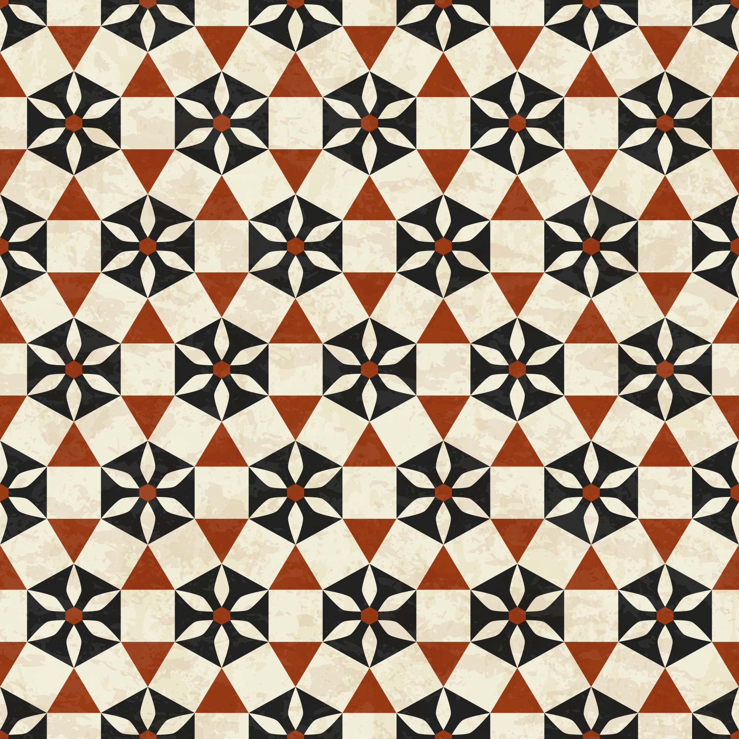

To think about tessellations mathematically, imagine tiling a floor that is infinitely large and goes on forever. Instead of tiling the entire infinite plane you can describe a self-repeating tiling pattern, or a tessellation, that will cover the entire plane.
In this project, you will explore the types of tessellations that can be created using different types of polygons and applying transformations.
As you complete the task, keep these questions in mind:
What are tessellations and what are the different types? How can you use transformations to create tessellations?
In this task, you will apply what you have learned in this lesson to answer these questions.

Directions
Complete each of the following tasks, reading the directions carefully as you go. Be sure to show all work where indicated, including inserting images.
In addition to the answers you determine, you will be graded based on the work you show, or your solution process. So, be sure to show all your work and answer each question as you complete the tasks. Type your work into this document, or print the document and show work by hand, so you can submit it to your teacher for a grade.
Your teacher will give you further directions about how to submit your work. You may be asked to upload the document, e-mail it to your teacher, or print it and hand in a hard copy.
Now, let’s get started!

Part 1: Explain the structure and creation of regular and semi-regular tessellations.
- What is a tessellation? Give two everyday examples of tessellations (that do not extend indefinitely). You may insert images or give a verbal description. (5 points)

- What is a regular tessellation? How many regular tessellations are possible? Why aren’t there infinitely many regular tessellations? (5 points)

- Explain how to use transformations to tessellate the regular hexagon. Draw a sketch and label the angle measures at a vertex of the tessellation to show that the sum of the measures must equal 360º. (5 points)
U
V
Z
W
X
Y

- What is a semi-regular tessellation? How many semi-regular tessellations are possible? Why aren’t there infinitely many semi-regular tessellations? (5 points)

- Is it possible to create a semi-regular tessellation using only squares and regular hexagons? If so, draw an example. If not, explain why it is impossible. (5 points)

Part 2: Explain the structure and creation of irregular tessellations.
- What is an irregular tessellation? How many irregular tessellations are possible? How can one create an irregular polygon that tessellates? (5 points)

- Below is a regular hexagon. A piece is cut out and translated to the opposite side to form an irregular polygon that will tessellate. On the right, the figure that can tessellate is drawn solid, and the original hexagon sides are shown as dashed lines. (10 points)

Perform two translations to the parallelogram below to transform it into an irregular polygon that can tessellate.

- Create an irregular tessellation using the grid below by modifying one of the squares, performing a glide reflection, and continuing the pattern to fill the grid. (10 points)

Part 3: Create a tessellation by hand.
You will need the following supplies to create a tessellation by hand: a pencil or pen, a 3” by 5” index card, scissors, tape, an 8.5” by 11” piece of paper, and markers, crayons, or colored pencils.

- Create a template using the index card and the template instructions that follow. You must use at least two different types of transformations to create your template. What transformations did you use to create your template? (10 points)

- Trace your template repeatedly on the 8.5” by 11” piece of paper so that the design covers the paper entirely. Note that the template may need to be reflected or rotated to get the pattern to interlock correctly, depending on which transformations were used to create the template. Color your tessellation with markers, crayons, or colored pencils. (40 points)

Your tessellation design will be graded on the following rubric:
- Content (20 points): Tessellated figure was created using at least two transformations. Figure tessellates without gaps or overlapping and covers the entire piece of paper.
- Construction (15 points): Tessellation shows attention to detail and neatness. The tessellation is colored.
- Design (5 points): Tesselation design demonstrates effort.

Tessellation Template Instructions
- Translation:
1. Begin with a 3” by 5” index card.

2. Connect the vertices of two adjacent corners using a combination of straight-line segments and curves so that they are continuous from vertex to vertex.

3. Cut the piece out.

4. Translate the piece to the opposite side, making sure corners match up. Secure the piece with tape.

5. This is your template. You can use it to create your tessellation.

- Glide Reflection:
1. Begin with a 3” by 5” index card.

2. Connect the vertices of two adjacent corners using straight-line segments, curves, or a combination so that it is continuous from endpoint to endpoint.

3. Cut the piece out.

4. Translate the piece to the opposite side. Then reflect (flip) the piece, making sure corners match up. Secure the piece with tape.

5. This is your template. You can use it to create your tessellation.

- Rotation:
1. Start with a 3” by 5” index card and cut off 2” from the long side so that you have a 3” by 3” square.

2. Connect the vertices of two adjacent corners using straight-line segments, curves, or a combination so that it is continuous from endpoint to endpoint.

3. Cut the piece out.

4. Rotate the piece about one of its corner endpoints so that it meets an edge of the square. Secure the piece with tape.

5. This is your template. You can use it to create your tessellation.

