From data to Victory

Predicting Olympic Athletes Success and Exploring

Cross-Disciplinary Traits with Machine Learning.

Total words : 5217

Project management methodology
In our research, we will follow the CRISP-DM methodology. As was pointed out by Kurgan L., and Musilek P (2006), the cross-industry process has already become a standard for the vast majority of industrial research and offers a very efficient research strategy.

Stages and Tasks

Field understanding
In this section, we are going to analyse the ground of the problem the industry is currently facing, data source and plan our research. Additionally, we will take a look at which potential bias is inside of the data set and which precautions we should take to make results as objective as possible and prevent any harm to all people or organisations somehow related to the dataset and this research.
  - Literature review
  - Data resources
  - Ethical consideration
  - Objectives
  - Methods

Data understanding
In this section, we will explore the dataset to set appropriate methods for preparation and modelling.
  - Statistic summary
  - Distributions
  - Correlations
  - Feature importance
  - PCA

Data Preparation
This section aims to prepare the dataset for further analysis.
  - Skewed features
  - Missing values
  - Feature engineering
  - Encoding
  - Splitting data
  - Scaling
Note: We will apply a few methods for each task to understand which method fits better for the dataset.

Data modeling
This section will be built based on the results from the first section after we analyse the industry background, current issues and studies which already have been done related to the subject. However, we can define the general process.
  - Define ML models
  - Define Hyperparameters
  - Fit models
Note: Important moment we need to keep in mind that the final report must briefly display the process of the model's selection. So. we need to create data frames for storing models' results.

Data evaluation
This section includes several evaluation methods and compares models' performance. The section aims to select the best model and hyperparameters. Additionally, we will need to extract information from the models' performance to form a conclusion.
  - Compare accuracy scores
  - ROC-Auc scores
  - Confusion matrix

Deployment
This section is going to serve several proposes such as forming a conclusion, tracking accurate results for different combinations of methods, tracking report development, and forming a final report.
  - Conclusion
  - Form final reports
  - Poster

Introduction
The vast majority of athletes consider the Olympic Games as the top of their sporting and physical achievements. A large number of advancements and discoveries can be associated with the drive to succeed in the Olympic games.
Olympic athletes represent the highest level of human physical abilities, as highlighted by Borms and Hebbelinck (1984) in their study. They assert that athletes competing in the Olympics or world-class athletes show the ideal composition of genetic predispositions and environmental factors, and as a result, they can reach a peak of their performance. Theoretically, those athletes who stand out the most in their specific events, possess the optimal physical structure for those types of physical activity, as discussed by Carter (1985).
Within the last century, the Olympic Games have been experiencing an enormous upward in competitiveness. In this evolving stage, coaches and support teams should collaborate closely with data scientists to create and develop predictive models for athletes' performance and identify outliers, patterns and trends. This collaboration is essential not only for improving current athletes' metrics but also for the selection of young talents for specific events. Numerous studies, including those by Cuk and Karácsony (2002), Arkaev and Suchilin (2004), pointed out the significance of anthropometric characteristics in influencing the success of athletes in achieving their goals.
The significance of elite athletes' age in their performance also must be mentioned. Sports researchers acknowledge that even the month of birth compared to other athletes may determine an athlete's likelihood of reaching high performance, a phenomenon known as the relative age effect, as highlighted by J. Musch (2001).
Another vital factor which has a significant impact on athletes’ successes is the nationality or the country they represent. It is very important to consider because each country which shows up at the Olympic Games has its methodologies for many disciplines. Identifying the correlations between countries which provide training and its success may be a key for mutually beneficial exchanges of methods, practices, approaches and databases between counties. Additionally, there is a strong correlation between a country and an athlete's performance directly related to the athlete selection process. As was mentioned by De Bosscher V. (2007), the larger population provides a bigger talent sample for recruitment opportunities for arranging training and competitions.
This study will specifically concentrate on predicting athletic performance by analysing anthropometric characteristics, including weight, height and body mass index. Also, relevant data such as age, gender and nationality for each athlete will be included in the analysis.

Importance
Using advanced analytical methods for predicting athletes' results in world-class sporting competitions can be highly beneficial for many departments, organisations and teams involved in the sports industry.

Improvements in training and selection
Sports performance analysis and techniques allow sports scientists, coaches, and athletes to analyze athlete performance objectively. Thus, performance analysis has become an important component of training Donoghue P. O. (2009), and it has a vital role in planning training and competition strategies Michalsik L.B. (2004) and Frantisek T. (2011). Machine learning uses previous experiences to make a connection with the future, and the success of the model is highly related to the characteristics of the dataset Sekeroglu B., Dimililer K. and Tuncal K. The highest level of sports competitions and data about elite athletes are very important subjects for the sports industry, many data scientists focused on machine learning modelling:
- Meayk E. and Unold O. (2011) combined fuzzy logic and machine learning to model swimming training. The accuracy of their classification model showed 68.66% of accuracy.
- Ofoghi B. et al. (2013) employed a machine learning approach to enhance athlete selection in cycling and optimize strategic planning. Their approach utilized statistical methods, including K-means clustering and a naive Bayes classifier, to assess performance across different events (inter-omnium). Additionally, they used Bayesian belief networks and discrete optimization methods to analyze performance within single events.
- Hore S. and Bhattacharya T. (2018) used naive Bayes, support vector machines (SVMs), multilayer perceptron feed-forward networks, and random forests to build a sustainability model for the National Basketball Association (NBA) players. It was discovered that SVM performed much better than the other models, with an accuracy of 85.65%.
- Muazu Musa R. et al. (2019), applied a variation of k-nearest neighbour and linear regression to classify archers with high-potential considering the results physical tests.
- Muazu Musa R. et al. (2019) conducted another study on the scouting of high-performance archers. They implemented artificial neural networks and k-nearest neighbour models. They selected 50 athletes specialising in Archery and analysed their performance. The obtained results showed that the artificial neural network model achieved a higher accuracy (92%) than the other models.
- Jesus K. et al. (2018) provides comparison analysis between models and artificial neural network to predict the start performances of ten backstroke swimmers. They found out that the ANN prediction was significantly more accurate compared with a linear model.
- Maanijou R. and Mirroshandel S. A. (2019) proposed a method to predict soccer player rankings based on an expert system and ensemble learning. Twenty features of soccer players were considered, and a comparison was performed by considering benchmark machine learning models such as multilayer perceptron, support vector machines, naive Bayes, logistic regression, etc. The methods they used achieved the highest accuracy (60%).
- Anik A.I. et al. (2018) introduced a method that combines feature elimination with machine learning techniques to predict cricket players' performance. The machine learning component utilized linear regression and support vector machines with both linear and polynomial kernels. The model showed 91.5% of accuracy for batsmen and 75.3% for bowlers.
- Zhou Z. et al. (2017) conducted study where they predicted countermovement jump heights by appling machine learning models. Decision trees, random forests, and linear regression models were implemented to train selected features of athletes. Authors used 3 metrics for model evaluation: R2 score, RMSE and MAE. Their results displayed how linear regression outperformed the other machine learning models they used in the project.
Equality and fairness
The concept of addressing inequalities that individuals cannot control and for which they bear no responsibility has deep roots in ethical thought and is reflected in many ethical theories (Arneson, 2015). Another form of inequality relates to what Heinilä K., (1982) describes as "system strength": the robustness of the material, financial, technological, and scientific resources available to support an athlete or team. The statistics on Olympic medals by nation highlight this point, as they align with the ranking of countries by gross national product (Flegl M. and Andrade L., 2018).

Sport medicine
As it was mentioned in research by Bahr R., et. al. (2018), Injuries are very frequent issues in individual and team sports and can cause physical and financial problems. Discovering and learning about factors which may cause an injury in sports is a key component of prevention methods. Bahr R., and Krosshaug T., (2005).

Objectives

Cross-Disciplinary Characteristics
1. We are going to discover if there is any chance to win a competition for an athlete with a different specialisation.
2. What is the probability of winning for the average athlete in their sport.
3. Which disciplines have the most similar requirements for physical characteristics.
4. Which disciplines have the least similar requirements for physical characteristics.
5. Compare the probability of winning in both disciplines.

Predictability Evaluation
In this section, we are going to check how given data behaves with different ML models and preparation phases. We will try to find out which models give us the most accurate prediction of athlete's performance.
For every stage of the preparation process we will create a few options to find which methods work better. For example, there are many different ways of performing imputations (mean, mode, ML models, dropping). So, we will try some methods for each stage.
Similarly, we will analyse how each selected model works with data. We will set a few different hyperparameters and use GridSearch to find the best tuning for each model - Every combination of preparation and best model with hyperparameters will be recorded in an accuracy log for concluding the section.

Data source and Methods

Data Source
As a data source, we will use an available for public use dataset "120 years of Olympic history: athletes and results" published on Kaggle (https://www.kaggle.com/datasets/heesoo37/120-years-of-olympic-history-athletes-and-results/data). The dataset contains 271116 rows and 15 columns which represent data about 134732 athletes performing in Olympic games from 1896 to 2016. The original source of the dataset we are working with is website (https://www.sports-reference.com)

EDA
Exploratory Data Analysis will help us to understand the structure of the dataset including the size, shape, properties and types of variables. Also, identify patterns and relationships between variables. Additionally, EDA allows us to select appropriate techniques and models for our further analysis.
1. Statistical summary
2. Distributions
- Bar plots
3. Correlation
- Heatmap
- Correlation matrix
- Scatter plots
4. Feature importance
- Gradient Boosting Classifier

Data Preparation
The data preparation process is a very important stage in the data analysis, it includes several steps to ensure that the data is in an appreciate format for analysis and modelling. Depending on the research objectives and goals, data preparation stages may vary. In this project we are going to perform the following stages:
1. Normalising skewed features
- Methods to test:
  - log Transformation
  - Cutting outliers
2. Missing values
- Methods to test:
  - Drop rows with missing values
  - Fill in the mean value
  - Fill with ML model
3. Feature engineering
- Methods to perform:
  - Drop irrelevant features
  - Create a new feature 'BMI'
  - Fill with ML model
4. Encoding
- Methods to test:
  - Standard encoder
  - One Hot encoder

Machine Learning Models
1. PCA
Our data set doesn't include a large number of features for applying Principal Components Analysis. However, it may be helpful to discover how this type of data can be compressed in case we get more detailed data.
2. Logistic Regression for probability calculations
This model mostly will be used for the Cross-Disciplinary Characteristics section to define the probability of successful performance.
3. GridSearch with different classifiers
Another section in our research "Predictability Evaluation" will have to define the best model and hyperparameters for predicting performance results. We are going to compare the performance of several models and each of them will be tuned as far as computing ability lets us to tune.
3.1. Machine Learning Models to test:
- Logistic Regression
- Decision Tree
- Random Forest
- Gradient Boosting
- K-Nearest Neighbors
- SMOTE

Ethical consideration

Privacy and Data Protection¶

To provide privacy during our analysis we will anonymise all records by removing personal information such as ID and Name of athletes. While doing our research we might discover information which can affect athletes' current lives even though they have already finished their careers. Many very dangerous zones in world-class media data analytics must be considered before creating and publishing a study. For instance, by analysing an athlete's performance during the training or previous performances and the main performance it is possible to find anomalies which can point to doping use. This unproven fact may have a negative impact on an athlete's life and career. To sum up, the information obtained from data may be misinterpreted and used against people related to it.

Transparency¶

All models, data preparation stages and conclusions are available for any reader. As well as comments with an explanation of why such a method was chosen. The reader can check how results were obtained and if there are any biases in the analysis.

Geographic bias¶

As was mentioned in the introduction section, geographical bias is a very big issue in world-class sports competitions. Athletes from different countries may be equipped differently and have different selection and training processes. Additionally, direct naming nationality of athletes may cause issues. Because nationality is a very important feature we are going to apply encoding techniques to anonymise it.

Competitive advantage¶

Because we use a public dataset and did not collect data using our resources, we should consider fair access to results for all people and organisations associated with the dataset, no matter how advanced the results are. The link to the repository is attached to this report.

Total words for Introduction section: 2459

EDA

Summary Statistics
If we take a look at the statistic summary, we may get important information for our further analysis:
- In the Age feature the mean value of 1.5 higher than the median, which tells us that this data is skewed.
- Height and Weight features also a slight skewness, however, the size of it is not significant and shouldn't affect our analysis.
- Standart deviation value tells us that:
  - 95% of athletes performing in the Olympic Games are aged approximately between 17 and 31 years
  - The range of height for the vast majority of athletes is between 165 and 185 centimetres
  - The weight feature follows a similar pattern as the height. The range of weight for 95% of athletes is approximately between 56 and 84 kg.

Distributions

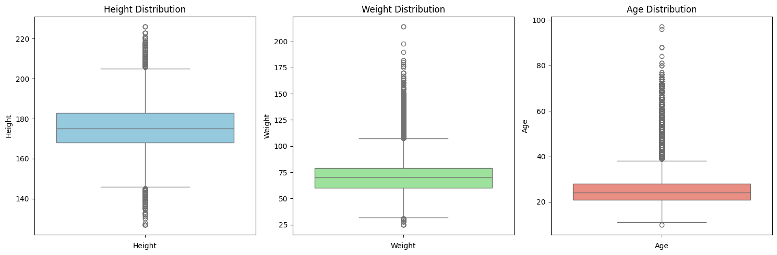

Correlations

Heatmap
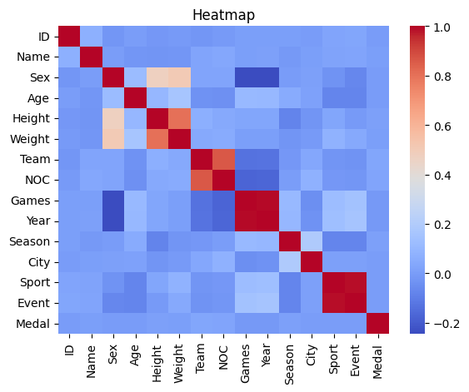

Scatter plots

Height vs. Weight + Medal
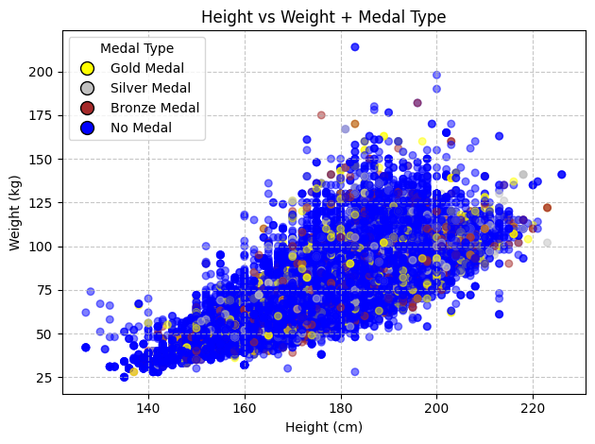

Gender
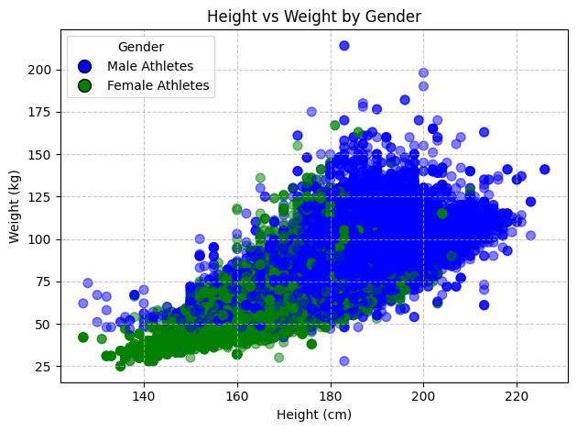

Feature importance
In this section, we will apply a tree-based method to calculate feature importance. The Model Gradient Boosting showes how each feature contributes to model prediction. Borisov, A. (2007) provides a detailed analysis of applying several models to multidimensional datasets. That study may be helpful if we want to include additional data related to athletes, such as specific anthropometric measurements, detailed physical descriptions, or particular skills. In that case, we would need to dedicate more time to feature importance analysis to include only features correlated with the target variable.
Feature Importance
7 NOC 0.267881
13 Event 0.169349
6 Team 0.131100
11 City 0.101784
1 Name 0.069743
0 ID 0.046816
8 Games 0.045450
5 Weight 0.031274
4 Height 0.029605
12 Sport 0.029221
10 Season 0.026998
3 Age 0.025692
9 Year 0.023556
2 Sex 0.001531

Skewed data
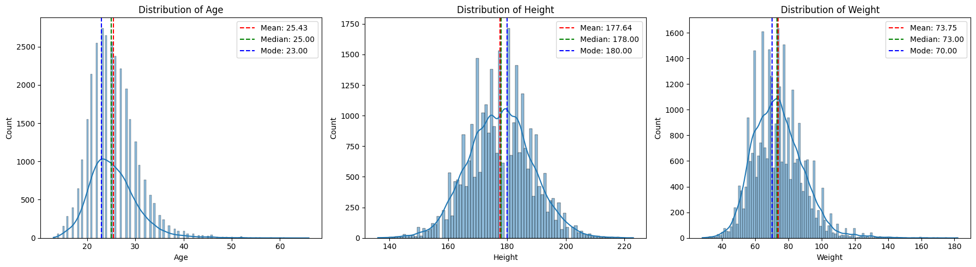

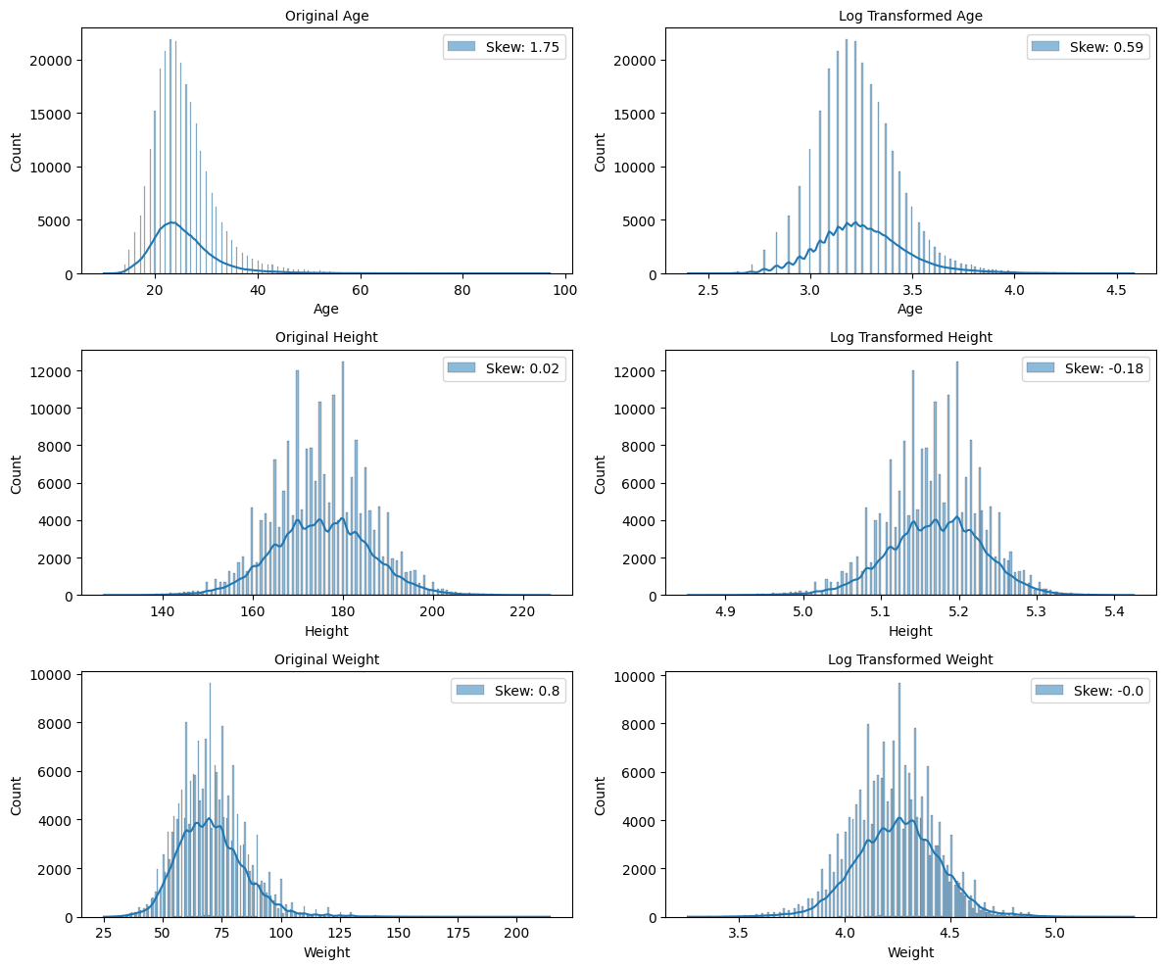

Missing values
Columns with missing values:
Index: 3, Name: Age, Type: float64, Missing Values Count: 9474
Index: 4, Name: Height, Type: float64, Missing Values Count: 60171
Index: 5, Name: Weight, Type: float64, Missing Values Count: 62875
Index: 14, Name: Medal, Type: object, Missing Values Count: 231333

Data Preparaton

Feature selection
In this section, we are going to select only those features which are relevant to our research and edit a target feature "Medal".
We need to think about what we will define as a successful performance. We can include in our search only gold medalists or winners who got at least "Bronze". Considering the level of competitiveness in Olympic Games the difference in performance between medalists is extremely small. In some events, it can be 0.01 seconds. Considering that I think it is fair enough to assign all medalists in our database as winners. So, "1" in the column "Medal" will indicate a medal and "0" no medal.

Missing values
As we displayed in the EDA section we have some missing values in the features we are going to use for our modeling stage. There are many parameters we should consider when doing imputation:
- Normality: We need to evaluate how each imputation method affects the distribution, which should be as close to normal as possible. (skewness, kurtosis and normality tests)
- Distributional Similarity We should ensure that imputed values align with the original distribution. (Histogram, Q-Q plot)
- Comparison models performances A Very effective approach to evaluate imputation methods is to run every combination. However, considering that we are going to test several models with different parameters, this task may be very time-consuming and exceeds the computing abilities of the local machine.
- Correlation During imputation we should ensure that the original correlation between features remains the same.
In this research, we are going to apply only normality testing for multiple imputation techniques. However, deeper investigation may be considered as a future scope for this project. Studies such as Yuan, Y.C., (2010) and Van Buuren, S., (2018) include comprehensive methods for dealing with missing values.
Building this block we came across a few other studies which helped us to get familiar with common imputation techniques:
- Palanivinayagam A. (2023), applies a machine learning method to impute missing values.
- Raja P. (2020), uses unsupervised machine learning models to fill in missing values.
- Makaba T. and Dogo E. (2019), compare different strategies of missing values imputation.
After reviewing those studies we came up with a certain strategy. We will separately apply 3 different imputation methods to each feature with missing values, such as dropping rows with missing values, filling with the mean value and filling using the ML model (KNN). After that, we will apply 4 tests to evaluate how each imputation method affects each distribution. That evaluation report allows us to apply the most effective imputation approach.
For evaluation, we will apply several tests:
- Shapiro-Wilk and Kolmogorov-Smirnov Tests:
Hypothesis tests for evaluation distribution's normality. Tests calculate the p-value, if below 0.05 means that data is not distributed normally. Tests may be sensitive to sample size, so we have included 2 tests for comparison.
- Kurtosis:
Kurtosis is another metric that will help us to evaluate normality, which is close to 3.
- Skewness
Skewness will help us to understand how each imputation method affects distribution. The ideal skewness is 0.

Drop rows with missing values
This approach has pros and cons. By removing rows which contain missing values we may lose a significant part of the dataset, however, the rest of the dataset will contain very accurate data.

Impute with Mean
This method allows us to save shape of dataset but it may harm to final accuracy or make model overfitted.

Fill missing values with ML models
Here we are going to fill in missing values using the KNN Regressor. However, we have an obstacle as missing values in multiple features, which will make an imputation a bit challenging. If we had only one feature, we could have a split dataset where missing values are y_test. However, in our case we need to temporarily define all missing values but y_test. ML models expect no NaN values in datasets. So ironically, to fill in missing values we need to fill missing values first.

Imputation report
---------- AGE ----------
---------- DROP ----------
Kurtosis: 6.271
Skewness: 1.747
KStest: 1.0 , p-value: 0.0
Shapiro Test: 0.8898 , p-value = 0.0
---------- MEAN ----------
Kurtosis: 6.606
Skewness: 1.778
KStest: 1.0 , p-value: 0.0
Shapiro Test: 0.8878 , p-value = 0.0
---------- KNN ----------
Kurtosis: 6.286
Skewness: 1.746
KStest: 1.0 , p-value: 0.0
Shapiro Test: 0.8902 , p-value = 0.0
---------- WEIGHT ----------
---------- DROP ----------
Kurtosis: 2.018
Skewness: 0.797
KStest: 1.0 , p-value: 0.0
Shapiro Test: 0.9698 , p-value = 0.0
---------- MEAN ----------
Kurtosis: 3.532
Skewness: 0.91
KStest: 1.0 , p-value: 0.0
Shapiro Test: 0.9399 , p-value = 0.0
---------- KNN ----------
Kurtosis: 2.485
Skewness: 0.699
KStest: 1.0 , p-value: 0.0
Shapiro Test: 0.9723 , p-value = 0.0
---------- HEIGHT ----------
---------- DROP ----------
Kurtosis: 2.013
Skewness: 0.793
KStest: nan , p-value: nan
Shapiro Test: nan , p-value = nan
---------- MEAN ----------
Kurtosis: 3.532
Skewness: 0.91
KStest: 1.0 , p-value: 0.0
Shapiro Test: 0.9399 , p-value = 0.0
---------- KNN ----------
Kurtosis: 2.485
Skewness: 0.699
KStest: 1.0 , p-value: 0.0
Shapiro Test: 0.9723 , p-value = 0.0

Implementation
As we can see the best options in terms of normality for our imputation are:
- Age: KNN
- Weight: Drop
- Height: KNN
However, I think we may sacrifice a bit of normality to save significant amount of data over 60k records, so we will apply KNN imputation for "Weight" column as well.

Feature Engineering
In this section we will create a new feature BMI (Body Mass Index).
Sex Age Height Weight Team Sport Medal BMI
0 M 24.0 180.0 80.0 China Basketball 0.0 24.691358
1 M 23.0 170.0 60.0 China Judo 0.0 20.761246

Skewness
Similarly to the previous section, we are going to test several techniques to normalise our data:
- Removing outliers
- Log Transformation
- Box-Cox Transformation
- Leave data hot as it is
After we will apply the best technique for each feature.
Several authors highlighted the impacts of using skewed data and some solutions to deal with it. Kazerouni A., et. al. (2020) and Monard M. (2002) discuss how skewed data may affect classification tasks.
Authors Ha T. N., Lubo-Robles D., Marfurt K. and Wallet B. (2021), highlighted the advantages of using log transform to deal with skewed data.

Log tranformation
LogTranformation gets logarithm from each value and creates more smoother distribution, and to some extent balances the ratio between small and large values. Briefly, the logarithm can be defined as a power which we need to transform the log base to a number which we need to get the logarithm from. The plot below illustrates how the feature's distribution will change if we apply logTransform.
---------- AGE ----------
---------- ORIGINAL IMPUTED DF ----------
Kurtosis: 6.286
Skewness: 1.746
KStest: 1.0 , p-value: 0.0
Shapiro Test: 0.8902 , p-value = 0.0
---------- OUTLIERS ----------
Kurtosis: 0.02
Skewness: 0.475
KStest: 1.0 , p-value: 0.0
Shapiro Test: 0.9802 , p-value = 0.0
---------- LOG TRANSFORM ----------
Kurtosis: 1.261
Skewness: 0.587
KStest: 0.9957 , p-value: 0.0
Shapiro Test: 0.9775 , p-value = 0.0
---------- BOX-COX TRANFORM ----------
Kurtosis: 0.526
Skewness: -0.025
KStest: 0.8986 , p-value: 0.0
Shapiro Test: 0.9934 , p-value = 0.0
---------- WEIGHT ----------
---------- ORIGINAL IMPUTED DF ----------
Kurtosis: 2.485
Skewness: 0.699
KStest: 1.0 , p-value: 0.0
Shapiro Test: 0.9723 , p-value = 0.0
---------- OUTLIERS ----------
Kurtosis: -0.137
Skewness: -0.159
KStest: 1.0 , p-value: 0.0
Shapiro Test: 0.9965 , p-value = 0.0
---------- LOG TRANSFORM ----------
Kurtosis: 1.032
Skewness: -0.169
KStest: 0.9996 , p-value: 0.0
Shapiro Test: 0.99 , p-value = 0.0
---------- BOX-COX TRANFORM ----------
Kurtosis: 1.068
Skewness: 0.015
KStest: 1.0 , p-value: 0.0
Shapiro Test: 0.9909 , p-value = 0.0
---------- HEIGHT ----------
---------- ORIGINAL IMPUTED DF ----------
Kurtosis: 0.719
Skewness: -0.117
KStest: 1.0 , p-value: 0.0
Shapiro Test: 0.9931 , p-value = 0.0
---------- OUTLIERS ----------
Kurtosis: 0.384
Skewness: -0.532
KStest: 1.0 , p-value: 0.0
Shapiro Test: 0.982 , p-value = 0.0
---------- LOG TRANSFORM ----------
Kurtosis: 0.865
Skewness: -0.338
KStest: 1.0 , p-value: 0.0
Shapiro Test: 0.9886 , p-value = 0.0
---------- BOX-COX TRANFORM ----------
Kurtosis: 0.727
Skewness: 0.02
KStest: 1.0 , p-value: 0.0
Shapiro Test: 0.9937 , p-value = 0.0

Implementation
Based on the skewness, kurtosis, and Shapiro Test results, we can conclude that the Box-Cox transformation consistently brings each feature closest to normal distribution characteristics, making it the most suitable transformation across all features.

PCA
In this particular case, we are dealing with a dataset which doesn't encounter a large number of features to make us use PCA compression. However, this data may be extended. On the world-class level of the sports industry, scientists tend to collect hundreds or even thousands of different anthropometric parameters for each athlete. In this case, PCA transformation is an essential tool for analysts. We are going to take a look at which ratio of principle components data has, and how data can be compressed.
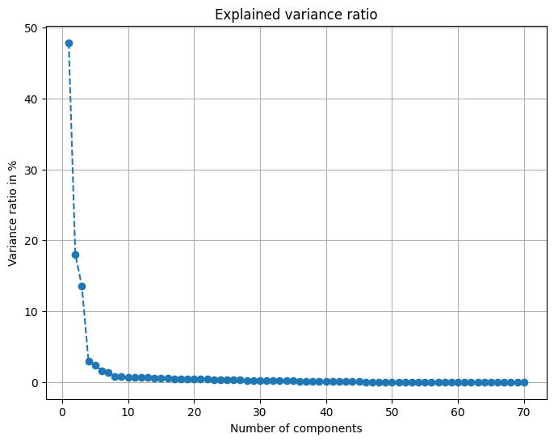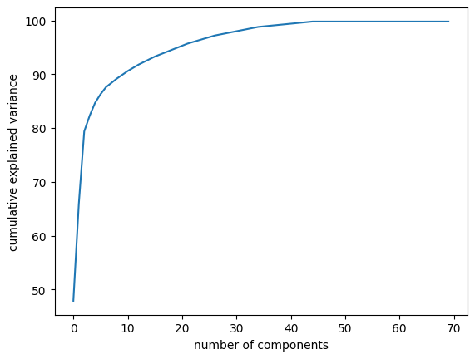

Total words in the Preparation section: 1253

Cross-Disciplinary Characteristics

Introduction
We will try to discover the requirements of physical condition for each sport and the likelihood of winning for the average athlete performing in a different sports competitions. The charts below illustrate the height and weight ratio of athletes who perform in 4 different sports.

Physical requirements for selected sports
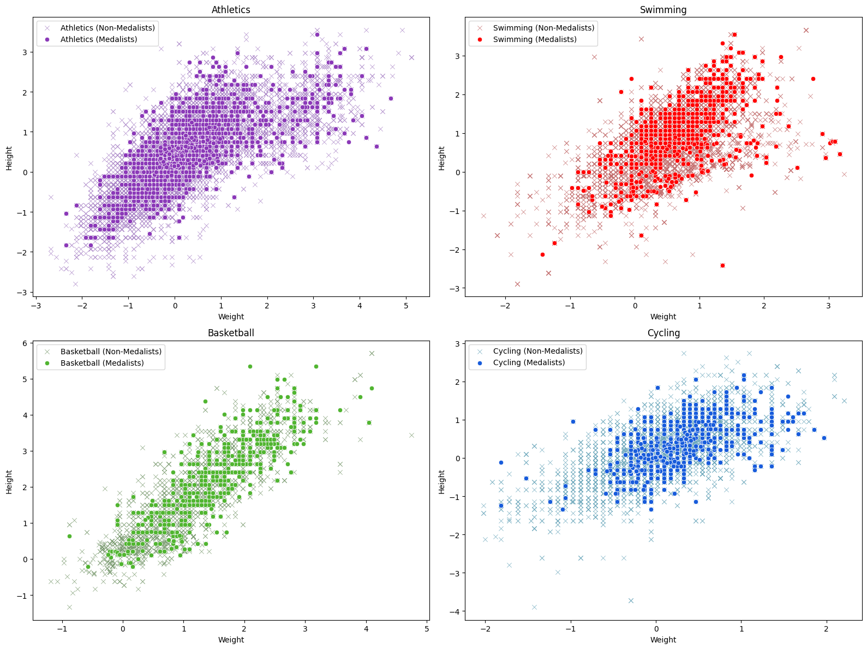
To see how physical characteristics vary depending on the sport we can place data of 3 different sports on one chart. So, now we can see the differences. Additionally, we will specify the gender.
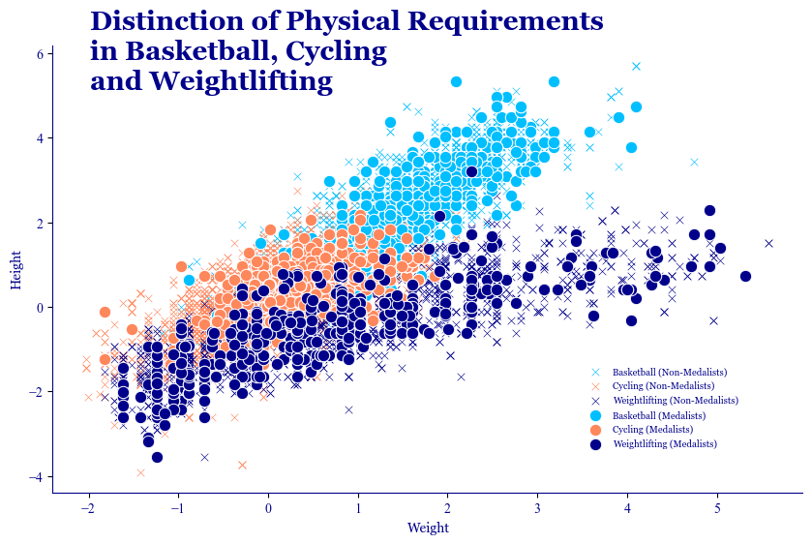

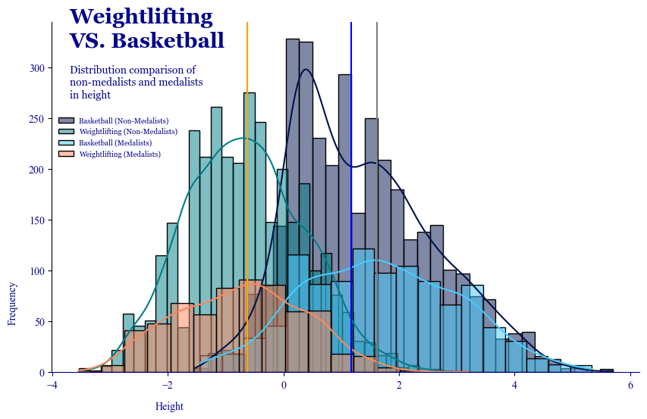

Probality to win for each athlete in their sport

Calculate mean values for each combunation in each feature
Medal Sex Sport Age Height Weight BMI
0 0.0 M Basketball 0.046560 1.597857 1.057494 0.217310
1 0.0 M Judo 0.070872 0.165439 0.736880 1.034143
2 0.0 F Speed Skating -0.324646 -0.813144 -0.634824 -0.248229
3 0.0 M Cross Country Skiing 0.185561 0.189178 0.068555 -0.107249
4 0.0 M Ice Hockey 0.180024 0.433776 0.773611 0.771467
Now we need to use the left join to transfer the mean values of each combination (Sex and Sport) into the main data frame. Before merging we need to drop all rows which represent mean values of non-medalists. As a result, we should get df with athletes' data and mean values for each feature of the winners in the same Gender and Sport.Get the euclidean distance between medalists mean values and actual athlete's fugures
Sex Age Height Weight Sport Medal_x BMI Total_Distance
0 M -0.096145 0.420405 0.683367 Basketball 0.0 0.612048 1.973286
1 M -0.295072 -0.627632 -0.881059 Judo 0.0 -0.808749 3.048704
2 F -0.738784 0.958253 0.822640 Speed Skating 0.0 0.347323 2.463403
3 F -0.738784 0.958253 0.822640 Speed Skating 0.0 0.347323 2.463403
4 F 0.089666 0.958253 0.822640 Speed Skating 0.0 0.347323 2.328975

Convert probability using sigmoid
We added a scaling factor 0.1 to make a probability's desreese not so sharp.

Propability score for each athlete of winning in each sport
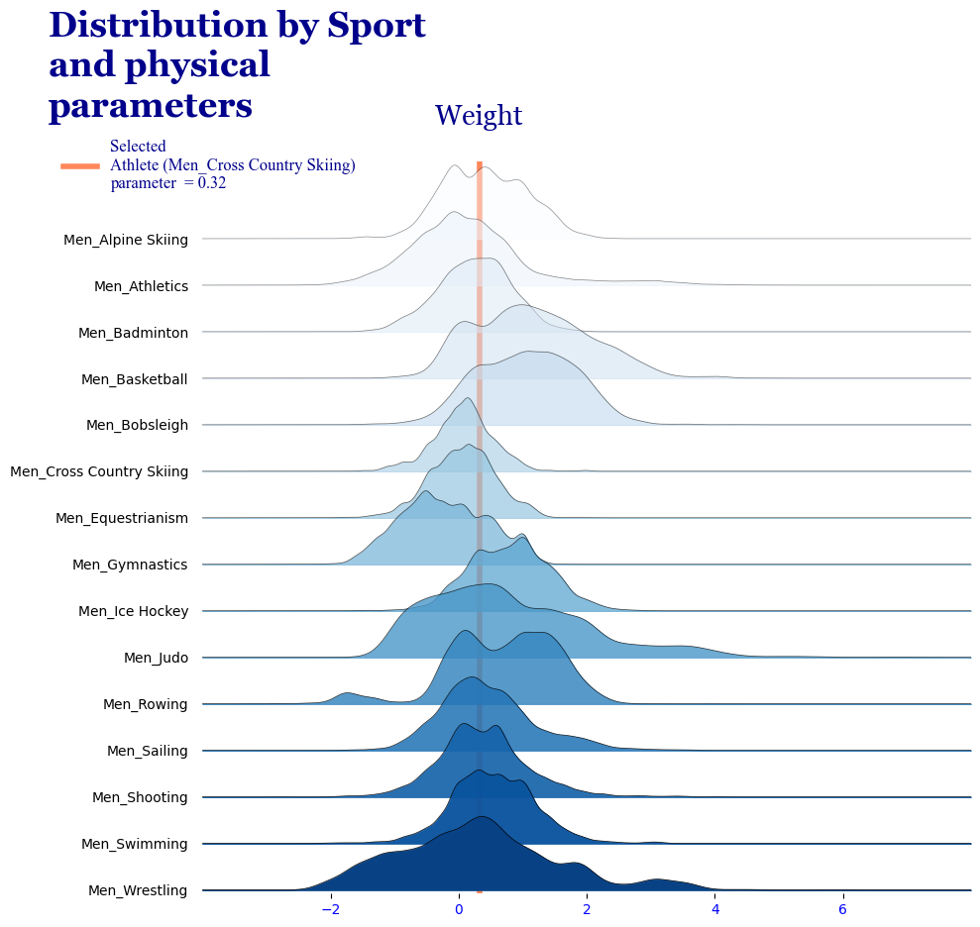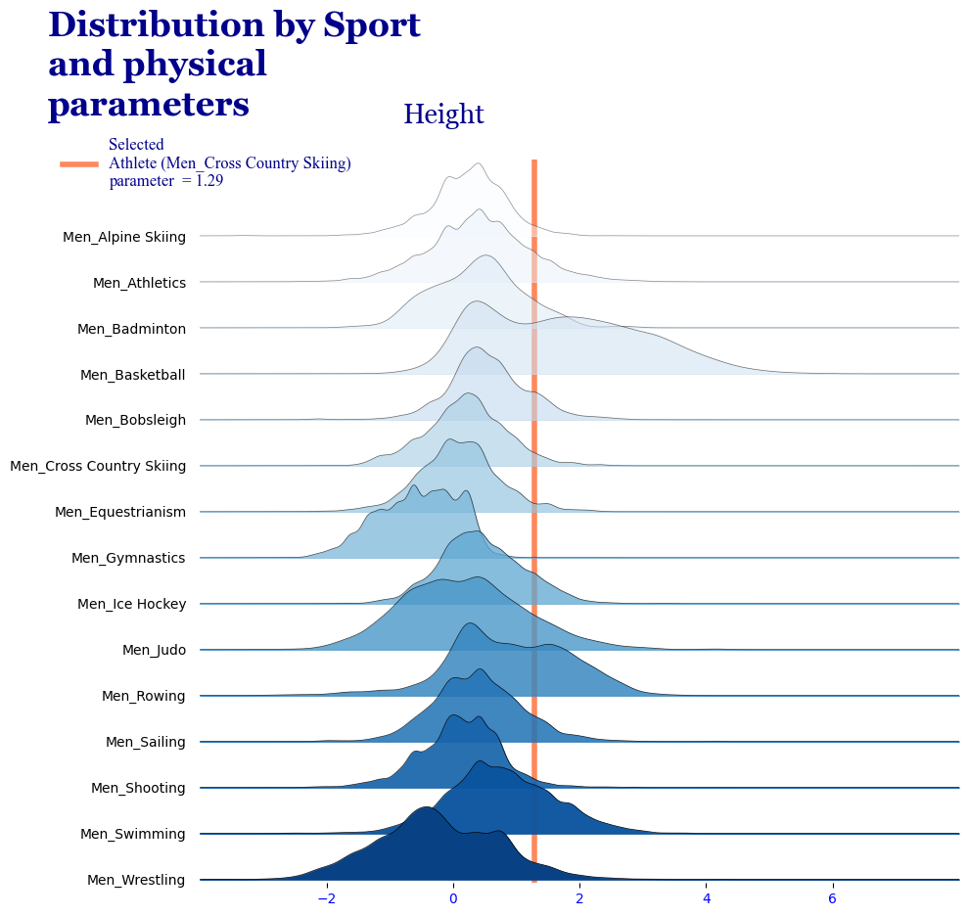

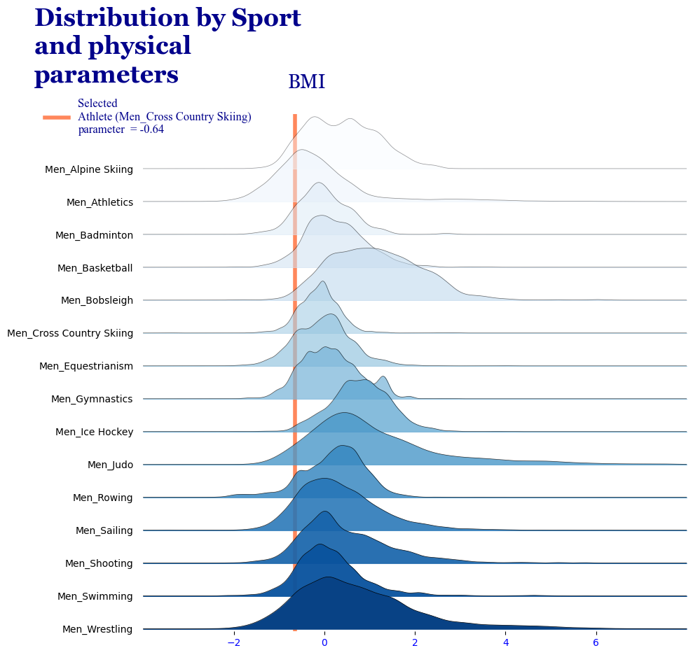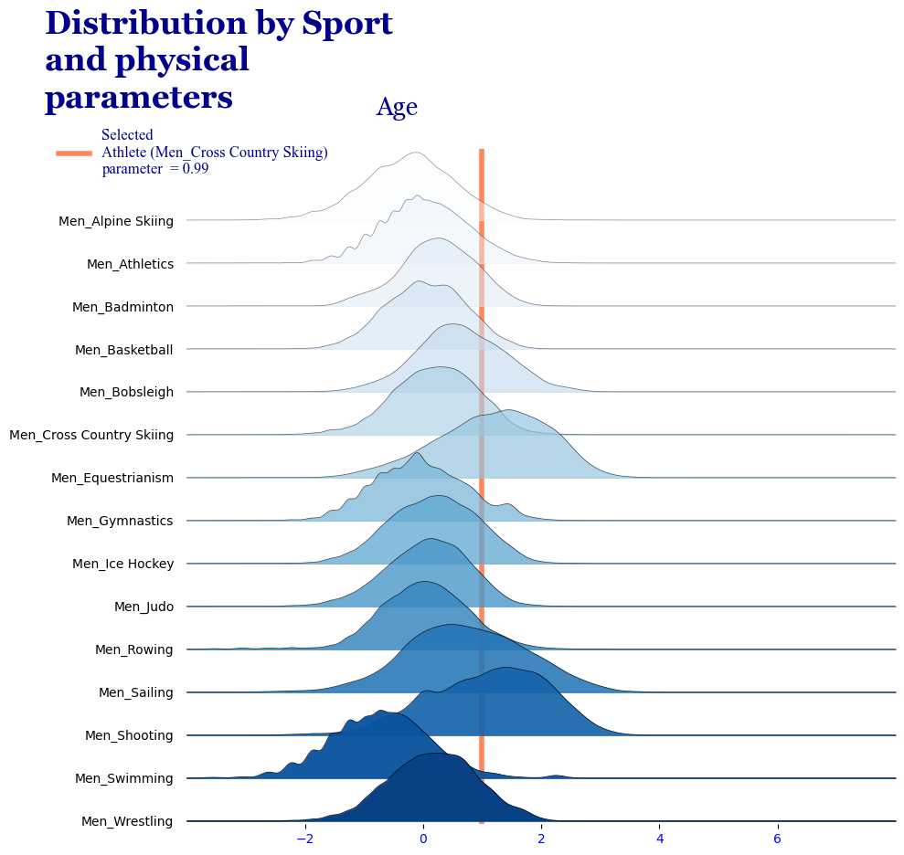

In this section, we have determined the probability of winning for an athlete with certain physical characteristics. This probability was calculated by measuring the Euclidean distance between the parameters of the selected athlete and the mean values of winners in each sport. In the plot below, the orange line represents the parameters of the selected athlete compared with the distribution of the same parameters among winners in each sport. The closer an athlete's parameters are to the mean parameters of winners, the higher the probability of winning, given the selected features. After calculating the Euclidean distance between the athlete's parameters and each sport's mean values, we transformed that distance into a probabilistic framework using the sigmoid function. Additionally, if we want to assess a person’s predisposition for a specific sport, we can use the same procedure, except for the final step. In this case, the Euclidean distance alone can serve as a predisposition score.

Calculate cross disceplinary transfer sore
This section is dedicated to the similarity of physical requirements in all sports presented in the dataset. Similarly to the previous stage, we have calculated Euclidean distance. However, in this case, instead of the parameters of a certain athlete, we applied the mean value of all athletes in each sport. As a result, we have a data frame with the similarity score for each pair of sports. The plot below illustrates 1 out of 227 rows in the data frame, where we visualised all similarity scores for selected sports (Basketball) in a specific gender group. This insight may be helpful for athletes and coaches. with planning cross-disciplinary transfers.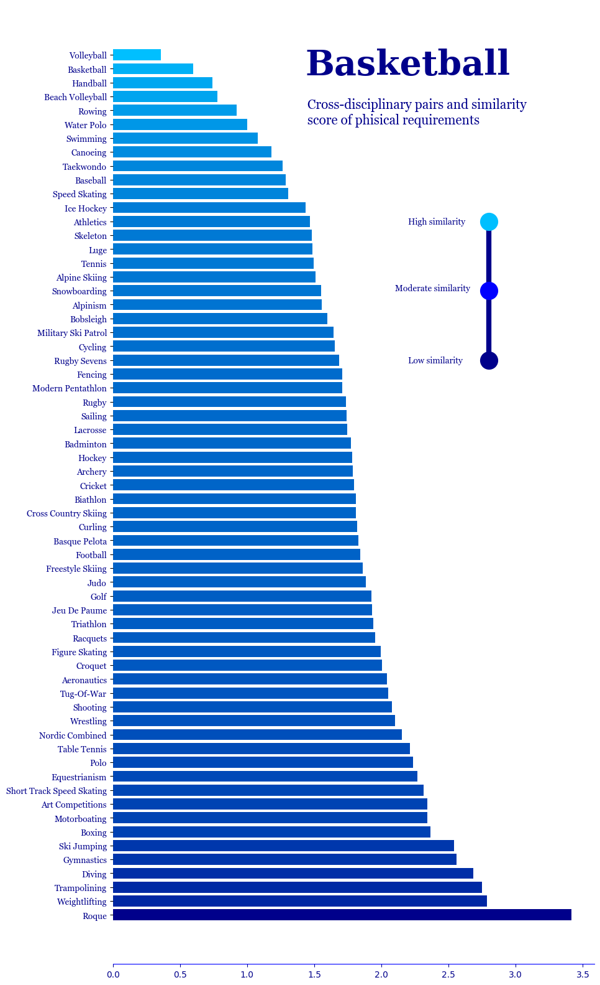
Total words for Cross-Disciplinary section: 380

Predictability Evaluation
In this section we are going to apply 6 machine learning models, using GridSearch tunning and Cross-validation. Additionaly, we are going to test 4 differently transformed dataset such as:
- Dataset transformed in data preparation section.
- Dataset with applied PCA (from 74 features up to 14 features)
- Dataset with applies SMOTE transformation for balancing X and y sets.
- Dataset with applied both PCA and SMOTE transformation.

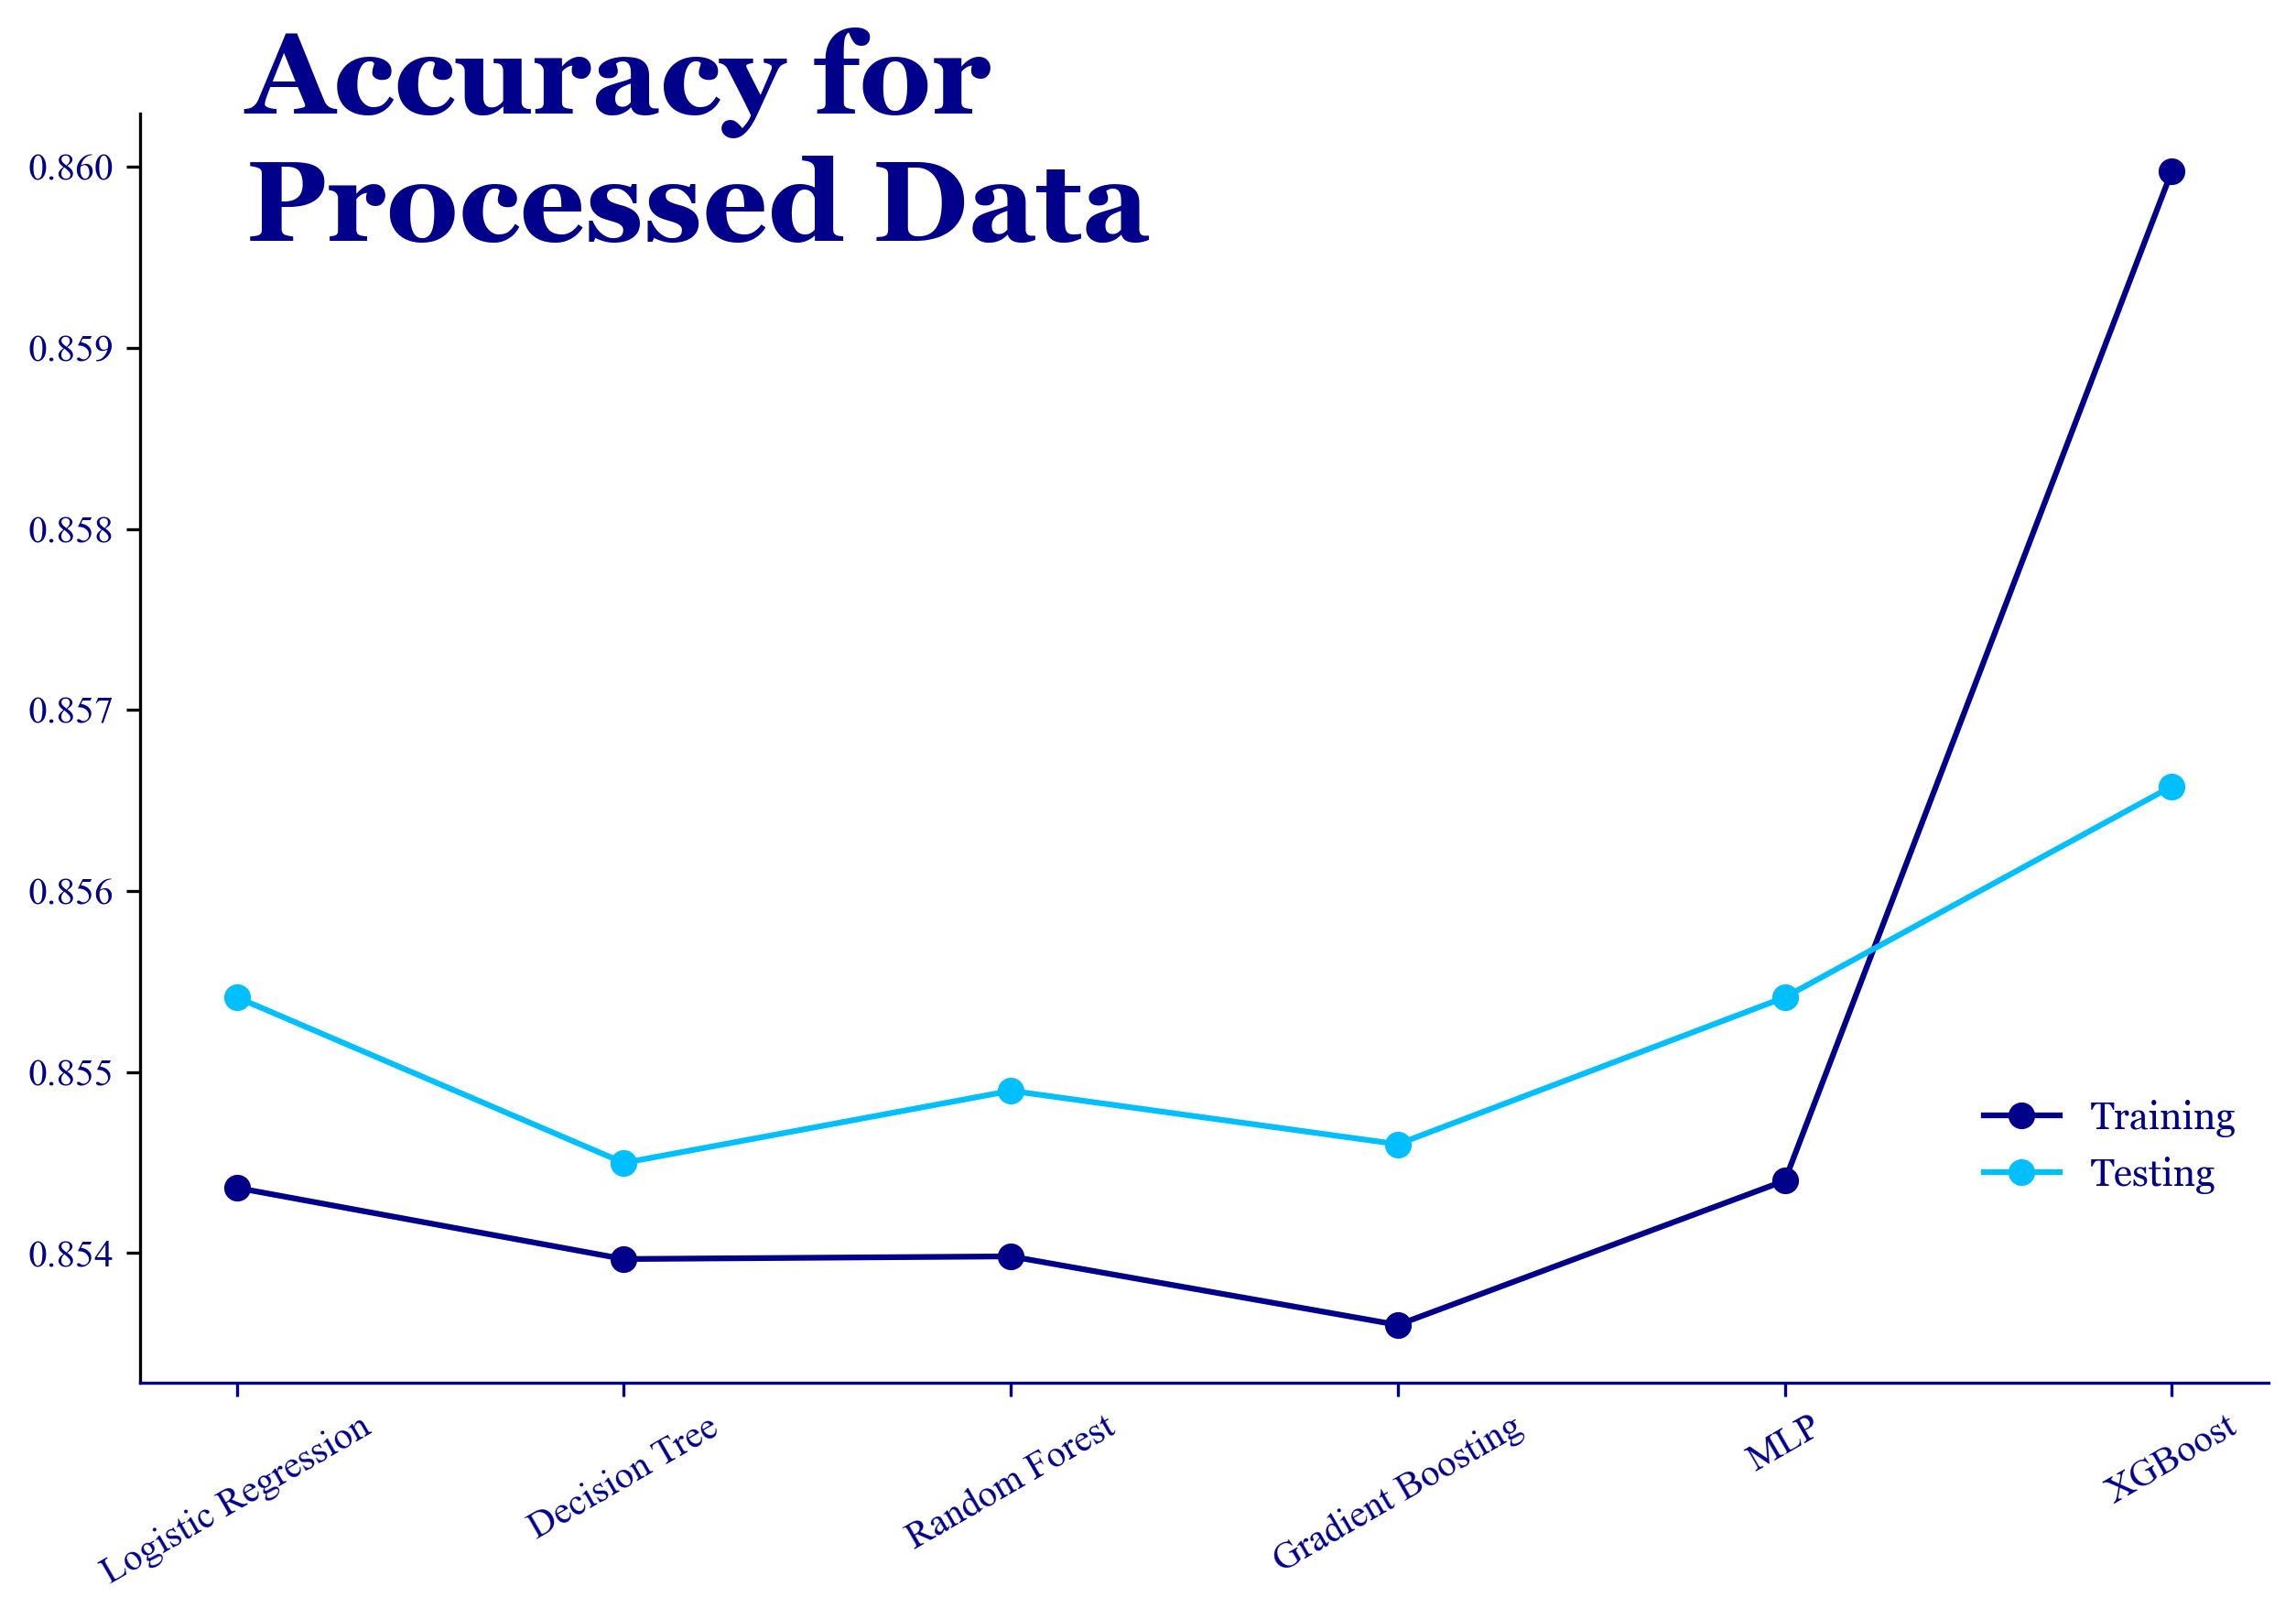
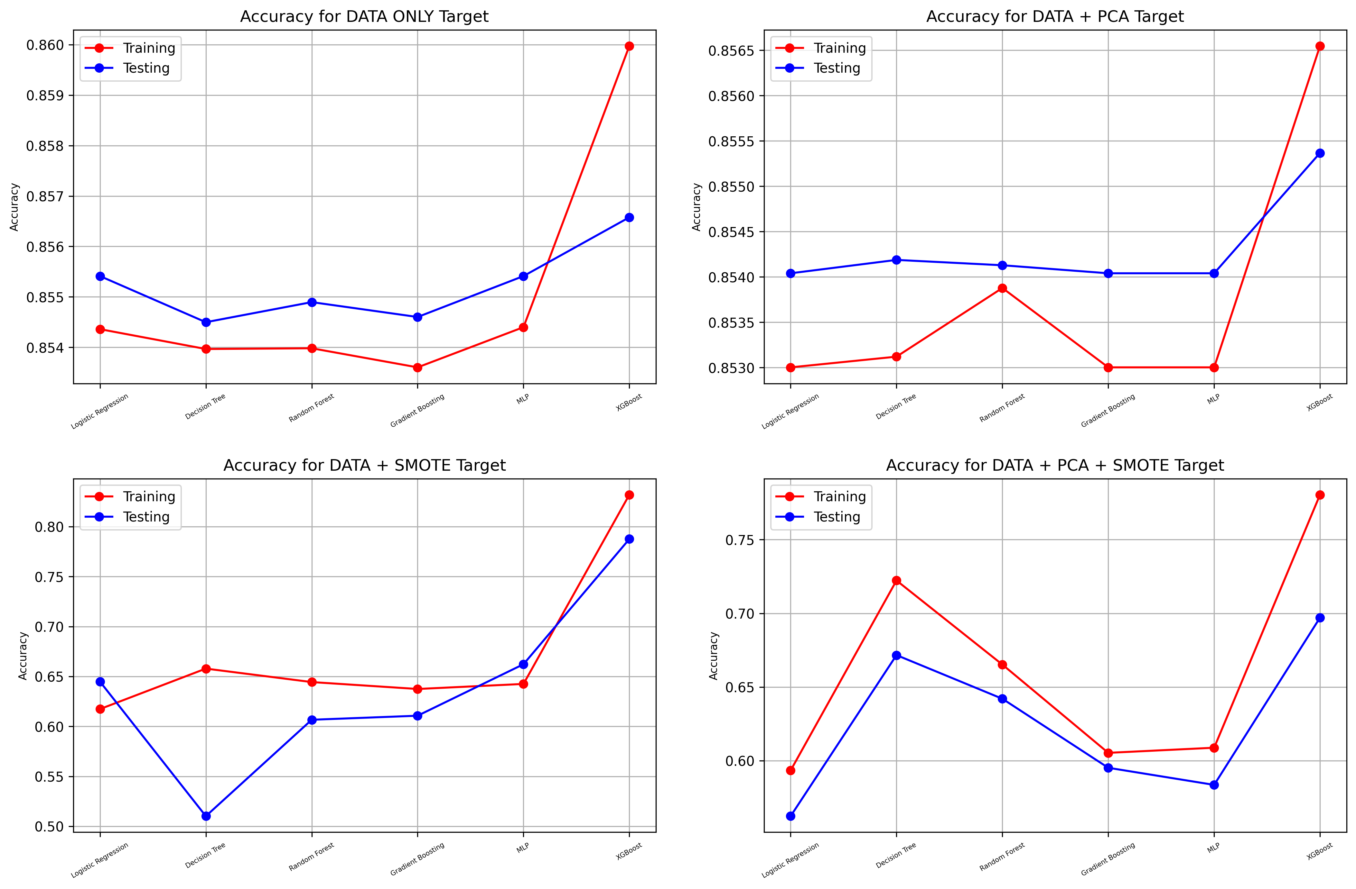

Evaluation

Overview:
We applied GridSearch Hyperparameters tunning with several variations of data transformation;
DATA ONLY: Original processed data without PCA and SMOTE.
DATA + PCA: Data with PCA applied for dimensionality reduction up to 14 features.
DATA + SMOTE: Original processed data balanced using SMOTE.
DATA + PCA + SMOTE: Data with both PCA and SMOTE applied.
Models:
Several classifiers were applied, including Logistic Regression, Decision Tree, Random Forest, Gradient Boosting, Multi-Layer Perceptron (MLP), and XGBoost.
Metrics:
You evaluated each model based on training and testing accuracy, precision, recall, F1 score, and the best estimator and parameters.

Best Performing Models for Each Dataset:
DATA ONLY:
XGBoost showed the highest test accuracy score (85.66%) and F1 score (0.798). Logistic Regression and MLP performed with similar metrics.
DATA + PCA:
XGBoost again had the highest test accuracy (85.55%) and F1 score (0.792). Other models gave similar but slightly lower scores.
DATA + SMOTE:
XGBoost achieved the best test accuracy (78.76%) and balanced F1 score (0.789). Most other models struggled with lower accuracy and F1 scores.
DATA + PCA + SMOTE:
XGBoost was again the top performer, with a test accuracy of 69.67% and an F1 score of 0.735. Despite the accuracy dropping compared to the other datasets, XGBoost maintained relatively good performance, making it the best model across different datasets.

Model Insights
XGBoost performed well across all datasets, being adaptive and effective in handling complex data, even with dimensionality reduction (PCA) and class balancing (SMOTE)
Logistic Regression and MLP performed well with the original processed data, however, it showed a drop in performance with PCA and SMOTE transformations, especially in recall and F1 score.
Decision Tree and Random Forest achieved reasonable accuracy but lower precision and F1 scores, especially with SMOTE, indicating potential overfitting or instability with synthetic data.
Gradient Boosting gave stable performance but generally had lower accuracy and F1 scores than XGBoost.

Conclusion
We can conclude that XGBoost is the top model in this project. It consistently achieves high test accuracy and balanced performance metrics across different datasets.
PCA and SMOTE did not significantly improve the models' performance. In some cases, they even reduced accuracy, suggesting that the original data might already capture the essential features well enough.
Using the original processed data with XGBoost seems to be the most effective approach for predicting medalists based on physical characteristics, providing a strong balance between precision, recall, and F1 scores.

Recommendation for future work
The study has many different ways for improvements, in this section, I would like to highlight 2 main ways to develop this study.
1. Qualitatively, using the same dataset but different methods
- Many methods of data preparation were not tested. So there is a big scope to investigate how each method applied affects the Machine learning model.
  - Investigate more relationships with the database.
  - Calculation probabilities for each specific class.
2. Quantitatively, using the same or similar method with extended or additional dataset
Any additional information may add complicity and make predictions and probability more accurate. There are many different athlete metrics which may significantly improve the outcome such as:
- Physical data:
  - Detailed anthropometrical measurements.
  - Results of physical testing.
  - Biochemical data such as blood testing.
  - Genetic data.
- Detailed environmental data such as:
  - Couches, methodologies, physiotherapist.
  - Establishment which provides an athlete's preparation.
  - Amount of investment, funds, grants, and salaries.
  - Athlete's background.

Total words for ML section: 744

References
Anik, A. I., Yeaser, S., Hossain, A. I., and Chakrabarty, A. (2018). Player’s Performance Prediction in ODI Cricket Using Machine Learning Algorithms. Proc. 4th Int. Conf. Electr. Eng. Inf. Commun. Technol. (iCEEiCT), pp. 500-505.
Arkaev, L. I., and Suchilin, N. G. (2004). How to Create Champions. Oxford, Meyer & Meyer Sport.
Arneson, R. (2015). Equality of opportunity. In E. Zalta (Ed.), The Stanford encyclopedia of philosophy (Summer 2015 ed.). Retrieved from https://plato.stanford.edu/archives/sum2015/entries/equal-opportunity/
Bahr, R., Clarsen, B., and Ekstrand, J. (2018). Why we should focus on the burden of injuries and illnesses, not just their incidence. Br J Sports Med, 52, 1018–1021. https://doi.org/10.1136/bjsports-2017-098160
Bahr, R., and Krosshaug, T. (2005). Understanding injury mechanisms: a key component of preventing injuries in sport. Br J Sports Med, 39, 324–329. https://doi.org/10.1136/bjsm.2005.018341
Borms, J., and Hebbelinck, M. (1984). Review of Studies on Olympic Athletes. In J. E. L. Carter (Ed.), Physical Structure of Olympic Athletes Part 11: Kinanthropometry of Olympic Athletes (pp. 7-27). New York: Basel-Karger.
Borisov, A. (2007). Feature selection, redundancy elimination, and gradient boosted trees. Journal of Machine Learning Research, 8, pp. 1659-1685.
Bunker, R. and Thabtah F. (2019). A machine learning framework for sport result prediction. Applied computing and informatics, 15(1), 27-33.
Carter, J. E. L. (1985). Morphological Factors Limiting Human Performance. In D. H. Clarke & H. M. Eckert (Eds.), Limits of Human Performance. American Academy of Physical Education Papers, No. 18. Champaign: Human Kinetics.
Cuk, I., and Karácsony, I. (2002). Rings. Methods, Ideas, Curiosities, History. Norman (OK), Paul Ziert & Associates.
De Bosscher, V. (2007). Sports Policy Factors Leading to International Sporting Success. Published Doctoral thesis, Vrije Universiteit Brussel, Brussel, VUBPRESS.
De Jesus, K., Ayala, H. V. H., de Jesus, K., Coelho, L. D. S., Medeiros, A. I. A., & Abraldes, J. A. (2018). Modelling and predicting backstroke start performance using non-linear and linear models. J. Hum. Kinetics, 61(1), 29-38.
Derrick, B., Toher, D., & White, P. (2017). How to compare the means of two samples that include paired observations and independent observations: A companion to Derrick, Russ, Toher and White (2017). The Quantitative Methods for Psychology, 13(2), 120–126.
Donoghue, P. O. (2009). Research Methods for Sports Performance Analysis. Evanston, IL, USA: Routledge.
Fisher, R. A. (1922). On the Interpretation of χ2 from Contingency Tables, and the Calculation of P. Journal of the Royal Statistical Society, 85(1), 87–94.
Flegl, M., and Andrade, L. A. (2018). Measuring countries’ performance at the Summer Olympic Games in Rio 2016. OPSEARCH, 55, 823–846. https://doi.org/10.1007/s12597-018-0347-8
Frantisek, T. (2011). Competitive Loading in Top Team Handball. Vienna, Austria: European Handball Federation WEB PERIODICAL.
Ha, T. N., Lubo-Robles, D., Marfurt, K., and Wallet, B. (2021). In-depth analysis of logarithmic data transformation and per-class normalization in machine learning. Interpretation, 9(3), T685-T710.
Heinilä, K. (1982). The totalization process in international sport. Sportwissenschaft, 12(3), 235–254.
Hore, S., and Bhattacharya, T. (2018). A machine learning based approach towards building a Sustainability Model for NBA players. Proc. 2nd Int. Conf. Inventive Commun. Comput. Technol. (ICICCT), pp. 1690-1694.
Johnson, E. (Ed.). (2000). Essentials of Exercise Physiology (pp. 500-527). Lippincott Williams and Wilkins, USA.
Kazerouni, A., Zhao, Q., Xie, J., Tata, S., and Najork, M. (2020). Active learning for skewed data sets. arXiv preprint arXiv:2005.11442.
Kendall, M. G., and Stuart, A. (1973). The Advanced Theory of Statistics, Volume 2: Inference and Relationship. Griffin.
Kurgan, L., and Musilek, P. (2006). A survey of Knowledge Discovery and Data Mining process models. Knowl. Eng. Rev., 21, 1–24.
Lovdal, S., Hartigh, R., and Azzopardi, G. (2021). Injury prediction in competitive runners with machine learning. International Journal of Sports Physiology and Performance, 16(10), 1522-1531.
Maanijou, R., and Mirroshandel, S. A. (2019). Introducing an expert system for prediction of soccer player ranking using ensemble learning. Neural Comput. Appl., 31(12), 9157-9174.
Makaba, T., and Dogo, E. (2019). A comparison of strategies for missing values in data on machine learning classification algorithms. International multidisciplinary information technology and engineering conference (IMITEC), 1-7.
Meayk, E., and Unold, O. (2011). Machine learning approach to model sport training. Comput. Hum. Behav., 27(5), 1499-1506.
Michalsik, L. B. (2004). Analysis of working demands of Danish handball players. In What’s Going Gym. Copenhagen, Denmark: Forlaget Underskoven, pp. 321-330.
Monard, M. C. (2002). Learning with skewed class distributions. GEAPA Batista, 85, 173-180.
Musa, R. M., Majeed, A. P. P. A., Taha, Z., Abdullah, M. R., Maliki, A. B. H. M., and Kosni, N. A. (2019). The application of artificial neural network and k-nearest neighbour classification models in the scouting of high-performance archers from selected fitness and motor skill performance parameters. Sci. Sports, 34, 241-249.
Musa, R. M., Majeed, A. P. P. A., Taha, Z., Chang, S. W., Nasir, A. F. A., and Abdullah, M. R. (2019). A machine learning approach of predicting high potential archers by means of physical fitness indicators. PLoS ONE, 14(1).
Musch, J., and Grondin, S. (2001). Unequal competition as an impediment to personal development: a review of the relative age effect in sport.
Nikulin, M. S. (1996). A guide to chi-squared testing. New York: Wiley.
Ofoghi, B., Zeleznikow, J., Macmahon, C., and Dwyer, D. (2013). Supporting athlete selection and strategic planning in track cycling omnium: A statistical and machine learning approach. Inf. Sci., 233, 200-213.
Palanivinayagam, A. (2023). Effective handling of missing values in datasets for classification using machine learning methods. Information, 14(2), 92.
Raja, P. (2020). Missing value imputation using unsupervised machine learning techniques. KJSC Thangavel Soft Computing, 24(6), 4361-4392.
Sekeroglu, B., Dimililer, K., and Tuncal, K. (2019). Artificial Intelligence in Education: Application in student performance evaluation. Dilemas Contemporaneos Educacion Politica Valores, 7(1), 1-21.
Sprinthall, R. C. (2011). Basic statistical analysis (9th ed.). Pearson Education.
Van Buuren, S. (2018). Flexible imputation of missing data. CRC press.
Yuan, Y.C., 2010. Multiple imputation for missing data: Concepts and new development (Version 9.0). SAS Institute Inc, Rockville, MD, 49(1-11), p.12.

Author: Ilia Grishkin
https://github.com/CCT-Dublin/capstone-project-feb-2024-ft-Ilia-Grishkin

