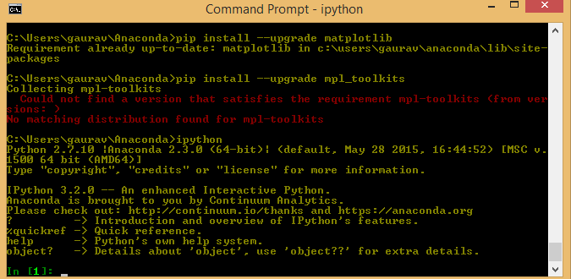

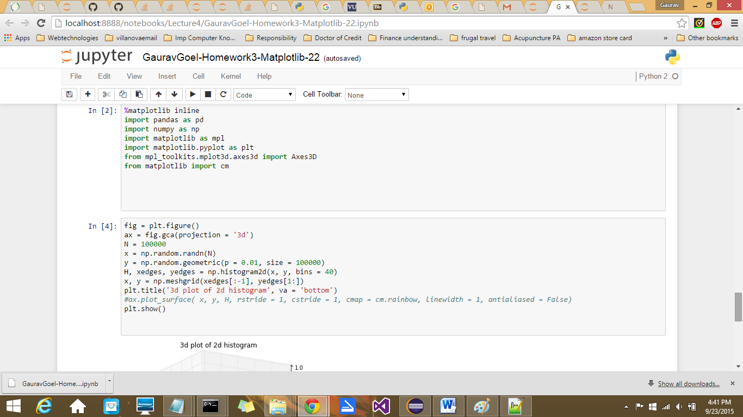

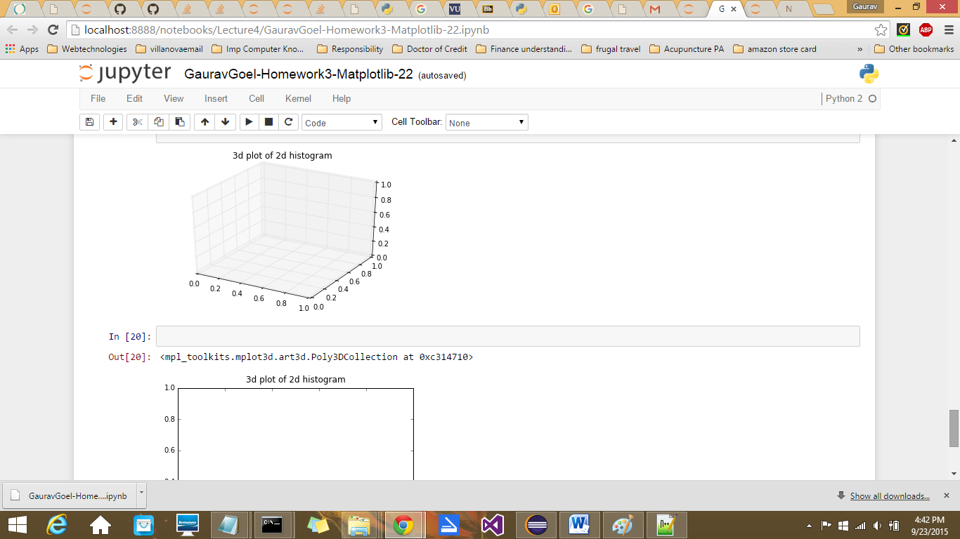

If I uncomment the code

**#ax.plot_surface( x, y, H, rstride = 1, cstride = 1, cmap = cm.rainbow, linewidth = 1, antialiased = False)**

I get an error as shown below

