Title: FCC & CE Testing
Test Plan: TP-RD-00002
Document Date: 07.12.16
Test Date: 07.05.16
Testing Location: EMI Test Lab LLC

PURPOSE:

Achieve FCC and CE compliance for radiated emissions on the Gladiola Mini.

RESULTS SUMMARY:

The results of the examination on 07/05/2016 showed that the Gladiola Mini is capable of passing conducted emissions testing with modifications. During the initial examination, the stock Gladiola Mini did not pass the initial EMC radiated emissions testing. It failed at 304MHz and was within the margin of error (+/-2.5dBμV/m) at 30Mhz, 160 Mhz, 192MHz, 214 Mhz, and 215Mhz. The results were not effected by having either a single or dual ferrite on the top harness.

After the initial tests were run, copper tape was used to modify the units as much as possible to close the gaps that the radiated emissions were escaping from. This included areas around the fan intake and outtake and the USB port. It was also discovered the frame pieces were not grounded to each other and were floating, this was partially modified on the spot. A Faraday cage was created around the electronics enclosure to help contain the noise. The two ground points were also tied together with a wire to provide an appropriate drain for the chassis and electronics. The X and Y motors also required double ended shield termination to remove the noise from the motors and drain it out through the ground. Adding a ferrite to the X harness and extending it by 6 inches decreased the emissions due to coupling however it was variable based on relative position to other harnesses. Extending the shielding to the termination points also helped to decrease the cross talk radiation.

The test was then run again with these modifications and the quasi peak data showed a marked drop in the radiated emissions. The 160MHz peak (the 10th harmonic of the 16MHz clock) was still within the margin or error, and the 30MHz peak was variable based on harness movement. The modifications were only made with sandpaper to remove powercoat and copper tape to provide conduction, but the testing did show that the philosophy of the improvements that were made would be effective.

CONCLUSION:

The results of the examination on 07/05/2016 showed that the Gladiola Mini is capable of passing conducted emissions testing with modifications.

In order to consistently pass EMC radiated emissions, we need to incorporate the following changes to the Gladiola machines:

EMC (Radiated Emissions)
Double End Terminate Motor Shielding to X and Y
(Best Practice All Motors Should Be Grounded)
Bring All Chassis Pieces to Common Ground
Create Faraday Cage Around Electronics Enclosure
Modify Fan Intake and Outtake from Slots to Holes
Ground Floating USB Port
Extend Harness Shielding Closer to Termination Point

These fixes are additive in nature and all help towards meeting the EMC goal. No one fix alone would bring the unit within the margin of error and further modifications could be included if needed.

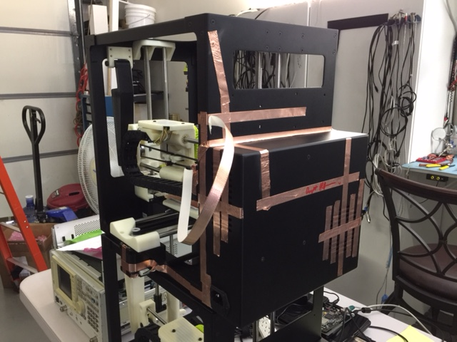
EQUIPMENT:

An HP 8566B Spectrum Analyzer was used when testing radiated emissions.

Here is an image of the EMI chamber:
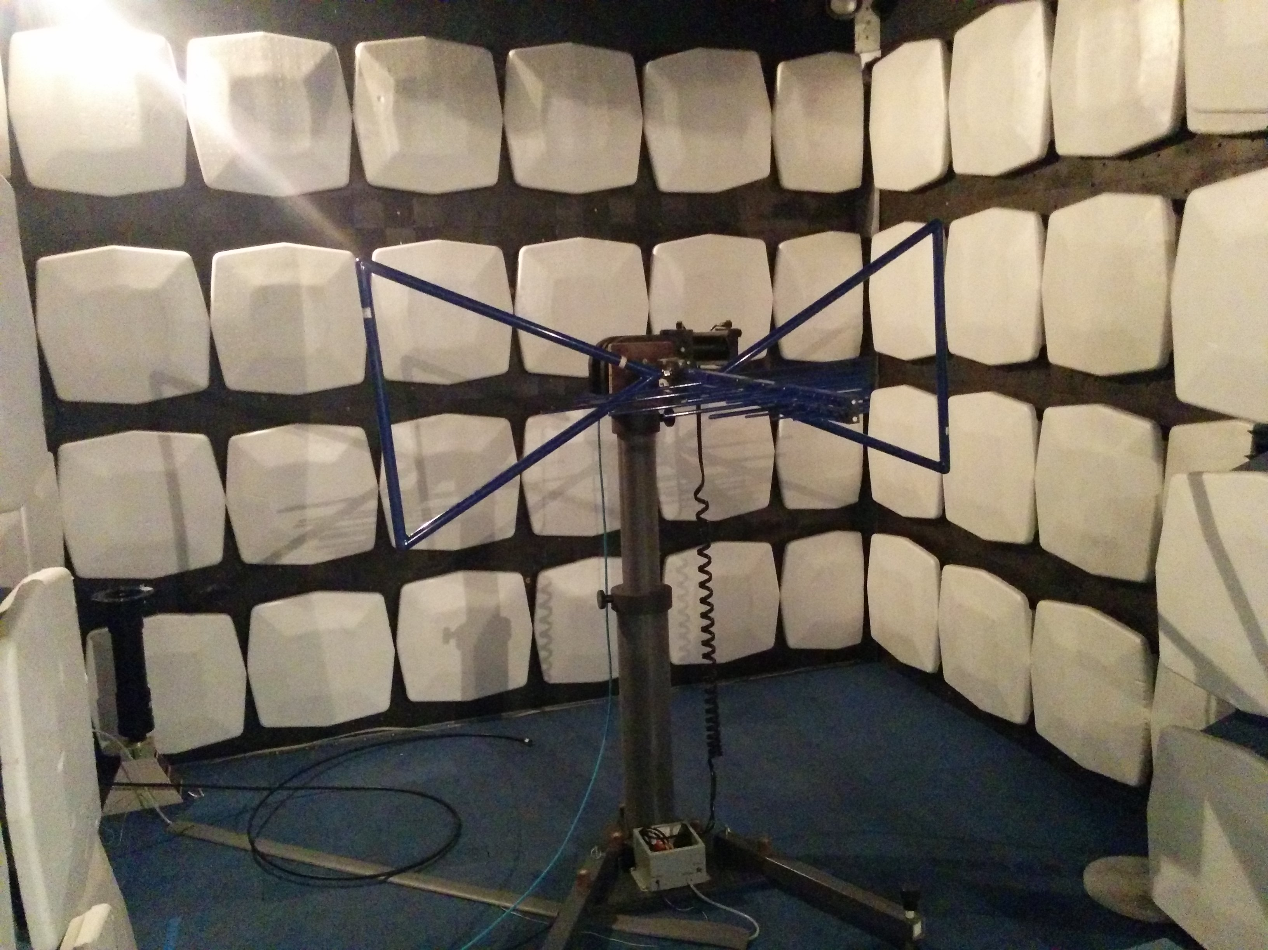

Here is an image the modified Gladiola Mini:

PROCEDURE:

EMI Testing Procedure:
Place the machine on the turning table in the EMI chamber. Run through the spectrum (30MHz – 1GHz) with the antenna in its horizontal and vertical positions. If any frequency is above the specified limit then examine those frequencies individually and modify the machine as needed to negate those specific frequencies.

TEST DATA and RESULTS:

The following data was gathered on 07/05/2016 when Gladiola Mini initially did not pass the EMC testing:
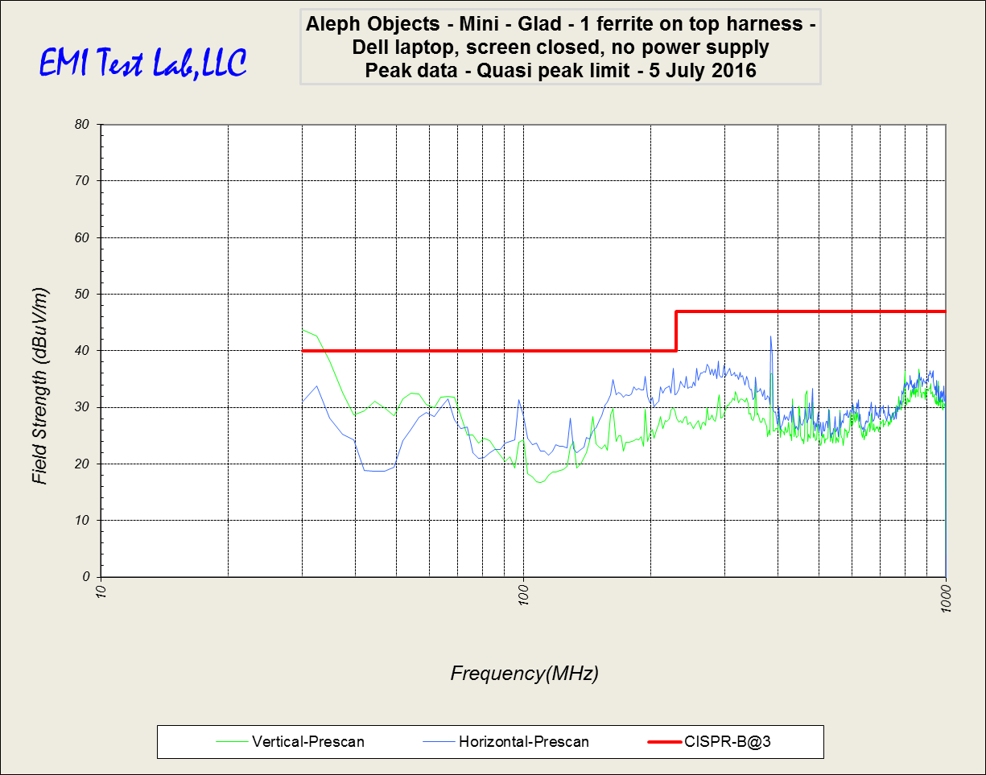
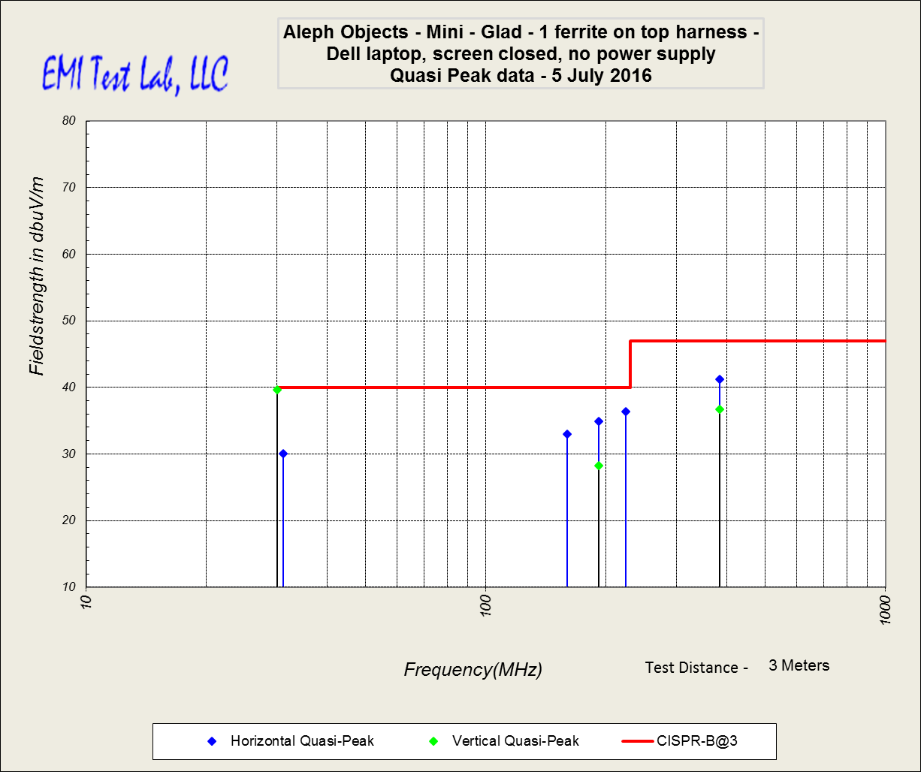

The following data was gathered on 07/05/2016 when Gladiola Mini passed the EMC test after modification:
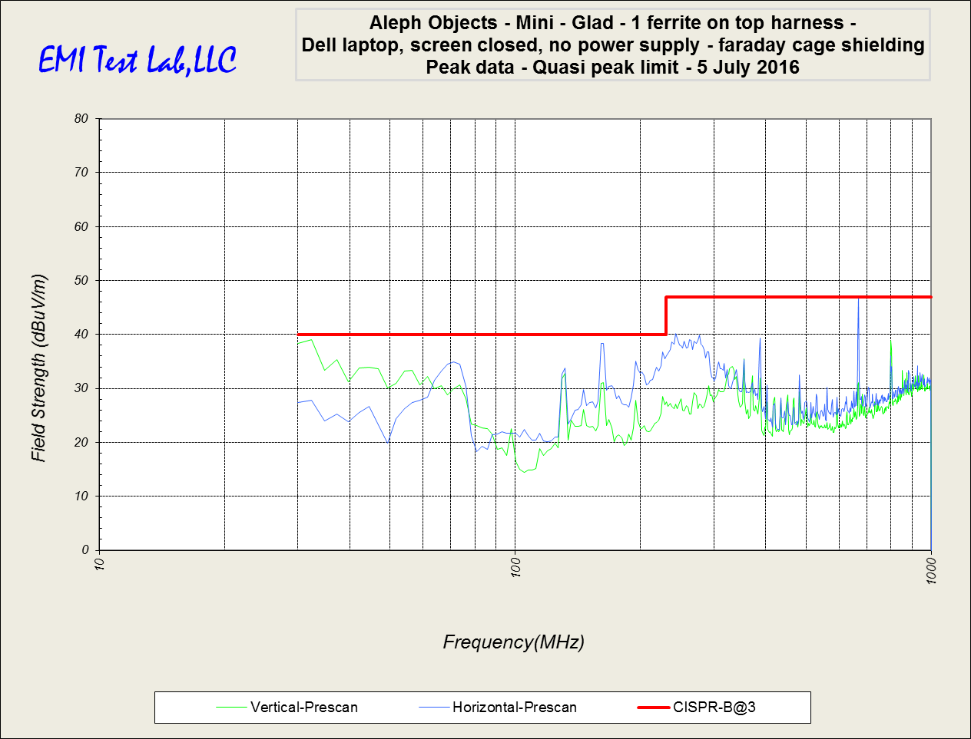

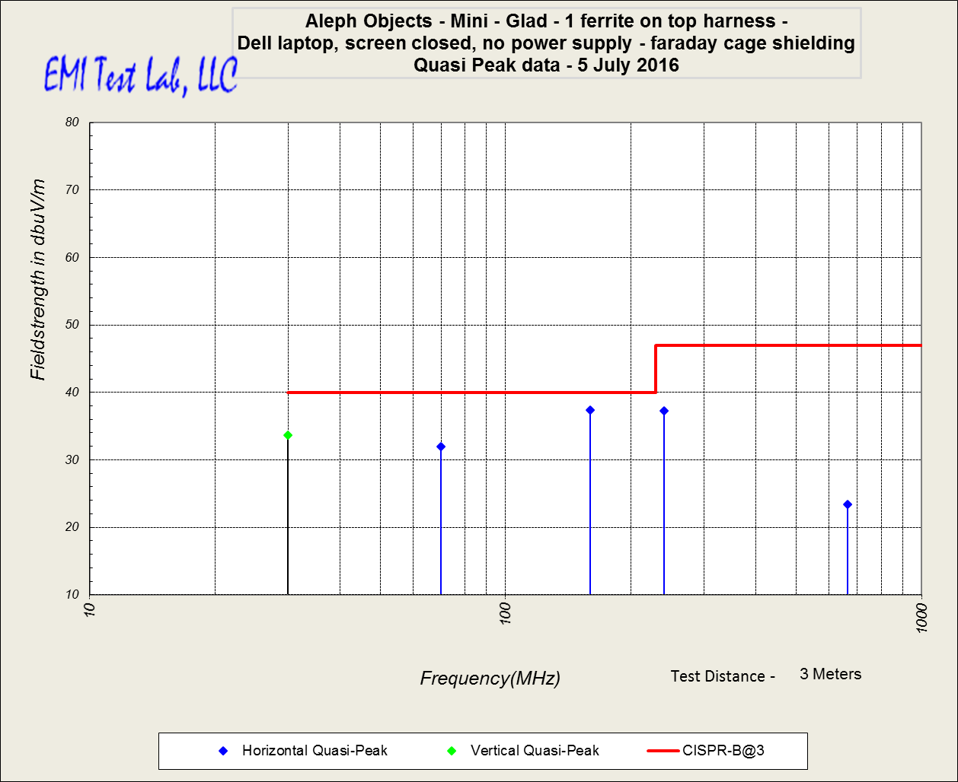

EMC Test Data:

Here is a table summarizing the frequencies closest to the limit after modifications:

Any value on the Limit delta column greater than 0dBμV/m would be considered failing.
Any value within +/- 2.5dBμV/m would be considered within the margin or error.

