Title: FCC & CE Testing
Test Plan: TP-RD-00010
Document Generated: 07/12/16
Document Last Updated: 07/25/16
Test Dates: 07/05/16, 07/22/16
Testing Location: EMI Test Lab LLC

PURPOSE:

Achieve FCC and CE compliance for radiated emissions on the Gladiola Mini.

RESULTS SUMMARY:

07/05/16 – First Test Day
The results of the examination on 07/05/2016 showed that the Gladiola Mini is capable of passing radiated emissions testing with modifications. During the initial examination, the stock Gladiola Mini did not pass the initial EMC radiated emissions testing. It failed at 304MHz and was within the margin of error (+/-2.5dBμV/m) at 30Mhz, 160 Mhz, 192MHz, 214 Mhz, and 215Mhz. The results were not effected by having either a single or dual ferrite on the top harness.

After the initial tests were run, copper tape was used to modify the units as much as possible to close the gaps that the radiated emissions were escaping from. This included areas around the fan intake and outtake and the USB port. It was also discovered the frame pieces were not grounded to each other and were floating, this was partially modified on the spot. A Faraday cage was created around the electronics enclosure to help contain the noise. The two ground points were also tied together with a wire to provide an appropriate drain for the chassis and electronics. The X and Y motors also required double ended shield termination to remove the noise from the motors and drain it out through the ground. Adding a ferrite to the X harness and extending it by 6 inches decreased the emissions due to coupling however it was variable based on relative position to other harnesses. Extending the shielding to the termination points also helped to decrease the cross talk radiation.

The test was then run again with these modifications and the quasi peak data showed a marked drop in the radiated emissions. The 160MHz peak (the 10th harmonic of the 16MHz clock) was still within the margin or error, and the 30MHz peak was variable based on harness movement. The modifications were only made with sandpaper to remove powercoat and copper tape to provide conduction, but the testing did show that the philosophy of the improvements that were made would be effective.

07/22/16 – Second Test Day
The results of the examination on 07/22/2016 showed that the Gladiola Mini is capable of passing radiated emissions testing with modifications. The Gladiola Minis tested during this session represented two levels of modifications deemed appropriate during the first test day; Minimum Improvements and maximum improvements. During the first examination on 7/22/16 the minimum improvements Gladiola was tested but failed within the margin or error (+/-2.5dBμV/m) at 160 MHz. While this one point failed, it was a significant improvement over the 07/05/16 results.

The second test which included the maximum improvements Gladiola Mini failed within the margin or error at 2 points, 30 MHz and 224 Mhz. On a subsequent run, the laptop power supply was found to be contributing noise at 30 MHz and once removed dropped significantly, so that point can be discounted. Once again, this was a radical improvement over the 07/05/16 results, but also showed there was not a significant difference between the minimum and maximum changes.

One difference between the two versions was how the ground lug was attached to the floating USB port. The minimum improvements version had the ground lug at an approximate 45 degree angle on the clip, providing spring force against the port and providing a better connection. This helped drop the overall noise level and kept the results more consistent, but did not completely eliminate the overall issues.

The focus was turned to the minimum improvements Gladiola to see how to eliminate the discrepancy at 160 MHz. Several troubleshooting steps were taken over the course of the afternoon which eventually led to a concrete solution. The limit switches, much like on the Taz 6, were generating a vast amount of variable noise due to them being normally open (NO). By changing these switches to be normally closed (NC) the noise spike at 160 MHz dropped over 5dBμV/m bringing it well within margin. This lead to a test that showed the Gladiola passed the FCC and CE testing with excellent margin across all tested radiated emissions frequencies (30 Mhz – 1 GHz). This change also attenuated the 224 Mhz noise on the maximum changes Gladiola.

A conducted emissions test (0.1 Mhz to 30 Mhz) was also performed on the normally closed (NC) modified Gladiola, which resulted in a passing test with significant margin on both 'Line' and 'Neutral', which was expected.

These tests proved that the philosophy of improvements adopted after the first set of testing were sound and only once further change was required in order to result in a firmly passing score. At least one further testing day will be required after the production electronics enclosure is available as the units tested were modified with copper tape and conductive gaskets to simulate the forthcoming changes.
CONCLUSION:

07/05/16 – First Test Day
The results of the examination on 07/05/2016 showed that the Gladiola Mini is capable of passing radiated emissions testing with modifications.

In order to consistently pass EMC radiated emissions, we need to incorporate the following changes to the Gladiola machines:

EMC (Radiated Emissions)
Double End Terminate Motor Shielding to X and Y
(Best Practice All Motors Should Be Grounded)
Bring All Chassis Pieces to Common Ground
Create Faraday Cage Around Electronics Enclosure
Modify Fan Intake and Outtake from Slots to Holes
Ground Floating USB Port
Extend Harness Shielding Closer to Termination Point

These fixes are additive in nature and all help towards meeting the EMC goal. No one fix alone would bring the unit within the margin of error and further modifications could be included if needed.

07/22/16 – Second Test Day
The results of the examination on 07/22/2016 showed that the Gladiola Mini is capable of passing radiated emissions testing with modifications.

The improvements recommended after the 07/05/17 test were implemented with positive results. However two further changes were made at the lab to result in a passing score.

EMC (Radiated Emissions)
Change NO limit switches to NC
Ensure the USB port ground lug is bent at 45 degrees to provide spring force on the port for good conductivity

It is understood that changing the NO limit switches to NC, while easily performed physically in just a couple minutes, would cause significant logistical challenges with backwards compatibility. With that in mind, alternative solutions are listed below as well as their confidence level of success.

Solution | Confidence Level | Risk
Swap limit switches from NO to NC | 100% | None, proven effective, would match the Taz 6 configuration
Firmware that can recognize if the limit switches are NO or NC to preserve backwards compatibility | 70% | Unknown performance effects but it is technically possible
Harness modification to allow for single end shielding on limit switches and allow them to stay NO | 50% | Unknown effectiveness and may not result in enough margin, but it is technically possible
Control Board Redesign  (Ultimately this needs to happen on the next version either way) | 90% | The current control board needs significant updates and layout changes which would eliminate much of the noise issues and shielding requirements. This does need to happen at some point however it would be a significant time investment at the moment.

It is also recommended that all LulzBot printers be tested for FCC and CE compliance on a monthly basis to confirm ongoing quality and monitor manufacturing variability over time. Currently this is not being performed and any variability in manufacturing errors may not be caught. Small changes can result in failed testing which should be caught early.

It should be noted that FCC and CE testing on the Mini prior to this set of testing, while accepted internally a passing score, was within the margin of error (+/-2.5dBμV/m) and therefore under best engineering practices should not have been passed to production without further modification. This was caused by a general lack of understanding of how to interpret the results within Aleph Objects. The lab clearly states this margin of error and the implications that it has. This means that the likelihood of a current unit that is out of spec is highly variable between each one that is manufactured.
EQUIPMENT:

An HP 8566B Spectrum Analyzer was used when testing radiated emissions.

Here is an image of the EMI chamber:
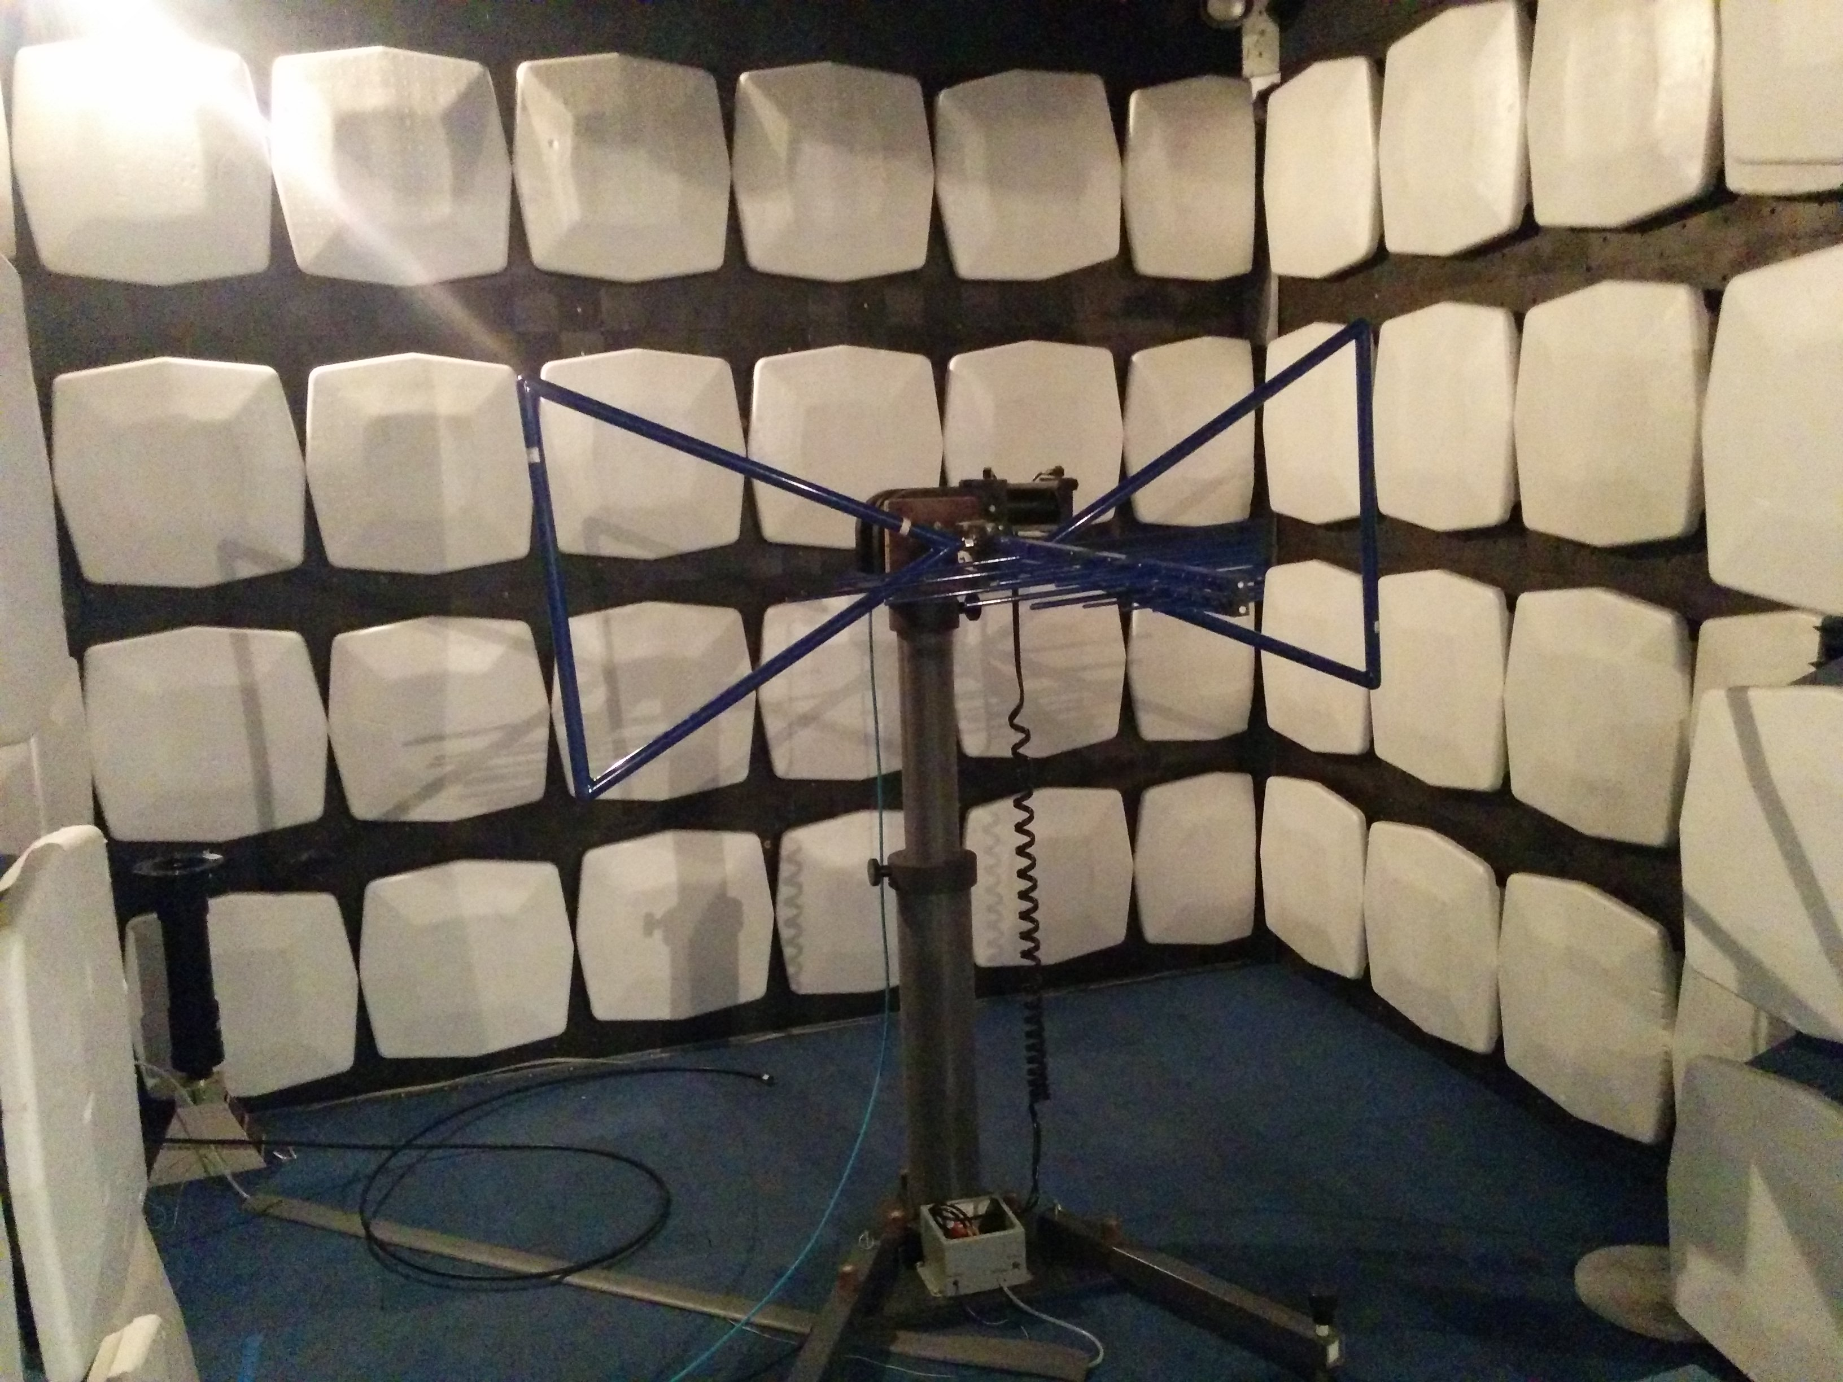

Here is an image the modified Gladiola Mini on 07/05/16:
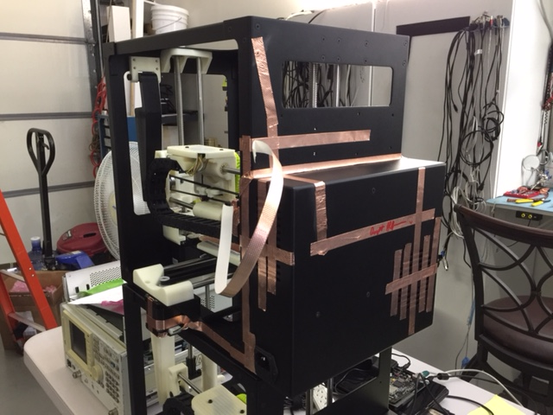

PROCEDURE:

EMI Testing Procedure:
Place the machine on the turning table in the EMI chamber. Run through the spectrum (30MHz – 1GHz) with the antenna in its horizontal and vertical positions. If any frequency is above the specified limit then examine those frequencies individually and modify the machine as needed to negate those specific frequencies.

TEST DATA and RESULTS:

The following data was gathered on 07/05/2016 when Gladiola Mini initially did not pass the EMC testing:
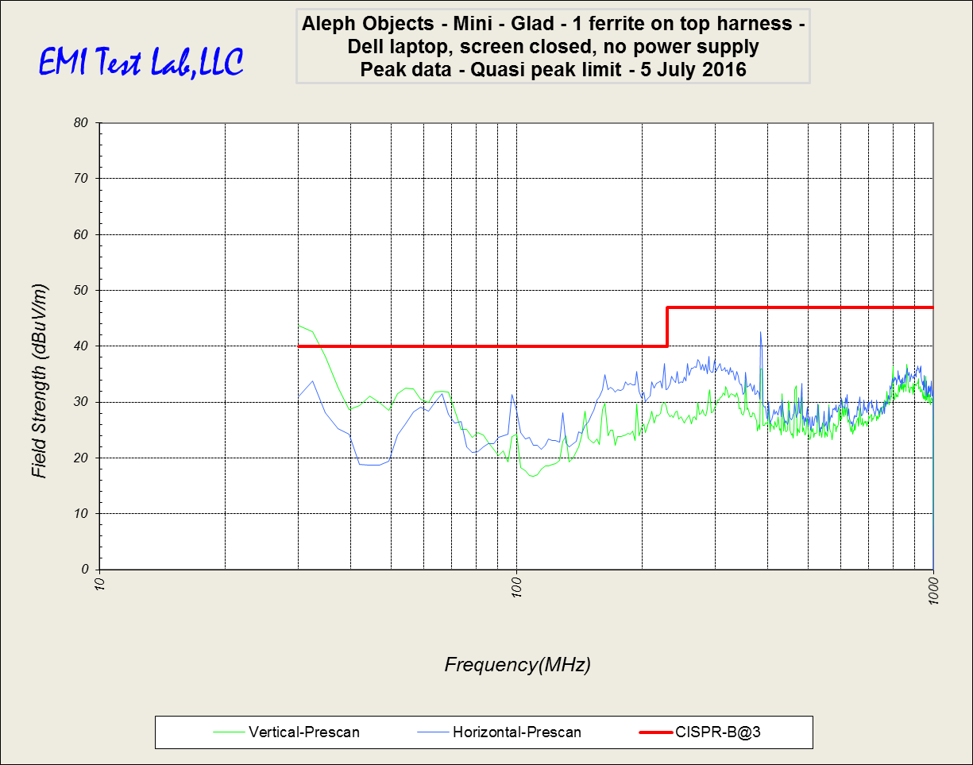
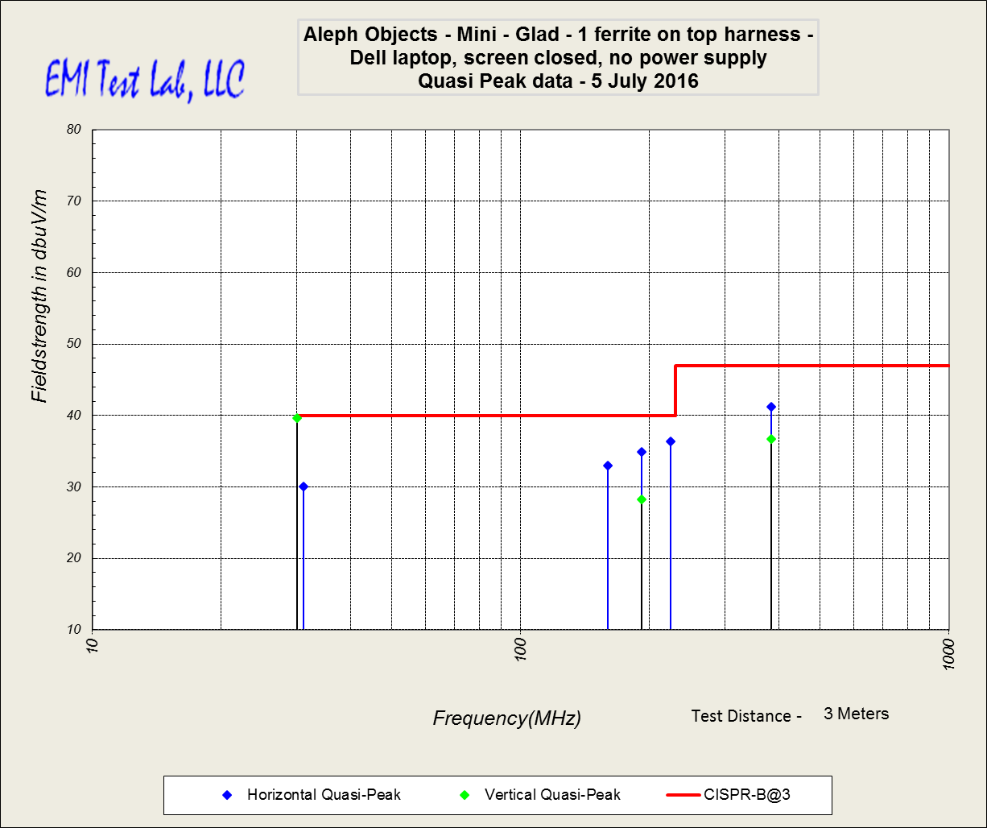

The following data was gathered on 07/05/2016 when Gladiola Mini passed the EMC test after modification:
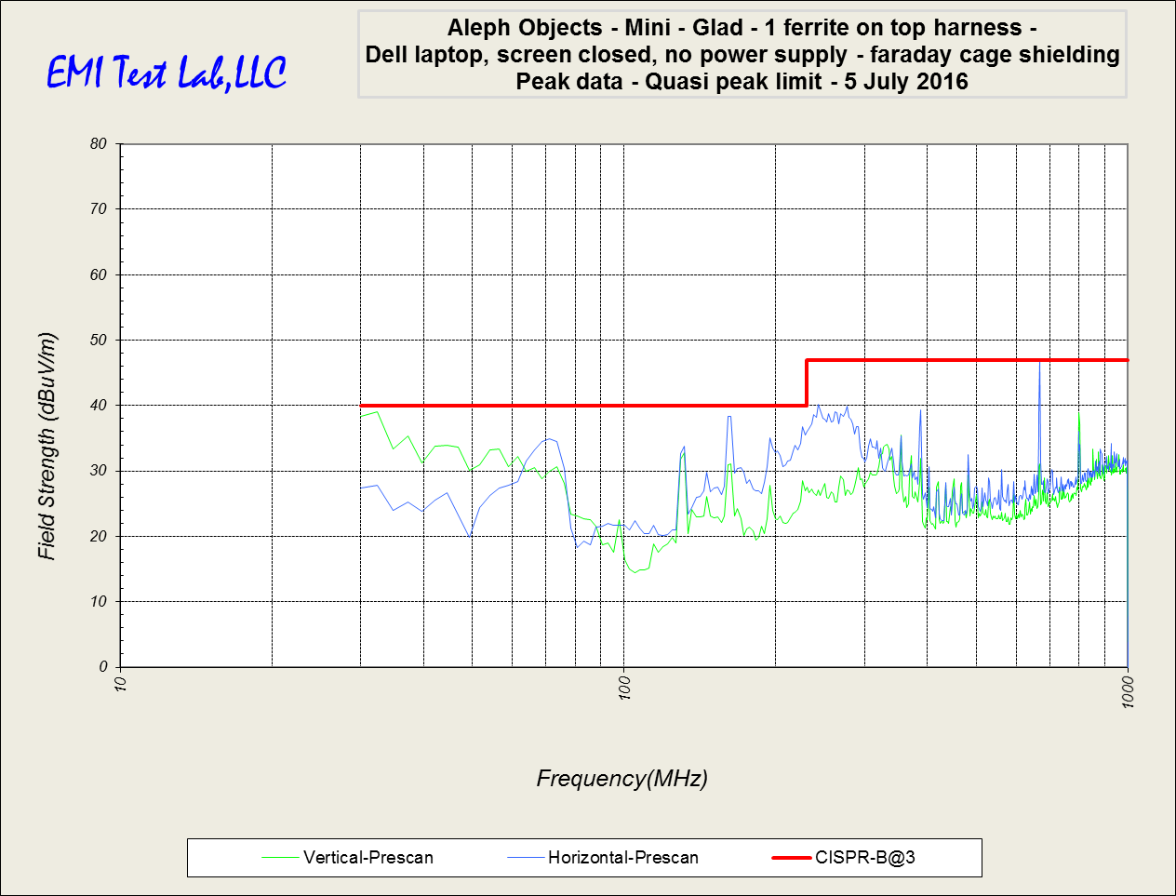

The following data was gathered on 07/22/2016:

This plot shows the minimum changes version with the limit switches in the NO configuration (Notice the point at 160 MHz near the line):
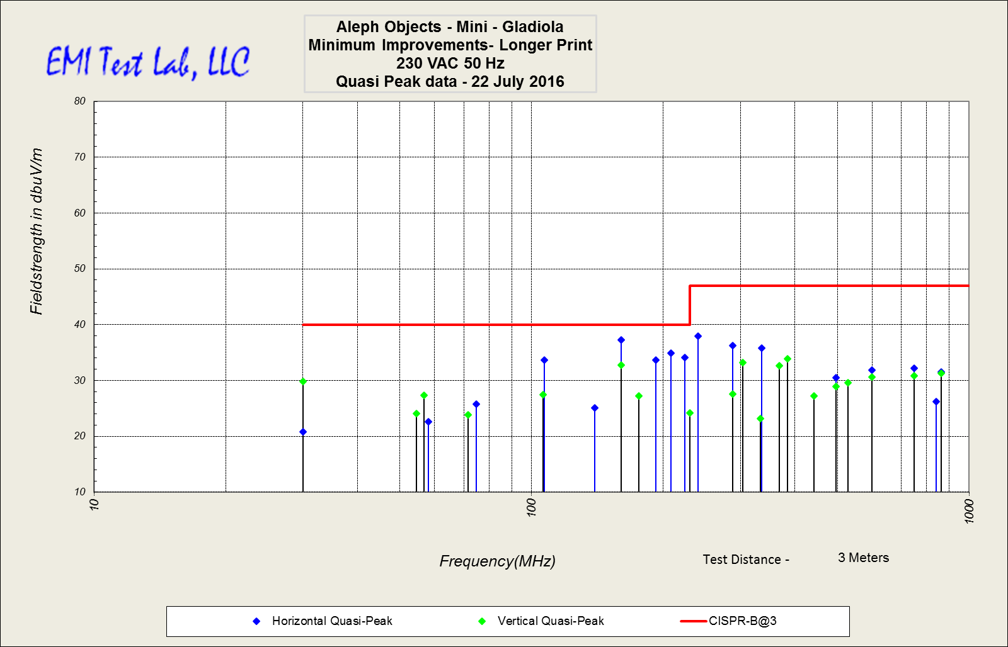

This plot shows the maximum changes version with the laptop PSU and the limit switches in the NO configuration (Notice the point at 224 MHz on the line from the switches):
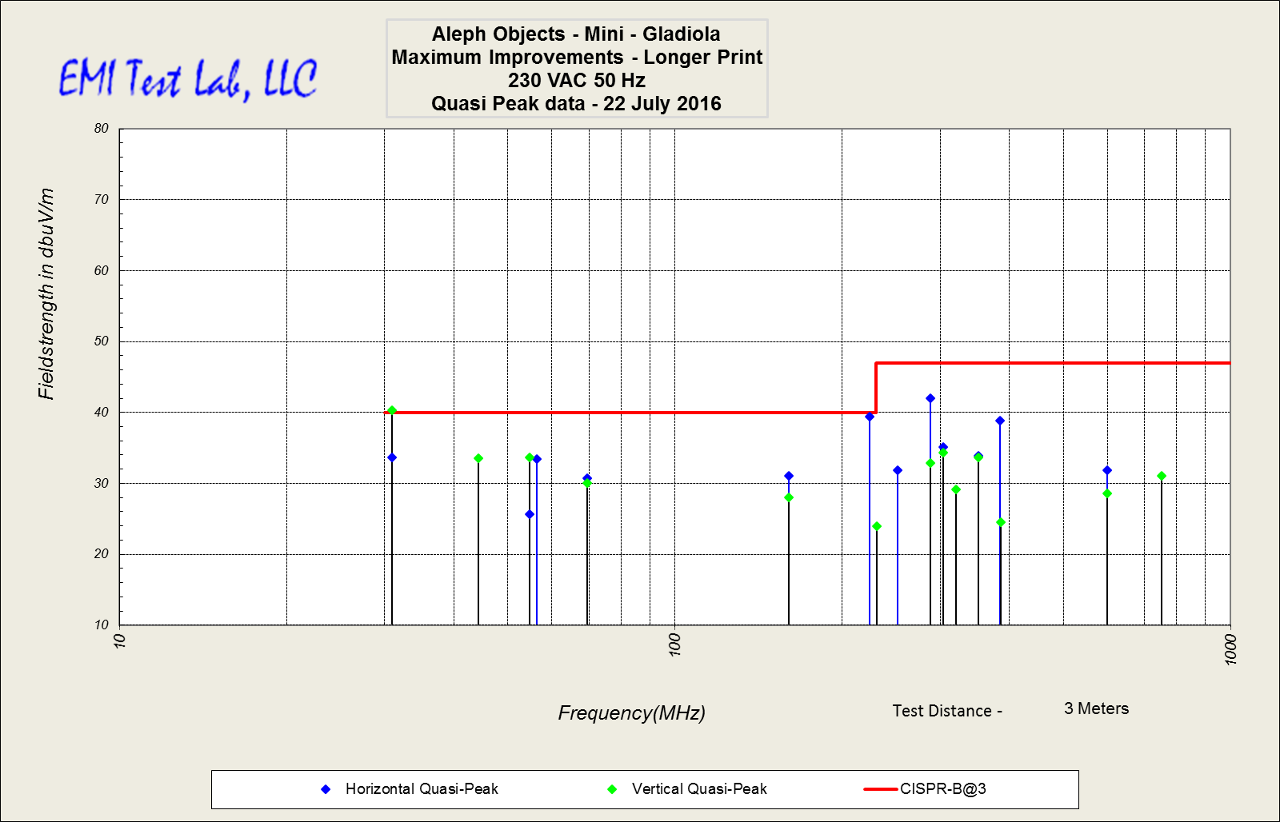

This plot shows the maximum changes version without the laptop PSU and the limit switches in the NC configuration (Notice the point at 224 MHz on the line from the switches):
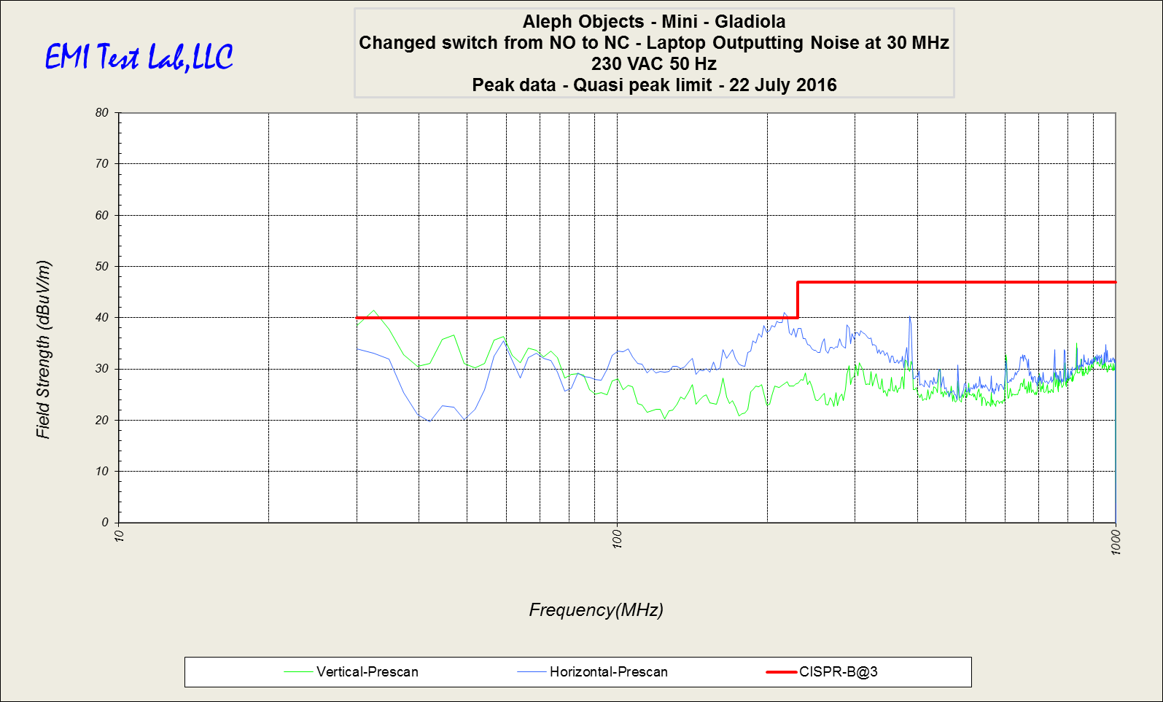

This plot shows the minimum changes version with the laptop PSU removed and the limit switches in the NC configuration (Notice the point at 160 MHz near the line has deminished):
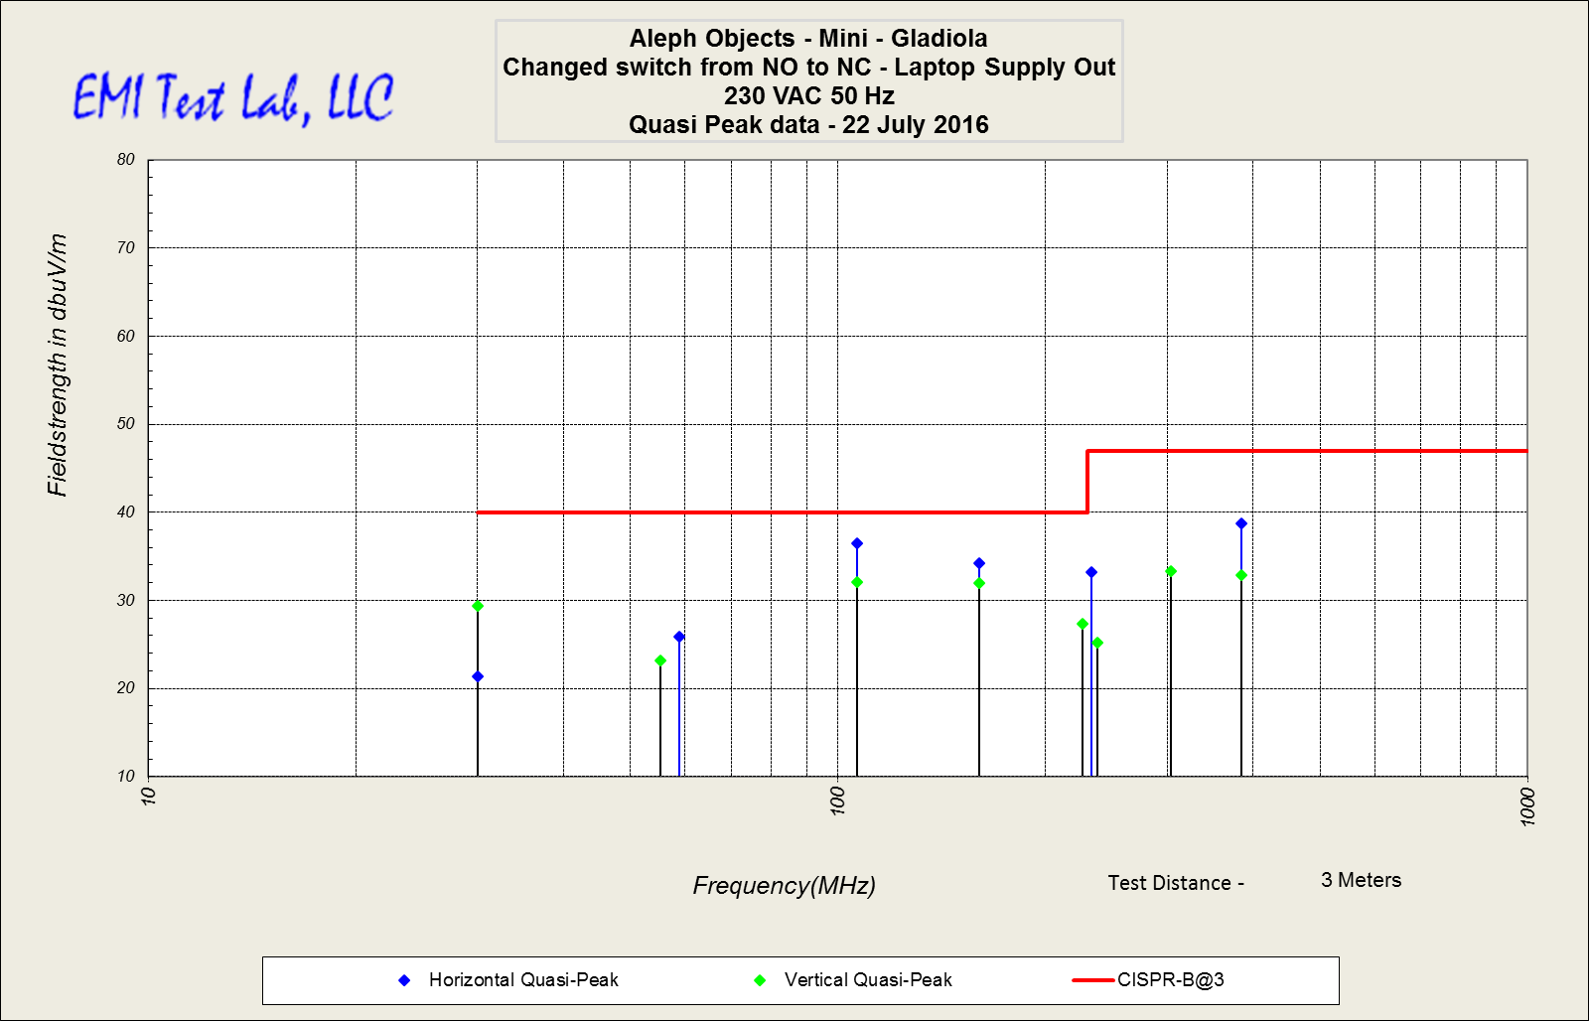

The following data was gathered on 07/22/2016 when the Gladiola Mini passed the EMC testing after modification (after NC change):

EMC Test Data:

Here is a table summarizing the frequencies closest to the limit after modifications on 07/05/16:

Any value on the Limit delta column greater than 0dBμV/m would be considered failing.
Any value within +/- 2.5dBμV/m would be considered within the margin or error.

Here is a table showing the passing test on 07/22/16 with all values 3.5dBμV/m or greater from the limit (Minimum changes Mini with NC switches):

