Title: FCC & CE Testing
Test Plan: TP-RD-00016
Document Generated: 10/12/16
Document Last Updated: 10/12/16
Test Dates: 09/26/16
Testing Location: EMI Test Lab LLC

PURPOSE:

Achieve FCC and CE compliance for radiated emissions on the Gladiola Mini.

RESULTS SUMMARY:

09/26/16 – Gladiola Verification
The results of the examination on 09/26/16 showed that the Gladiola Mini continues to pass with the modifications made after the 08/03/16 experimentation. The Gladiola Mini tested during this session represented the closest configuration to production coming from R&D. The appropriate modifications were made to avoid making the endstops normally closed and did not require the previously proposed firmware modifications. The frequency found to be closest to the limit was ~30MHz with the antenna in its vertical polarity and the turn table's azimuth at 248.0°, the margin at this frequency being -3.51μV/m. The second closest quasi-peak being ~224MHz @168° (horizontal) with a margin of -3.97μV/m. The low frequency 30MHz was found to mostly radiating from the X-motor (as well as all the other motors), the 224MHz is known to mostly radiated from the X-min endstop (as well as all the other endstops). The unit was also tested for conducted emissions and was found to pass with significant margin. The previously composed formal EMC test reports were validated by these measurements and still apply to the LulzBot Mini product line.
CONCLUSION:

09/26/16 – Gladiola Verification
The prototype unit which was assembled to be as close as possible to the production units was found to pass the radiated emissions limits as defined by CISPR 22. Additional testing will be done on two units assembled by manufacturing technicians, a test report will be produced for the unit with a lower margin. After those two units are verified the first production unit will also be tested, another report from the lab may be created for this unit as well.
EQUIPMENT:

An HP 8566B Spectrum Analyzer was used when performing the radiated emissions test.

Here is an image of the semi-anechoic chamber and the antenna:
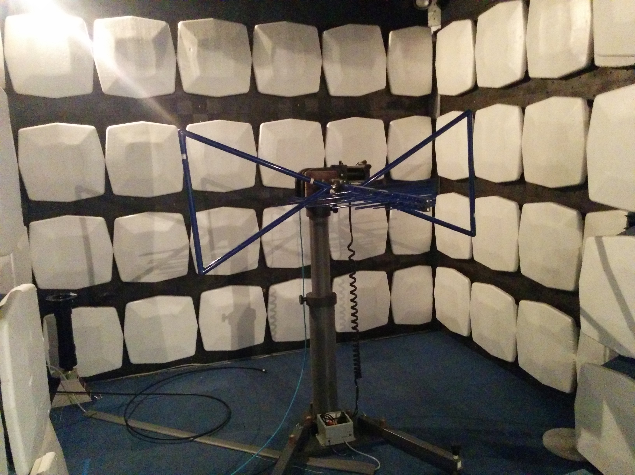

Here is an image of the Gladiola Mini which was tested on 09/26/16:
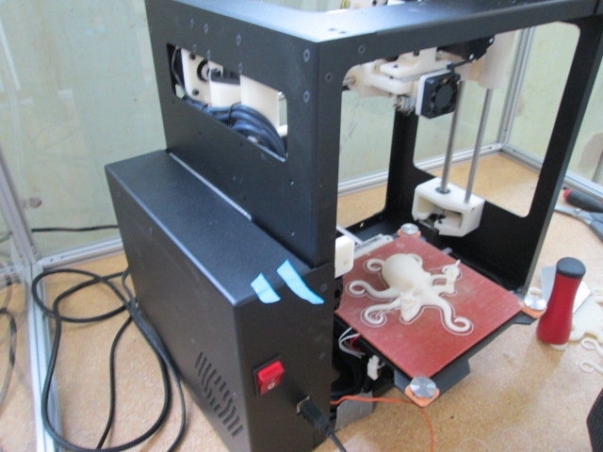
PROCEDURE:

EMI Testing Procedure:
Place the machine on the turning table in the anechoic chamber. Run through the spectrum (30MHz – 1GHz) with the antenna in its horizontal and vertical positions. If any frequency is found to be above the limit then examine those frequencies individually and modify the machine as needed in an attempt to attenuate those radiated frequencies.

TEST DATA and RESULTS:

The following data was gathered on 09/26/2016 when Gladiola Mini passed radiated emissions:
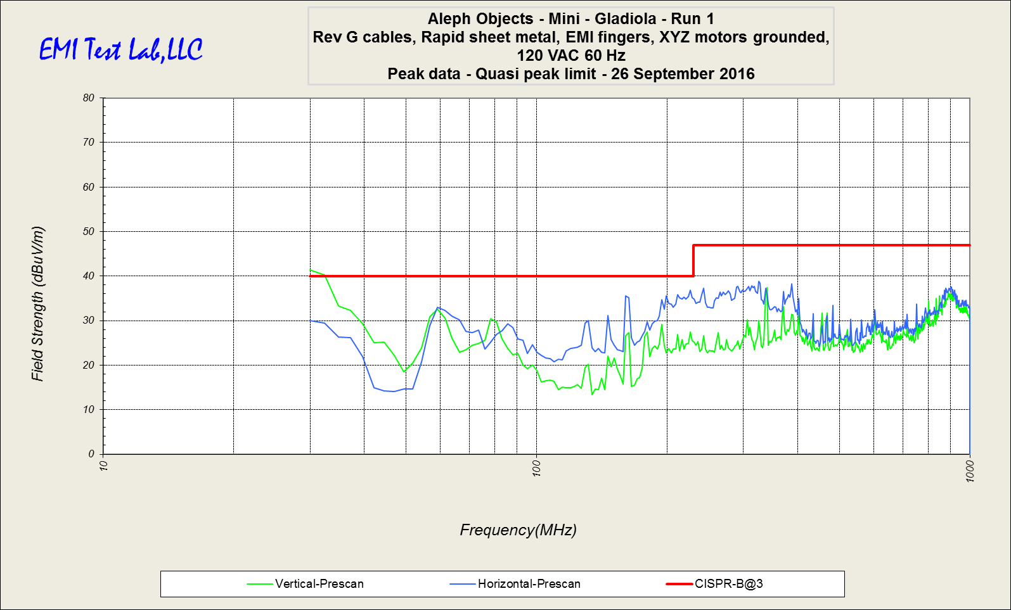
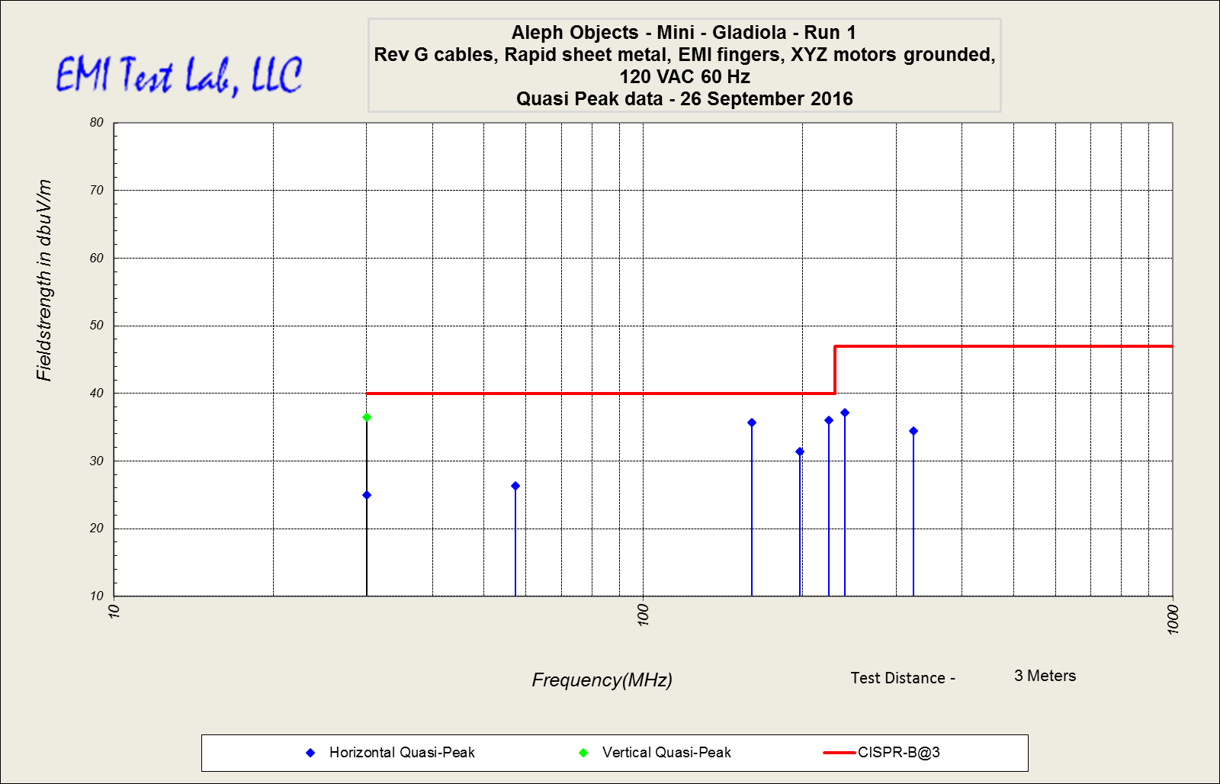

Quasi-peak Table:

Here is a table showing the unit passing on 09/26/16 with all margins -3.5dBμV/m or less from the CISPR 22 limit line:

