Reproducibility review of: Accessibility for pedestrians under heat stress - the example of Heidelberg, Germany


Lorena Abad †, https://orcid.org/0000-0003-0554-734X

2025-03-20

This report is part of the reproducibility review at the AGILE conference. For more infor- mation see https://reproducible-agile.github.io/. This document is published on OSF at https://osf.io/chx28/. To cite the report use
Abad, Lorena. 2025. “Reproducibility Review of: Accessibility for Pedestrians under Heat Stress - the Example of Heidelberg, Germany.” OSF. June 6. doi:10.17605/OSF.IO/CHX28.

Reviewed paper

Huber, J., Ludwig, C., Foshag, K., Kolaxidis, N., Zipf, A., and Lautenbach, S.: Accessibility for pedestrians under heat stress - the example of Heidelberg, Germany, AGILE GIScience Ser., 6, 4, https://doi.org/10.5194/agile-giss-6-4-2025, 2025.

Summary

The authors included a DASA section on the paper with an anonymous GitHub link to the repository with the code for the reproduction. After initial contact with the authors, the unanonymized link to the GitHub repository was obtained and forked into the reproducible AGILE organization.
The repository prepared by the authors has clear instructions on reproducibility for the Jupyter notebooks and points to the included QGIS project to recreate figures 2-4. Figure 5 is the result of one of the notebooks (lcz_analysis.pynb). A table of the reproduction of each Jupyter notebook with notes and comments can be found on the next section. One cell was added at the end of each notebook to document the session info of the reproduction environment.
Initially, the code limited the AOI to a subset for testing purposes. This was not initially clear from the documentation, but contacting the authors clarified the discrepancies. For this report, the code was successfully run for the whole AOI. Figures 2 to 5 could also be successfully reproduced besides manual edits in Figure 5.
See next section for technical details and recommendations.

Reproducibility reviewer notes

Re-running scripts

Notebook Comment

Get_POIs.ipynb Easy reproduction and resulted in no errors or issues. Note on
the last output, there are 4 more amenities than the original run, 1 more supermarket and 3 more doctors
Isocalors_POI.ipynb Updated backslashes to forward slashes, changed append to
_append due to differences in geopandas versions, pyogrio save to JSON also needed to specify driver = "GeoJSON", generated files saved to data directory.
lcz_analysis.ipynb Updated backslashes to forward slashes, changed append to
_append due to differences in geopandas versions, pyogrio save to JSON also needed to specify driver = "GeoJSON", generated files saved to data directory. Figure 5 generated.

Generated files and figures

Figures 2 to 5 were successfully generated with the provided code and data in the GitHub repository.

- Figure 3 and 4: Files vul_pop_grid_hd_fct5_noon.tif and vul_pop_grid_hd_fct3_noon.tif are not generated by code but manually uploaded to GitHub.
- From communication with the authors:
The layers vul_pop_grid_hd_fct5_noon.tif and vul_pop_grid_hd_fct3_noon.tif were created using QGIS. For this, the vulnerable population was extracted from the population raster file zensus_2022_hd_LAEA.tif and masked us- ing vul_area_transport_all.json via the “Clip Raster by Mask Layer” function in QGIS. Specifically, the corresponding polygons were selected: - For vul_pop_grid_hd_fct5_noon.tif: shadow_factor = 5 AND timeof- day = ‘noon’ AND value = 900 - For vul_pop_grid_hd_fct3_noon.tif: shadow_factor = 3 AND timeofday = ‘noon’ AND value = 900 The function was applied separately for shadow_factor = 5 and shadow_factor = 3, using zensus_2022_hd_LAEA.tif as the input layer and vul_areas_transport_all with the “Selected features only” option enabled. The results were saved as vul_pop_grid_hd_fct5_noon.tif and vul_pop_grid_hd_fct3_noon.tif.
- Figure 5 matches the paper submission. The legend seems to be manually edited afterwards.

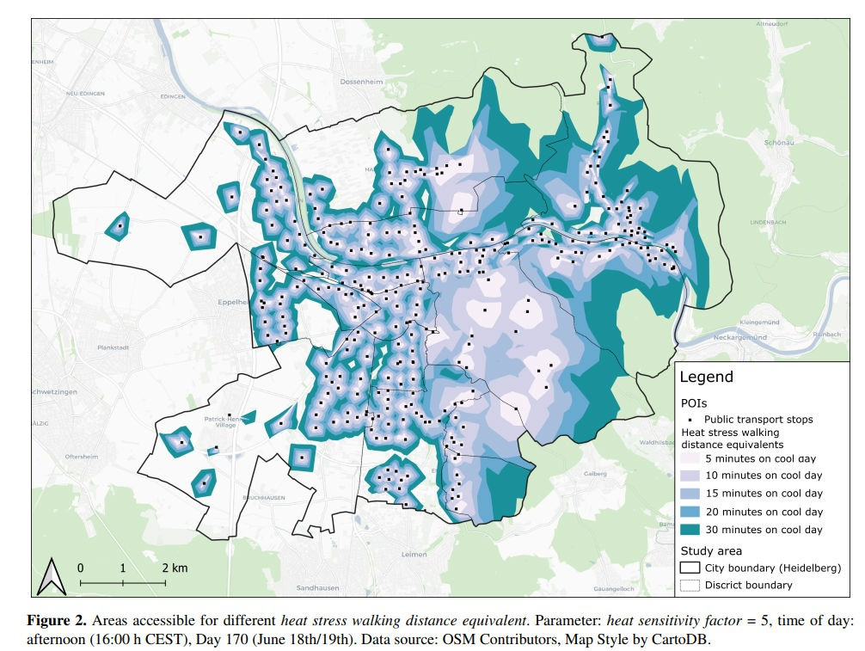
  - From submitted manuscript

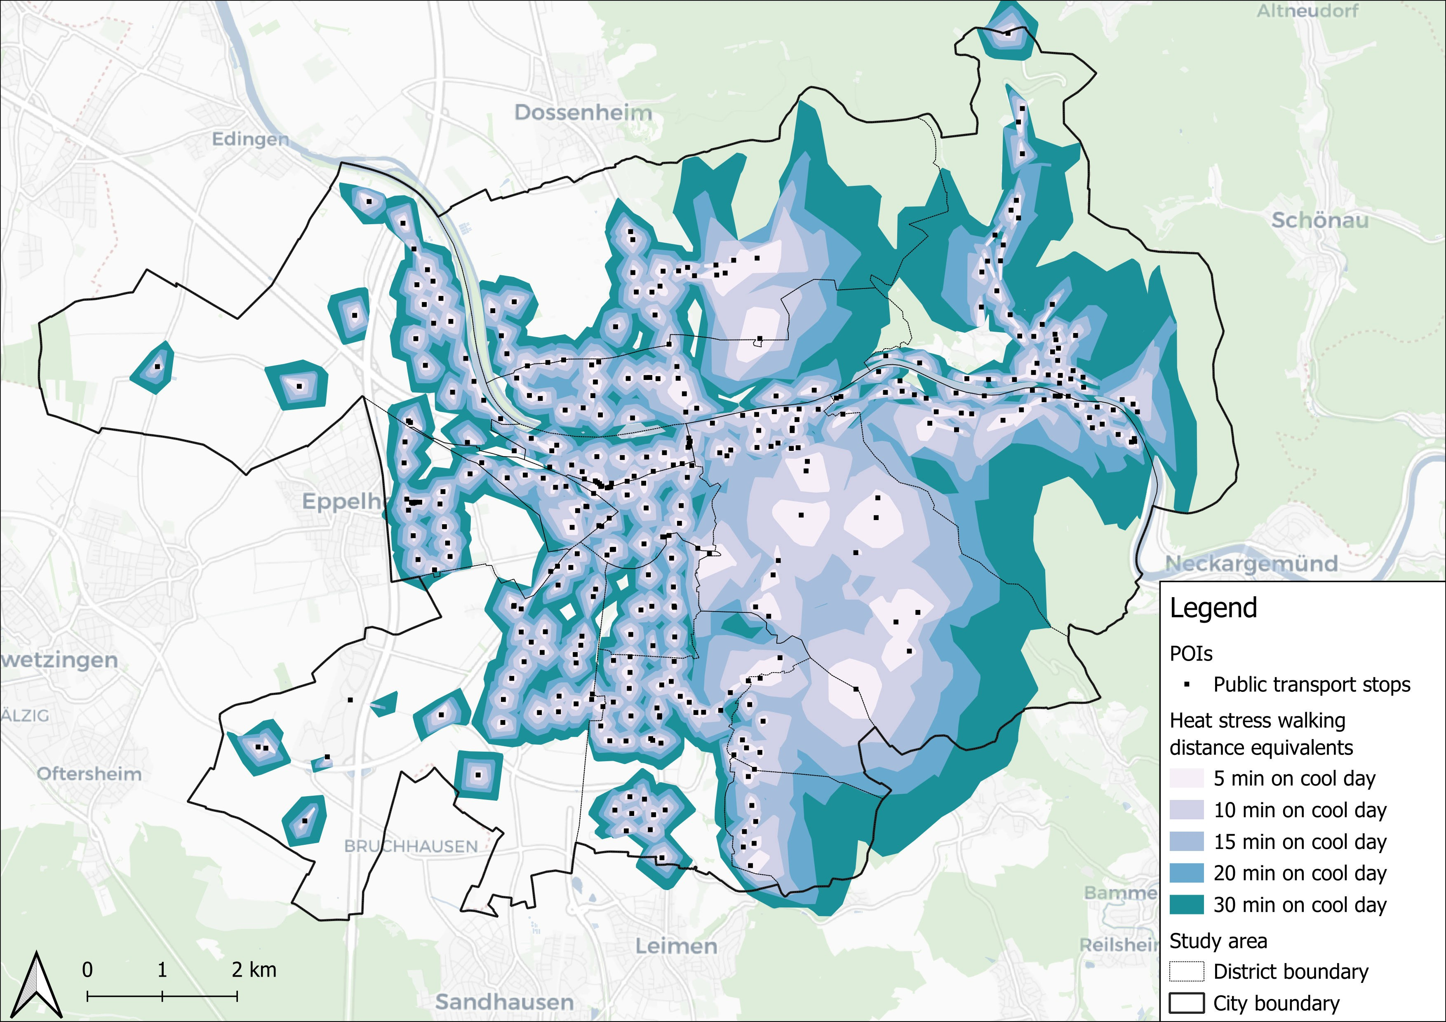

Figure 2
- From reproduction attempt

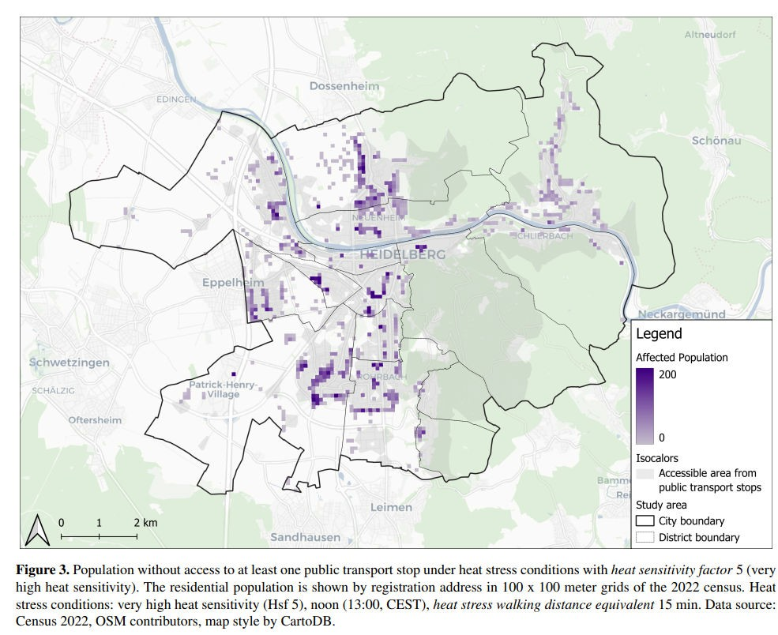
  - From submitted manuscript

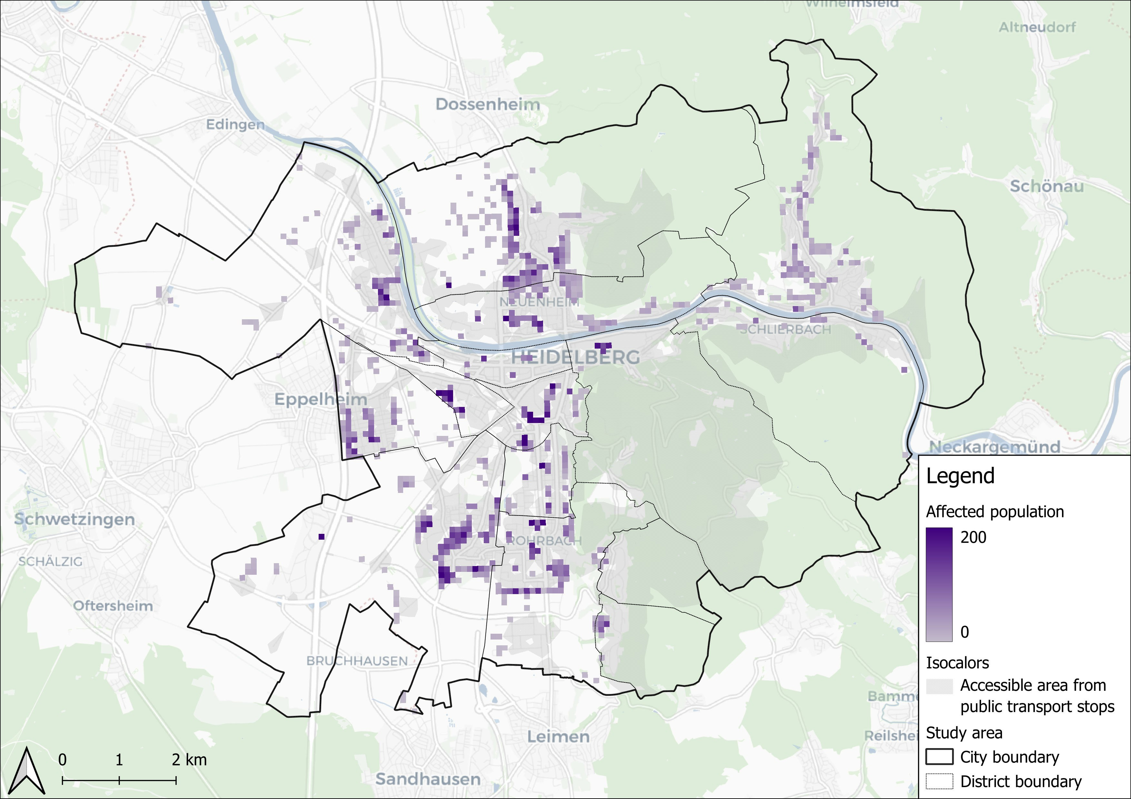

Figure 3
- From reproduction attempt

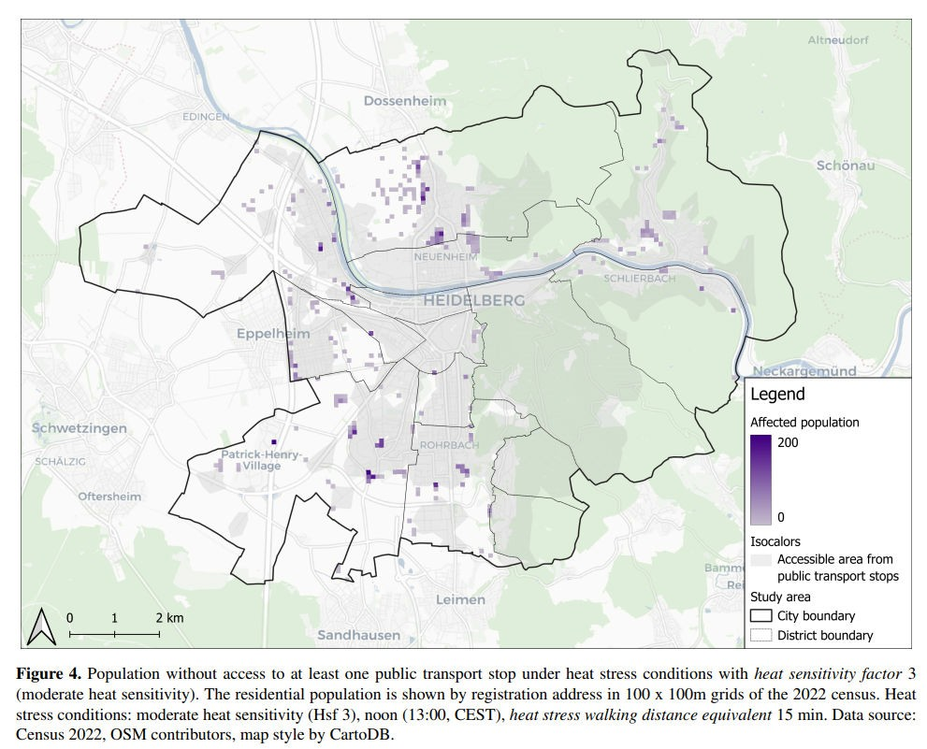
  - From submitted manuscript

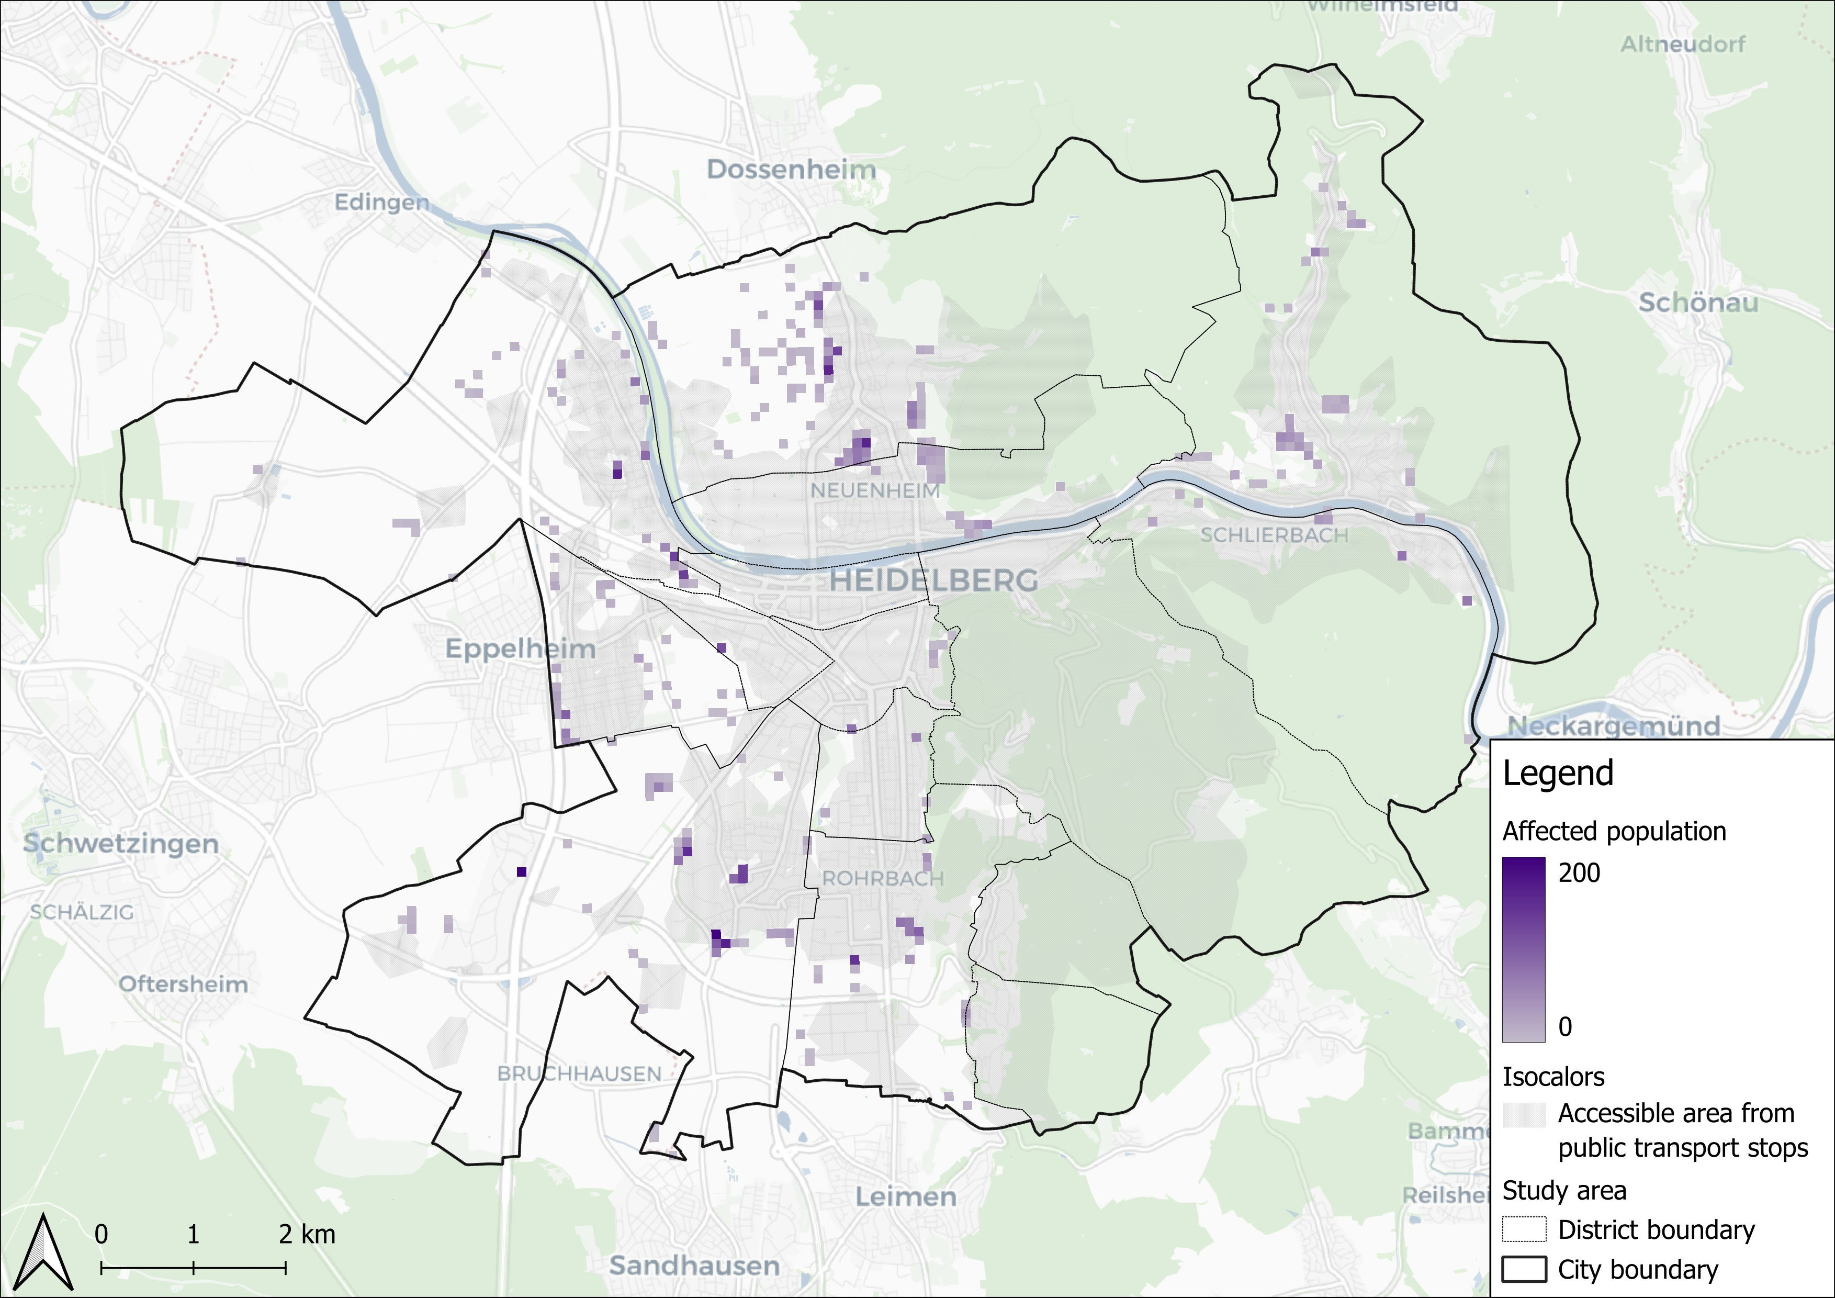

Figure 4
- From reproduction attempt

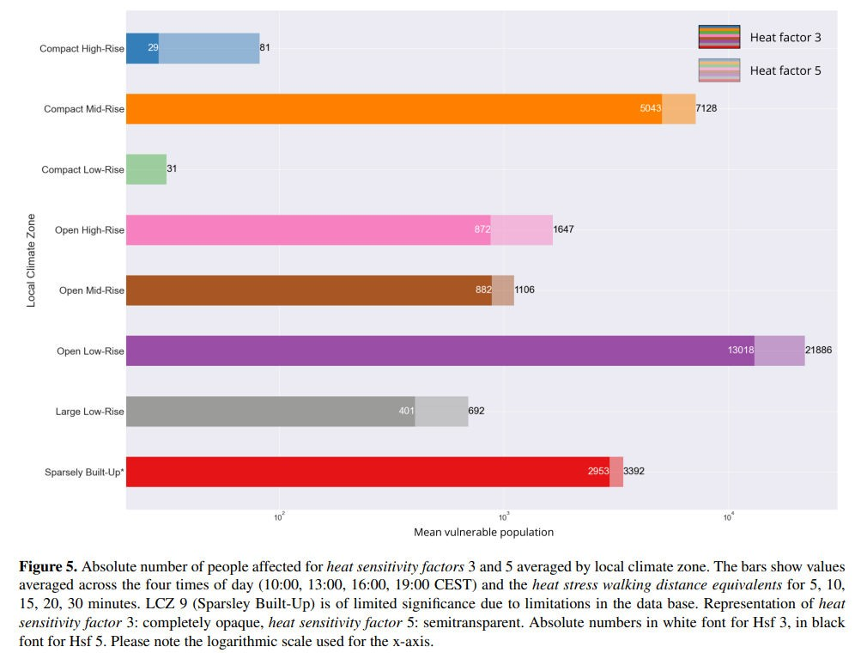
  - From submitted manuscript

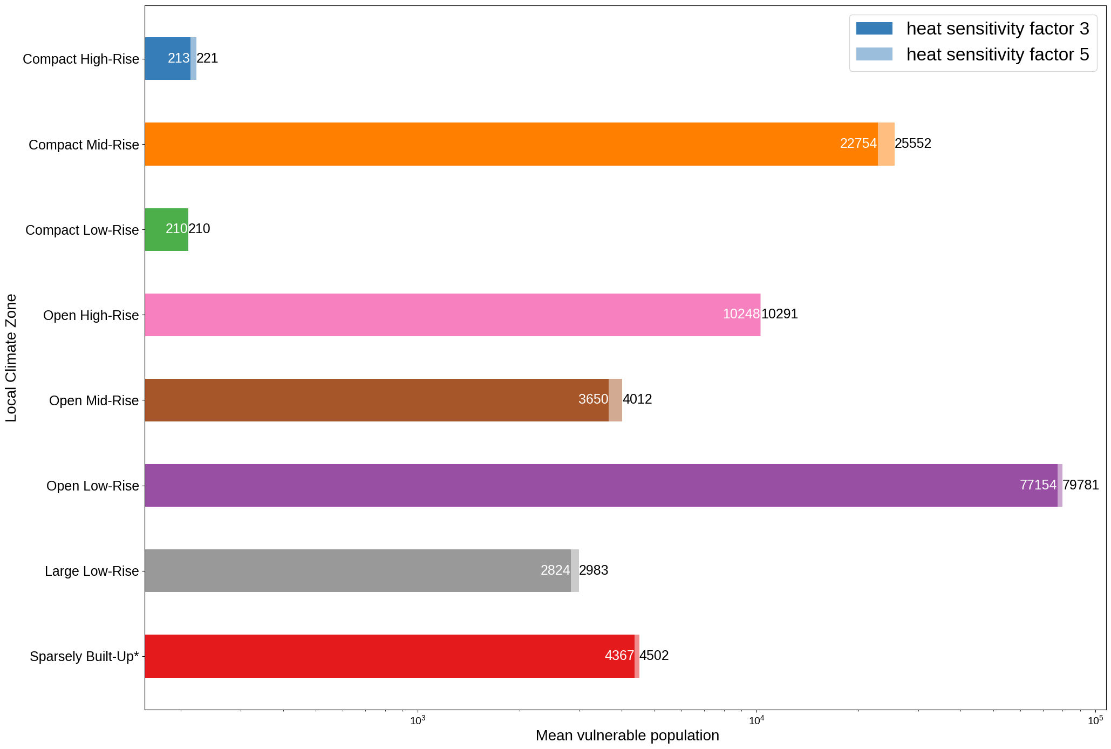

Figure 5
(a) From reproduction attempt

Recommendations
    - Including the library versions and OS environments for the analysis can help identify discrepancies between code and pinpoint the cause of errors easily. I recommend using packages such as session_info to do so.
    - It is smart to provided code that runs on a subset when the analysis takes resources and time to run. However, this should be properly documented in the reproduction steps, in this case, in the repository README.
    - If there is data generated without code, an explanation of the steps is of value, to be able to understand and replicate the workflow.

Other than this, the reproduction code is very well documented, had minimal issues and was fairly straightforward to run, supporting in a very good way the analysis.

