Демидович Варвара Александровна. 451001
Классы:
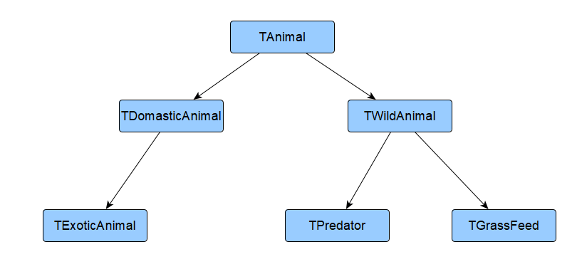
Интрефейс:
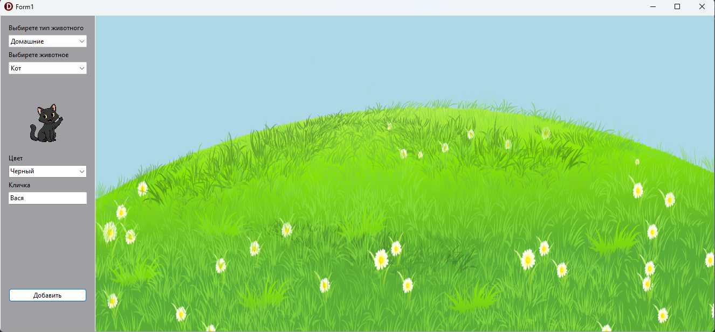
Код:
unit lab1;

interface

uses
Winapi.Windows, Winapi.Messages, System.SysUtils, System.Variants,
System.Classes, Vcl.Graphics,
Vcl.Controls, Vcl.Forms, Vcl.Dialogs, Animal, WildAnimal, DomasticAnimal,
ExoticDomastic,
Predator, GrassFeed, Vcl.ExtCtrls, Vcl.Imaging.pngimage, Vcl.StdCtrls,
System.Generics.Collections;
type
TForm1 = class(TForm)
procedure btnDeleteClick(Sender: TObject);
published
pMainMenu: TPanel;
pField: TPanel;
imgBackground: TImage;
cbType: TComboBox;
lType: TLabel;
cbAnimal: TComboBox;
lAnimal: TLabel;
lColor: TLabel;
lDanger: TLabel;
eNickName: TEdit;
lNickName: TLabel;
eDanger: TEdit;
lPrey: TLabel;
ePrey: TEdit;
lMainFood: TLabel;
eMainFood: TEdit;
btnAdd: TButton;
btnDelete: TButton;
pInf: TPanel;
cbColor: TComboBox;
imgAnimal: TImage;
procedure FormCreate(Sender: TObject);
procedure cbAnimalChange(Sender: TObject);
procedure cbTypeChange(Sender: TObject);
procedure btnAddClick(Sender: TObject);
procedure FormDestroy(Sender: TObject);
procedure OnClick(Sender: TObject);
private
procedure FillEdits(cbType: TComboBox; cbAnimal: TComboBox);
var
Animal: TAnimal;
public
end;
var
Form1: TForm1;
AnimalsList: TObjectList<TAnimal>;
imgAnimalPath: string;
implementation
{$R *.dfm}
procedure TForm1.OnClick(Sender: TObject);
var
Found: Boolean;
curAnimal: TAnimal;
begin
Animal := nil;
Found := False;
if Sender is TImage then
begin
btnAdd.Visible := False;
btnDelete.Visible := True;
cbType.Enabled := False;
cbAnimal.Enabled := False;
cbColor.Enabled := False;
eNickName.ReadOnly := True;
for curAnimal in AnimalsList do
begin
if curAnimal.img = Sender then
begin
Found := True;
Animal := curAnimal;
if curAnimal is TDomasticAnimal then
begin
cbType.ItemIndex := 0;
cbTypeChange(cbType);
cbAnimal.ItemIndex := curAnimal.Ind;
cbAnimalChange(cbAnimal);
eNickName.Text := (curAnimal as TDomasticAnimal).NickName;
cbColor.ItemIndex := curAnimal.Color;
end
else
begin
cbType.ItemIndex := 1;
cbTypeChange(cbType);
cbAnimal.ItemIndex := curAnimal.Ind;
cbAnimalChange(cbAnimal);
cbColor.ItemIndex := curAnimal.Color;
end;
end;
end;
end;
if not Found then
begin
btnAdd.Visible := True;
btnDelete.Visible := False;
cbType.Enabled := True;
cbAnimal.Enabled := True;
cbColor.Enabled := True;
eNickName.ReadOnly := False;
end;
end;
procedure ShowLabelEdit(lName: TLabel; eName: TEdit);
begin
lName.Visible := True;
eName.Visible := True;
end;
procedure HideLabelEdit(lName: TLabel; eName: TEdit);
begin
lName.Visible := False;
eName.Visible := False;
end;
procedure TForm1.btnAddClick(Sender: TObject);
var
NewAnimal: TAnimal;
NewImage: TImage;
begin
NewImage := TImage.Create(pField);
NewImage.Parent := pField;
NewImage.Width := 205;
NewImage.Height := 205;
NewImage.Stretch := True;
NewImage.Top := pField.Height div 2;
NewImage.Left := pField.Width div 2;
NewImage.Visible := True;
NewImage.Picture.LoadFromFile(imgAnimalPath);
NewImage.OnClick := OnClick;
if (cbType.ItemIndex = 0) then
begin
case cbAnimal.ItemIndex of
0 .. 1:
begin
NewAnimal := TDomasticAnimal.Create(cbAnimal.ItemIndex,
cbColor.ItemIndex, eNickName.Text, NewImage);
end;
2 .. 3:
begin
NewAnimal := TExoticAnimal.Create(cbAnimal.ItemIndex,
cbColor.ItemIndex, eNickName.Text, eDanger.Text, NewImage);
end;
end;
end
else
begin
case cbAnimal.ItemIndex of
0 .. 1:
begin
NewAnimal := TPredator.Create(cbAnimal.ItemIndex, cbColor.ItemIndex,
eDanger.Text, ePrey.Text, NewImage);
end;
2 .. 3:
begin
NewAnimal := TGrassFeed.Create(cbAnimal.ItemIndex, cbColor.ItemIndex,
eDanger.Text, eMainFood.Text, NewImage);
end;
end;
end;
AnimalsList.Add(NewAnimal);
end;
procedure TForm1.btnDeleteClick(Sender: TObject);
begin
if Animal <> nil then
begin
Animal.img.Free;
AnimalsList.Remove(Animal);
Animal := nil;
btnAdd.Visible := True;
btnDelete.Visible := False;
cbType.Enabled := True;
cbAnimal.Enabled := True;
cbColor.Enabled := True;
eNickName.ReadOnly := False;
end;
end;
procedure TForm1.cbAnimalChange(Sender: TObject);
begin
FillEdits(cbType, cbAnimal);
end;
procedure TForm1.cbTypeChange(Sender: TObject);
begin
if cbType.ItemIndex = 0 then
begin
cbAnimal.Items[0] := 'Кот';
cbAnimal.Items[1] := 'Собака';
cbAnimal.Items[2] := 'Змея';
cbAnimal.Items[3] := 'Енот';
end
else
begin
cbAnimal.Items[0] := 'Волк';
cbAnimal.Items[1] := 'Лев';
cbAnimal.Items[2] := 'Олень';
cbAnimal.Items[3] := 'Заяц';
end;
cbAnimal.ItemIndex := 0;
FillEdits(cbType, cbAnimal);
end;
procedure TForm1.FillEdits(cbType: TComboBox; cbAnimal: TComboBox);
begin
HideLabelEdit(lNickName, eNickName);
HideLabelEdit(lDanger, eDanger);
HideLabelEdit(lPrey, ePrey);
HideLabelEdit(lMainFood, eMainFood);
if (cbType.ItemIndex = 0) then
begin
case cbAnimal.ItemIndex of
0:
begin
imgAnimalPath := ExtractFilePath(ParamStr(0)) + '../../img/cat.png';
ShowLabelEdit(lNickName, eNickName);
cbColor.Items[0] := 'Черный';
cbColor.Items[1] := 'Белый';
cbColor.Items[2] := 'Рыжий';
cbColor.ItemIndex := 0;
eNickName.Text := 'Вася';
end;
1:
begin
imgAnimalPath := ExtractFilePath(ParamStr(0)) + '../../img/dog.png';
ShowLabelEdit(lNickName, eNickName);
cbColor.ItemIndex := 0;
eNickName.Text := 'Тузик';
end;
2:
begin
imgAnimalPath := ExtractFilePath(ParamStr(0)) + '../../img/snake.png';
ShowLabelEdit(lNickName, eNickName);
ShowLabelEdit(lDanger, eDanger);
cbColor.Items[0] := 'Зеленый';
cbColor.Items[1] := 'Черный';
cbColor.Items.Delete(2);
cbColor.ItemIndex := 0;
eNickName.Text := 'Лия';
eDanger.Text := '3';
end;
3:
begin
imgAnimalPath := ExtractFilePath(ParamStr(0)) +
'../../img/racoon.png';
ShowLabelEdit(lNickName, eNickName);
ShowLabelEdit(lDanger, eDanger);
cbColor.Items[0] := 'Белый';
cbColor.Items[1] := 'Серый';
cbColor.Items.Delete(2);
cbColor.ItemIndex := 0;
eNickName.Text := 'Толик';
eDanger.Text := '3';
end;
end;
end
else
begin
case cbAnimal.ItemIndex of
0:
begin
imgAnimalPath := ExtractFilePath(ParamStr(0)) + '../../img/wolf.png';
ShowLabelEdit(lDanger, eDanger);
ShowLabelEdit(lPrey, ePrey);
cbColor.Items[0] := 'Черный';
cbColor.Items[1] := 'Белый';
cbColor.Items[2] := 'Серый';
cbColor.ItemIndex := 0;
eDanger.Text := '5';
ePrey.Text := 'Зайцы, косули';
end;
1:
begin
imgAnimalPath := ExtractFilePath(ParamStr(0)) + '../../img/lion.png';
ShowLabelEdit(lDanger, eDanger);
ShowLabelEdit(lPrey, ePrey);
cbColor.Items[0] := 'Желтый';
cbColor.Items[1] := 'Белый';
cbColor.Items.Delete(2);
cbColor.ItemIndex := 0;
eDanger.Text := '5';
ePrey.Text := 'Зебры, антилопы';
end;
2:
begin
imgAnimalPath := ExtractFilePath(ParamStr(0)) + '../../img/deer.png';
ShowLabelEdit(lMainFood, eMainFood);
ShowLabelEdit(lDanger, eDanger);
cbColor.Items[0] := 'Коричневый';
cbColor.Items[1] := 'Серый';
cbColor.Items[2] := 'Белый';
cbColor.ItemIndex := 0;
eMainFood.Text := 'Трава, листья';
eDanger.Text := '4';
end;
3:
begin
imgAnimalPath := ExtractFilePath(ParamStr(0)) + '../../img/hare.png';
ShowLabelEdit(lMainFood, eMainFood);
ShowLabelEdit(lDanger, eDanger);
cbColor.Items[0] := 'Белый';
cbColor.Items[1] := 'Серый';
cbColor.Items[2] := 'Рыжий';
cbColor.ItemIndex := 0;
eMainFood.Text := 'Трава, морковка';
eDanger.Text := '2';
end;
end;
end;
try
imgAnimal.Picture.LoadFromFile(imgAnimalPath);
except
ShowMessage('Не удалось найти картинку')
end;
end;
procedure TForm1.FormCreate(Sender: TObject);
begin
AnimalsList := TObjectList<TAnimal>.Create(True);
FillEdits(cbType, cbAnimal);
btnDelete.Visible := False;
end;
procedure TForm1.FormDestroy(Sender: TObject);
begin
AnimalsList.Free;
end;
end.

unit Animal;
interface
uses Vcl.ExtCtrls, System.Types, Vcl.Controls, System.Classes;
type
TAnimal = class
private
FIndex: integer;
FColor: integer;
FImage: TImage;
FIsDragging: Boolean;
FStartPos: TPoint;
public
constructor Create(AIndex: integer; AColor: integer; AImage: TImage);
procedure MouseDown(Sender: TObject; Button: TMouseButton;
Shift: TShiftState; X, Y: integer);
procedure MouseMove(Sender: TObject; Shift: TShiftState; X, Y: integer);
procedure MouseUp(Sender: TObject; Button: TMouseButton; Shift: TShiftState;
X, Y: integer);
property Img: TImage read FImage;
property Ind: Integer read FIndex;
property Color: integer read FColor;
end;
implementation
constructor TAnimal.Create(AIndex: integer; AColor: integer; AImage: TImage);
begin
FIndex := AIndex;
FColor := AColor;
FImage := AImage;
FStartPos := Point(FImage.Left, FImage.Top);
FIsDragging := False;
FImage.OnMouseDown := MouseDown;
FImage.OnMouseMove := MouseMove;
FImage.OnMouseUp := MouseUp;
end;
procedure TAnimal.MouseDown(Sender: TObject; Button: TMouseButton;
Shift: TShiftState; X, Y: integer);
begin
if Button = mbLeft then
begin
FIsDragging := True;
FStartPos := Point(X, Y);
FImage.BringToFront;
end;
end;
procedure TAnimal.MouseMove(Sender: TObject; Shift: TShiftState; X, Y: integer);
begin
if FIsDragging then
begin
FImage.Left := FImage.Left + (X - FStartPos.X);
FImage.Top := FImage.Top + (Y - FStartPos.Y);
end;
end;
procedure TAnimal.MouseUp(Sender: TObject; Button: TMouseButton;
Shift: TShiftState; X, Y: integer);
begin
FIsDragging := False;
end;
end.

unit WildAnimal;
interface
Uses Animal, Vcl.ExtCtrls;
type
TWildAnimal = class(TAnimal)
private
FDanger: string;
public
constructor Create(AIndex: integer; AColor: integer; ADanger: string;
AImage: TImage);
end;
implementation
constructor TWildAnimal.Create(AIndex: integer; AColor: integer; ADanger: string;
AImage: TImage);
begin
inherited Create(AIndex, AColor, AImage);
FDanger := ADanger;
end;
end.

unit DomasticAnimal;
interface
Uses Animal, Vcl.ExtCtrls;

type
TDomasticAnimal = class(TAnimal)
private
FNickName: string;
public
constructor Create(AIndex: integer; AColor: integer; ANickName: string;
AImage: TImage);
property NickName: string read FNIckName;
end;
implementation
constructor TDomasticAnimal.Create(AIndex: integer; AColor: integer;
ANickName: string; AImage: TImage);
begin
inherited Create(AIndex, AColor, AImage);
FNickName := ANickName;
end;
end.

unit ExoticDomastic;
interface
Uses DomasticAnimal, Vcl.ExtCtrls;
type
TExoticAnimal = class(TDomasticAnimal)
private
FDanger: string;
public
constructor Create(AIndex: integer; AColor: integer; ANickName: string;
ADanger: string; AImage: TImage);
end;
implementation
constructor TExoticAnimal.Create(AIndex: integer; AColor: integer;
ANickName: string; ADanger: string; AImage: TImage);
begin
inherited Create(AIndex, AColor, ANickName, AImage);
FDanger := ADanger;
end;
end.

unit Predator;
interface
uses WildAnimal, Vcl.ExtCtrls;
type
TPredator = class(TWildAnimal)
private
FPrey: string;
public
constructor Create(AIndex: integer; AColor: integer; ADanger: string;
APrey: string; AImage: TImage);
end;
implementation
constructor TPredator.Create(AIndex: integer; AColor: integer; ADanger: String;
APrey: string; AImage: TImage);
begin
inherited Create(AIndex, AColor, ADanger, AImage);
FPrey := APrey;
end;
end.

unit GrassFeed;
interface
uses WildAnimal, Vcl.ExtCtrls;
type
TGrassFeed = class(TWildAnimal)
private
FMainFood: string;
public
constructor Create(AIndex: integer; AColor: integer; ADanger: string;
AMainFood: string; AImage: TImage);
end;
implementation
constructor TGrassFeed.Create(AIndex: integer; AColor: integer; ADanger: string;
AMainFood: string; AImage: TImage);
begin
inherited Create(AIndex, AColor, ADanger, AImage);
FMainFood := AMainFood;
end;

end.

