Group Assignment

Course: Business Intelligence for Data Science (880682-M-6)
Semester: Spring 2026/Block 4

Business Topic: Monitoring billing performance within a healthcare clinic network

Contributors:
Safaa Azaioui, 2082729
Reqaya Ghandour, 2160726
Oluwatomisin Oladitan, 2156954
Amneet Kaur Singh, 2161446
Semhal Tadese, 2123313

1. Motivation & Goals
The main motivation for creating a DW within our healthcare clinic network is to provide a centralized repository for efficiently storing and managing data from sources such as patient records, doctor appointments, medical procedures and billing transactions. Currently, these data are stored across separate tables, making it hard for management to observe patterns in billing performances. Without this insight, the healthcare clinic chain cannot efficiently plan doctor capacity, allocate resources for specific procedures or anticipate periods of high and low billing activity. The aim is therefore to analyze how billing performance differs by medical procedure, doctor specialization and time period. This would help identify which procedures generate the most revenue, which specializations carry the highest workload and in which months billing activity peaks or drops. Ultimately, with these analytics, the clinic network can take informed steps to optimize scheduling, improve resource allocation and reduce operational costs without threatening patient care quality.

2. Source OLTP schema
Patient has one or more Appointments (Appointment has FK from Patient).
Doctor has one or more Appointments (Appointment has FK from Doctor).
Appointment has one or more MedicalProcedures (MedicalProcedure has FK from Appointment).
Appointment has one or more Billings (Billing has FK from Appointment).
Patient has one or more Billings (Billing has FK from Patient).

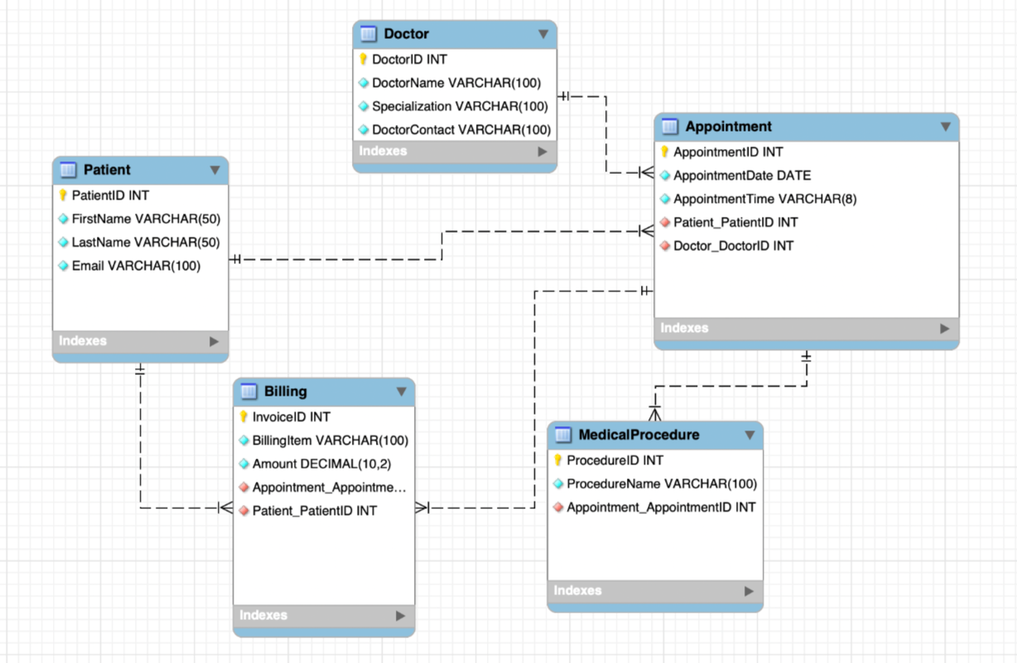
Figure 1. OLTP schema for Healthcare Clinic.
3. Transferring OLTP schema to Tables in MySQL
Order of transfer is as follows:
- Patient_final.csv
- Doctor_final.csv
- Appointment_final.csv
- MedicalProcedure_final.csv
- Billing_final.csv

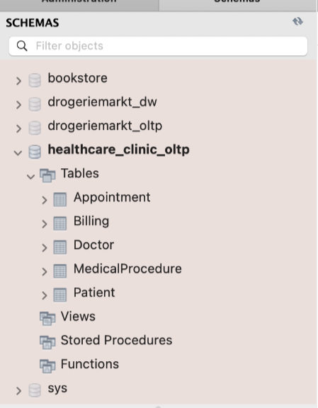
Figure 2. Transferring the OLTP schema into MYSQL tables.

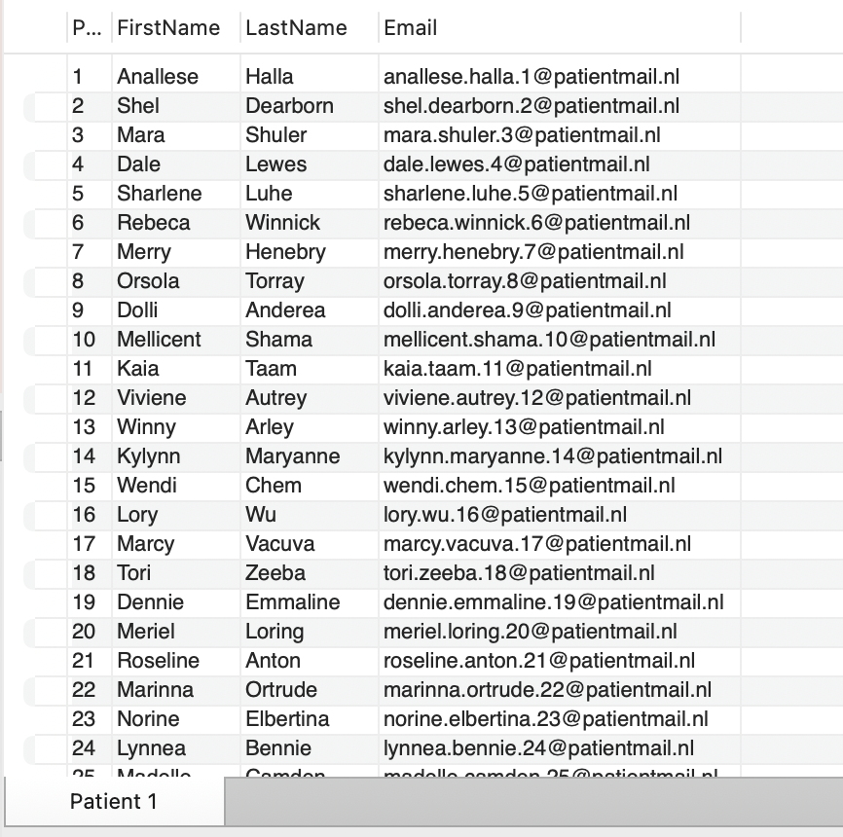
Figure 3. Imported data for the Patient table.

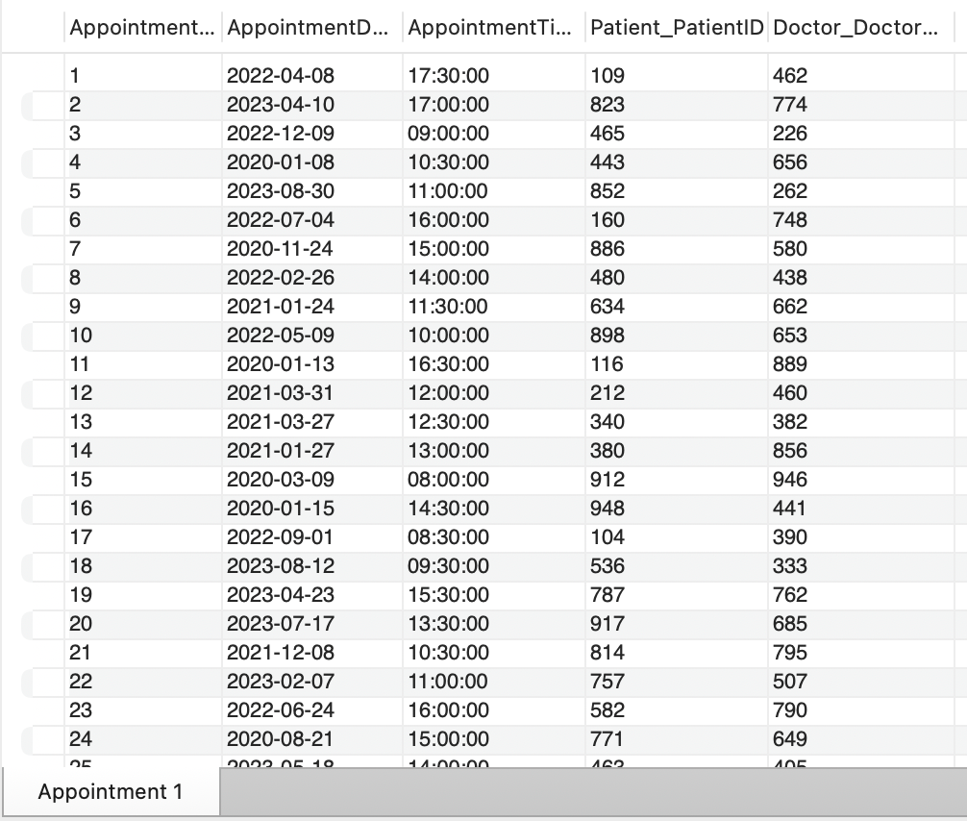
Figure 4. Imported data for the Appointment table.
4. DW schema
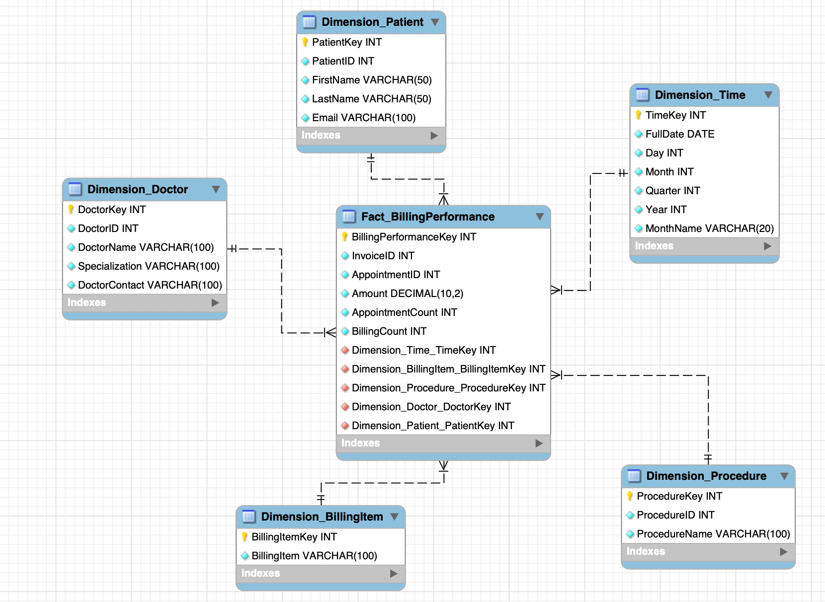
​​Figure 5. DW schema for Healthcare Clinic.

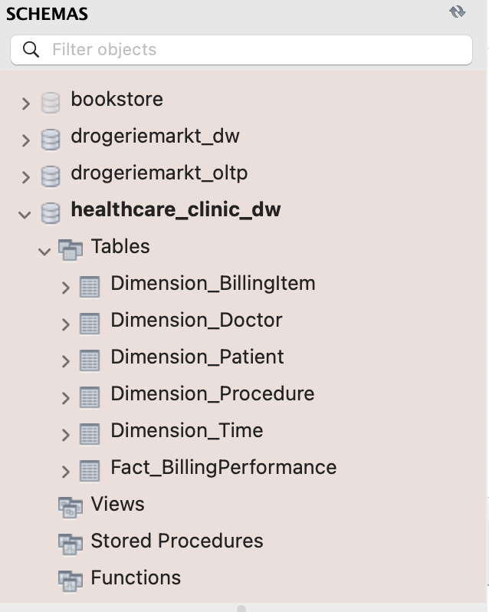
Figure 6. Transferring the DW into Tables.
5. Dimensions & Facts of DW
The chosen schema is a star schema. In this schema, Fact_BillingPerformance is at the center and is surrounded by five dimension tables: Dimension_Patient, Dimension_Doctor, Dimension_Time, Dimension_BillingItem, and Dimension_Procedure. The dimensions are therefore flat and directly linked to the fact table, which makes queries simpler and faster.
Dimension | Purpose
Dimension_Patient | Identifies the patients
Dimension_Doctor | The attending doctor
Dimension_Time | Time context of the billing
Dimension_BillingItem | What has been billed
Dimension_Procedure | Which medical procedure was performed
Table 1: Overview of Dimension Tables and Their Purpose
Fact Table: Fact_BillingPerformance
The main goal of the data warehouse is to monitor billing performance in a healthcare clinic network, this table shows how the clinic performs financially and operationally.
The fact Table contains three main measures: Amount, AppointmentCount, and BillingCount. Amount presents the billed amount for each billing record. It makes it possible to analyse revenue by doctor, patient, procedure, billing item, or time period.
AppointmentCount represents the number of appointments, it can help the clinic to understand workload and capacity usage. For example, it can show which doctors or specializations have many appointments and during what period the clinic is busiest.
BillingCount represents the number of billing records or invoice lines. This measure gives insight into the level of billing activity and the administrative workload. This can show which procedure, doctor or patient is linked to frequent billing activity.
Amount shows how much money was billed, while AppointmentCount and BillingCount help explain why this amount is high or low. A high billed amount may be caused by many appointments, many invoice lines, or by expensive medical procedures.
By connecting the fact table to the dimension tables, the clinic will be able to answer questions such as which medical specializations generate the highest billed revenue, which medical procedures are billed most frequently, and how billing performance changes across different months and years. This supports the main objective of analyzing billing performance by doctor specialization, medical procedure, and time period.
The chosen star schema is closely related to the ETL transformations. During the ETL process, data from the OLTP tables are extracted, transformed, and loaded into the data warehouse. Dimension_Time is created from appointment dates, while patient, doctor, procedure, and billing information are cleaned and loaded into their corresponding dimension tables. Finally, the Fact_BillingPerformance table is created by combining the foreign keys from these dimensions with the measures Amount, AppointmentCount, and BillingCount. This structure enables the analysis of billing performance by medical procedure, doctor specialization, and time period.
6. ETL transformations in KNIME Analytics tool

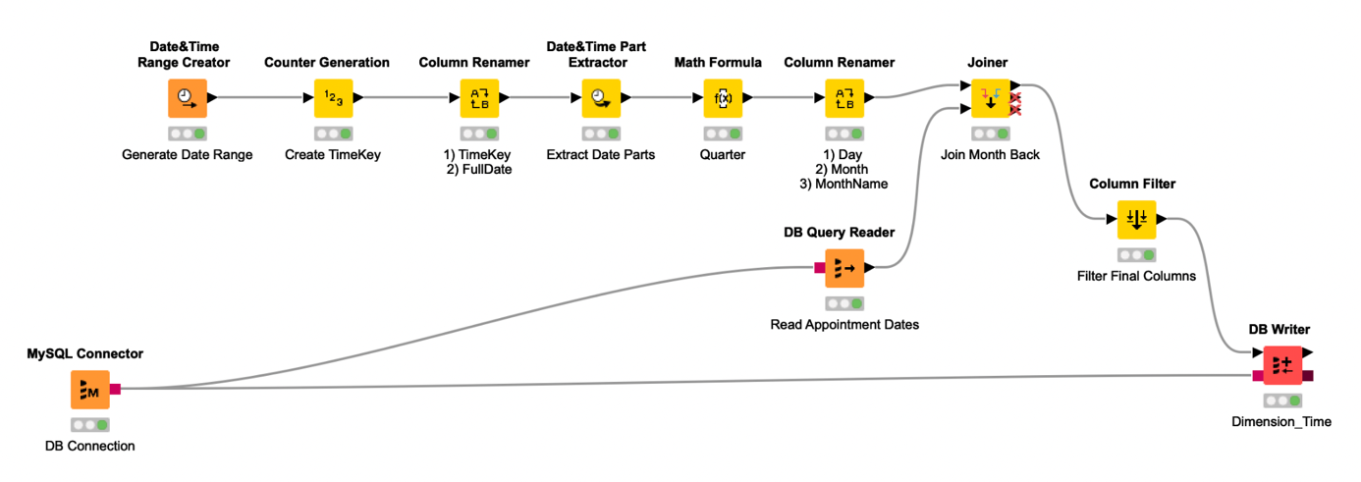
Figure 7. Dimension_Time transformation.

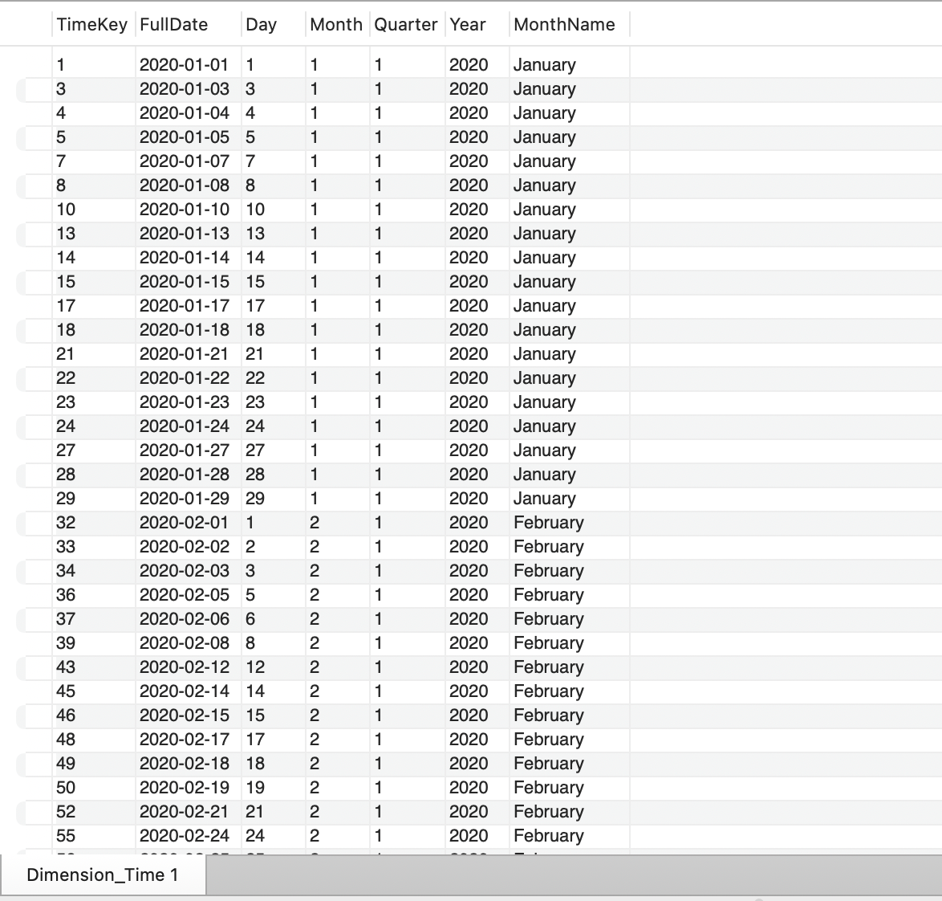
Figure 8. Dimension_Time in MySQL.

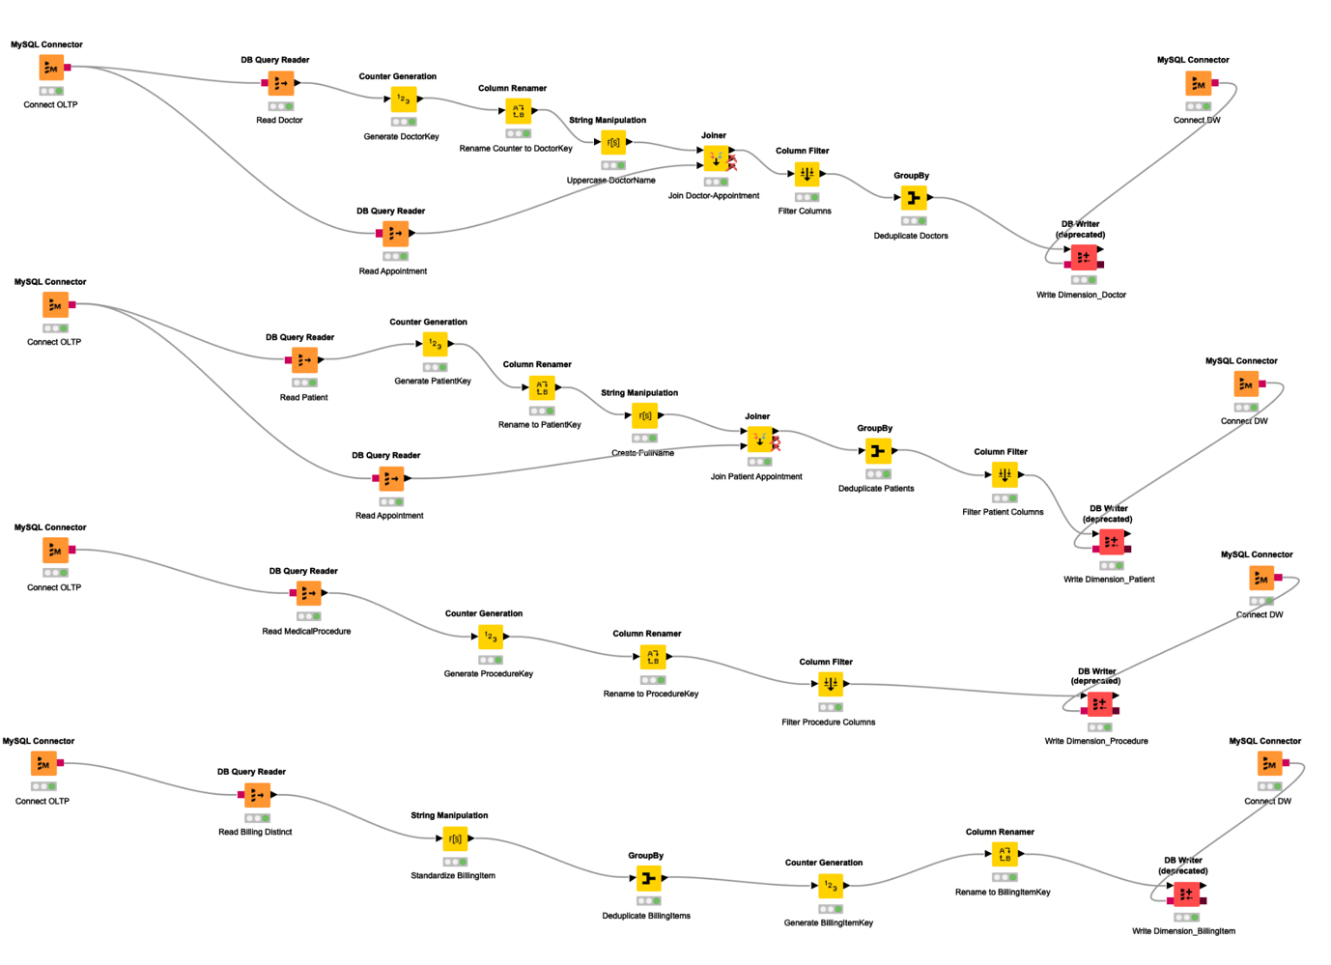
Figure 9. Dimension_Tables transformation.

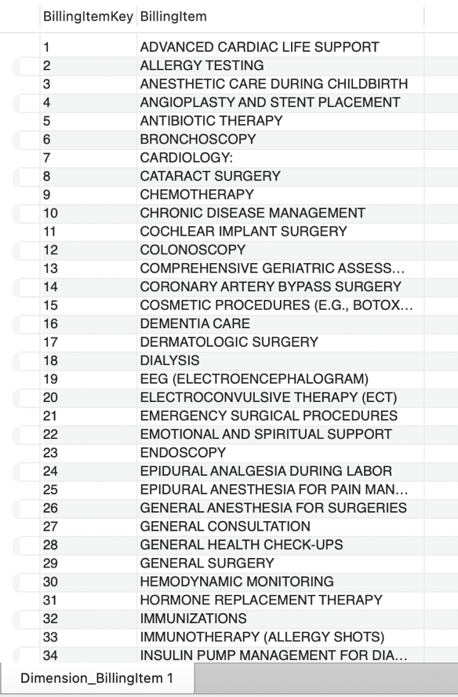
Figure 10. Dimension_BillingItem in MySQL
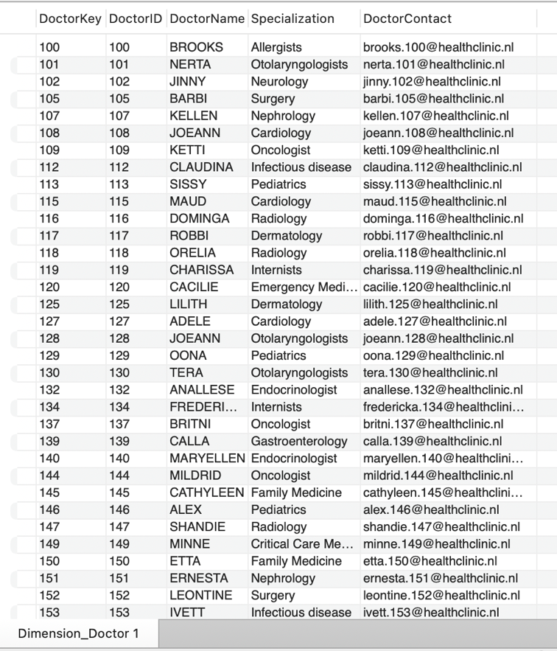
Figure 11. Dimension_Doctor in MySQL

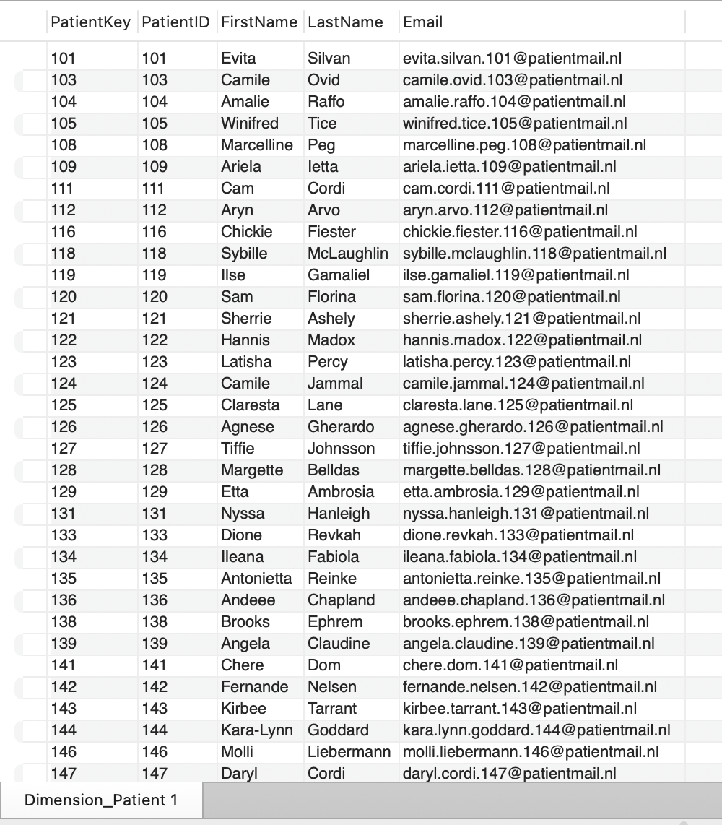
Figure 12. Dimension_Patient in MySQL

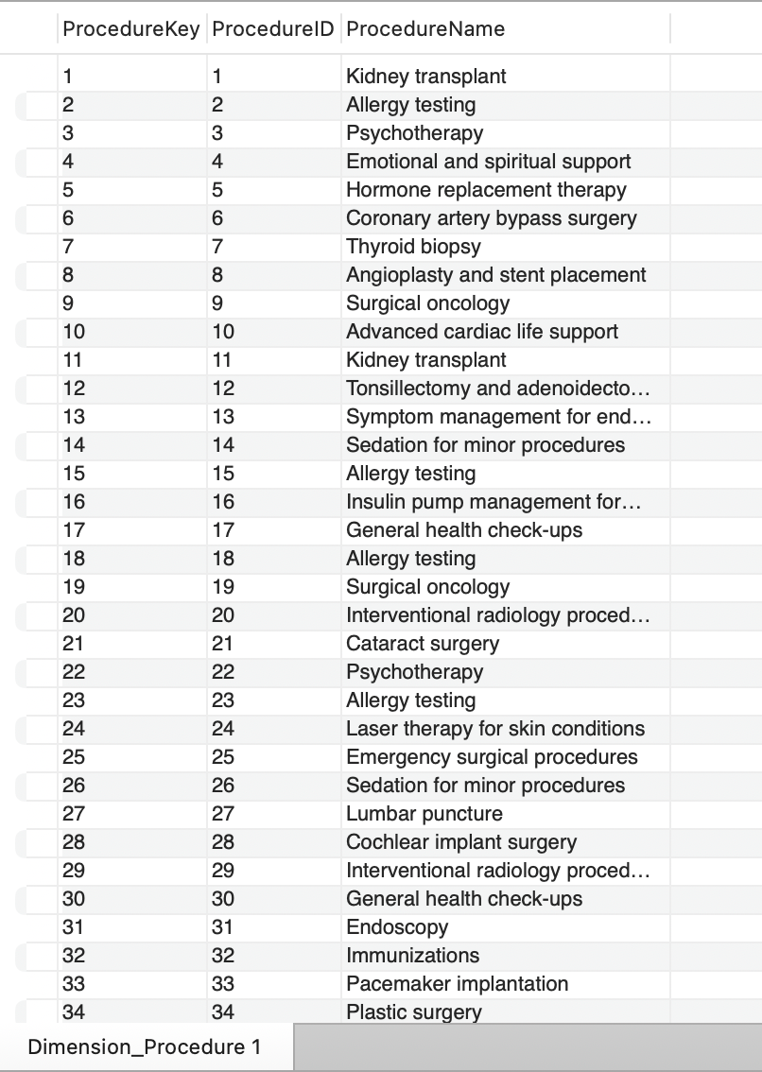
Figure 13. Dimension_Procedure in MySQL
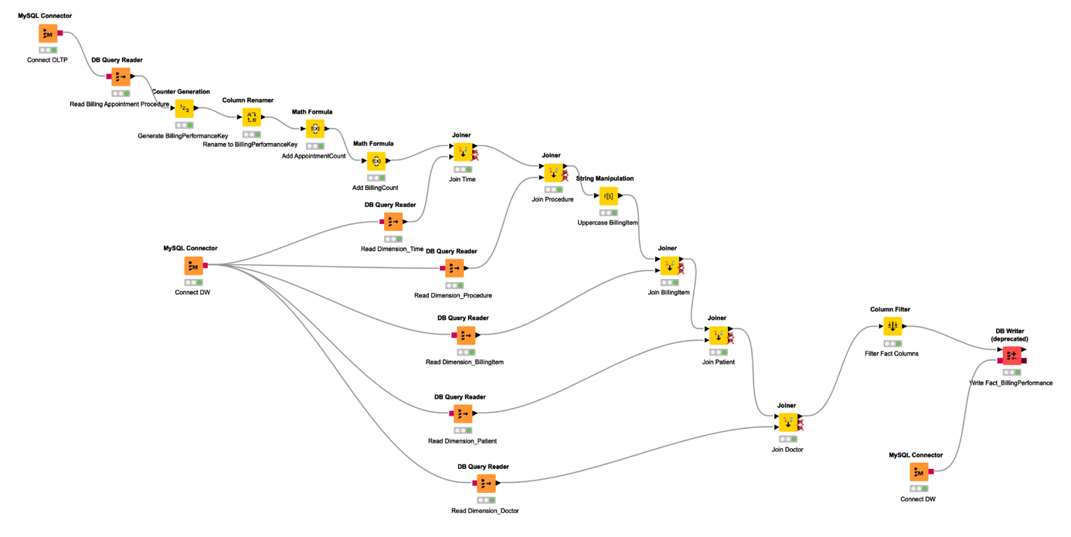
Figure 14. Fact_Table transformation.

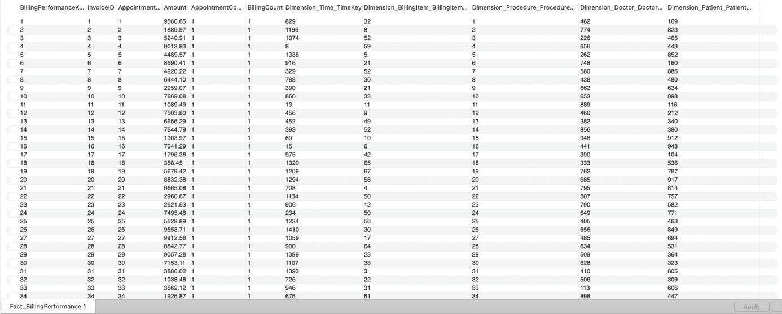
Figure 15. Fact_Table in MySQL.

7. View in MySQL

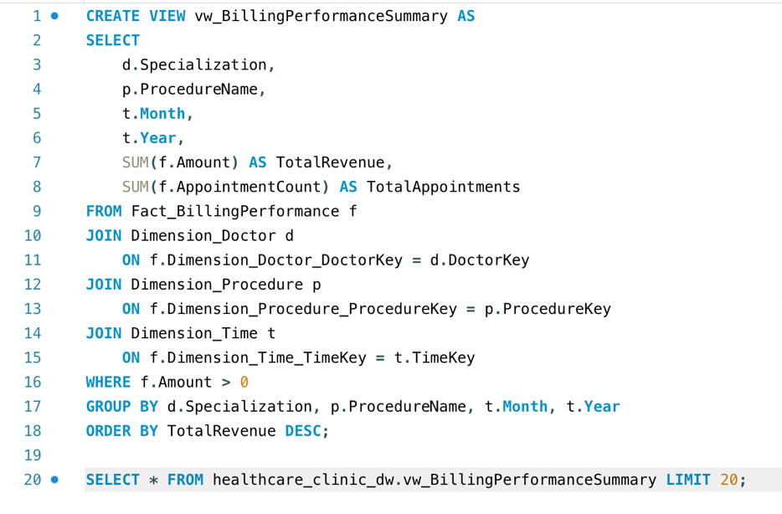
Figure 16. Billing Performance Summary View showing total revenue and appointment counts by doctor specialization, medical procedure and time period.
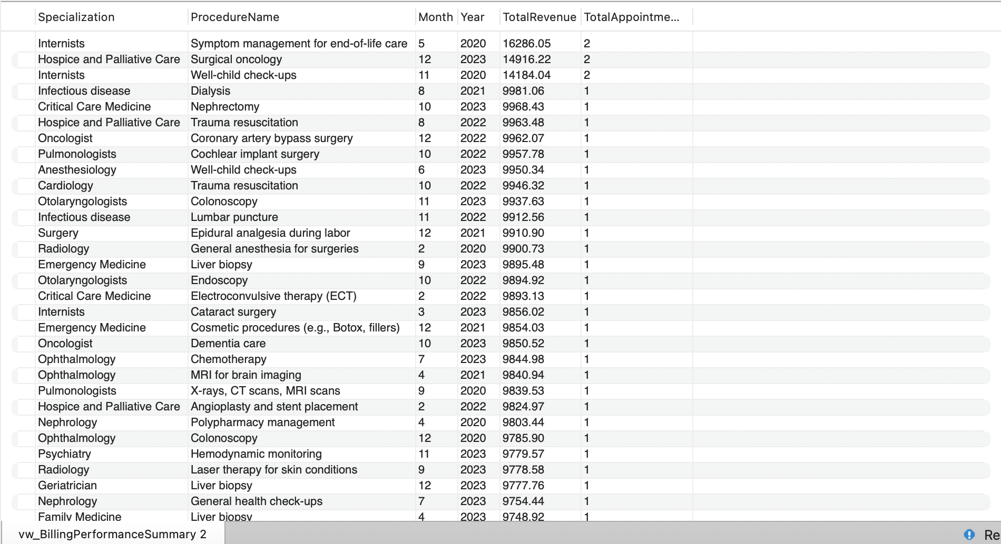
Figure 17. Output of the Billing performance view.

8. Report in KNIME Analytics tool

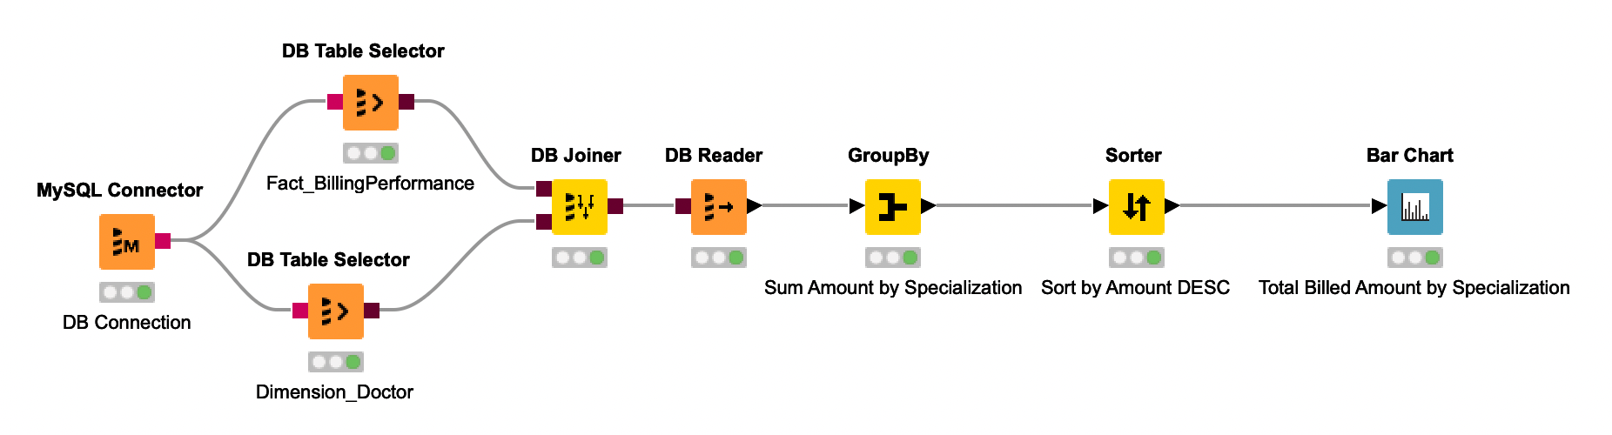
Figure 18. Transformation for reporting total billed revenue by medical specialization.
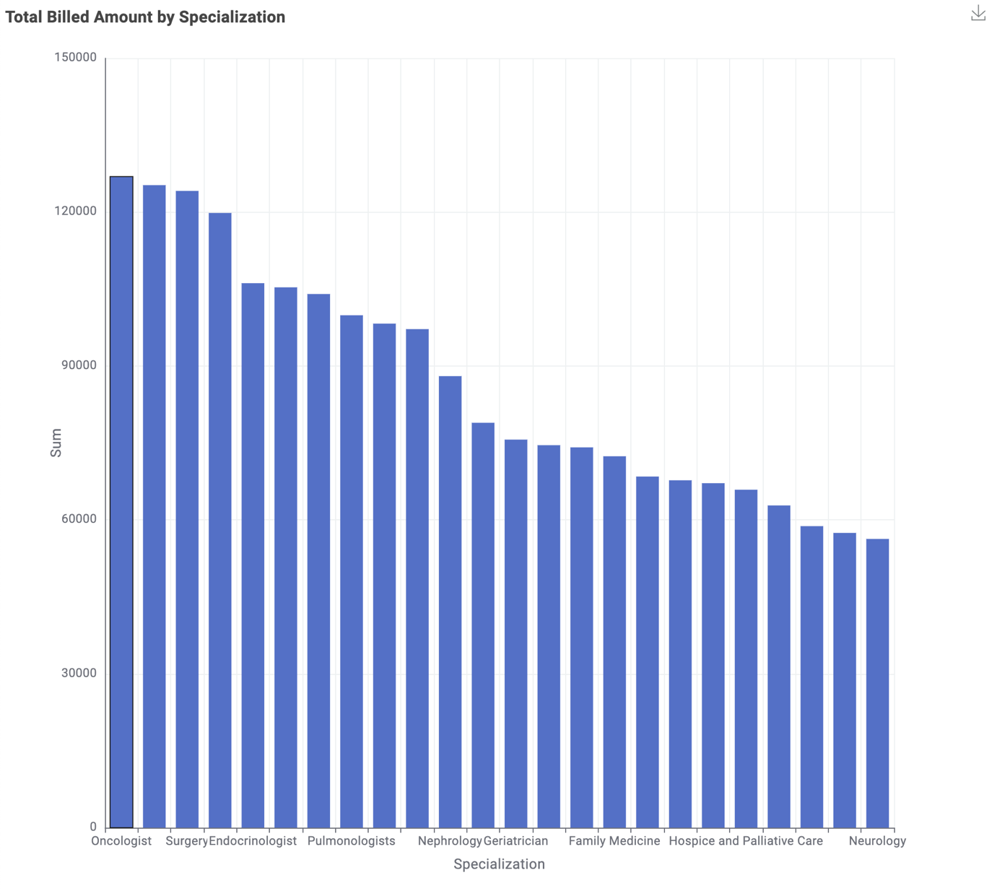
Figure 19. Bar chart showing total billed revenue by doctor specialization based on the Fact_BillingPerformance table.

