Training

# Savitsky Golay filter + no class weights + no early stop

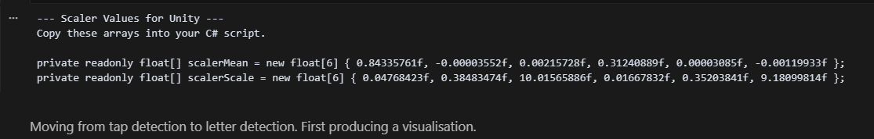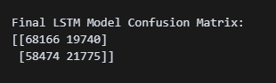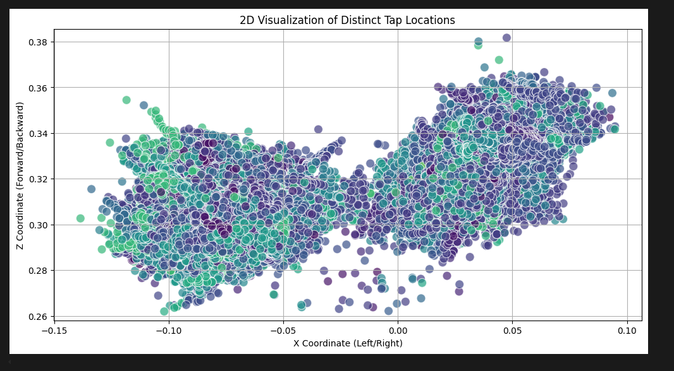

# Class weights but same

