Dear course cordinator,

hello i am Teza and i am enrolled in COIT20245- INTRODUCTION TO PROGRAMMING. Sir/ mam, i have been provided feedback of my assignment result. I have some doubt regarding that.

Sir/mam, i have been given 0 marks out of 2 in sorting creteria. Sir/mam. It was mention we can either use selection sort, or insertion sort or array.sort(). And i have used array.sort in the program. And i have been awareded 0 marks for that.

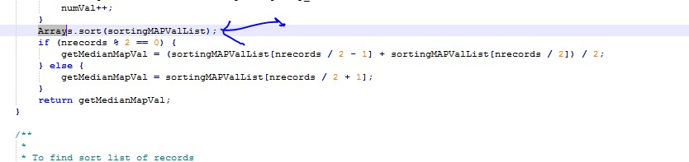

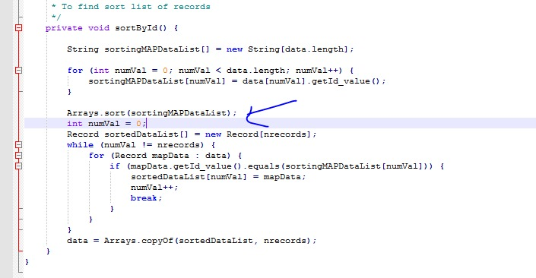

In the next part of documentation and layout i have been given 0 marks in comments parts with feedback of ***no comments used*** but i have prepared a full documented code.

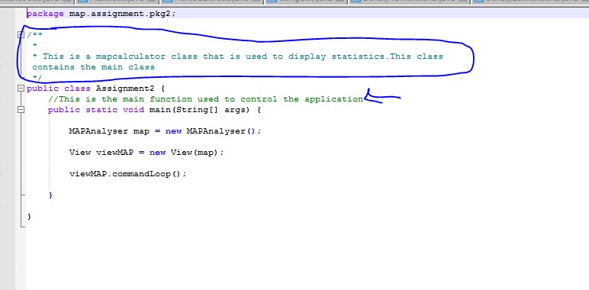

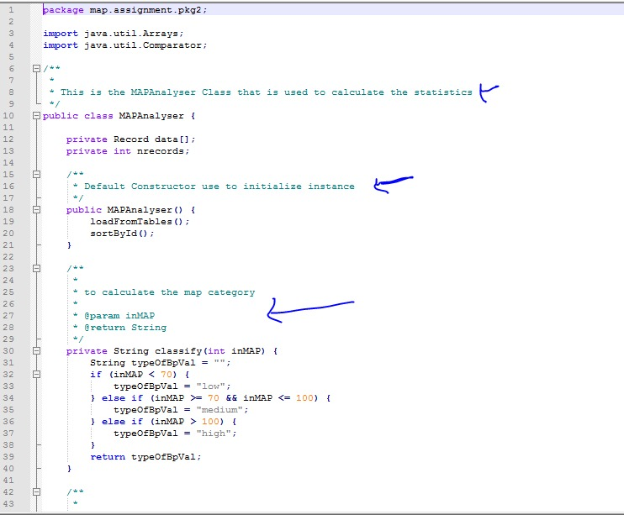

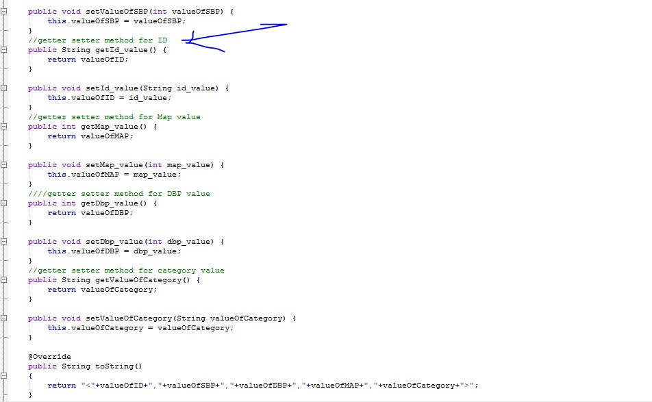

In Report part, under test plan and test result i have used every numeric input and out result. Please look at the out screens i have provided over there.

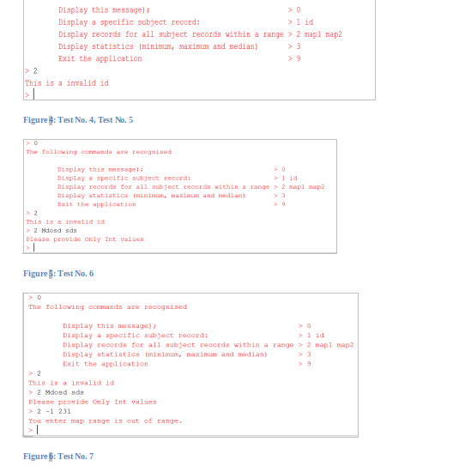

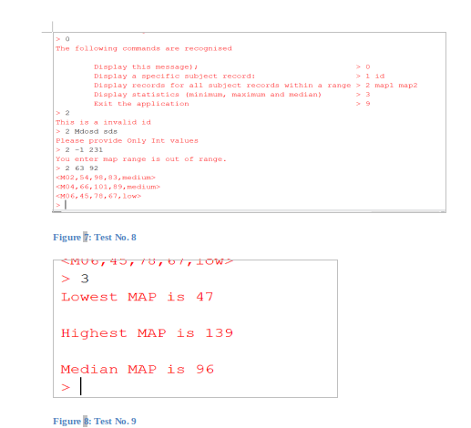

sir/mam, please look into the matter i have worked hard and i have been given 0 for those part that i have attempted. You always have been so much helpful snd supportive. Please consider this application.

Reagrds

Teza