Sol:

Finding Nth highest salary in a table is the most common question asked in interviews. Here is a way to do this task using dense_rank() function.

Consider the following table:  
**Employee**

| **ename** | **sal** |
| --- | --- |
| A | 23000 |
| B | 31000 |
| C | 24500 |
| D | 35000 |
| E | 28500 |
| F | 31500 |
| G | 39800 |
| H | 51000 |
| I | 39800 |

**Query :**

select * from(

select ename, sal, dense_rank()

over(order by sal desc)r from Employee)

where r=&n;

To find to the 2nd highest sal set n = 2

To find 3rd highest sal set n = 3 and so on.

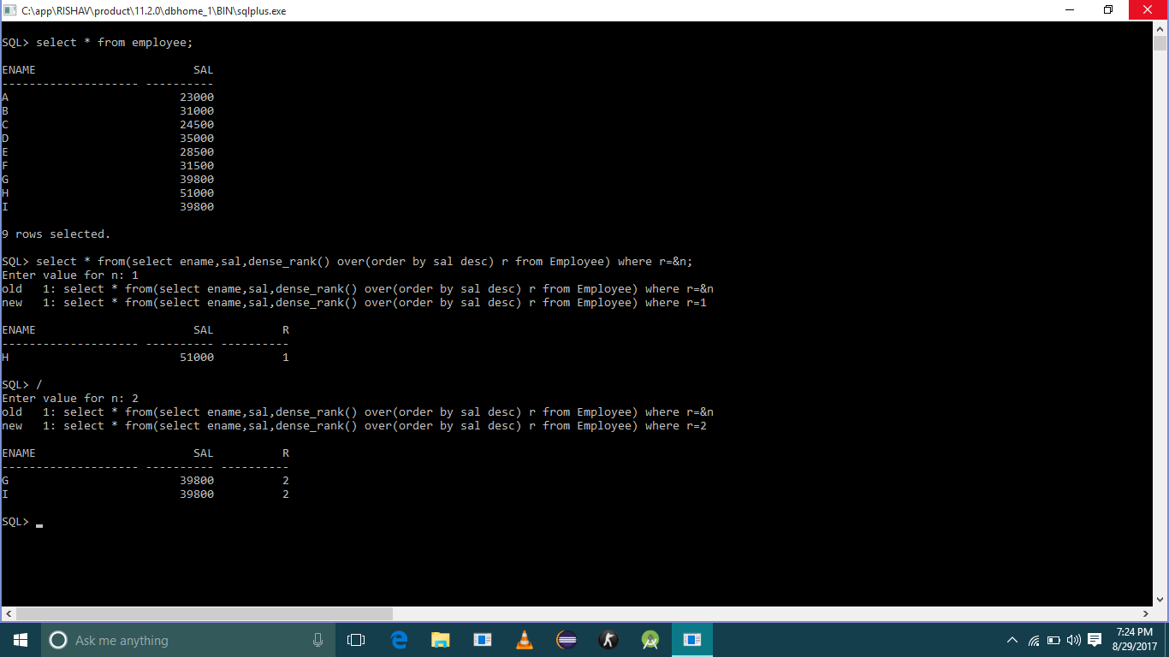**Output :**