Points | Check-ins | My peer review interactions | Demonstration of course objectives | Tangible output and clear analysis
20-25 | completes check ins descriptively and respectfully | 1-page response thoroughly addressing peer review | demonstrates understanding and clear addressing of objectives intention | Project has tangible outputs that have completed descriptions and properly significant information and analyses
12-19 | completes most check-ins descriptively and respectfully | 1-page response not so thoroughly addressing peer review | demonstrates either understanding or clear addressing of objective intentions | Project has tangible outputs but incomplete descriptions or not significant information or analyses
 | Currently I think I have done all current check-ins well, but we are not done yet, hence not a complete score. |  | I think that since, I have not actually done any analysis, I have not completely addressed the objectives, but I think as my project currently stands I have covered some objectives
5-11 | not descriptive | barely or only partial addressing of peer review | poorly demonstrates both | Intangible outputs, or lacking descriptions, or meaningless information
 |  |  |  | As it stands I have not yet completed any of the actual analysis for this yet, I have only had time to do the data cleaning, and importing. Primarily because I was unable to get PySpark to download/install and so in order to use Pandas, there is more data cleaning I was required to do directly within the excel sheet itself, as well as more lines of code needed to do specific tasks than expected.
0-5 | not completed or rude | no address of peer review | no demonstration or failure to demonstrate | A poor job at all or a complete lack or both
 |  | Not currently relevant/done

All that is left to do is to actually code the analyses, these should be relatively straightforward at this point because my data has been prepared so it is just comparisons and relatively straightforward analyses.
Beyond these dataframe structure screenshots, which just show the overall structure of the dataframes, I do not really have any ability to show my program running at this point. The closest other thing would be my output excel file, which shows the anonymized dataframe info.
Alphabetic DataFrame Structure State DataFrame Structure Joined DataFrame Structure
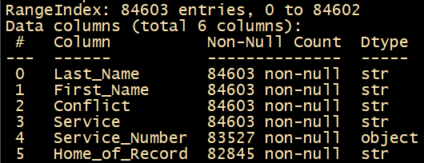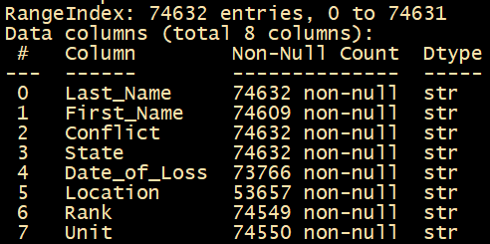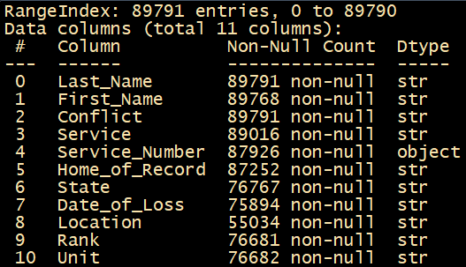
Duplicate removed DataFrame Structure Non-US Removed DataFrame Structure Anonymized DataFrame Structure
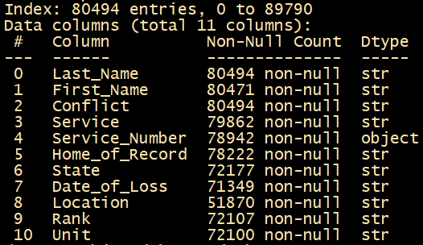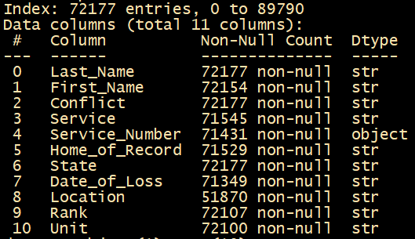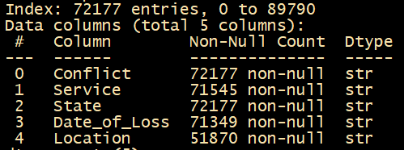

In actual code terms, my intentions are to — [grouped by conflict – analyze the spread of the states, analyze the total service balance, (potentially)analyze the spread of location, analyze the date of loss patterns], [grouped by conflict and state – see the balance of services, analyze the spread of location], [grouped by state – see the overall balance of branch, analyze the conflict loss trends, analyze the date of loss patterns, and analyze the overall location spread]

