Project Members

Member 1: Rinamae E. Roperos

Member 2: Brent Leward Vineles

Member 3: Niño Anthony Espartero

Member 4: John Paul Tinguha

System Title: Blood Donation Management System (BDMS)

The Blood Donation Management System is a web-based application designed to efficiently manage blood donation activities. It helps connect blood donors, recipients, and administrators in one centralized platform.
The system allows users to:
- Register as blood donors
- Request blood donations
- View available donors and blood types
- Manage donor records
- Track donation history

It is developed using React.js (frontend framework) and designed using Stitch AI (UI/UX design tool). The system focuses on providing a simple, fast, and user-friendly interface for managing blood donation processes.
The main goal of the system is to make blood donation more organized, accessible, and efficient, especially during emergencies.

System Flowchart (Overall Process)
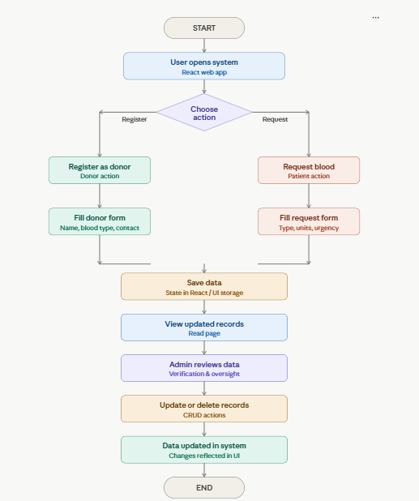

Tools Used
- React.js (Frontend Development)
- Vite (Project Setup)
- Stitch AI (UI/UX Design)
- CSS (Styling)
- Netlify (Deployment)

The Blood Donation Management System simplifies the process of managing blood donors and recipients through a modern web interface. It improves accessibility, organization, and efficiency using a clean CRUD-based system design.

